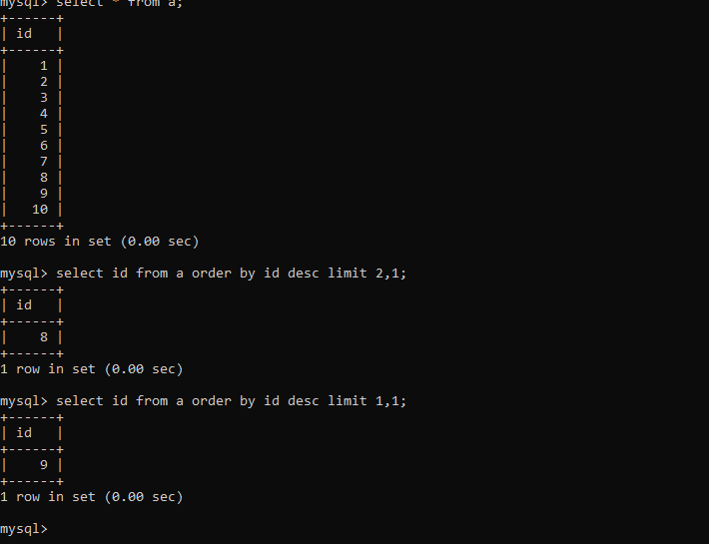

Find second highest value .

[Home](http://www.mysqltutorial.org/) / [Basic MySQL Tutorial](http://www.mysqltutorial.org/basic-mysql-tutorial.aspx) / MySQL LIMIT

MySQL LIMIT

**Summary***:*in this tutorial, you will learn how to use MySQL LIMIT clause to constrain the number of rows returned by a query.

Introduction to MySQL LIMIT clause

The LIMIT clause is used in the [SELECT](http://www.mysqltutorial.org/mysql-select-statement-query-data.aspx) statement to constrain the number of rows to return. The LIMIT clause accepts one or two arguments. The values of both arguments must be zero or positive [integers](http://www.mysqltutorial.org/mysql-int/).

The following illustrates the LIMIT clause syntax with two arguments:

|  |  |
| --- | --- |
| 1  2  3  4  5 | SELECT      select_list  FROM      table_name  LIMIT [offset,] row_count; |

In this syntax:

* The offset specifies the offset of the first row to return. The offset of the first row is 0, not 1.
* The row_count specifies the maximum number of rows to return.

The following picture illustrates the LIMIT clause:

