Enforce least-privilege access through identity-aware, application-specific access policies using Zscaler Private Access (ZPA)

TEAM DETAILS
S.No | NAME | COLLEGE NAME | CONTACT
1. | SRIMATHI M | SRI KRISHNA ADITHYA COLLEGE OF ARTS AND SCIENCE | 23bsct262srimathim@skacas.ac.in
2. | ABDUL RAHIM A | SRI KRISHNA ADITHYA COLLEGE OF ARTS AND SCIENCE | 23bsct203abdulrahima@skacas.ac.in
3. | ABDUL HAMEED J | SRI KRISHNA ADITHYA COLLEGE OF ARTS AND SCIENCE | 23bsct202abdulhameedj@skacas.ac.in
4. | AMARAVATHY V | SRI KRISHNA ADITHYA COLLEGE OF ARTS AND SCIENCE | 23bsct209amaravathyv@skacas.ac.in

Project details

Title: Enforce least-privilege access through identity-aware, application-specific access
policies using Zscaler Private Access (ZPA)

INTRODUCTION:

In an era where the digital landscape is constantly evolving, organizations face an ever-increasing threat from cyberattacks. The need for swift and effective incident response has become paramount to safeguard sensitive data, protect digital assets, and maintain the trust of stakeholders. In response to this growing challenge, we present a visionary project: the development of an AI-driven incident response platform that empowers cybersecurity teams with the tools to automate and enhance incident triage and response tasks.

In response to the evolving threat landscape and the dissolution of the traditional network perimeter, modern enterprises are rapidly shifting away from legacy VPN-centric remote access models. These conventional approaches often grant excessive network-level access, creating a significant attack surface and increasing the risk of lateral threat movement. To address these challenges, this project centers on the implementation of a Zero Trust security architecture, fundamentally operating on the principle of "never trust, always verify." By moving beyond location-based access, we aim to establish a security posture where trust is no longer implicit, and access is determined by granular context rather than network connectivity.

The core of this initiative involves the deployment of Zscaler Private Access (ZPA), a cloud-delivered Zero Trust Access solution designed to create identity-aware, application-specific connectivity. Unlike traditional VPNs that place users on the internal network, ZPA leverages a "service-initiated" model to establish direct, one-to-one connections between authorized users and specific applications, completely hiding the corporate network and IP address space from the internet. This ensures that users connect exclusively to the applications they are permitted to access, based on continuous identity verification and context, rendering the applications invisible to unauthorized users and preventing common attack vectors such as port scanning and distributed denial-of-service (DDoS) attacks.

Ultimately, this project will enforce a least-privilege access model, ensuring users and devices are granted the minimum required access necessary to perform their functions. By decoupling application access from network access, we will eliminate the risk of lateral movement across the network, as users have no visibility or connectivity to other hosts. This strategic move not only significantly enhances security by reducing the attack surface but also simplifies the user experience and reduces operational overhead associated with legacy remote access infrastructure, positioning the organization at the forefront of secure and efficient access management

Abstract:

The proliferation of hybrid work and cloud-based resources has rendered traditional perimeter-based security models, such as VPNs, obsolete and increasingly dangerous. These legacy solutions often provide overly broad network access, exposing organizations to significant risks including lateral threat movement and an expanded attack surface. This project addresses these vulnerabilities by implementing a Zero Trust Architecture (ZTA) utilizing Zscaler Private Access (ZPA). The primary objective is to transition from network-centric to identity-centric access, thereby enforcing the principle of least privilege.

The methodology involves deploying ZPA’s cloud-based service to create application-specific, identityaware micro-tunnels. Unlike conventional VPNs that place users on the internal network, this solution establishes direct, one-to-one connections between verified users and authorized applications. The network infrastructure and all non-authorized applications remain completely invisible to the end-user, effectively eliminating surface for reconnaissance and attack. Access policies are dynamically governed by user identity, device posture, and contextual attributes, ensuring that connectivity is strictly limited to what is explicitly required for specific job functions.

The implementation of ZPA successfully decouples application access from network access, resulting in a demonstrable reduction in the organization's attack surface and the complete prevention of lateral movement. This project delivers a robust, scalable, and user-friendly remote access framework that aligns with modern security best practices. By shifting to an identity-aware, least-privilege model, the organization significantly enhances its security posture while simultaneously reducing operational complexity and improving the end-user experience

Use Case Scenarios:

Scenario 1: Finance Department Access to ERP System

A senior accountant in the finance department needs to access the corporate Enterprise Resource Planning (ERP) system to process monthly payroll. The user connects from a remote location using their company-managed laptop. Upon launching the ZPA Client Connector, they authenticate via Azure Active Directory with multi-factor authentication (MFA). ZPA evaluates the user's identity, group membership (Finance_ERP_Users), device posture (antivirus active, disk encryption enabled), and connection context. The policy engine determines that the user is authorized and brokers a secure, direct micro-tunnel to the ERP application only. The user can interact with the ERP interface, but has no visibility or network-level access to any other internal systems, such as development servers or the HR database.

Output:

• User authenticated and authorized based on identity and group membership

• Direct micro-tunnel established specifically to the ERP application

• All other internal applications and network segments remain invisible and inaccessible

Scenario 2: Contractor Access to Specific Project Repository

An external software consultant is hired for a three-month project and requires access only to a specific Git repository hosted on an internal server. The contractor is onboarded as a guest user in the identity provider and assigned to the "Project_X_Contractors" group. When the contractor connects using the ZPA client, the system verifies their identity and checks the device for basic security compliance (OS patch level, firewall enabled). ZPA enforces a policy that grants access exclusively to the Git repository application (port 22/SSH or port 443/HTTPS) during business hours (9 AM to 5 PM). The contractor can clone, push, and pull code, but cannot discover or connect to any other internal resources, including the corporate intranet or file servers.

Output:

• Time-bound and role-specific access enforced

• Contractor restricted to a single application (Git repository)

• Lateral movement to adjacent systems completely blocked

Scenario 3: Executive Access to Confidential Board Documents

A company executive needs to access a confidential folder containing board meeting materials hosted on an internal file server. The executive connects from a tablet device while traveling internationally. ZPA integrates with the mobile device management (MDM) solution to verify that the tablet is compliant (not jailbroken, passcode enabled, encryption active). Upon successful authentication, ZPA evaluates the policy: "If user is in 'Executive_Board' group AND device is MDM-compliant AND connection is from a trusted country (allowlist), THEN grant access to 'Board_Documents' application." The executive is connected directly to the specific file share, and all data in transit is encrypted via TLS. Any attempt to access other shares or network resources is automatically blocked and logged.

Output:

• Context-aware access based on user role, device posture, and geographic location

• Granular access to a specific file share (Board_Documents)

• Comprehensive logging of access events for audit and compliance

Scenario 4: IT Administrator Access to Server Management Interfaces

A systems administrator requires access to management interfaces (SSH for Linux servers and RDP for Windows servers) to perform routine maintenance. Instead of granting VPN access to the entire management network, ZPA is configured to treat each server or management interface as a separate application segment. The administrator authenticates and is presented only with the specific servers they are authorized to manage based on their IT subgroup (e.g., "Linux_Admins" see only Linux servers; "Windows_Admins" see only Windows servers). When the admin connects via SSH to a Linux server, ZPA creates a direct micro-tunnel to that specific IP and port combination. The admin cannot scan the subnet, access other servers, or initiate connections to non-authorized ports.

Output:

• Micro-segmentation at the individual server/interface level

• Role-based access controlling visibility of specific management consoles

• Elimination of network-level reconnaissance capabilities for admins

Scenario 5: Mergers and Acquisitions Integration

A company acquires a smaller firm and needs to provide the acquired company's HR team with temporary access to the parent company's benefits enrollment application. The acquired company's users are added as external collaborators in the identity provider with limited attributes. ZPA policies are created that specifically grant the "Acquired_HR" group access only to the "Benefits_App" (a web application hosted internally). The acquired users install the ZPA client, authenticate, and are connected directly to the benefits application. Because ZPA provides access without network connectivity, the parent company's entire internal network remains completely hidden and protected. The acquired users cannot ping, scan, or access any other corporate resource. After six months, when the integration is complete and users are migrated to the parent identity system, the temporary policies are revoked.

Output:

• Secure, temporary access provided without network exposure

• Complete network invisibility protecting the parent company's infrastructure

• Simplified deprovisioning through policy revocation rather than complex network changes

Stage-1

Title Of the Project: -

Enforce least-privilege access through identity-aware, application-specific access policies using Zscaler Private Access (ZPA)

Overview: -

In response to the evolving threat landscape and the dissolution of the traditional network perimeter, modern enterprises are rapidly shifting away from legacy VPN-centric remote access models. These conventional approaches often grant excessive network-level access, creating a significant attack surface and increasing the risk of lateral threat movement. To address these challenges, this project centers on the implementation of a Zero Trust security architecture, fundamentally operating on the principle of "never trust, always verify." By moving beyond location-based access, we aim to establish a security posture where trust is no longer implicit, and access is determined by granular context rather than network connectivity

The core of this initiative involves the deployment of Zscaler Private Access (ZPA), a cloud-delivered Zero Trust Access solution designed to create identity-aware, application-specific connectivity. Unlike traditional VPNs that place users on the internal network, ZPA leverages a "service-initiated" model to establish direct, one-to-one connections between authorized users and specific applications, completely hiding the corporate network and IP address space from the internet. This ensures that users connect exclusively to the applications they are permitted to access, based on continuous identity verification and context, rendering the applications invisible to unauthorized users and preventing common attack vectors such as port scanning and distributed denial-of-service (DDoS) attacks.

Ultimately, this project will enforce a least-privilege access model, ensuring users and devices are granted the minimum required access necessary to perform their functions. By decoupling application access from network access, we will eliminate the risk of lateral movement across the network, as users have no visibility or connectivity to other hosts. This strategic move not only significantly enhances security by reducing the attack surface but also simplifies the user experience and reduces operational overhead associated with legacy remote access infrastructure, positioning the organization at the forefront of secure and efficient access management

List of Vulnerability Table:

S.no | Vulnerability Name | CWE - No
1 | Improper Ownership Management | CWE-282
2 | Clear text Storage of Sensitive Information in a Cookie | CWE-315
3 | Use of Unmaintained Third Party Components | CWE-1104
4 | Insufficient Entropy | CWE-331
5 | Unchecked Error Condition | CWE-391
6 | Embedded Malicious Code | CWE-506
7 | Missing Encryption of Sensitive Data | CWE-311
8 | Missing XML Validation | CWE-112
9 | Missing Critical Step in Authentication | CWE-304
10 | Insufficient Logging | CWE-778

REPORT: -

Vulnerability Name: Improper Ownership Management

CWE/CVE: CWE-282

OWASP/SANS Category: A01:2025-Broken Access Control

Description: Improper Ownership Management occurs when a system fails to correctly assign or enforce ownership permissions for resources such as files, applications, or data. In such situations, unauthorized users may gain the ability to access, modify, or delete resources that should be restricted to specific owners or administrators. This vulnerability often arises due to incorrect configuration of access controls, weak permission management, or improper handling of user roles and privileges. Attackers may exploit this weakness to manipulate ownership settings, leading to unauthorized control over critical system resources.
Business Impact: If ownership management is not properly enforced, attackers or unauthorized users may gain access to sensitive resources and perform actions that compromise system integrity. This can result in unauthorized modification or deletion of important data, disruption of business operations, and potential data breaches. Additionally, organizations may face financial losses, legal consequences, and reputational damage if sensitive information or critical systems are compromised due to improper access control mechanisms.
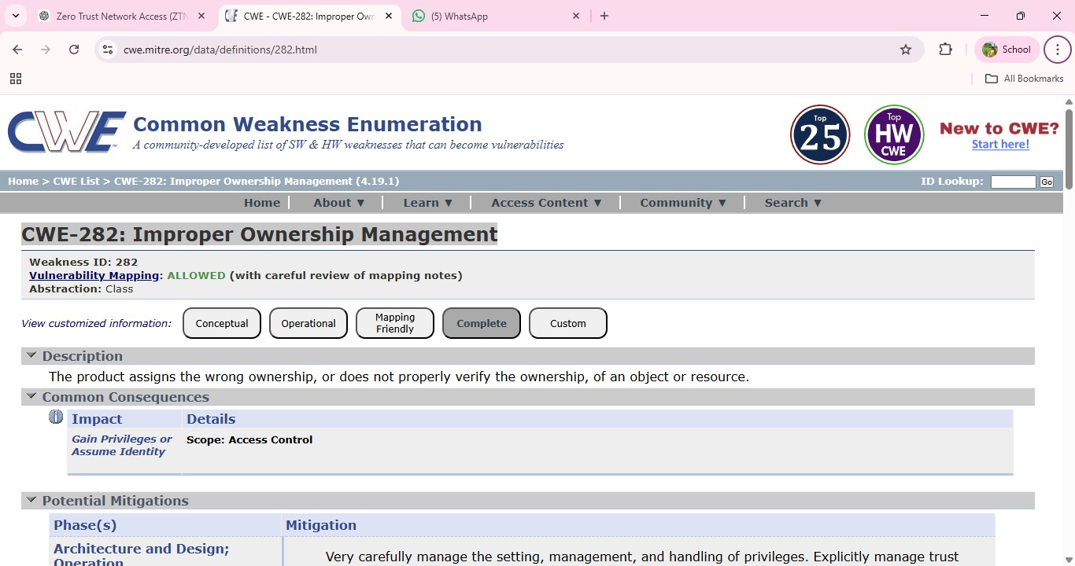

Vulnerability Name: Cleartext Storage of Sensitive Information in a Cookie

CWE/CVE: CWE-315

OWASP/SANS Category: A02:2025-Security Misconfiguration

Description: Cleartext Storage of Sensitive Information in a Cookie occurs when an application stores confidential data such as user credentials, session identifiers, or personal information in browser cookies without encryption. Since cookies are stored on the client side, they can be accessed by attackers through browser vulnerabilities, cross-site scripting (XSS) attacks, or by intercepting network traffic. If sensitive information is stored in plain text, attackers can easily read and misuse the data to gain unauthorized access to user accounts or application resources.
Business Impact: Storing sensitive information in cleartext cookies can lead to serious security risks such as session hijacking, unauthorized account access, and data breaches. Attackers may impersonate legitimate users and gain access to confidential information or internal systems. This can result in financial loss, legal liabilities, and damage to the organization's reputation, especially if customer or employee data is exposed.

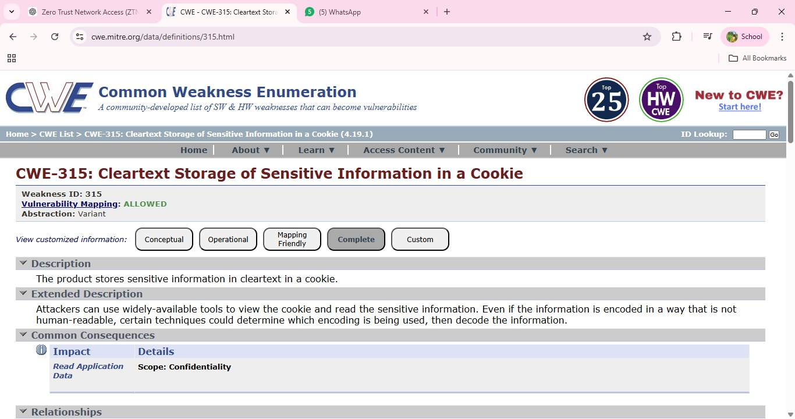

Vulnerability Name: Use of Unmaintained Third Party Components

CWE/CVE: CWE-1104

OWASP/SANS Category: A03 :2025-Software Supply Chain Failures

Description: Use of Unmaintained Third Party Components occurs when an application depends on external libraries, frameworks, or software components that are no longer actively maintained or updated by their developers. These outdated components may contain known security vulnerabilities that remain unpatched, making the application susceptible to exploitation. Attackers often scan systems for such components and exploit their weaknesses to gain unauthorized access, execute malicious code, or compromise the system.
Business Impact: Using unmaintained third-party components can expose an organization to significant security risks. Attackers may exploit known vulnerabilities to compromise applications, leading to data breaches, service disruptions, or unauthorized system access. This can result in financial losses, regulatory compliance issues, and damage to the organization's reputation. Maintaining updated and supported software components is therefore essential for ensuring long-term system security.

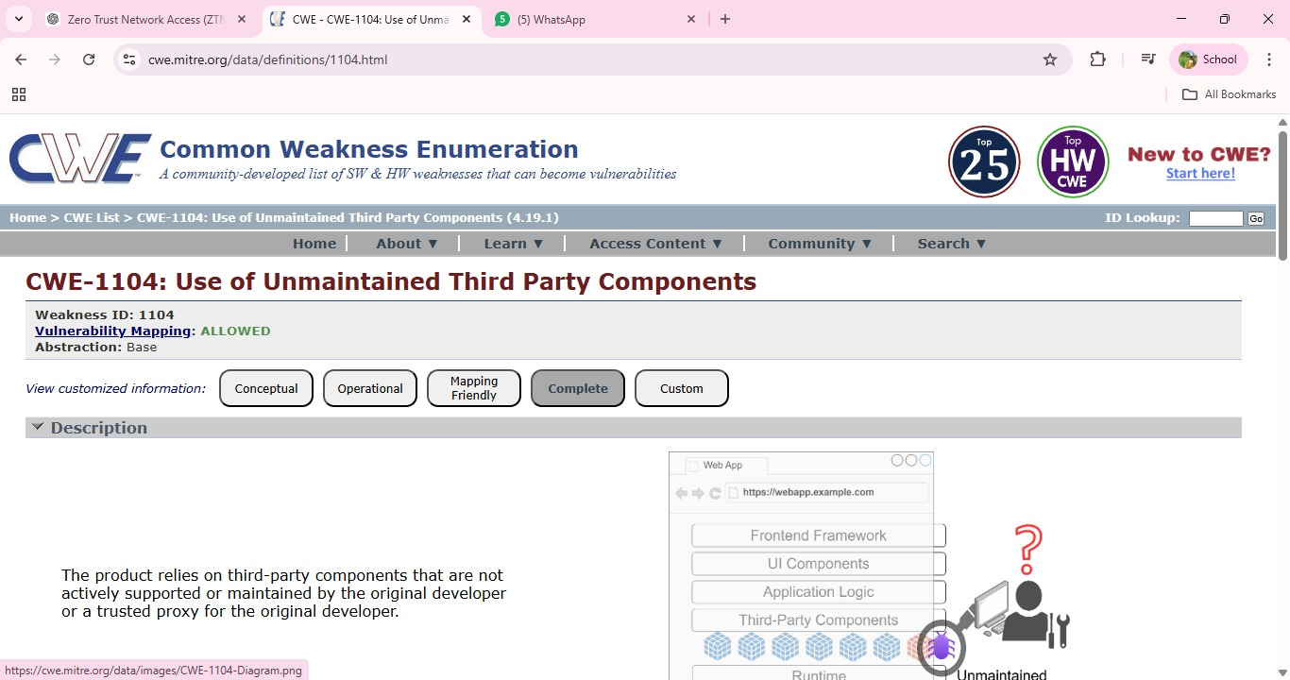
- Vulnerability Name: Insufficient Entropy
CWE/CVE: CWE-331
OWASP/SANS Category: A04 :2025-Cryptographic Failures

Description: Insufficient Entropy occurs when a system generates random values, such as cryptographic keys, session IDs, or tokens, using weak or predictable sources of randomness. Entropy refers to the level of unpredictability in generated values. When entropy is insufficient, attackers may be able to predict or reproduce these values, allowing them to bypass security mechanisms. This vulnerability often appears in authentication systems, encryption processes, or session management where strong randomness is required to maintain security.

Business Impact: If attackers can predict security tokens, session identifiers, or cryptographic keys, they may gain unauthorized access to user accounts or sensitive systems.This can lead to session hijacking, data breaches, and unauthorized transactions. For organizations, such incidents may result in financial losses, legal consequences, and damage to customer trust and reputation. Ensuring strong random number generation is essential to maintain system security.

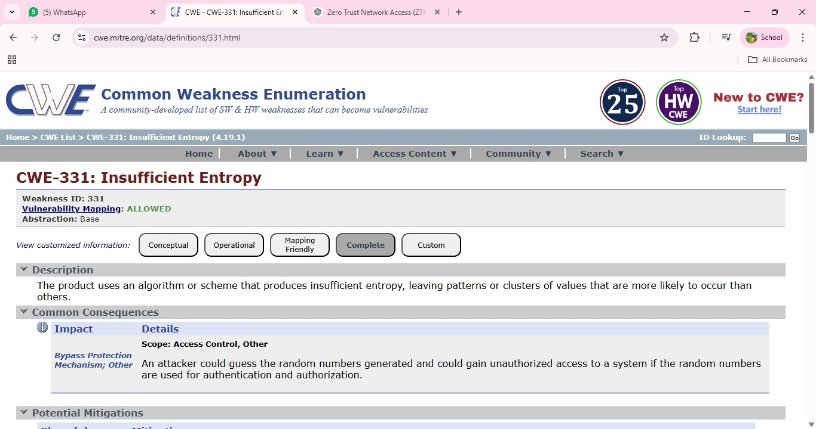

Vulnerability Name: Unchecked Error Condition

CWE/CVE: CWE-391
OWASP/SANS Category: A10 :2025-Mishandling of Exceptional Conditions

Description: Unchecked Error Condition occurs when a system or application fails to properly handle errors that occur during program execution. Instead of detecting and responding to these errors appropriately, the system may ignore them or continue processing without taking corrective action. This can lead to unexpected system behavior, incorrect outputs, or security weaknesses. Attackers may exploit such situations to trigger abnormal conditions, potentially bypassing security controls or causing the application to behave in unintended ways.
Business Impact: Failure to properly handle errors can result in system instability, data corruption, or unauthorized system behavior. Attackers may exploit these weaknesses to disrupt services, manipulate application functionality, or gain access to sensitive information. For organizations, this can lead to operational downtime, financial losses, and damage to reputation due to unreliable or insecure systems. Proper error handling and monitoring mechanisms are essential to maintain application reliability and security.

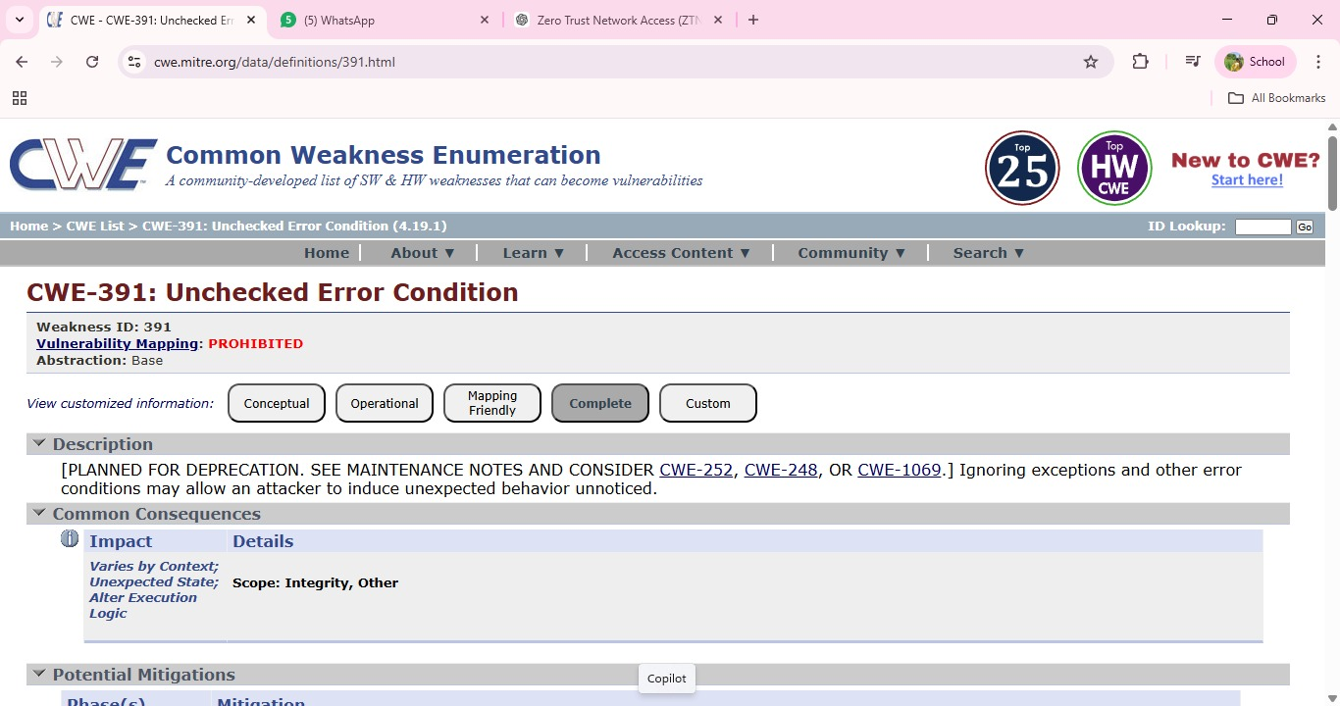
- Vulnerability Name: Embedded Malicious Code
CWE/CVE: CWE-506
OWASP/SANS Category: A08 :2025-Software or Data Integrity Failures

Description: Embedded Malicious Code refers to the presence of intentionally harmful code hidden within an application or software component. This malicious code may be inserted by attackers, compromised third-party libraries, or during insecure development practices. Such code can perform unauthorized actions such as stealing sensitive information, creating backdoors, or executing harmful operations without the user’s knowledge. Because the code is embedded within legitimate software, it may remain undetected for long periods and can be triggered under specific conditions.
Business Impact: The presence of embedded malicious code can severely compromise the security and reliability of an organization’s systems.Attackers may use it to steal confidential data, gain unauthorized access, or disrupt system operations. This can lead to data breaches, financial losses, operational downtime, and reputational damage. In critical environments, malicious code may also affect the integrity of applications and undermine trust in the organization’s software systems.
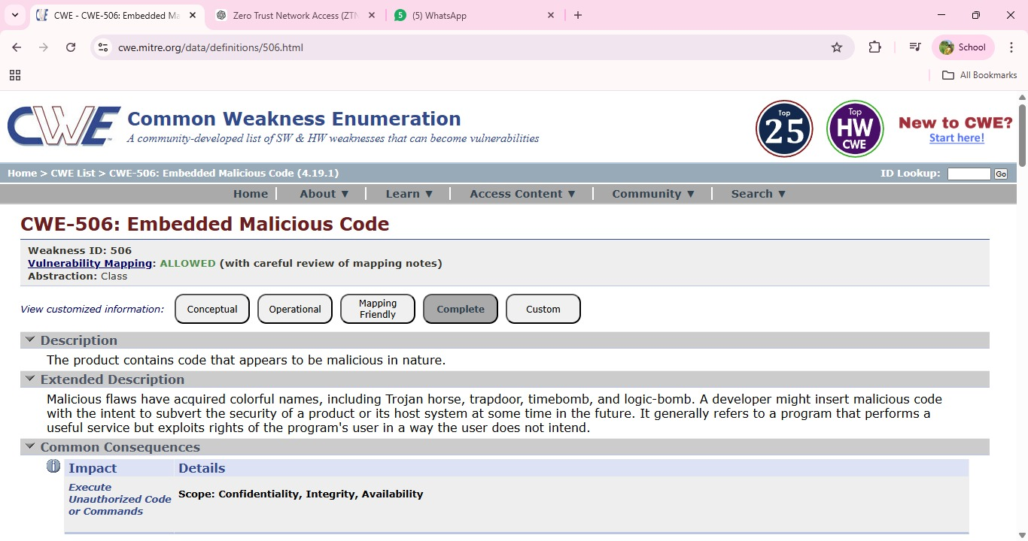

Vulnerability Name: Missing Encryption of Sensitive Data

CWE/CVE: CWE-311

OWASP/SANS Category: A06 :2025-Insecure Design

Description: Missing Encryption of Sensitive Data occurs when an application or system transmits or stores confidential information without using proper encryption mechanisms. Sensitive data such as user credentials, financial records, personal information, or internal system details may be exposed in plain text. If this data is intercepted during transmission or accessed by unauthorized users, attackers can easily read and misuse the information. This vulnerability often arises due to poor security configuration or failure to implement secure communication protocols.
Business Impact: Missing Encryption of Sensitive Data occurs when an application or system transmits or stores confidential information without using proper encryption mechanisms. Sensitive data such as user credentials, financial records, personal information, or internal system details may be exposed in plain text. If this data is intercepted during transmission or accessed by unauthorized users, attackers can easily read and misuse the information. This vulnerability often arises due to poor security configuration or failure to implement secure communication protocols.

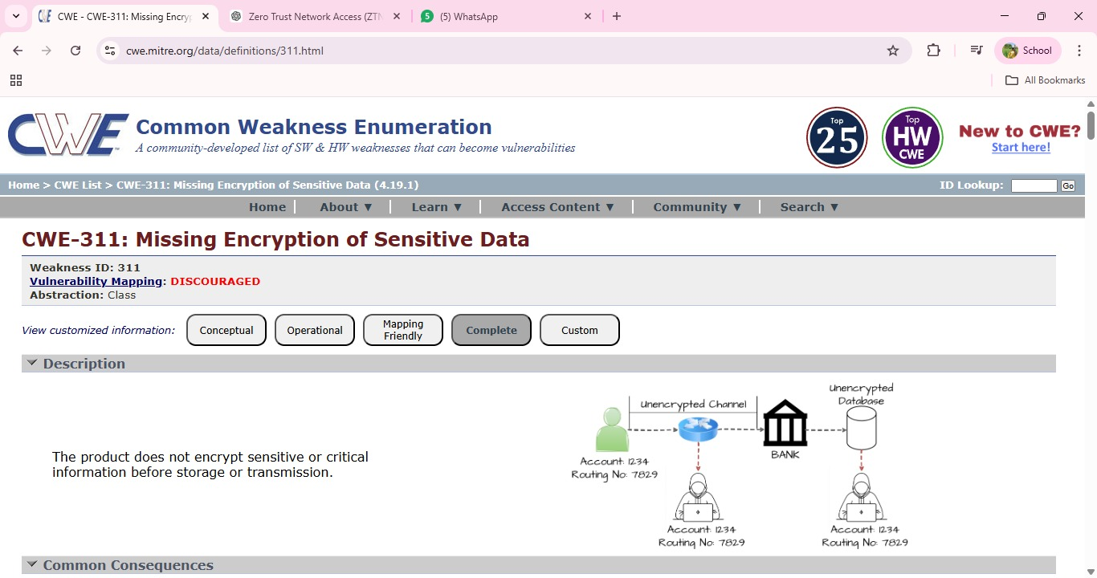

Vulnerability Name: Missing XML Validation

CWE/CVE: CWE-112

OWASP/SANS Category: A05 :2025-Injection

Description: Missing XML Validation occurs when an application processes XML input without properly validating its structure or content. XML is widely used for data exchange between systems, and if proper validation mechanisms are not implemented, attackers may send specially crafted XML data to manipulate application behavior. Without validation, the system may accept malicious or malformed XML input that can lead to security vulnerabilities such as XML injection, data manipulation, or unauthorized access to system resources.

Business Impact: If XML inputs are not properly validated, attackers may exploit this weakness to alter application data, bypass security checks, or disrupt normal system operations. This can lead to data integrity issues, service interruptions, and potential exposure of sensitive information.For organizations, such incidents may result in operational disruptions, financial losses, and reduced trust from customers or partners due to compromised system security.

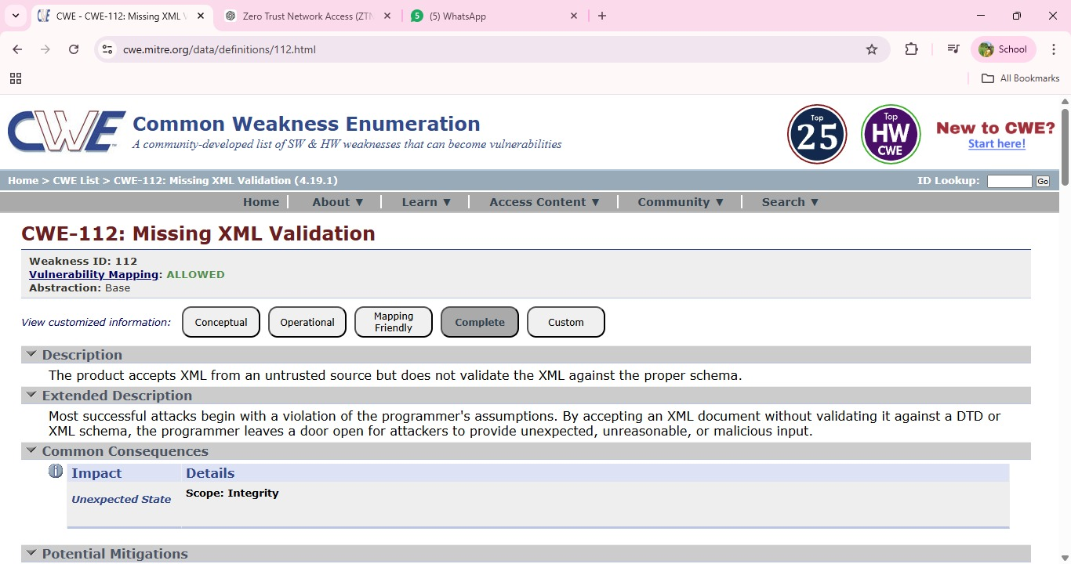
- Vulnerability Name: Missing Critical Step in Authentication
CWE/CVE: CWE-304
OWASP/SANS Category: A07 :2025-Authentication Failures

Description: Missing Critical Step in Authentication occurs when an application fails to enforce an essential step in the authentication process required to verify a user's identity. This may happen when security mechanisms such as multi-factor authentication, verification tokens, or session validation are skipped or improperly implemented. As a result, attackers may bypass authentication controls and gain unauthorized access to protected resources or user accounts. Such vulnerabilities often arise due to poor authentication logic or incomplete implementation of security checks.

Business Impact: If critical authentication steps are missing, attackers may successfully bypass login protections and gain unauthorized access to sensitive systems or user accounts.This can lead to data breaches, unauthorized transactions, and compromise of confidential information. For organizations, the impact may include financial losses, legal consequences, and damage to their reputation due to the failure to properly protect user authentication processes.

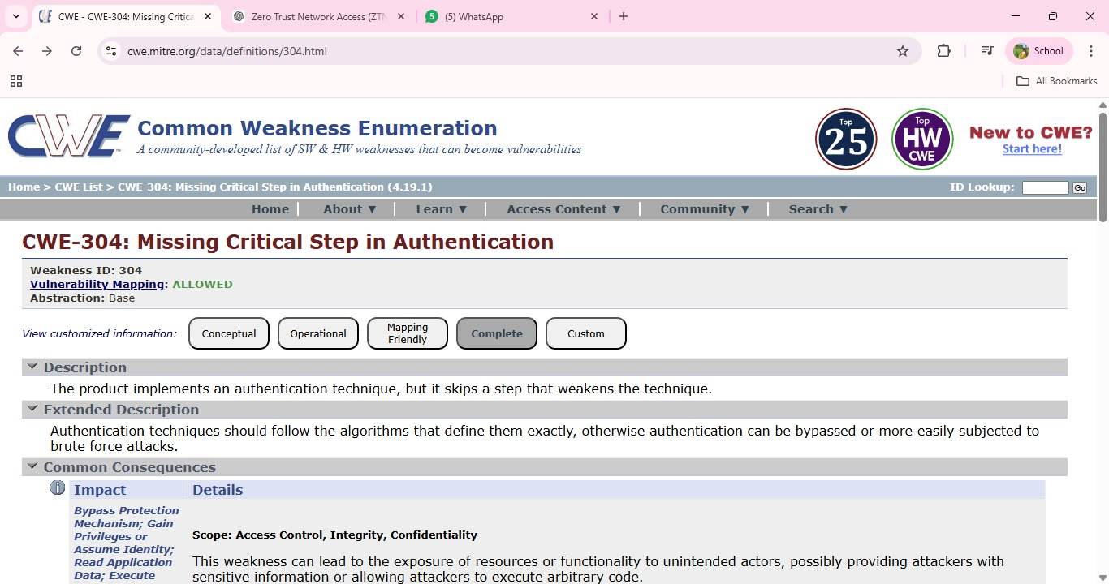

Vulnerability Name: Insufficient Logging

CWE/CVE: CWE-778

OWASP/SANS Category: A09 :2025-Security Logging and Alerting Failures

Description: Insufficient Logging occurs when an application or system fails to properly record security-related events such as login attempts, access requests, system errors, or configuration changes. Without adequate logging mechanisms, it becomes difficult to detect suspicious activities, unauthorized access attempts, or potential security breaches. Attackers may exploit this weakness to perform malicious actions without leaving sufficient evidence for administrators to identify or investigate the incident.
Business Impact: Lack of proper logging can significantly delay the detection of security incidents and make it difficult for organizations to respond effectively to cyber threats. Without accurate logs, identifying the source and impact of an attack becomes challenging, which may result in prolonged system compromise or data breaches. This can lead to operational disruptions, financial losses, regulatory compliance issues, and damage to the organization’s reputation.

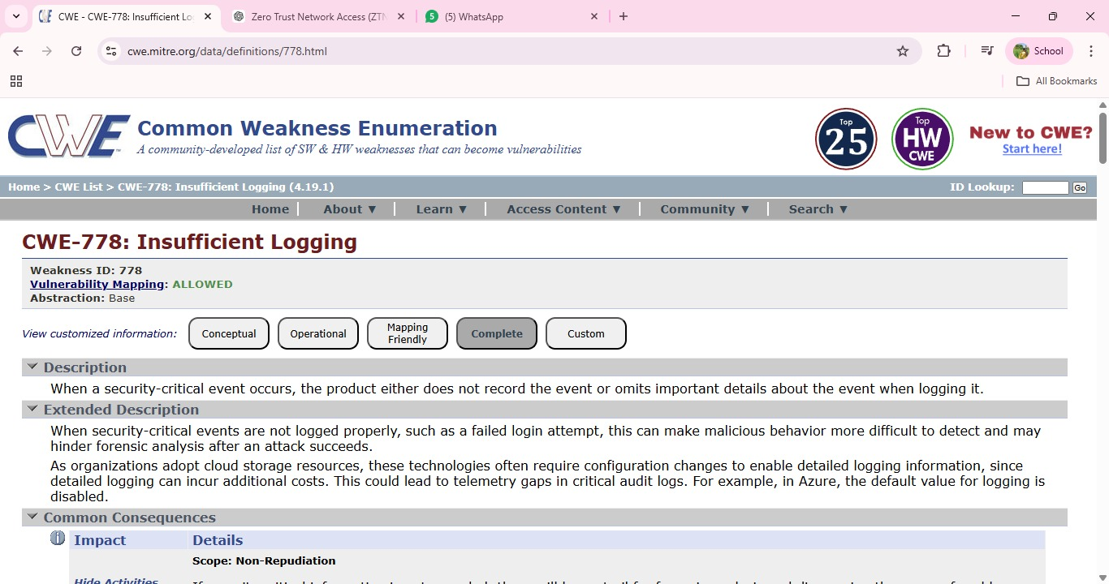

Stage 2

Overview :-

Nessus is a vulnerability scanner developed by Tenable, Inc. It is a remote scanner, meaning that it does not need to be installed on the target host to scan it. Nessus works by sending a variety of probes to the target host in order to identify vulnerabilities. These probes can include network traffic, operating system commands, and application requests.

Nessus uses a plugin-based architecture. Plugins are small pieces of code that are designed to identify specific vulnerabilities. There are over 1200 plugins available for Nessus, covering a wide range of vulnerabilities in operating systems, applications, and network devices.

When Nessus scans a host, it first uses a discovery plugin to identify the operating system and services running on the host. Once the host has been discovered, Nessus runs a series of plugins to test for vulnerabilities. For each vulnerability that Nessus finds, it provides a detailed report that includes the severity of the vulnerability, the steps to reproduce the vulnerability, and the steps to remediate the vulnerability

Nessus can be used to scan a variety of targets, including single hosts, networks, and web applications. It can also be used to scan specific ports and services. Nessus can be configured to run scans on a schedule or manually.

Here is a step-by-step explanation of how Nessus works:

- Nessus connects to the target host using a variety of protocols, including TCP, UDP, and ICMP.
- Nessus sends a series of probes to the target host in order to identify its operating system and services.
- Nessus runs a series of plugins to test for vulnerabilities.
- Nessus generates a report that includes the severity of each vulnerability, the steps to reproduce the vulnerability, and the steps to remediate the vulnerability.

Nessus is a valuable tool for security professionals who need to identify and remediate vulnerabilities in their networks. It is easy to use and provides comprehensive reports that can be used to prioritise remediation efforts.

Here are some of the benefits of using Nessus:

  - Comprehensive vulnerability coverage: Nessus has over 1200 plugins available, covering a wide range of vulnerabilities in operating systems, applications, and network devices.
  - Easy to use: Nessus has a user-friendly interface that makes it easy to configure and run scans.
  - Comprehensive reporting: Nessus provides detailed reports that include the severity of each vulnerability,the steps to reproduce the vulnerability, and the steps to remediate the vulnerability.
  - Scalability: Nessus can be used to scan a variety of targets, including single hosts, networks, and web applications.
  - Flexibility: Nessus can be configured to run scans on a schedule or manually.

Nessus is a powerful tool that can be used to improve the security of any network. It is a valuable asset for any security professional.

Target website :- http://testfire.net/
Target ip address:- 65.61.137.117

List of vulnerability:-
s.no | Vulnerability name | Severity | plugins
1 | TCP/IP Timestamps Supported | INFO | 25220
2 | Service Detection | INFO | 22964
3 | SSL / TLS Versions Supported | INFO | 56984
4 | TLS Version 1.3 Protocol Detection | INFO | 138330
5 | Additional DNS Hostnames | INFO | 46180
6 | TLS ALPN Supported Protocol Enumeration | INFO | 84821
7 | Common Platform Enumeration  (CPE) | INFO | 45590
8 | Device Type | INFO | 54615
9 | OS Fingerprints Detected | INFO | 209654
10 | TLS Version 1.2 Protocol Detection | INFO | 136318

REPORT: -

- Vulnerability Name : - 25220 - TCP/IP Timestamps Supported
Severity: INFO
Plugin: - 25220
Port: - N/A
Description: - The remote host supports TCP timestamps as defined in RFC1323. This feature is used to improve network performance and reliability by helping with round-trip time calculations and protection against wrapped sequence numbers. However, a side effect of TCP timestamps is that an attacker may be able to estimate the uptime of
the remote system. By analyzing timestamp values in TCP packets, it may be possible to determine how long the system has been running since its last reboot.
Solution: -
If the exposure of system uptime information is a concern, administrators can disable TCP timestamps in the operating system's network configuration. This can typically be done by modifying system network settings or kernel parameters depending on the operating system in use. Disabling this feature may slightly affect certain TCP performance optimizations
Business Impact:
This issue does not directly compromise the system or expose sensitive data. However, it can reveal system uptime information, which may provide useful insights to attackers when performing reconnaissance on the network. Understanding system uptime could help attackers plan targeted attacks or identify systems that have not been recently restarted or updated. Proper configuration and monitoring can help minimize such information exposure.
2. Vulnerability Name : - Service Detection
Plugin: - 22964

Port: - 80 / tcp / www
Description: - The scan detected the service running on the remote host by analyzing the service banner or by examining the response returned when an HTTP request was sent. Banner information or error messages from services may reveal details about the software, web server, or application running on the target system. This information helps identify the type and version of services operating on the host.
Solution: - Administrators can reduce information exposure by configuring services to hide or limit banner information and detailed error messages. Web servers and applications should be configured to suppress version details and unnecessary system information. Regular updates and proper service configuration also help minimize unnecessary information disclosure.
Business Impact: - This issue does not directly pose a security threat. However, exposed service details can assist attackers during the reconnaissance phase by revealing information about the technologies used in the system. Such information may help attackers identify potential vulnerabilities associated with specific services or software versions. Proper configuration helps reduce this information exposure and strengthens overall security posture.

Vulnerability Name : - SSL / TLS Versions Supported

Severity: - INFO
Plugin: - 56984

Port: - 443 / tcp / www
Description: - The scan identified the Secure Sockets Layer (SSL) and Transport Layer Security (TLS) protocol versions supported by the remote service for encrypting communications. These protocols are used to secure data transmitted between the client and the server. Detecting supported SSL/TLS versions helps administrators understand which encryption protocols are enabled on the server and whether they meet current security standards.
Solution: - Administrators should review the enabled SSL/TLS versions on the server and ensure that only secure and up-to-date protocols are allowed. Older and insecure versions should be disabled to maintain strong encryption standards. Regularly updating the server configuration and security settings will help ensure that secure communication protocols are used.
Business Impact: - This information does not directly represent a vulnerability but reveals which encryption protocols the server supports. Attackers could use this information during reconnaissance to identify outdated or weak SSL/TLS versions if they are enabled. Ensuring that only modern and secure protocols are supported helps maintain strong protection for data transmitted over the network.

Vulnerability Name: - TLS Version 1.2 Protocol Detection

Severity: - INFO
Plugin: - 136318

Port: - 443 / tcp / www
Description: - The scan detected that the remote service supports Transport Layer Security (TLS) version 1.2 for encrypting communications. TLS 1.2 is a widely used cryptographic protocol that helps secure data transmitted between clients and servers over the internet. This detection simply confirms that the service can establish encrypted connections using TLS 1.2.
Solution: - Ensure that the server continues to support secure and up-to-date encryption protocols. Administrators should verify that insecure protocols such as older SSL or TLS versions are disabled if they are not required. Regular updates and proper configuration of SSL/TLS settings help maintain strong communication security.
Business Impact: - This finding is informational and does not indicate a direct vulnerability. The presence of TLS 1.2 support confirms that the server is capable of providing secure encrypted communication. Proper management of supported protocols ensures that data transmitted between users and the server remains protected from interception.

Vulnerability Name: - 46180 - Additional DNS Hostnames

Severity: - INFO
Plugin: - 46180

Port: - 0
Description: - Hostnames different from the current hostname have been collected by miscellaneous plugins. Nessus has generated a list of hostnames that point to the remote host. Note that these are only the alternate hostnames for hosts discovered on a web server.
Different web servers may be hosted on name-based virtual hosts.
Solution: - If you want to test them, re-scan using the special vhost syntax, such as : www.example.com [192.0.32.10]
Business Impact: -This does not pose an immediate threat to business operations or data security. It indicates the discovery of hostnames that are associated with the remote host, particularly in cases of web servers utilizing name-based virtual hosts. While not a security risk on its own, it could be useful for understanding the server's configuration and infrastructure.
Organizations should consider this information as part of their network documentation but do not need to take immediate action to mitigate it as a security threat.

Vulnerability Name:-TLS ALPN Supported Protocol Enumeration

Severity: - INFO
Plugin: - 84821

Port: - 443 / tcp / www
Description: The scan detected that the remote host supports the Application-Layer Protocol Negotiation (ALPN) extension in TLS. ALPN allows the client and server to negotiate which application-layer protocol should be used during the TLS connection, such as HTTP/1.1 or HTTP/2. This plugin enumerates the protocols supported by the ALPN extension on the remote service.

Solution: - Administrators should review the protocols supported by the ALPN extension and ensure that only necessary and secure protocols are enabled. Disabling unused or outdated protocols can help reduce unnecessary information exposure and improve the security configuration of the server. Regular updates and proper server configuration are also recommended.
Business Impact: - This finding is informational and does not indicate a direct security risk. However, the disclosure of supported protocols may provide useful information to attackers during the reconnaissance phase. Understanding which protocols are enabled on a server could help attackers identify potential weaknesses if outdated or insecure protocols are present. Proper configuration and monitoring can help reduce this exposure.

Vulnerability Name: - 45590 - Common Platform Enumeration (CPE)

Severity: - INFO

Plugin: - 4559

Port: - 0
Description: - By using information obtained from a Nessus scan, this plugin reports CPE (Common Platform Enumeration) matches for various hardware and software products found on a host.
Note that if an official CPE is not available for the product, this plugin computes the best possible CPE based on the information available from the scan.

Solution: - n/a
Business Impact: - This provides insights into hardware and software products identified on a host through a Nessus scan. It reports CPE matches, which are standardized identifiers for these products. This information is valuable for asset management and inventory purposes. While it doesn't signify a security threat, it aids administrators in understanding the components within their network, contributing to effective resource management and facilitating future system maintenance.

VulnerabilityName: - Device Type Severity: - INFO
Plugin: - 54615

Port: - 0
Description: - Based on the remote operating system, it is possible to determine what the remote system type is (eg: a printer, router, general-purpose computer, etc).

Solution: -
Business Impact: - It allows for the identification of the remote system type, such as a printer, router, or general-purpose computer, based on the remote operating system. While this doesn't pose a direct security threat, it offers valuable insights for network administrators to better understand and classify the devices in their network. This information aids in network
management, optimization, and ensures that the right security measures are in place for each device type.

9.Vulnerability Name: - OS Fingerprints Detected

Severity: - INFO
Plugin: - 209654

Port: - N/A
Description: - The scan detected operating system fingerprints from the remote host using multiple remote probing techniques such as TCP/IP, SMB, HTTP, NTP, and SNMP. These probes analyze how the system responds to network requests in order to identify characteristics of the underlying operating system. While the most accurate result is reported in the OS Identification plugin, this plugin lists all fingerprints that were detected during the scanning process.
Solution: - Administrators can reduce the exposure of system fingerprint information by limiting unnecessary network services and filtering external requests using firewalls or intrusion prevention systems. Proper network configuration and regular system updates can also help reduce information disclosure about the operating system.
Business Impact: - This finding is informational and does not represent a direct security vulnerability. However, information about the operating system can assist attackers during reconnaissance activities. Knowing the type of operating system may help attackers search for known vulnerabilities related to that system. Limiting unnecessary information exposure can improve the overall security posture of the network.

10.Vulnerability Name: - TLS Version 1.3 Protocol Detection

Severity: - INFO
Plugin: - 138330

Port: - 443 / tcp / www
Description: The scan detected that the remote service supports Transport Layer Security (TLS) version 1.3 for encrypting network communications. TLS 1.3 is the latest and more secure version of the TLS protocol, designed to provide stronger encryption, improved performance, and better protection against modern security threats. This detection confirms that the server is capable of establishing secure encrypted connections using TLS 1.3.

Solution: - Administrators should ensure that TLS 1.3 remains enabled and properly configured on the server. It is also recommended to disable older and less secure protocols such as SSL and outdated TLS versions if they are not required. Regular updates and proper configuration of encryption settings help maintain strong communication security.
Business Impact: - This finding is informational and does not represent a security vulnerability. Supporting TLS 1.3 is considered a good security practice because it provides stronger encryption and better protection for data transmitted over the network. Proper management of encryption protocols ensures secure communication between users and the server.

Report: -

Stage-3

Title: - Enforce least-privilege access through identity-aware, application-specific access policies using Zscaler Private Access (ZPA).

Zscaler Private Access (ZPA)
Zscaler Private Access (ZPA) is a cloud-delivered ZTNA solution that provides identity- and context based access to private applications without granting network-level access. ZPA operates on a "service initiated" model, where users connect to the Zscaler cloud, and the cloud brokers a secure connection to the specific application via ZPA App Connectors deployed in the data center or cloud environment. Because ZPA never places the user on the corporate network, internal IP addresses and network infrastructure are completely hidden. Access policies are dynamically enforced based on user identity, group membership, device posture, and location, ensuring that each user sees only the applications they are explicitly permitted to use.

Principle of Least Privilege

The principle of least privilege (PoLP) is a security concept in which a user, device, or process is granted only the minimum levels of access—or permissions—necessary to perform its function. In the context of network security, this means moving away from "fat" network access (where authenticated users can reach large segments of the network) to "thin," application-specific access. By enforcing least privilege through ZPA, organizations ensure that even if a user's credentials are compromised, the attacker cannot pivot to other systems because the network itself is invisible and inaccessible. This principle is foundational to reducing insider threats and limiting blast radius during a security incident.

Identity-Aware Access

Identity-aware access is a security model that bases access decisions on who the user is, rather than where they are connecting from. ZPA integrates directly with existing identity providers (IdPs) such as Microsoft Active Directory, Azure AD, Okta, or Ping Identity. This integration allows security teams to leverage existing user attributes, group memberships, and roles to build granular access policies. For example, a policy can state that only members of the "Finance" group, using a company-managed device, can access the "SAP Finance" application during business hours. This ensures that access is tightly coupled with the user's identity and context, reducing reliance on static IP addresses or network segments.

Application-Specific Access Policies

Application-specific access policies are the core enforcement mechanism within ZPA. Instead of creating rules that allow traffic to entire subnets or IP ranges, administrators define policies that target individual applications or groups of applications. These policies are written in plain language logic and can incorporate multiple conditions, including user identity, device posture, location, and time of day. ZPA allows for the segmentation of internal applications—such as HR systems, internal wikis, development servers, and database interfaces—so that each application has its own unique access policy. This micro-segmentation ensures that a user authenticated for one application has no visibility or connectivity to any other application.

ZPA Architecture and Components
The ZPA architecture is composed of several key components that work together to provide secure, scalable access:

1. Zscaler Cloud (Service Edge): A globally distributed cloud platform that acts as the broker between users and applications. It handles authentication, policy enforcement, and connection brokering without sitting in the data path.
2. App Connectors: Lightweight software VMs or containers deployed within the private data center or cloud environments. These connectors initiate outbound connections to the Zscaler cloud, eliminating the need for inbound firewall rules. They establish secure tunnels to the ZPA edge and forward traffic to the internal applications.
3. ZPA Client Connector: A software client installed on end-user devices (Windows, macOS, Linux, iOS, Android). It authenticates the user, checks device compliance, and establishes a micro-tunnel to the ZPA edge for application access.
4. Application Segments: Logical groupings of applications defined within the ZPA admin console. These segments represent the private resources that users need to access.

Implementation Methodology

The deployment of ZPA follows a structured, phased approach to ensure minimal disruption and maximum security efficacy:
• Phase 1: Discovery and Inventory: Identify all internal applications currently in use. Categorize them by criticality, department, and user base. Tools like network scanners, configuration management databases (CMDB), and interviews with department heads are used to build a comprehensive application inventory. • Phase 2: Connector Deployment: Deploy ZPA App Connectors in the data center or cloud environments where the applications reside. This involves provisioning virtual machines (using VMware, Hyper-V, or cloud-specific images) and configuring them to connect to the ZPA cloud.
• Phase 3: Application Onboarding: Define application segments within the ZPA console. This includes specifying the IP addresses and ports of the internal applications and associating them with the appropriate App Connector groups.
• Phase 4: Policy Creation: Integrate ZPA with the corporate identity provider (e.g., Azure AD). Create granular access policies based on user groups, device posture, and location. Policies are tested in a simulation mode before enforcement.
• Phase 5: Pilot and Rollout: Select a pilot group of users to test the new access method. Gather feedback, monitor performance, and refine policies. Gradually migrate user populations from legacy VPN access to ZPA.
• Phase 6: VPN Decommissioning: Once all users and applications are migrated, the legacy VPN infrastructure is decommissioned, eliminating a significant attack surface.
Tools and Technologies

• Primary Platform: Zscaler Private Access (ZPA) – The core Zero Trust access broker.
• Identity Provider (IdP): Microsoft Azure Active Directory (AD), Okta, or Ping Identity for user authentication and group synchronization.
• Endpoint Protection Platform (EPP): Integration with endpoint security tools (e.g., CrowdStrike, SentinelOne, Microsoft Defender for Endpoint) to assess device posture and hygiene before granting access.
• Security Information and Event Management (SIEM): Integration with SIEM platforms (e.g., IBM QRadar, Splunk, LogRhythm) for centralized logging and correlation of access events.
• Virtualization Platforms: VMware vSphere, Microsoft Hyper-V, or public cloud environments (AWS, Azure, GCP) for hosting ZPA App Connectors.
• Infrastructure as Code (IaC): Tools like Terraform or Ansible for automated deployment and configuration of App Connectors at scale.
• Digital Experience Monitoring (DEM): Tools to monitor end-user connection quality and application performance.

Integration with Identity Providers

Integrating ZPA with the organization's existing identity provider is a critical step in establishing identity-aware access. This integration is typically done via SAML (Security Assertion Markup Language) or LDAP (Lightweight Directory Access Protocol). Once integrated, ZPA synchronizes user attributes and group memberships, allowing policies to reference these groups directly. For example, when a user authenticates via the ZPA Client Connector, they are redirected to the corporate IdP for credentials and multi-factor authentication (MFA). Upon successful authentication, ZPA receives identity attributes that are then used to evaluate access policies and determine which applications the user is allowed to see and connect to.

Device Posture Checking

Beyond user identity, ZPA can enforce policies based on the security posture of the connecting device. Through integration with endpoint detection and response (EDR) and mobile device management (MDM) solutions, ZPA can assess factors such as:
• Antivirus software status and definition updates • Disk encryption status (e.g., BitLocker, FileVault)
• Operating system patch level
• Presence of jailbreak or root compromise on mobile devices
• Real-time risk score from the EDR tool
If a device fails to meet the defined posture requirements (e.g., antivirus is disabled), ZPA can block access, grant limited access, or trigger a remediation workflow.

Micro-tunneling and Application Visibility

ZPA establishes a secure TLS/DTLS tunnel between the ZPA Client Connector and the ZPA service edge, and another tunnel between the service edge and the App Connector. Crucially, this creates a direct "app-to-user" micro-tunnel. The user's device is never placed on the corporate network; instead, traffic is proxied at Layer 7 (application layer). From the user's perspective, they can only resolve and connect to the specific DNS names or IP addresses of the applications they are authorized to access. All other internal resources remain completely invisible, preventing port scanning, vulnerability reconnaissance, and lateral movement.

Threat Intelligence

Integration To enhance security monitoring, ZPA can be integrated with threat intelligence platforms. Logs generated by ZPA—including connection attempts, policy violations, and user activity—can be forwarded to a SIEM (Security Information and Event Management) system. Within the SIEM, these logs can be correlated with threat intelligence feeds (such as those from MISP) to identify suspicious behavior. For example, if a user's credentials are used to access an application from an IP address associated with known malicious activity, the SIEM can trigger an alert, and integration with ZPA can automatically revoke that user's session.

Incident Response in a ZPA Environment

ZPA significantly streamlines the incident response process. When a potential threat is detected, security teams can leverage ZPA's capabilities to:

1. Isolation: Immediately revoke access for a compromised user account or device through the ZPA console, cutting off their connectivity to all internal applications.

2. Forensics: Access detailed logs within ZPA showing exactly which applications were accessed, by whom, from which location, and for how long.

3. Containment: Because users have no network-level access, a compromised endpoint cannot be used to scan or attack other internal systems, containing the blast radius.

4. Granular Blocking: Temporarily block access to specific high-risk applications while allowing access to others, ensuring business continuity during an investigation.

Understanding ZPA: Key Takeaways

Zscaler Private Access represents a fundamental shift in how remote access is architected and secured. Here are the key aspects to understand about the solution:

1. It is cloud-native: ZPA is delivered entirely from the Zscaler cloud, eliminating the need for hardware appliances and complex VPN head-end management.

2. It is identity-centric: Policies are built around users and groups, not IP addresses, making access control more intuitive and aligned with organizational structure.

3. It ensures network invisibility: By never placing users on the network, ZPA renders internal infrastructure invisible to the internet, preventing reconnaissance and DDoS attacks.

4. It is scalable: The cloud architecture allows ZPA to scale instantly to accommodate thousands of concurrent users without performance degradation.

5. It supports hybrid environments: ZPA works seamlessly for applications hosted in on-premises data centers, private clouds, and public cloud environments.

6. It improves user experience: Users get direct, optimized connections to applications without back hauling traffic through a centralized VPN concentrator, reducing latency.

Conclusion: -

Stage 1: In conclusion, web application testing is a crucial process that ensures the security, functionality, and reliability of web-based software. It involves a comprehensive evaluation of various aspects, including user interface, functionality, performance, and security to identify and rectify issues before they impact end-users. This process not only enhances the quality of web applications but also bolsters their resilience against potential threats and vulnerabilities. In an age where online services and applications are integral to our daily lives, effective web application testing is essential to deliver a seamless and secure user experience.

Stage 2: The Nessus report for the specific website has highlighted key security insights. It identified vulnerabilities, categorized by severity, with a focus on critical and high-risk issues that need immediate attention. Recommendations for addressing these vulnerabilities include patching, reconfiguration, and other security measures, with a priority on actions that can have the most significant impact. Compliance with industry standards and best practices is considered, ensuring alignment with recognized security benchmarks like OWASP guidelines. The report underscores the need for continuous monitoring, regular updates, and ongoing security efforts to maintain a strong security posture. In summary, the Nessus report offers a clear view of the website's security state, provides guidance on mitigating vulnerabilities, and stresses the importance of sustained vigilance against evolving threats.

Stage 3: The implementation of Zscaler Private Access marks a pivotal shift from a vulnerable, network centric security model to a resilient, identity-centric Zero Trust architecture. By enforcing least privilege access and rendering private applications invisible to the internet, this project effectively neutralizes the threats of lateral movement and network-based attacks. The solution not only fortifies the organization's security posture against modern cyber threats but also delivers a seamless and high-performance experience for a distributed workforce. Furthermore, the decoupling of access from the network simplifies IT operations, reduces dependency on legacy VPN infrastructure, and provides granular visibility into user-application interactions. Ultimately, this initiative establishes a future-ready foundation for secure digital transformation..

Future Scope: -

Future of web application testing
The future scope of web application testing is promising and evolving rapidly, driven by the continuous growth of the internet and web-based applications.
Here are some key aspects of its future scope:
▪ Increased Demand: As more businesses and services move online, the demand for web applications continues to grow. This, in turn, increases the demand for web application testing to ensure security, reliability, and functionality.
▪ Advanced Technologies: The complexity of web applications is rising with the integration of advanced technologies like AI, IoT, and blockchain. Testing these cutting-edge applications will require specialized skills and tools.
▪ Security Emphasis: With the growing number of cyber threats and data breaches, security testing for web applications will become even more critical. Testers will need to focus on vulnerabilities, data protection, and compliance with regulations like GDPR.
▪ Mobile and Cross-Browser Testing: Mobile usage is on the rise, and web applications must be responsive and functional on various devices and browsers. Testing for cross-compatibility will be essential.
▪ Performance Testing: As user expectations for speed and performance increase, load testing, stress testing, and other performance testing types will be crucial to ensure web applications can handle traffic spikes.

Future scope of the testing process

The future scope of the web application testing process, particularly in terms of identifying vulnerabilities, is exceedingly promising due to the continuous growth of digital platforms, the escalating importance of cybersecurity, and the ever-evolving threat landscape. Here are some key aspects that highlight the prospective scope of web application testing for vulnerability discovery:

▪ AI-Driven Testing: The integration of artificial intelligence (AI) and machine learning (ML) into web application testing tools will revolutionize the way vulnerabilities are identified. AI algorithms can swiftly scan vast amounts of code and data to pinpoint vulnerabilities that might elude human testers.

▪ IoT and Mobile App Testing: With the proliferation of Internet of Things (IoT) devices and the increasing usage of mobile applications, the scope of web application testing will extend to encompass these areas. Ensuring the security of IoT devices and the interfaces they use will become critical.

▪ Blockchain and Cryptocurrency Security: As blockchain technology and cryptocurrencies continue to gain traction, security testing will be imperative to safeguard transactions and digital assets. Ensuring the robustness of blockchain-based applications will be a specialized niche in web application testing. Serverless Architectures: With the adoption of serverless computing, web application testing will need to adapt to assess the security of serverless functions and APIs. Ensuring that serverless components are free from vulnerabilities will be paramount.

▪ Container Security: As containerization technologies like Docker and Kubernetes become ubiquitous, web application testing will extend to cover container security. This includes ensuring that container images and orchestration configurations are free from vulnerabilities.

future scope of Zero Trust

The successful deployment of ZPA lays the groundwork for a broader, more integrated security ecosystem. Future enhancements can be explored to further mature the organization's security capabilities:

▪ Integration with Zscaler Internet Access (ZIA): Converging Private Access (ZPA) with Internet Access (ZIA) to create a unified Secure Access Service Edge (SASE) platform, managing all web and private traffic through a single policy framework.

▪ Advanced Device Posture Checking: Moving beyond basic compliance to incorporate real-time risk scores from EDR tools, blocking access if a device shows signs of active compromise.

▪ Privileged Remote Access: Extending ZPA to third-party vendors and contractors with time-bound, audited access to specific critical systems, replacing jump boxes and bastion hosts.

▪ IoT/OT Segmentation: Applying the same micro-tunneling principles to Internet of Things (IoT) and Operational Technology (OT) devices to ensure they can only communicate with specific management servers.

▪ AI-Driven Anomaly Detection: Leveraging machine learning on ZPA logs to detect behavioral anomalies, such as a user accessing an application at an unusual hour or from a strange location, triggering automated MFA challenges or access revocation.

▪ Cloud Workload Protection: Utilizing ZPA to secure connections between containers and microservices in multi-cloud environments (AWS, Azure, GCP), ensuring east-west traffic between workloads is encrypted and authenticated.

▪ Automated Provisioning/Deprovisioning: Enhancing the identity provider integration to automatically revoke application access the moment an employee is terminated or changes roles, ensuring near real-time access control.

▪ Digital Experience Monitoring (DEM): Implementing DEM tools to proactively monitor the end user experience, identifying network latency or application performance issues before they impact productivity.

Topics explored: -

Zscaler , Zero trust , ZPA ,VPN , MISP , College Network Information , Deployment of SOC in the College , Threat Intelligence , Incident Response

Tools explored: -
Nessus Scanner

THE END

