Chapter 4: Eelectomagnetic Radiation Notes

4.1 WAVES

Waves
- The transfer of energy without matter is called a wave
- There are two types of waves that can transfer energy

Transverse Waves
Where the particles vibrate at right angles to the direction of the wave. Eg. Waves at the beach.
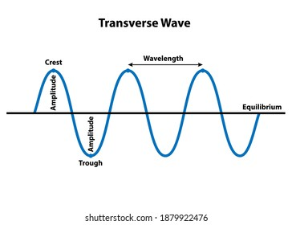

Longitudinal Waves
Where particles vibrate backwards and forwards in the same direction as the wave.
Eg. sound waves
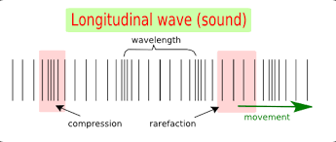

Frequency (f)
- The number of waves produced each second
- Measured in hertz (Hz), which means cycles (waves) per second

Wave Length
- The distance between two successive waves
- Represented by the Greek symbol lambda
- Measured in metres (m)
- The wave length of some radio waves is several kilometres, whereas the wavelength of visible light is less than one thousandth of a millimetre.

Amplitude
- The height of its crests above their normal middle position

Velocity / Speed (v)
- The speed at which a wave travels
- Measured in ms-1

Period (T)
- The time taken for each wave
- Measured in seconds (s)
- T= 1/f and f= 1/T

Wave Equation
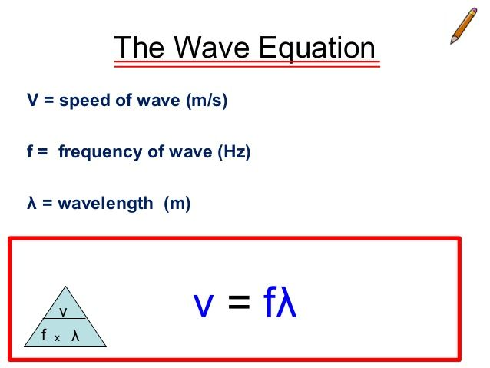
The speed, wavelength and frequency of a wave depend upon each other and are linked by some formula called the wave equation.

Example
Problem:
At caves beach, a wave hits the shore every 10 seconds. If there is 6 metres between successive waves, calculate the speed of the waves.

Given: wavelength = 6 m
Period = T = 10s (ie 10 seconds for each wave)
F= 1/T = 1/10 = 0.1 Hz

V= f x λ
  - x 6 = 0.6 ms-1

Problem 2:
Goran strikes a tuning fork in class and produces a note frequency 440 Hz. If the speed of sound is 330 m/s, then calculate the wavelength of the sound produced.

Given: f= 440Hz
λ = ?
v= 330 m/s

λ = v/ f = 330/ 440 = 0.75m

Problem 3:
Felicity produces a sound wavelength of 2m. if the speed of the sound is 330 m/s. then calculate the frequency of the sound wave.

Given: λ= 2m
F= ?
V = 330 m/S

F= v/ λ = 330/ 2 = 165 Hz

Do the three practice questions in the green section on Pg134

WAVE CALCULATIONS : NB : Write the formula first!!!!!

Use the speed of light as 3x10⁸ ms⁻¹

1. What is the speed of a water wave that has a frequency of 0.5Hz and a wavelength of 3m?

V= y x f
= 0.5 x 3
=1.5 m/s

2. What is the wavelength of a radio wave transmitting at 98.3 MHz?
Y= v/f
Y= 3x108
Y= (3x108)/ 98 300 000
Y= 3.05 m

3. Calculate the velocity of a wave that has a wavelength of 2m and a frequency of 1.5Hz.
V= y x f
= 2 x 1.5
= 3 m/s
4. Orange light has a wavelength of 6x10⁻⁷ m. Calculate the frequency of orange light if it has a velocity of 3x10⁸ms⁻¹.
F= V/ Y
=6x10⁻⁷ / 3x10⁸
= 20 Hz

5. What is the frequency of radio waves that have a wavelength of 0.50m?

F= V/ Y
= 3x10⁸ / 0.5
= 600 000 000 Hz

6. Radio station 6PM broadcasts at a frequency of 990kHz. What is the wavelength of the radio waves? (1kHz = 1000Hz)

Y= V/ F
= 3x10⁸ / 990 000
= 303.03 m

Frequency = 5kHz
Velocity = 1.5
Wavelength = ?

ELECTROMAGNETIC RADIATION : (Pg 134)
- Electromagnetic waves are generated naturally in our upper atmosphere and from stars, including our Sun.
- It includes visble light, mircowaves and x-rays.

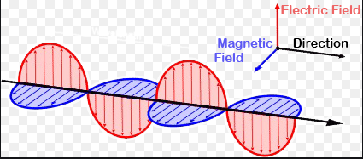
- Define electromagnetic radiation : Electromagnetic waves consisting of electric and magnetic fields travelling at the speed of light.
- Define an electromagnetic wave : Are transverse electric magnetic waves at 90 degrees to each other travelling through space at the speed of light.
- Electromagnetic waves can travel through empty space, gases, liquids and some solids.
- When a substance absorbs any kind of electromagnetic radiation, it also absorbs its heat. The substance may heat up or change in some way. (eg : a solar cell can convert light into an electric current)

Electromagnetic spectrum Pg 136
The electromagnetic spectrum showing the relative positions, frequencies, and spacing of the different types of radiation bands :
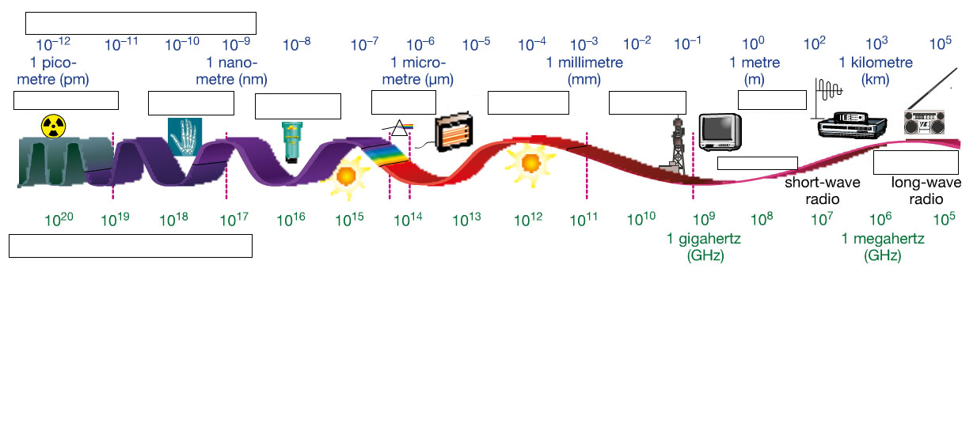
Frequency
FM radio
AM radio
radiowaves
mircowaves
Infrared
visible
Ultra violet
x-rays
gamma
Wave length

List the seven types of electromagnetic waves from smallest to largest wavelength

Smallest wavelength

Gamma
X-rays
Ultra Violet
Visible
Infrared
Mircowaves
Radio Waves

Largest wavelength

List the seven types of electromagnetic waves from lowest to highest frequency (refer to pg 183 of Pearson or the diagram above)

Lowest frequency Radiowaves

Mircowaves

Infrared

Visible
Ultra Violet

Xrays

Highest frequency Gamma

- Which electromagnetic wave has the most energy? Gamma

- The shorter the wavelength the higher the frequency, the more energy is carried.

4.2 The visible spectrum (Pg 141)

Define the following terms :
Visible spectrum : The range of colours that can been seen by the eye

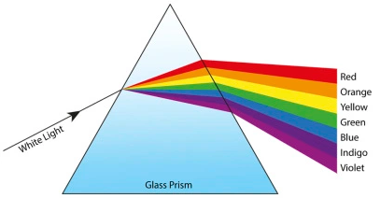
Primary and secondary colours : Primary colours (blue, red and green) are used to make white light. Secondary colours are cyan, magenta and yellow.

Colour blindness : When cone in the retina of the eye that detect colour (red, blue and green) don’t work correctly (genetic, inherited)

Polarization: The separation light waves into the direction of vibration.

Dispersion : When white light passes through a prsim and slipts into colours of a visible spectrum (Eg. Bubbles)

Explain how a rainbow is formed:
- sunlight passes through droplets of water in the atmosphere
- droplets act like a prism dispersing the light into the visible spectrum displaying all the colours

Read scattering of light p 145. Put into your own words the answer to the age old question, Why is the sky blue?

The sky is blue because the blue light scatters easier than the red light because it has a higher frequency.

4.3 Low Energy Radiation (Pg 149)
- Radio waves
  - Transmitted by transmitting aerial
  - Produced by electrons moving backwards and forwards
  - Longest wavelengths of EMR
  - Can travel large distances in air or space
  - Different wavelengths used for different purposes :
    - microwaves (± 3 cm)
    - short radio waves (30 cm), used in communication
    - long radio waves (3 – 3 000 m) used in communication

- AM and FM Radio waves
  - each radio station has a frequency specific to that station
  - AM signals transmitted at lower frequency than FM signals
  - AM = amplitude modulation where the signal is used t ochange or modulate the amplitude of the carrier wave
  - FM = frequency modulation where the signal is used to change the frequency of the carrier wave.
- Microwaves
  - short wave lengths
  - used in radar
  - when ‘line of sight’ can be used
  - used in cooking : where the waves are absorbed by water, sugar and fat molecules start to vibrate and then warm up the food.

    - Infrared radiation
  - heat is transferred form the sun to the earth as infrared radiation
  - ‘infra’ means below - lower frequency than red light rays
  - all objects emit infrared that are: above 0 degrees Kelvin (-273 degrees celcius)
  - Infrared can be detected using an infrared camera

Modern communication networks : Notes
Modern communcation networks carry vast amounts of dta from landlines, mobile phones, radio, TV and the internbet. Data is in the form of data files, voice conversations and satellite images.
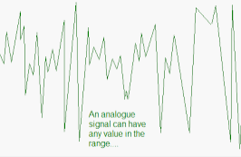
- Analogue or digital signals :
  - Copper sires were designed to carry analogue signals
  - In these analogue signals the information (eg : voice)
is transmitted as changes in voltage
  - Disadvantages of this is that these signals experience
interference and signal loss along the way

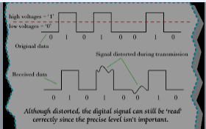
- Digital signals :
  - More modern’
  - Cable televfision and internet rely on digital signals
  - Information is coded into ‘on’ and ‘off’ pulses using
a binary number system
  - Advantages : can BE read even when there is
interference making signals clearer and more
accurate

- Channels of communication :
  - Bandwidth is the ability to send information more quickly alog a single communication channel
  - Optical fibre is a thin, flexible tube made of glass or plastic :
    - a central core of pure silica glass surrounded by a layer of less dense glass called cladding and then covered by a plastic jacket to minimize interference
    - a laser light is then use to transmit signals down the fibre with internal reflection
    - the laser is a narrow beam of light wave that are coherent (waves in phase with each other) and this is then coded as a series of binary numbers
    - at the other end the light pulses are converted back into a digital signal and can be sent along a copper wire
    - a single optical fibre can transmit over 30 000 phone calls
    - advantages of optic fibre : lighter and more flexible than copper wire, can be transmitted many kilometers with no signal loss, very little interference, bandwith can be expanded sending signals of different frequencies at the same time

- microwave links :
  - used for long range mobile communications and for communications in remote areas
  - use repeater towers every 50 km

- mobile networks :
  - when dialing a number on you mobile phone, a digital signal sent as a microwave is received by a base station and sent to the mobile exchange
  - the call is then sent by copper wire or optic fibres through a series of exchanges to the base station closest to the person you are dialing

- The internet :
  - a router manages the connection between your computer and the internet server
  - data to be sent as a downloaded file or an email is split into a ‘packet’ made up of about 1 500 bytes (each byte is a group of 8 binary digits)
  - these packets travel across a network which directs the packet along a pathway to its destination

- Wireless internet networks :
  - uses radio waves
  - allows a wifi (wireless fidelity) enabled device such as a mobile phone, tablet, laptop etc to connect to the internet when within the range of an access point

5.4 High frequency radiation (Pg 208)
- Ultraviolet light :
  - rays with energy greater than violet light (therefore “ultra” – beyond, more than)
  - We need UV for vitamin D (for bones)
  - high exposure can cause sunburn, skin cancer and cataracts in eyes

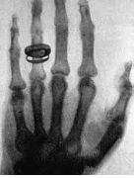
- X-rays :
  - have great penetrating power and so are used to investigate the
structure of objects and find flaws in metals
  - has high energy which can damage cells and affect the and material inside cells
  - used to form images of bones and in the treatment of cancer

- Gamma rays :
  - wavelengths of 10⁻¹⁹ m
  - only a thick sheet of lead or concrete will stop them penetrating
  - produced by radioactive materials, nuclear power plants and nuclear bombs
  - are detected with photographic film or a geiger counter
  - cause ionization of atoms
  - used to target and kill cancer cells
  - are useful in medical diagnosis: pet scans.

