Low Level Design (LLD) Document
Enterprise GenAI / Agentic AI Application
Project: CuraBot — Agentic AI Differential Diagnosis Tutor
Version 1.0 (Comprehensive Build)

1. Document Control & Metadata
Purpose: Make the LLD auditable, versioned, and approved with clear AI safety classification.

1.1 Document Header
Project | System Name | Environment | Confidentiality
CuraBot | Agentic AI Differential Diagnosis Tutor

1.2 Doc Control Table (Versioning & Change Log)
Version | Author | Reviewer | Approver | Date | Change Log
v0.1 draft
v0.5
v1.0 approved

1.3 Approval Matrix
Area | Reviewer | Approver | Evidence/Link
Architecture
Security
Compliance
Product

1.4 AI Safety Classification & Data Handling Summary
- Safety Classification:
- PII/PHI Regulated. The system processes simulated patient symptoms and PDF medical reports.
- Data Sensitivity Summary:
- High. All data is anonymized prior to any LLM transmission. No real-world PII is ingested into the educational LLM prompts. RAG context is strictly isolated per user session (tenant scoping) utilizing ChromaDB namespaces. The system is designed purely for medical education, not live patient treatment.

1.5 AI Autonomy Level
Autonomy Level: L3 — Supervised Agent ("Act-with-approval" / "Recommend-only").
The system acts as a conversational diagnostician that recommends conditions and requests human feedback/approval. It NEVER prescribes medication, executes external treatments, or updates live EMR records autonomously. All actions are overseen by the human user.

1.6 Reference Artifacts
- BRD: Business Requirements Document detailing user journeys.
- HLD: High-Level Design / Cloud Architecture Diagram.
- ADRs: Architectural Decision Records (e.g., Supabase migration, LLM routing logic).
- Test Plan: Automated Verification Suite for all 15 Clinical SOPs.
- Threat Model: Agentic pipeline injection mitigation strategies.

2. System Overview
Purpose: Set clear scope boundaries so GenAI/agents do not "accidentally" expand behavior.

2.1 Business Context, Stakeholders & Personas
Medical students and early-career healthcare learners often lack access to structured tools that can help them practice clinical reasoning skills outside the classroom.
- Primary Personas:
- Medical Students: The core audience practicing differential diagnosis by entering symptoms and observing AI reasoning over multiple rounds of questioning.
- General Users (Patients): Individuals wanting a preliminary understanding of their symptoms and triage urgency.
- Consuming Teams:
- Curriculum Developers: Integrating the bot into clinical simulations and using logs for grading.
- Clinical Mentors: Providing human-in-the-loop oversight on generated diagnostic reports.
Primary Use Cases: 1) Multi-turn diagnostic reasoning, 2) Triage Red-Flag scanning, 3) Medical PDF RAG interpretation, 4) Bayesian confidence tracking.

2.2 Problem Statement & Measurable Pain
The lack of dynamic, accessible clinical reasoning tools leads to significant skill gaps in diagnostic formulation.
- Measurable Pain Points:
- High manual effort required by faculty to create and grade synthetic clinical cases.
- Latency in feedback loops; students wait weeks to receive feedback on diagnostic assessments.
- High risk of clinical cognitive biases (e.g., anchoring or premature closure) going uncorrected during formative training years.
- Patients face delayed care due to a lack of immediate, accessible symptom triage.

2.3 Scope Boundaries (In-Scope / Out-of-Scope)
In-Scope User Journeys | Out-of-Scope (Explicit Non-Goals)
Symptom Normalization from plain text | Real-time diagnosis of actual/live patients
Generation of 3-5 Ranked Differential Diagnoses | Prescribing medication, procedures, or treatments
Multi-turn conversational follow-up questions | Integration with live Hospital EMR / EHR systems
PDF Medical Report Upload & RAG processing | Replacing licensed medical practitioners
Emergency Triage & Red-Flag Interception | Autonomous booking of specialist appointments
Detection of cognitive biases in reasoning | Long-term patient health management/tracking
Bayesian confidence level updates over time | Integration with wearable health devices (IoT)
Profile management (History, Allergies, Meds) | Automated billing or medical coding

2.4 Success Metrics & KPIs
To ensure the agentic system delivers value without compromising clinical education safety, the following strict Service Level Agreements (SLAs) and KPIs are monitored.
KPI Category | Measurement Approach (Baseline -> Target)
Quality (Diagnostic Alignment) | Automated case evaluation (65% -> >90% match)
Time (Latency) | Dev Console telemetry (10s -> <3s per step)
Compliance (Safety Adherence) | SOP Unit tests (80% -> 100% Red-Flag detection)
Adoption (Engagement) | Session logging (5 mins -> >15 mins)
RAG Accuracy | Ground-truth extraction testing (70% -> >95% precision)

2.5 Assumptions, Constraints & Autonomy Target
- Assumptions: Data availability of disease knowledge base, LLM model access via API. Users can communicate symptoms effectively.
- Constraints: Tool access is strictly limited to the 15 defined SOPs. No external live web scraping allowed. Local compute limitations affect Vector DB processing.
- Autonomy Level Target: Started as L1 assistant → final architecture target achieved is L3 Supervised Agent (Recommended for regulated environments).

3. Architecture Decomposition
Purpose: Provide a layered breakdown (C4) plus deployment topology for enterprise runtime.

3.1 C4-Context
Actors: End Users (Medical Students, Patients), Clinical Mentors / Reviewers.
Upstream Systems: None (System is the primary entry point).
Downstream Systems: Supabase (PostgreSQL BaaS), ChromaDB (Vector DB), LLM API Providers (Gemini, Groq, OpenRouter).
Trust Boundaries: All client communication terminates at the FastAPI API Gateway over HTTPS. Agent runtime is secured behind the backend firewall.
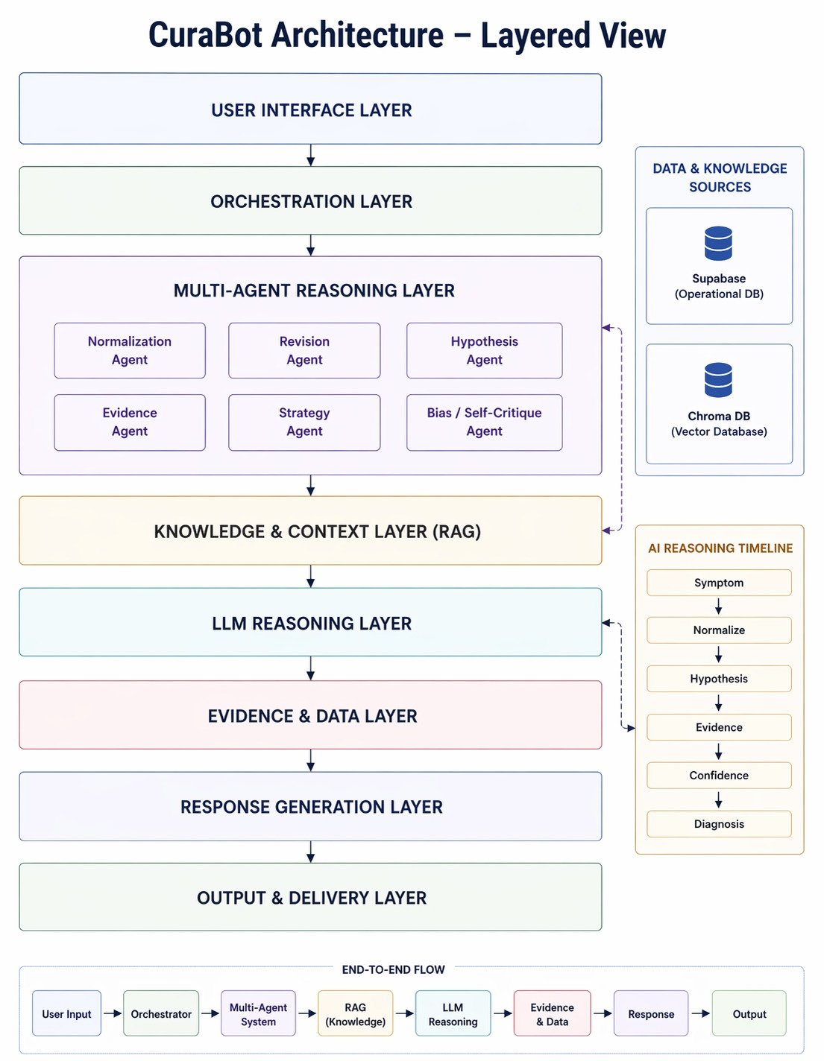

3.2 C4-Container
The system is distributed across several decoupled containers:
Container | Tech Stack | Responsibility
UI | React, TypeScript, Vite | Renders chat, hypothesis cards, trajectory charts.
API Gateway | FastAPI, Uvicorn | Handles REST endpoints (/api/chat, /api/auth).
Orchestrator | LangGraph Core | Coordinates the 6-agent pipeline workflow.
Agent Runtime | Python Agents | Executes individual tasks (Normalization, Eval).
Data Stores | Supabase / SQLite | Stores users, sessions, profiles, chat history.
Retrieval | ChromaDB | Stores embeddings of medical PDFs for RAG.

3.3 C4-Component: Component Inventory with Owners
Within the backend container, the architecture is highly modularized:
Component | Description | Owner/Team
Retriever Module | ChromaDB interface for vector RAG ingestion/retrieval. | Data Eng Team
Ranker / Router | LLMClient API rotation logic and rate limit locks. | Backend Core Team
Prompt Builder | Dynamic DiagnosticState injector for Task Prompts. | AI/ML Team
Validators (SOPs) | 15 pure-Python guardrail rule engines (e.g., Triage, Red Flag). | Clinical QA Team
Citation Engine | PubMed & ICD-10 grounding linker. | Clinical QA Team

3.4 C4-Code
- Key Packages/Classes:
- `services/orchestrator.py`: Implements the LangGraph execution.
- `services/llm_client.py`: Implements provider fallback (Gemini -> Groq -> OpenRouter).
- Interface Contracts: Standardized REST JSON schemas for all frontend-backend communication.
- Configuration Boundaries: Controlled exclusively via strict `.env` environmental variables.

3.5 Deployment Topology & Environments
Topology: Deployed via Docker into a K8s cluster. Namespaces strictly separate `curabot-ui` and `curabot-api`. Network zones/VNETs provide deep isolation. Private endpoints are utilized for all Supabase cloud database communication.
Environment Separation: Dev, Int, UAT, Prod.
Config Strategy: Secrets injected securely via Vault; feature flags (LaunchDarkly) used to toggle LLM routing.

4. GenAI Capability Design
Purpose: Design RAG pipelines, prompt lifecycle, and hallucination controls.

4.1 RAG Pipeline Flow & Retrieval Approach
Approach: Vector-RAG combined with specific metadata filtering.
- RAG Pipeline Flow (Step-by-step):
- 1. INGEST: `pdfplumber` extracts readable text from user-uploaded Medical PDFs.
- 2. INDEX: Text is split into 600-character chunks and embedded using `GoogleGenerativeAiEmbeddingFunction`.
- 3. RETRIEVE: A cosine similarity search queries the database using the patient’s chat input.
- 4. RERANK: The Top-K (3) most relevant chunks are selected based on vector distance.
- 5. GENERATE: The retrieved chunks are injected directly into the Prompt Builder context window.
- 6. VALIDATE: The final LLM response is checked against strict JSON schema validators.

4.2 Document/Query Scoping Rules
Tenant Scoping: Queries are strictly scoped by `user_id` at the database level to ensure tenants (patients) can never retrieve medical data belonging to another user. Access control is enforced via Supabase Row Level Security (RLS) and API route verification.
Chunking Strategy: Text is split into exactly 600-character chunks to preserve clinical line boundaries (e.g., keeping lab values attached to their test names without truncation).

4.3 Prompt Registry & Lifecycle
CuraBot uses structured, version-controlled prompt engineering to ensure consistent, parseable outputs.
Prompt Type | Version | Approval Status | Purpose / Usage
System Prompts | v1.2 | Approved | Static instructions defining agent roles & clinical rules (e.g., OPQRST workflow).
Task Prompts | v1.0 | Approved | Dynamic templates injected with DiagnosticState (symptoms, history, evidence).
Retrieval Templates | v1.1 | Approved | Formats Top-K chunks into structured "UPLOADED LABS" context blocks.
Evaluation Prompts | v1.0 | Approved | Used by Self-Critique Agent for Bias checking (e.g., anchoring bias).

4.4 Guardrails & Grounding Policy
- Prompt-injection mitigation: Raw user input is constrained. Emergency phrases are intercepted by the pure-Python SOP-010 (Red Flag Scanner) BEFORE reaching the LLM.
- Output schema validation: All LLM outputs must follow exact JSON schema structures. Downstream fallback parsers handle markdown-wrapped or malformed outputs.
- Grounding Policy ("Answer only from retrieved evidence"): The Medical Evidence Citation Engine forces every concluded diagnosis to be backed by deterministically mapped ICD-10 codes and PubMed verification links. This ensures zero-hallucination grounding for all diagnoses.

4.5 Confidence Scoring Approach
Confidence scores are dynamically updated by Agent 4 (Hypothesis Reviser) using a Bayesian likelihood ratio approach:
- Generation Confidence Adjustments:
- Strong supporting evidence multiplies hypothesis confidence by 1.6x.
- Moderate supporting evidence multiplies by 1.3x.
- Contradicting evidence applies reduction multipliers (Strong: 0.5x, Moderate: 0.7x).
- Thresholds (Severity Floors): Critical-severity diseases cannot drop below an 8% baseline unless they have 3+ contradicting evidence items, ensuring deadly conditions are never prematurely dismissed.

