Low-Level Design (LLD): Agentic AI Applications
Project: CuraBot - Agentic AI Differential Diagnosis Tutor

1. Document Control & Metadata

1.1 Document Header
- Project: CuraBot - Agentic AI Differential Diagnosis Tutor
- System Name: CuraBot Diagnostic Engine
- Environment: Development / Staging / Production
- Confidentiality: Confidential - Internal Use Only

1.2 Versioning & Change Log
Version | Author | Description of Changes | Date | Status
v0.1 | Architecture Team | Initial draft for AI safety and LLD structure | 2026-04-22 | Draft
v1.0 | Project Sponsor | Final complete documentation covering all 13 sections | 2026-04-22 | Approved

1.3 Approval Matrix
Area | Reviewer | Approver | Evidence/Link
Architecture | Lead Architect | ARB/TRB | [ADR list](#)
Security | Security Lead | CISO delegate | [Threat model](#)
Compliance | Compliance SME | AIRB/Compliance board | [Policy checklist](#)
Product | Product Manager | VP of Product | [BRD](#)

1.4 AI Safety Classification & Data Handling
- Classification: Non-Regulated (Medical Education Use Only)
- Data Sensitivity: Handles Simulated PHI/PII for educational patient scenarios. However, the underlying knowledge base is built on real-world, medically validated data for 275 diseases sourced directly from clinical studies and authoritative medical websites. No real patient profiles are ingested.

1.5 AI Autonomy Level
- Target: L3 Supervised Agent (Recommend-Only). The AI cannot execute final clinical actions or prescribe treatments without human instructor approval.

2. System Overview

2.1 Business Context and Stakeholders
- Primary Personas: Medical Students (Users), Clinical Instructors (Curriculum Designers).
- Consuming Teams: University Medical Programs.

2.2 Problem Statement
- Pain: High latency in instructor feedback, manual effort required to design patient cases, difficulty catching cognitive biases (anchoring, premature closure) during diagnostic training.

2.3 Scope Boundaries
Category | In-Scope | Out-of-Scope (Explicit Non-Goals)
Journeys | Simulated diagnostic interviews, real-time bias detection, 15 core Clinical SOPs. | Actual clinical diagnosis for real patients, autonomous prescription generation.

2.4 Success Metrics & KPIs
- Quality: Reduction in cognitive bias occurrences during simulated cases.
- Time: Real-time agentic response latency (< 2.5 seconds).
- Cost: Reduction in instructor hours per simulated case creation.

2.5 Assumptions & Constraints
- Assumptions: Users understand the purely educational nature.
- Constraints: Strict 10-turn interaction limit to control LLM cost and drift.

3. Architecture Decomposition

3.1 C4 Context Diagram
The CuraBot Diagnostic Engine sits between the Medical Student UI, the Gemini LLM Gateway, and the Medical Knowledge Base (Vector DB).
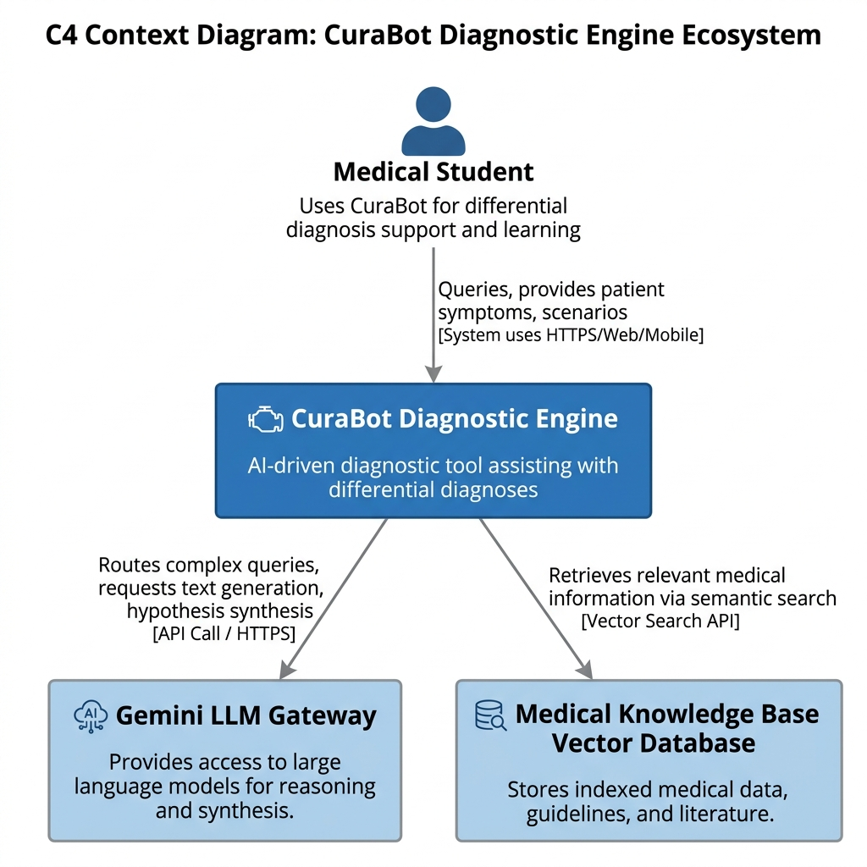

3.2 C4 Container & Components
- UI: React 18.2 Dashboard (Glassmorphism UI).
- API Gateway: FastAPI Gateway handling auth and rate-limiting.
- Orchestrator: Python backend managing agent state and 10-turn limits.
- Agent Runtime: LangChain/Custom agent execution environment.
- Data Stores: ChromaDB/Pinecone for Vector Retrieval, Supabase for logging.

3.3 Deployment Topology
The system is deployed in a secure Kubernetes cluster with private endpoints separating the LLM gateway.
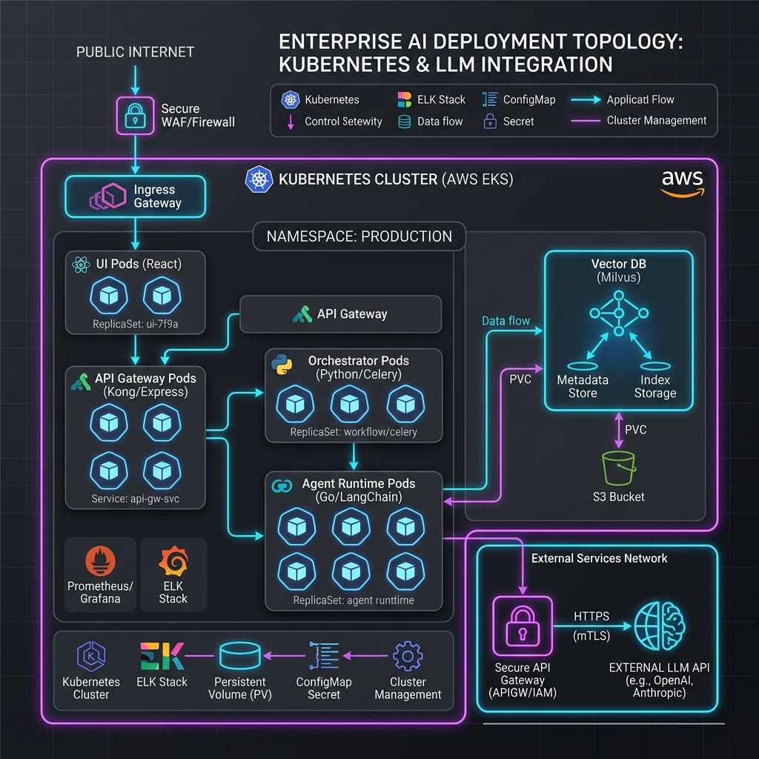

4. GenAI Capability Design

4.1 RAG Pipeline Flow
- Approach: Vector-RAG with Metadata filtering (hybrid).
- Pipeline: Ingest Medical SOPs → Chunk by logical section → Embed using standard text-embedding models → Vector Index → Retrieve top-K → Generate Answer → Validate Schema.
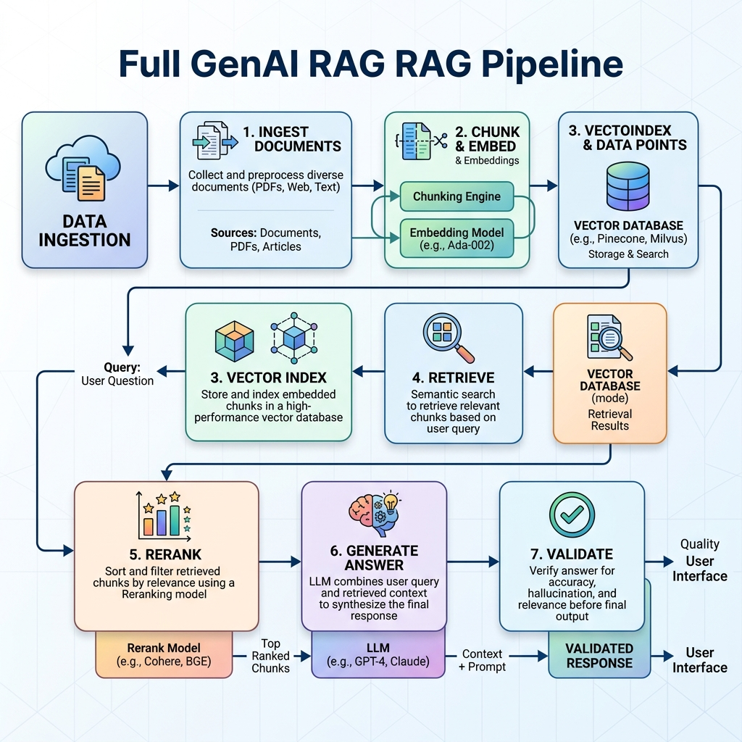

4.2 Guardrails & Confidence Scoring
- Grounding Policy: "Answer only from retrieved evidence."
- Guardrails: Prompt-injection mitigation via standard system prompts; output validation strictly enforcing JSON schemas for agent outputs.

5. Agentic Design

5.1 Agent Inventory
Agent | Type | Inputs | Outputs | Tools Allowed | Cannot Do
Symptom Normalizer | Utility | Raw text | Standardized medical terms | SNOMED mapping | No diagnosis
Hypothesis Generator | Specialist | Symptoms | Differential Diagnosis list | Vector Search | No treatment
Evidence Evaluator | Governance | Hypotheses + new data | Updated Bayesian weights | Evidence validation | No final action

5.2 Orchestration Graph
The orchestrator dictates the workflow graph, coordinating specialist agents through human-in-the-loop checkpoints.
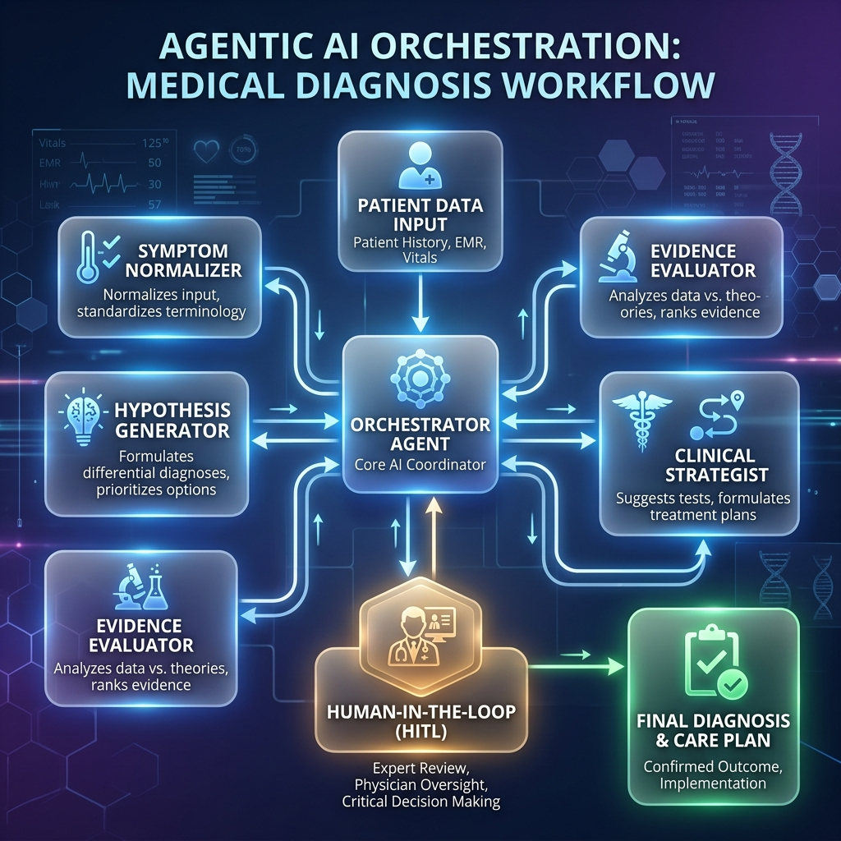

6. Data & Knowledge Fabric
- Sources: 15 Standardized Clinical SOPs, and a medically validated Knowledge Base containing real-world symptom and diagnostic data for 275 distinct diseases, sourced from verified medical websites and clinical studies.
- Ingestion: Extract → Normalize → Chunk → Embed → Index.
- Caching: Semantic cache for common medical queries; TTL set to 24 hours.
- Retention Policies: Strictly no retention of actual PHI; simulated logs retained for 30 days for instructor review.

7. API & Service Design
- API Gateway: Centralized routing.
- Endpoints:
- `POST /api/v1/chat` (Must-have): Sends user message, returns agent thought streams.
- `GET /api/v1/case/{id}` (Must-have): Retrieves specific scenario data.
- Error Handling: Retries/backoff for LLM API timeouts; graceful degradation with fallback to cached "standard" responses.

8. Security & Governance
- LLM Gateway: All calls route through a single secure gateway applying policy-as-code.
- RBAC: Medical Students (read/interact), Instructors (write scenarios), Admin (system config).
- Audit Trails: Complete retention of prompts, retrieved chunks, and final outputs in a secure log schema.
- FinOps: Token usage monitoring with hard caps at 10 turns per session.

9. Non-Functional Design
Metric | Target | Notes
Performance (Latency) | p95 < 2.5s | Time from query to first generated token.
Scalability | HPA | Horizontal Pod Autoscaling based on queue depth.
Availability | 99.9% | Multi-zone failover within the region.
Security | Zero-Trust | Secret rotation every 30 days, regular vulnerability scanning.

10. Observability & Evaluation
- Telemetry: Enforced end-to-end correlation IDs tracing a student's session across all agent nodes.
- RAG Evaluation: Offline harness testing precision/recall of the top-5 retrieved medical SOPs.
- Dashboards: Monitoring latency, API cost/tokens, and safety flag overrides.
- A/B Testing: Canary rollout for new System Prompt versions.

11. SDLC Integration
- CI/CD Stages: Lint → Test → Security Scan → Build → Deploy → AI Regression Test.
- Quality Gates: Prompt validation and policy compliance before merge.
- Drift Detection: Triggering documentation updates via webhooks when Agent definitions change.
- Release Governance: Clear rollback runbooks; kill-switch defaults agents to "recommend-only".

12. Risks & Failure Modes
Risk | Detection Signal | Mitigation / Fallback
Hallucination | Low generation confidence | Grounding policy; fallback to deterministic rules.
Prompt Injection | Policy violation spike | Safe refusal; disable tool access temporarily.
Cost Spikes | FinOps alert | Hard cap on tokens; disable complex agents, use simpler models.

13. Appendix
- Reference Diagrams: [C4 Context Diagram](#31-c4-context-diagram), [Deployment Topology](#33-deployment-topology).
- Glossary:
- *SOP:* Standard Operating Procedure
- *PHI:* Protected Health Information
- *LLM:* Large Language Model
- *RAG:* Retrieval-Augmented Generation

