Revised Problem Statement: Tailmate
1. Introduction & Vision
Tailmate envisions a world where responsible pet ownership is simplified and enriched through technology. We aim to become the premier all-in-one platform that connects pet owners, fosters communities, and streamlines pet care, starting with the fundamental challenge of finding compatible mates for pets.
2. The Problem: A Fragmented and Inefficient Experience
For millions of pet owners, the journey to find a suitable mate for their beloved companion is frustrating, outdated, and often unsafe. The current process is characterized by:
- Lack of a Centralized Platform: Owners resort to a disjointed mix of social media groups, local bulletin boards, and word-of-mouth, which is time-consuming and offers no quality control or effective filtering.
- Ineffective Discovery & Compatibility: Existing solutions lack sophisticated algorithms to suggest matches based on key compatibility factors like breed, temperament, health, location, and owner preferences.
- Unsafe and Awkward Communications: Initial interactions happen over impersonal public comments or unsecured channels, lacking a structured and safe environment for owners to discuss details and arrange meetings.
- Missed Opportunities: Without a system to track interests (likes/passes) and send notifications, potential matches are easily lost in the noise.
- Disconnected Pet Care Ecosystem: Even after a match is made, owners must juggle multiple other apps to find meeting places (parks), schedule health checks (vets), or arrange grooming, disrupting the end-to-end experience.
This fragmentation results in a stressful, inefficient, and potentially risky process for pets and their owners.
3. Proposed Solution: The Tailmate Platform
Tailmate is a comprehensive mobile application designed to address these pain points directly. It provides a secure, intuitive, and all-in-one solution for pet social networking, starting with mate discovery.
Our solution will deliver:
- Intelligent, Preference-Driven Discovery: A curated feed of potential mates using a Tinder-style swipe interface, powered by algorithms that prioritize compatibility and proximity.
- Secure Matchmaking Protocol: A double-opt-in system where a "match" is only made upon mutual interest, ensuring respectful connections and reducing unwanted contact.
- Integrated Communication Hub: An in-app, real-time messaging system that allows matched users to chat safely and arrange meetings without sharing personal contact information prematurely.
- Unified Pet Care Dashboard: A dedicated space with quick actions to find and book nearby pet services like parks, vets, and groomers, directly supporting the meeting arrangement process.
- A Trusted Community: User verification and detailed pet profiles create a reliable environment focused on the well-being of the animals.
4. Value Proposition
- For Pet Owners: Saves significant time and reduces stress. Provides a safer, more reliable, and enjoyable way to connect with other responsible owners and manage their pet's social life.
- For the Pets: Leads to healthier, more responsible breeding through better-matched pairs and ensures their well-being with integrated care features.
5. Technology Stack
- Frontend: React Native for a performant, cross-platform (iOS & Android) mobile experience.
- Backend: Node.js with Express.js framework to build a robust and scalable RESTful API.
- Database: MongoDB for its flexibility in storing unstructured data like user profiles, chat messages, and pet information.
- Authentication: JWT (JSON Web Tokens) for secure user authentication and session management.
- Real-time Features: Socket.IO for instant notifications and live messaging.
6. Success Metrics
We will measure the success of Tailmate through:
- User acquisition rate and monthly active users (MAUs).
- Number of successful matches made per week.
- User engagement metrics (time in app, messages sent, service bookings).
- User satisfaction scores and app store ratings.

OVERALL FLOW
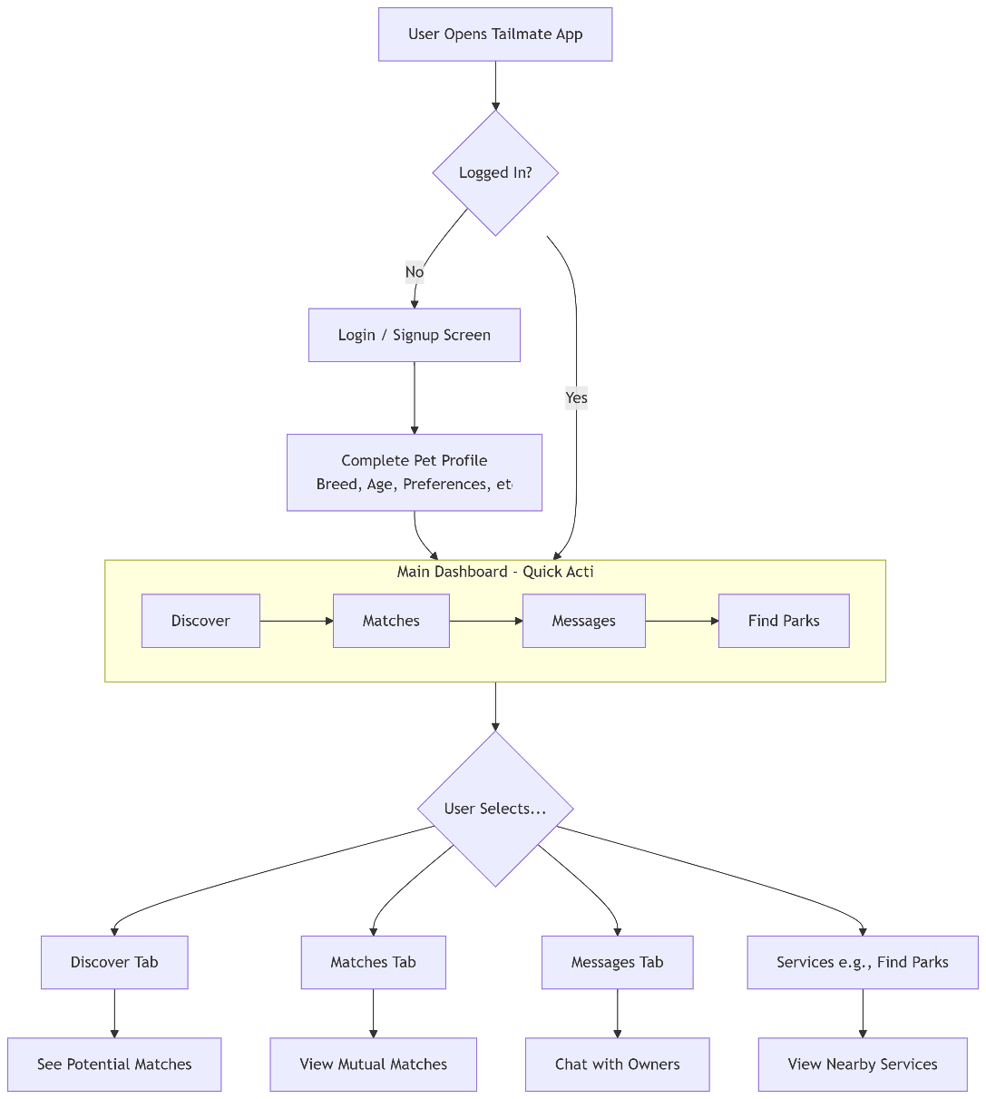

Matching flow
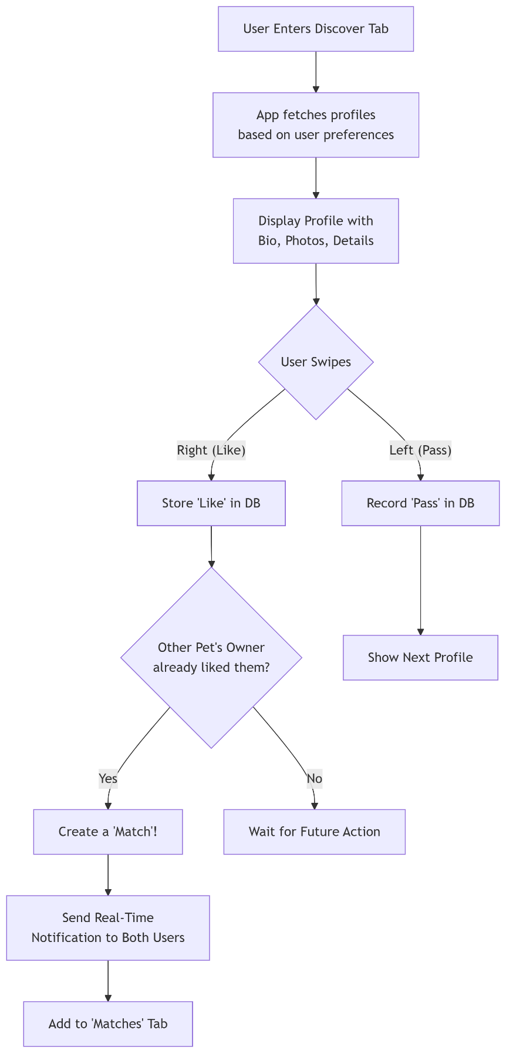

Message and communication flow
