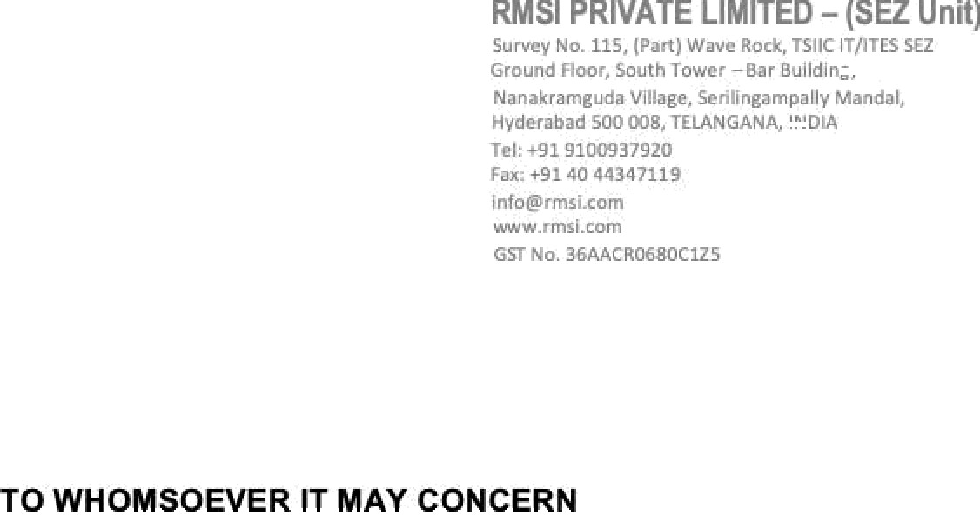

21 Sep 2021

This is to certify that Ms. Segu La!itha (Emp. Code: SZ3775) has worked in our organization from 14 Nov 2018 to 21 Sep 2021. Her designation at the time of relieving was Engineer



She resigned from the services of the company on her own accord and was relieved from closing hours of 21 Sep 2021.

We wish her all the very best in her future endeavors.

For RMS! Private Limited

