# Manual test:

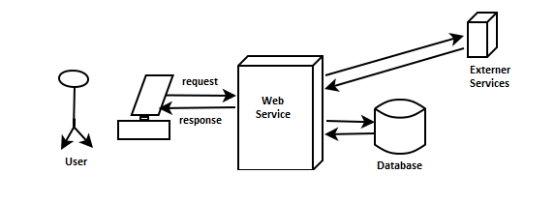

# Automation test:

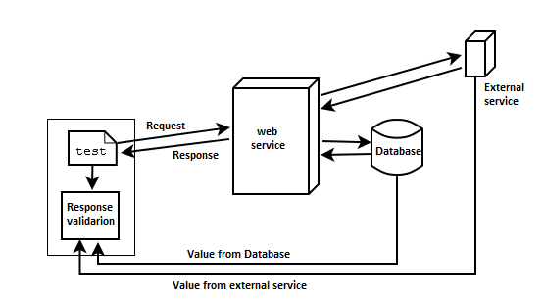

# Our test:

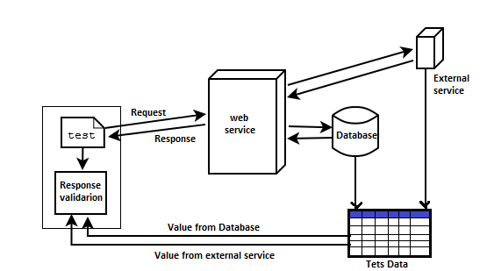

* Data is not in sync with backend all the time backend data changes.
* Test environment stability.
* Existing tests are designed for both S and V-env.