# Refactor Definition

## Update test request after WSDL change:

At any part of time if there are changes in the WSDL design (ex: a new filed is added/removed/renamed etc.) it is required to update the same changes in tests, below is the procedure to refactor the changes in WSDL into tests in SoapUI.

1. Refactor the new WSDL file into interface

* Right click request Interface > Refacor Definition

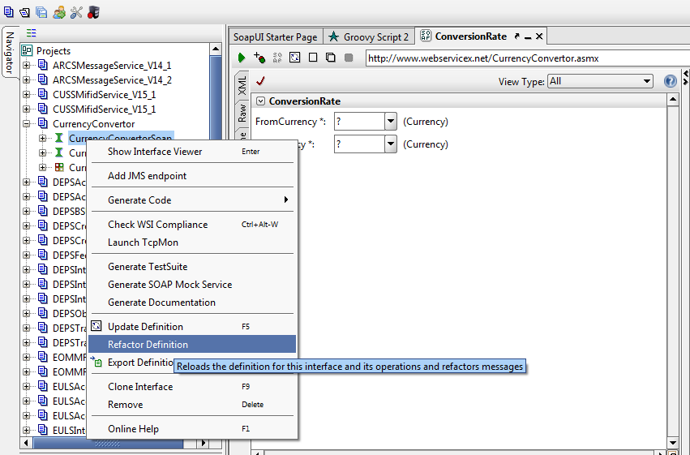

1. Definition URL: Provide WSDL path (if wsdl path is changed else remains same)

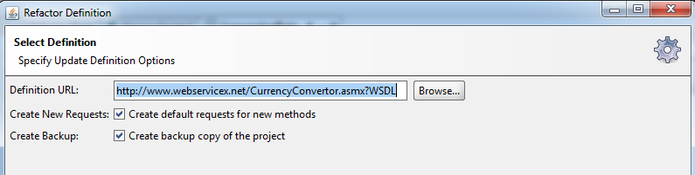

1. Follow wizard… finish.
2. To update test suite request

* Go to Test request > click “Recreate a default request..” icon 

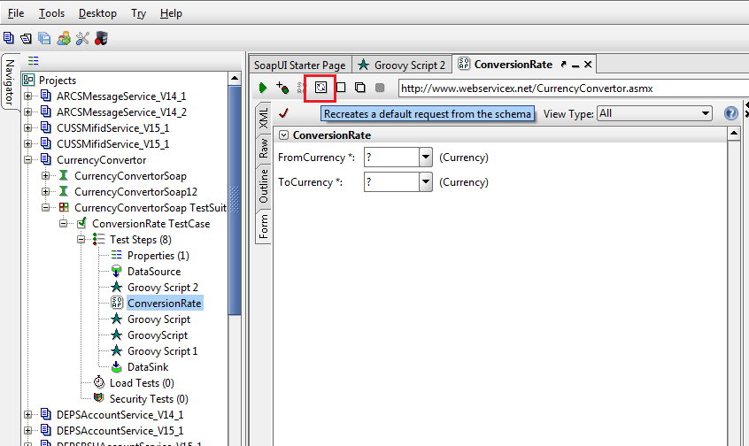

1. Keep existing value > Yes. (will keep the existing mapped values in request)