E –Auction

User Manual

Important Point: *For Internet explorer users go to tools -> Compatibility View   
Settings, uncheck display intranet sites and use Microsoft compatibility list -> close*

**Purpose of the document:**

*Intention of this document is to guide the user to effectively use the application. The logical arrangement of the information and screen prints shall enable the user to understand the sequence and navigation of the system.*

1. *Connecting to the application :*

*You must connect to the application using the following address:*

*http://ctsc00849530701:9000/e-Auction/*

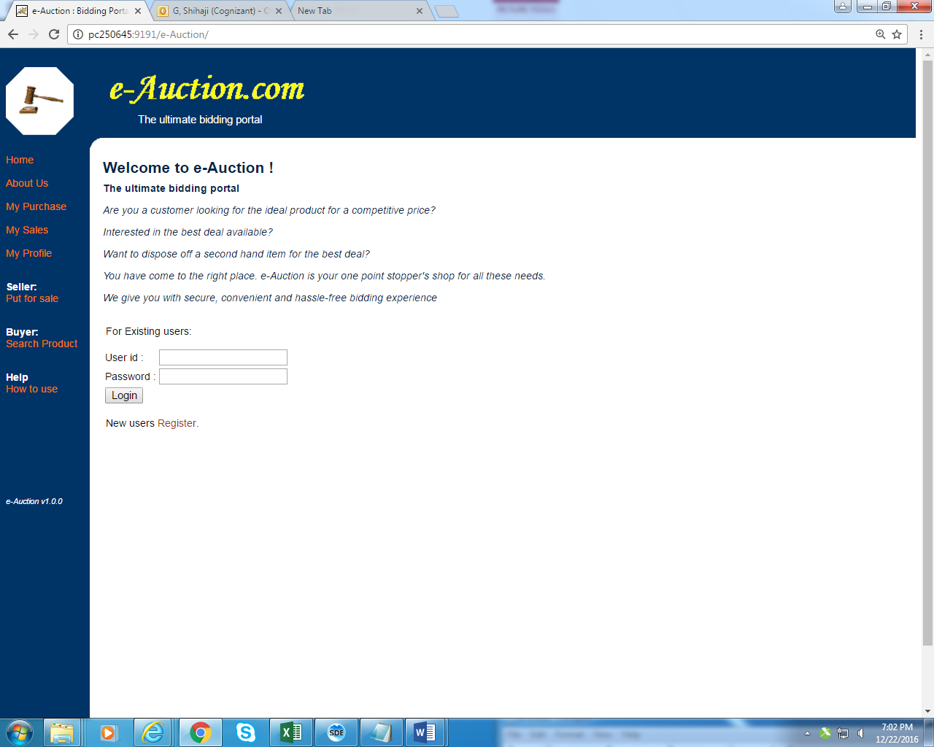 *Fig 1*

1. *Authentication :*

*User can login with his user id and password and check all the functionality from the menu. Refer screen print below for the User login.*

### Login Module

|  |  |  |
| --- | --- | --- |
| **Field** | **Validation** | **Error Message When Validation Fails** |
| User Id | Cannot be Null | Please enter name |
| Length less than 20 characters | Value cannot be more than 20 characters |
| Only contain alphanumeric characters | Invalid user id |
| Password | Cannot be Null | Please enter Password |
| Length less than 20 characters | Value cannot be more than 20 characters |
| Only contain alphanumeric characters | Invalid Password |

### Sample Data:

|  |  |
| --- | --- |
| User Id | Password |
| manikanta | manikanta |
| sanjay | Pass1234 |
| Bargavi | pass321 |
| Karthi12 | welcome |

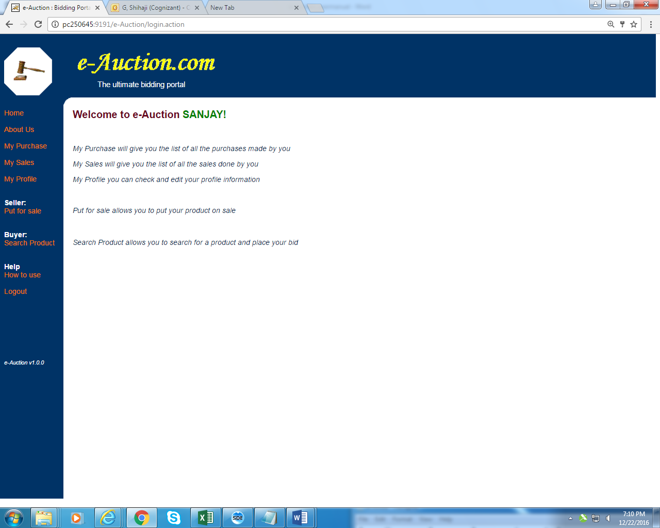

*Fig 2*

1. *New User Registration :*

*New user can be enrolled to the application by clicking* ***Register*** *link (fig 1). User will be guided to fill registration form (fig 3). User has to fill in all the mandatory field, not adhering to which lead to error message dialog to pop up. User can cancel the pop up by clicking* ***ok*** *in the dialog box and fill in the required field. Refer fig 4 when user leaves User name field blank , error dialog pops up. If the user enters all the correct credentials(fig 5 ) and click submit button user will redirected to welcome page (fig 6)*

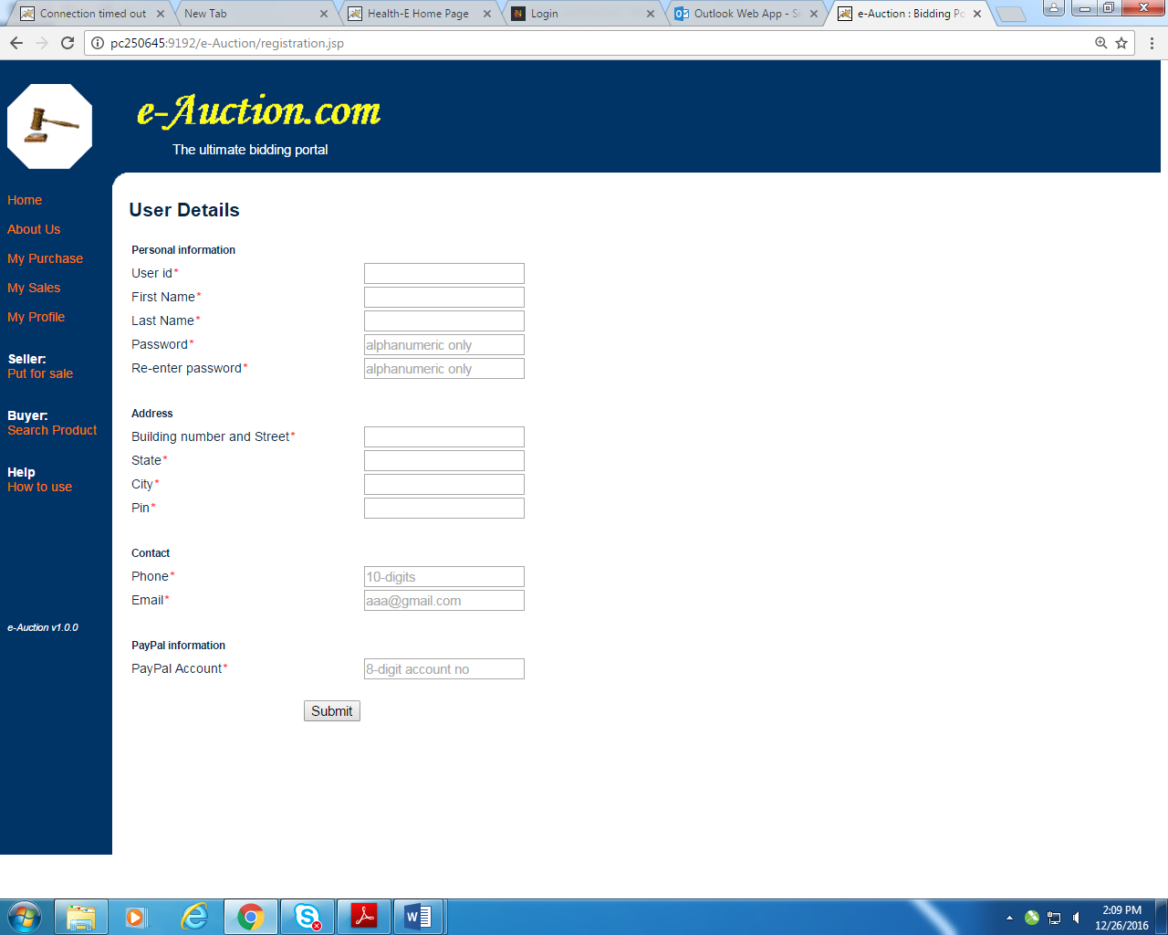 *Fig 3*

### New User Register

|  |  |  |
| --- | --- | --- |
| **Field** | **Validation** | **Error Message When Validation Fails** |
| User Id | Cannot be Null | Please enter User Id |
| Length less than 30 characters | Value cannot be more than 30 characters |
| Only contain alphanumeric characters | User name can only contain alphanumeric characters |
| First Name | Cannot be Null | Please enter first Name |
| Length less than 30 characters | Value cannot be more than 30 characters |
| Only contain alphanumeric characters | First name can only contain alphabets |
| Last Name | Cannot be Null | Please enter last Name |
| Length less than 30 characters | Value cannot be more than 30 characters |
| Only contain alphanumeric characters | Last name can only contain alphabets |
| Password | Cannot be Null | Please enter password |
| Length less than 20 characters | Value cannot be more than 20 characters |
| Only contain alphanumeric characters | Password can only contain alphanumeric characters |
| Re-enter password | Cannot be Null | Please confirm password |
| Length less than 20 characters | Value cannot be more than 20 characters |
| Password & re-enter password must be same | Please enter same value for password and retype password |
| Building number and Street | Cannot be Null | Please enter Building number and Street |
| Length less than 30 characters | Value cannot be more than 30 characters |
| Only contain alphanumeric characters and spaces. | Please enter only alphanumeric and space values for building number and street |
| City | Cannot be Null | Please enter City |
| Length less than 30 characters | Value cannot be more than 30 characters |
| Only contain alphanumeric characters and spaces. | Please enter only alphanumeric and space values for city |
| State | Cannot be Null | Please enter State |
| Length less than 20 characters | Value cannot be more than 20 characters |
| Only contain alphanumeric characters and spaces. | Please enter only alphanumeric and space values for state |
| Pin | Cannot be Null | Please enter Pin code |
| Length less than 6 digits | Value cannot be more than 6 digits |
| Only contain numeric values | Please enter a valid pin code |
| Phone | Cannot be Null | Please enter Phone number |
| Length less than 10 digits | Value cannot be less than 10 digits |
| Only contain numeric values | Please enter a valid phone number |
| Email | Cannot be Null | Please enter Email |
| Length less than 30 characters | Value cannot be more than 30 characters |
| Only contain valid email format. | Please enter a valid email address |
| Paypal Account | Cannot be Null | Please enter PayPal Account number |
| Length less than 8 digits | Value cannot be more than 8 digits |
| Only contain number value. | Please enter a valid PayPal account |

### Sample Data:

|  |  |  |  |  |  |  |  |  |  |  |  |
| --- | --- | --- | --- | --- | --- | --- | --- | --- | --- | --- | --- |
| User Id | First Name | Last Name | Password | Re-Enter Password | Building number and Street | City | State | Pin | Phone | Email | Paypal Account |
| manikanta | manikanta | srikakulam | manikanta | manikanta | 17 pqs street | coimbatore | Tamil nadu | 641035 | 9786511322 | divins95@gmail.com | 4444448454 |
| Soumya | Soumya | Krish | arun123 | arun123 | 20/4B Nallappa Street | Namakkal | Tamilnadu | 641023 | 9543727107 | anu20121994@gmail.com | 456876976978 |
| Ctsuser04 | Sunil | Kumar | Pass1234 | Pass1234 | Line 1 | chennai | Tamilnadu | 603103 | 9789993668 | sunil@gmail.com | 12341234 |

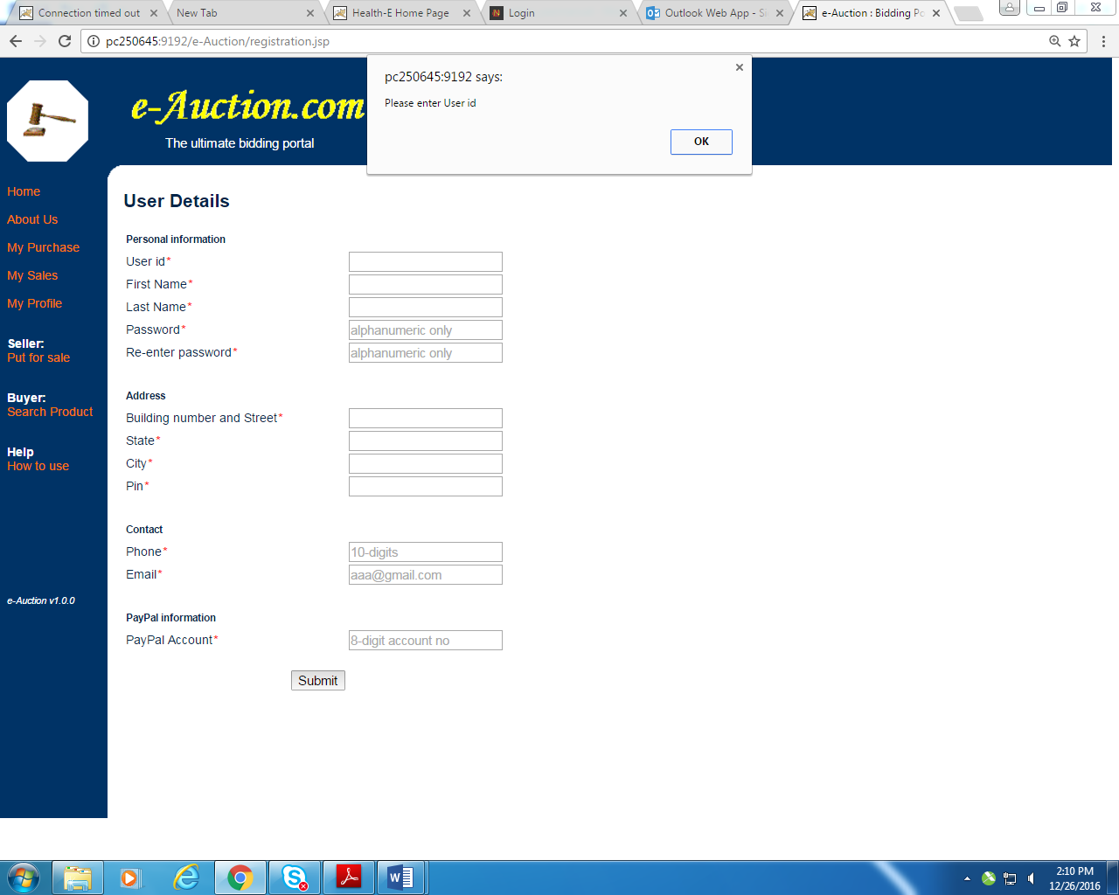 *Fig 4*

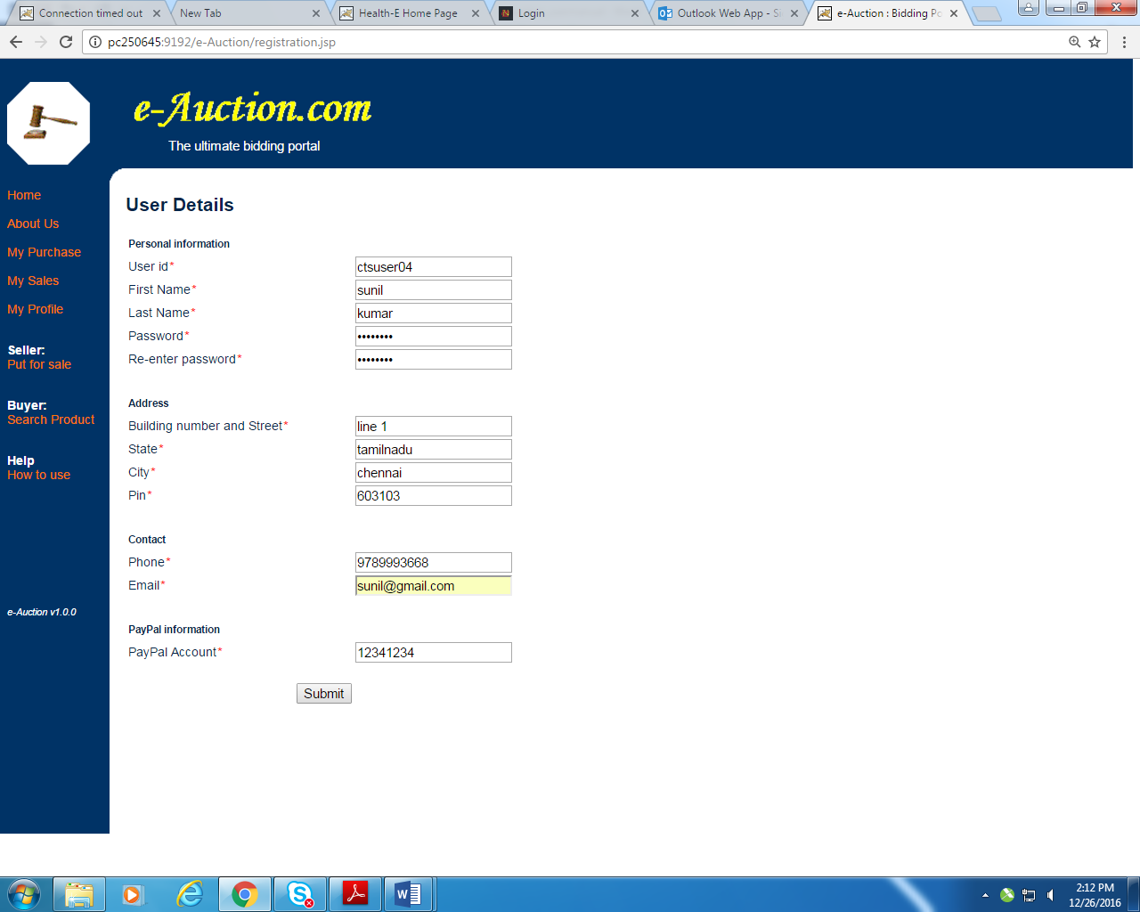

*Fig 5*

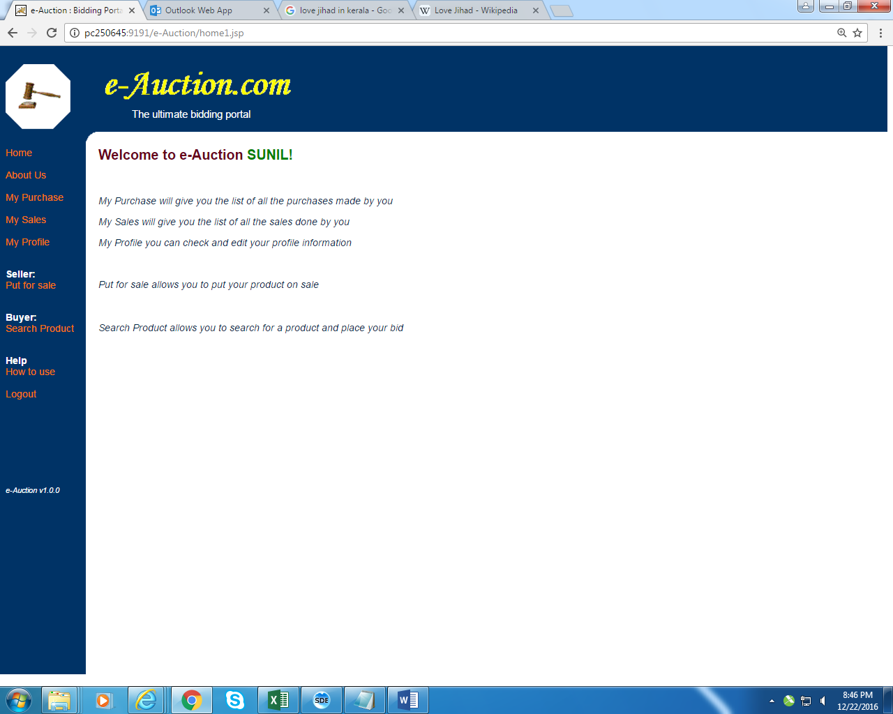

*Fig 6*

1. *My Purchases :*

*Once user has successfully logged in , user can click My Purchases link from the menu which will show the purchases done by the user in Fig 7*

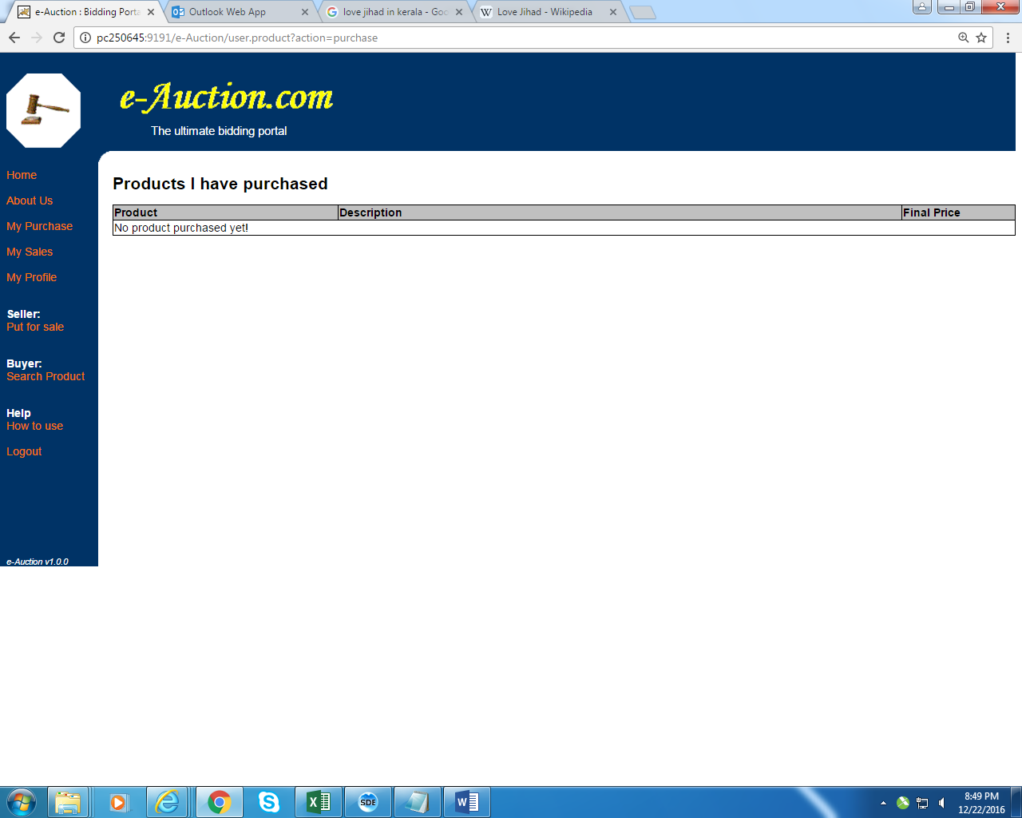

*Fig 7*

1. *My Sales :*

*If user clicks My Sales link he can see all the sales done by him (fig 8)*

1. *My Profile :*

*If user clicks My Profile link he can check his profile information and update it (fig 9)*

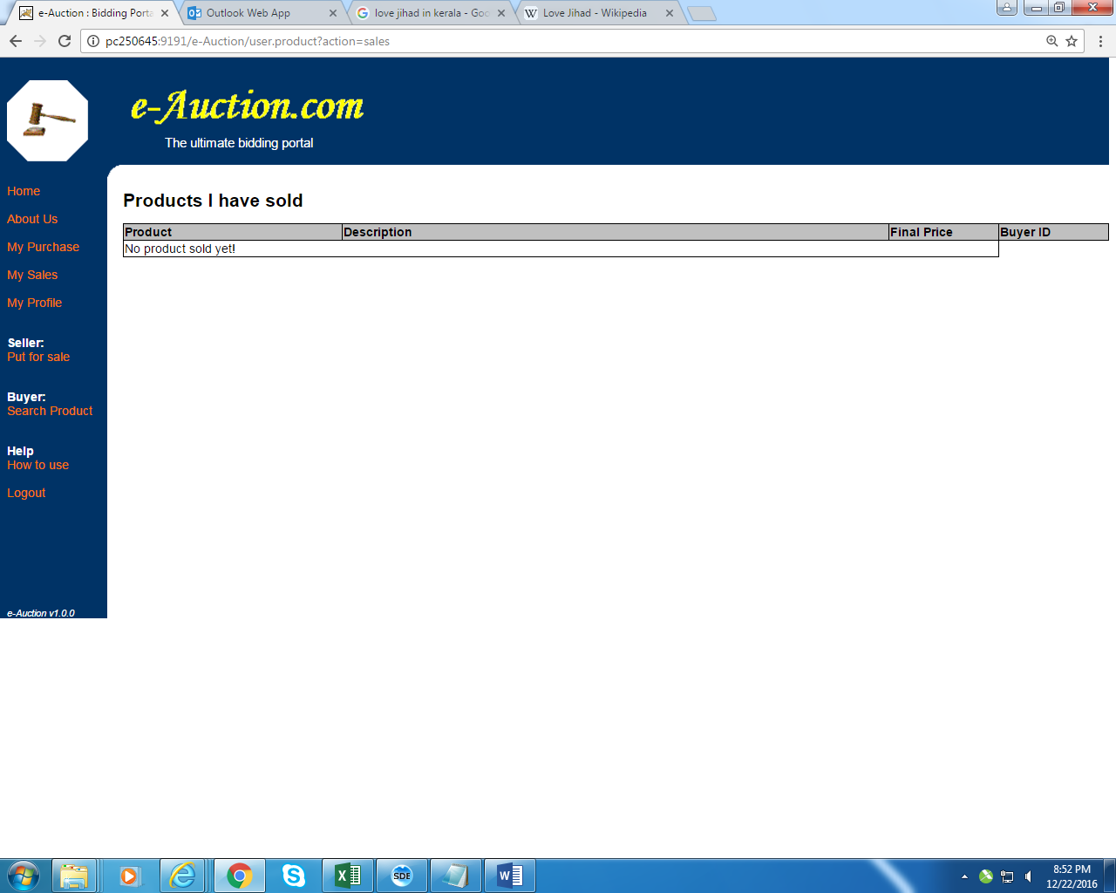 *. Fig 8*

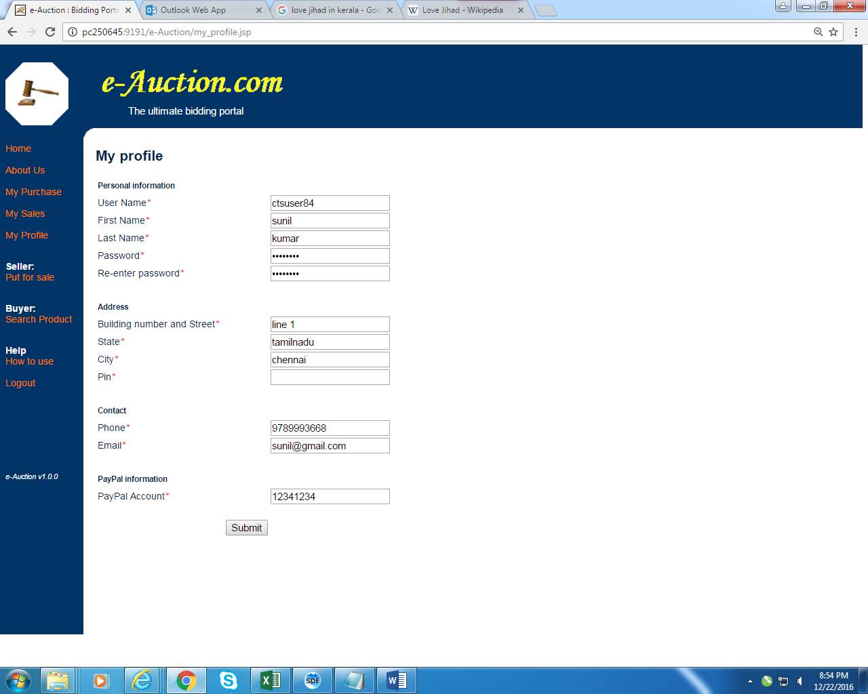

*Fig 9*

1. *Put for sale:*

*By clicking put for sale link user can put his item to sold by maximum bid*  (fig 10). After user clicks submit button after filling all the mandatory fields like category from drop box ,choose a starting price for his product , when he want to close the bid etc, he will be redirected to welcome page with confirmatory message(fig 11)

|  |  |  |
| --- | --- | --- |
| **Put for Sale Page** | | |
| **Field** | **Validation** | **Error Message When Validation Fails** |
| Product Name | Cannot be Null | Please Enter Product Name |
| Length less than 30 characters | Value cannot be more than 30 characters |
| Only contain alphanumeric characters and spaces | Product name can only contain alphanumeric characters and spaces |
| Short Description | Cannot be Null | Please Enter Short Description |
| Length less than 40 characters | Value cannot be more than 40 characters |
| Only contain alphanumeric characters and spaces | Short Description can only contain alphanumeric characters and spaces |
| Detailed Description | Cannot be Null | Please Enter Detailed Description |
| Length less than 60 characters | Value cannot be more than 60 characters |
| Only contain alphanumeric characters and spaces | Detailed Description can only contain alphanumeric characters and spaces |
| Category | Must select a value. | Please select the category |
| Category can be any one of the values like below   * Book * Furniture * Electronics * Etc., |  |
| Starting Price | Cannot be Null | Please Enter Starting Price |
| Length less than 10 characters | Value cannot be more than 6 characters |
| Only contain number value | Please enter a valid starting price |
| Bid end Date | Cannot be Null | Please Enter Bid End date |
| Date value should be entered in the format “MM/dd/yyyy” | Bid End Date should be entered in the following format “MM/dd/yyyy” |
| If the Bid end Date is less than current date | Bid end date cannot be less than current date |

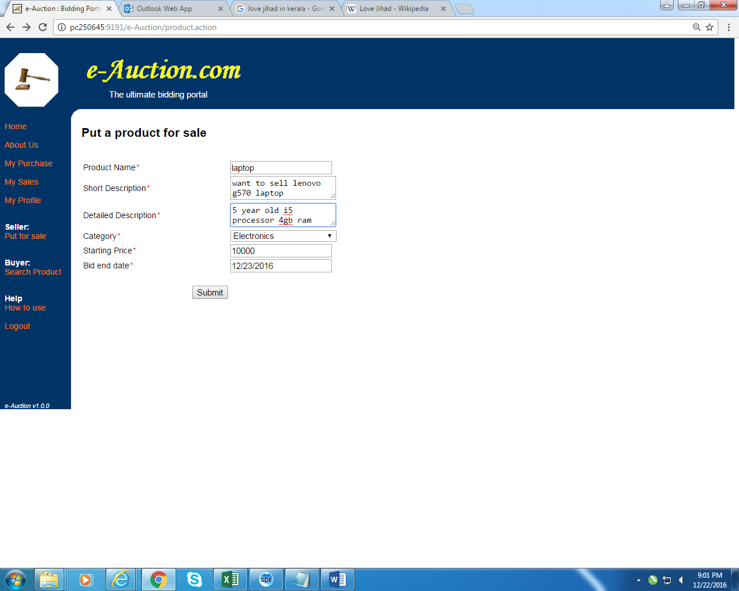

*Fig 10*

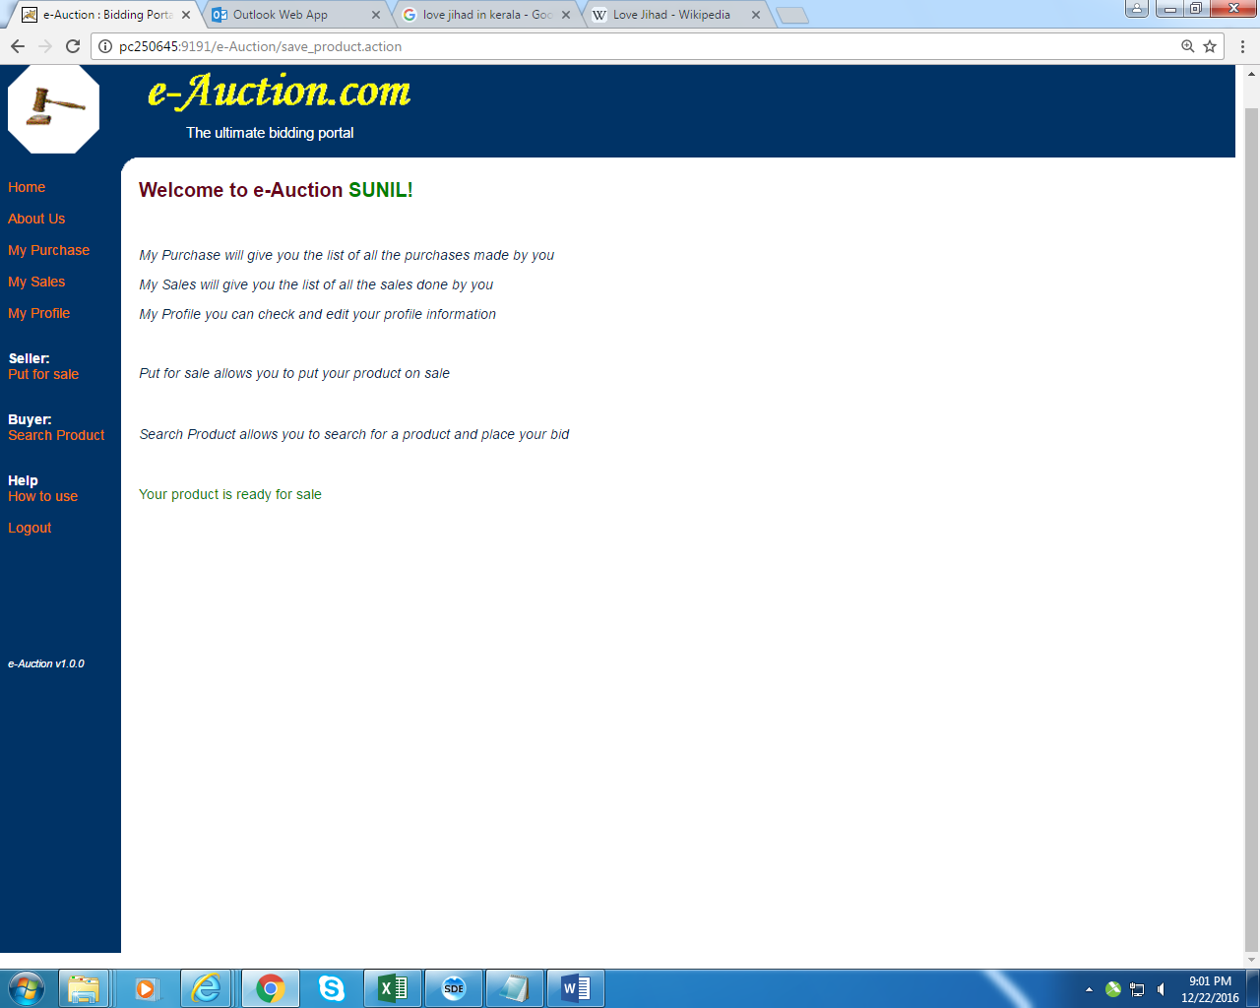

*Fig 11*

1. *Search product:*

*By clicking search product he can buy any product by searching the product in choose a category drop box(fig 12) .User will be provided with the list of all the products available in that category, he/she can click hyper link of any product he/she likes . User will be redirected to Bidding Center to bid for the product which should be greater than the starting price. His bid will be posted in the bidding table with bid closing date (fig 13)*

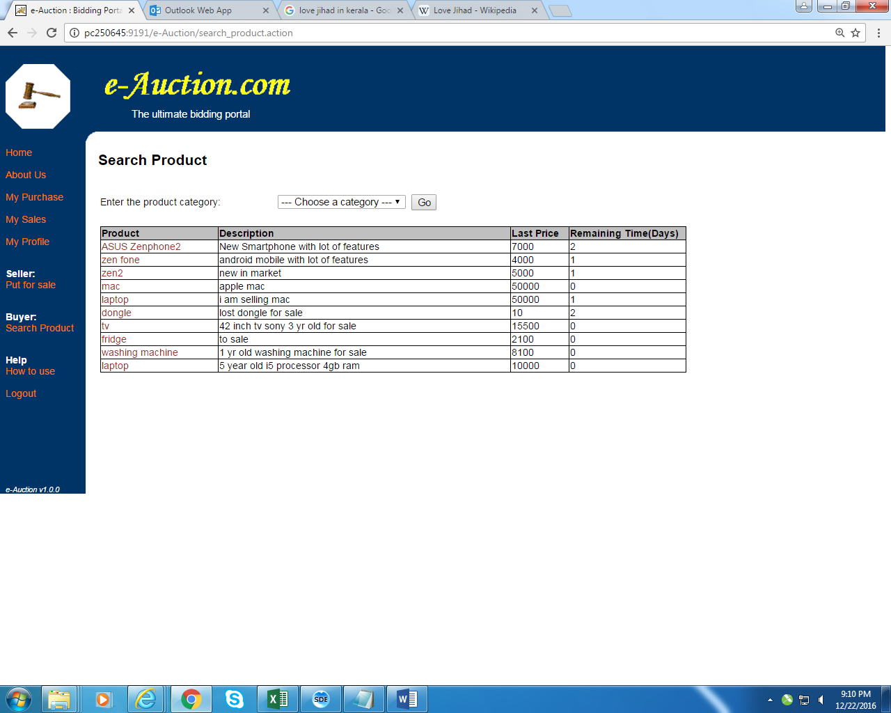

*Fig 12*

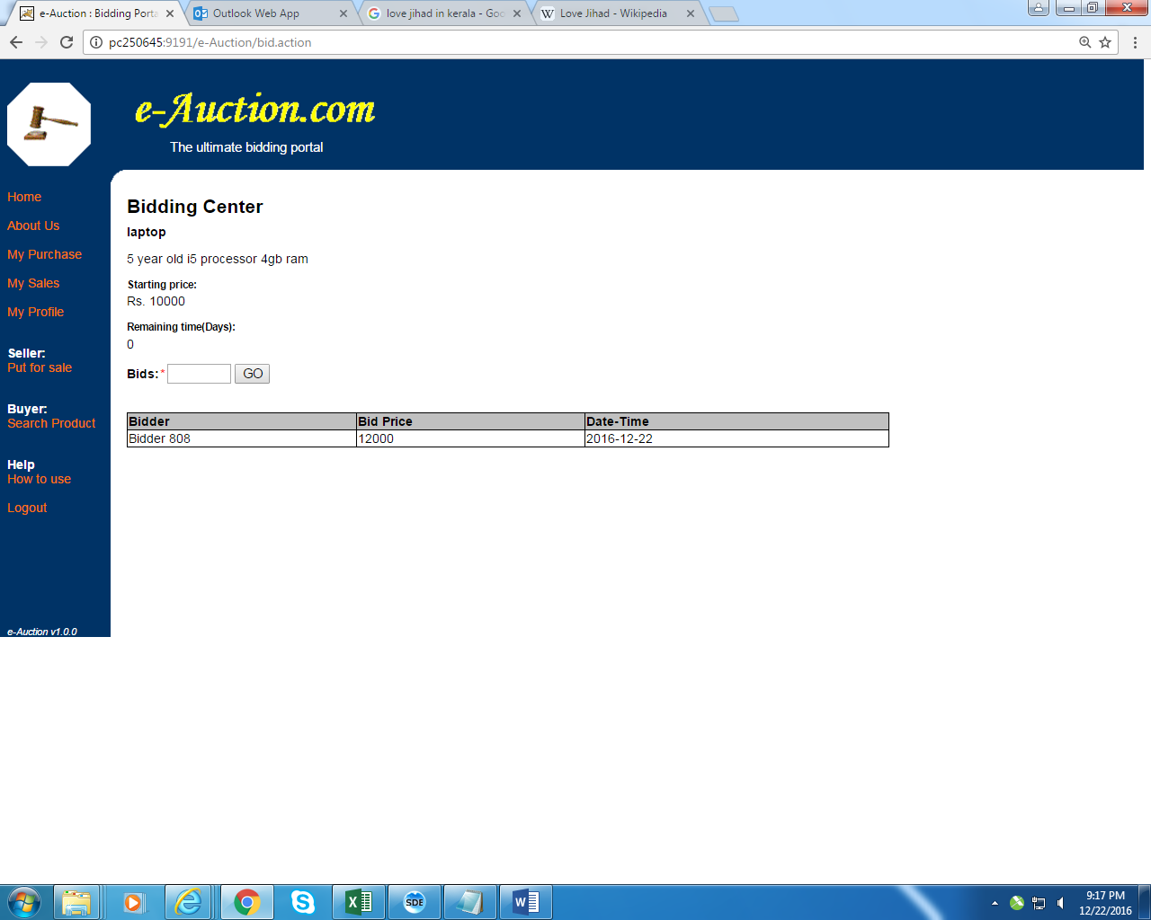

*Fig 13*

|  |  |
| --- | --- |
| **Bidding Center Page** | |
| **Field** | **Validation** |
| Bids Price | Cannot be Null |
| Length less than 7 characters |
| Only contain number value |