“FOOD BILLING SYSTEM”

**Contents**

* Abstract
* Introduction
* Objectives
* Scope
* Case Diagram
* Advantages
* Disadvantages
* Code
* Output
* Suggestion
* Conclusion

***Abstract***

The "Food Billing System" has been developed to override the problems prevailing in the practicing manual system. This software is supported to eliminate and, in some cases, reduce the hardships faced by this existing system. Moreover, this system is designed for the particular need of the company to carry out operations in a smooth and effective manner.

***Introduction***

The "Food Billing System" has been developed to override the problems prevailing in the practicing manual system. This software is supported to eliminate and, in some cases, reduce the hardships faced by this existing system. Moreover, this system is designed for the particular need of the company to carry out operations in a smooth and effective manner.

The application is reduced as much as possible to avoid errors while entering the data. It also provides error message while entering invalid data. No formal knowledge is needed for the user to use this system. Thus, by this all it proves it is user-friendly. Online Food Ordering System, as described above, can lead to error free, secure, reliable and fast management system. It can assist the user to concentrate on their other activities rather to concentrate on the record keeping. Thus, it will help organization in better utilization of resources.

***Objectives***

**✓ To Provides the searching facilities based on various factors. Such as Food them Customer, Order, Confirm Order.**

**✓ To Online Food Ordering System also manage the Payment details online for Order details Confirm Order details Food item.**

**✓ To It tracks all the information of Category, Payment. Order etc**

***Scope***

It may help collecting perfect management in detail. In a very short time, the collection will be obvious, simple and sensible. It will help a person to know the management of passed year perfectly and vividly. It also helps in current all works relative to Online Food Ordering System. It will be also reduced the cost of collecting the management & collection procedure will go on smoothly. we have tried to computerize various processes of Online Food Ordering System.

* In computer system the person has to fill the various forms & number of copies of the forms can be easily generated at a time.
* In computer system, it is not necessary to create the manifest but we can directly print it, which saves our time.
* To assist the staff in capturing the effort spent on their respective working areas.
* To utilize resources in an efficient manner by increasing their productivity through automation.
* The system generates types of information that can be used for various purposes.
* It satisfy the user requirement
* Be easy to understand by the user and operator

***Case Diagram***

***Advantages***

The food billing system service is a local restaurant and food cooperative website or application for customers. Due to the rapid growth of smart phone or tablet in the use of internet and the technologies associated with the several opportunities to communicative, consumer. so many restaurant are now undertaking into their business with communicate because of the internet and telephone. One of the businesses that the internet introduced is an online food ordering system. In today life many restaurants have focus on quick preparation and speedy delivery orders.

* Time saving

The online food ordering is now days popular among the young generation comfortable, time saving and convenient. It is recent survey a consumer makes a mind to purchase online food he or she is multiple food items or menu card. The main identified factors are time saving, and convenience. People compare prices in online food delivery website and apps selection of the dish. the restaurants have to make proper strategies to increase the consumer level of satisfaction.

* Delivery place (Location)

In the system design to allow customers to go online and place order for their food single or multiple food items. Recently, most of this delivery orders were placed over the phone, a breakthrough is the wireless 2 telephone system which comes in landline telephone lines or Mobile communication and internet and have the goods delivered at his/her home. because main function his, GPS system should be on the facility to search service by any location and home location.

***Disadvantages***

* Cost of increase

Online food ordering system service know days increase your budget. Because of need a new delivery team to provide the services and you need to spend extra charges. In this system all type expense can be transfer on consumers.

* Change of environment

The main different between the online food ordering and dining in a restaurant is the environment around us. If one person eats within home or he may not feel a change in environment and refreshment and relax. But comfort is really high level of online food take away. If he dine-in luxury restaurant with super design and light music that environment gives better relax compared to the other.

***Code***

<!DOCTYPE html>

<html lang="en">

<head>

    <meta charset="UTF-8">

    <meta http-equiv="X-UA-Compatible" content="IE=edge">

    <meta name="viewport" content="width=device-width, initial-scale=1.0">

    <title>navigation bar</title>

    <link rel="stylesheet" href="nav.css">

    <link href="https://fonts.googleapis.com/icon?family=Material+Icons" rel="stylesheet">

</head>

<body>

    <header>

        <nav class="navbar">

            <ul>

                <li><a href="nav.html" target="_blank">

                        <h1>Home</h1>

                    </a>

                </li>

                <li><a href="login.html" target="_blank">

                        <h1>Login</h1>

                    </a></li>

                <div class="search" target="_blank">

                    <h1>Search</h1>

                </div>

            </ul>

        </nav>

    </header>

    <div class="s">

        <img src="delicious food1.jpg" alt="">

    </div>

    <div class="main">

        <!-- card1 -->

        <div class="cards">

            <div class="image">

                <img src="R.jpg" alt="erorr...">

            </div>

            <div class="title">

                <h1>Burger</h1>

            </div>

            <div class="des">

                <a href="Order.html" target="_blank"><button><b>order now</b></button> </a>

            </div>

        </div>

<!-- descripition of thew page -->

        <div class="about">

            <h1>about us</h1>

            <p><b>our company which offers an on-demand food delivery platform designed to provide food from Neighbourhood restaurants to the customers. The company's platform utilizes a smartphone application that has local restaurants and their online ordering menu listed, from which it provides delivery using a fleet of personnel, enabling people to order food at their convenient places.</b></p>

            <button>read more</button>

        </div>

</div>

</body>

</html>

Css file

* {

  margin: 0px;

  padding: 0px;

}

.navbar li img {

  width: 50px;

  height: 45px;

  padding: 0%;

}

.navbar {

  background-color: rgba(253, 228, 215, 0.982);

  border-bottom-right-radius: 5px;

  border-bottom-left-radius: 5px;

  height: 50px;

  font-family: cursive;

}

.navbar ul {

  overflow-x: hidden;

}

.navbar li {

  float: left;

  list-style: none;

  margin: 13px 20px;

}

.navbar li a {

  padding: 0px 0px;

  text-decoration: none;

  color: rgb(0, 0, 0);

}

.material-icons {

  padding: 0px 0px 1px 1px;

  text-decoration: none;

  color: rgb(0, 0, 0);

}

.search {

  overflow: auto;

  padding: 13px 20px;

  float: right;

}

.main {

  padding: 3px;

  height: 1550px;

  background-color: rgb(214, 235, 186);

  overflow-y: hidden;

}

.cards {

  margin: 25px;

  background-color: rgb(255, 248, 199);

  display: inline-block;

  width: 20%;

  border-radius: 10px;

  cursor: pointer;

  transition: 2ms;

}

.cards:hover {

  background-color: rgb(176, 250, 255);

  box-shadow: 3px 3px 3px 3px;

  transition: 0.5s;

  transform: scale(1.09);

  z-index: 1;

}

.image img {

  width: 100%;

  border-top-left-radius: 10px;

  border-top-right-radius: 10px;

}

.title {

  text-align: center;

  padding: 5px;

  text-transform: uppercase;

}

.des {

  text-align: center;

  padding: 5px;

}

button {

  border-radius: 5px;

  border-color: rgb(0, 0, 0);

  background-color: rgb(224, 223, 223);

  padding: 5px;

  overflow-x: hidden;

}

button:hover {

  background-color: rgb(173, 245, 149);

  transition: 1ms;

  cursor: pointer;

}

.s img {

  padding: 0px;

  height: 500px;

  width: 100%;

  border-radius: 2px;

}

.about {

  padding: 25px;

}

***Output***

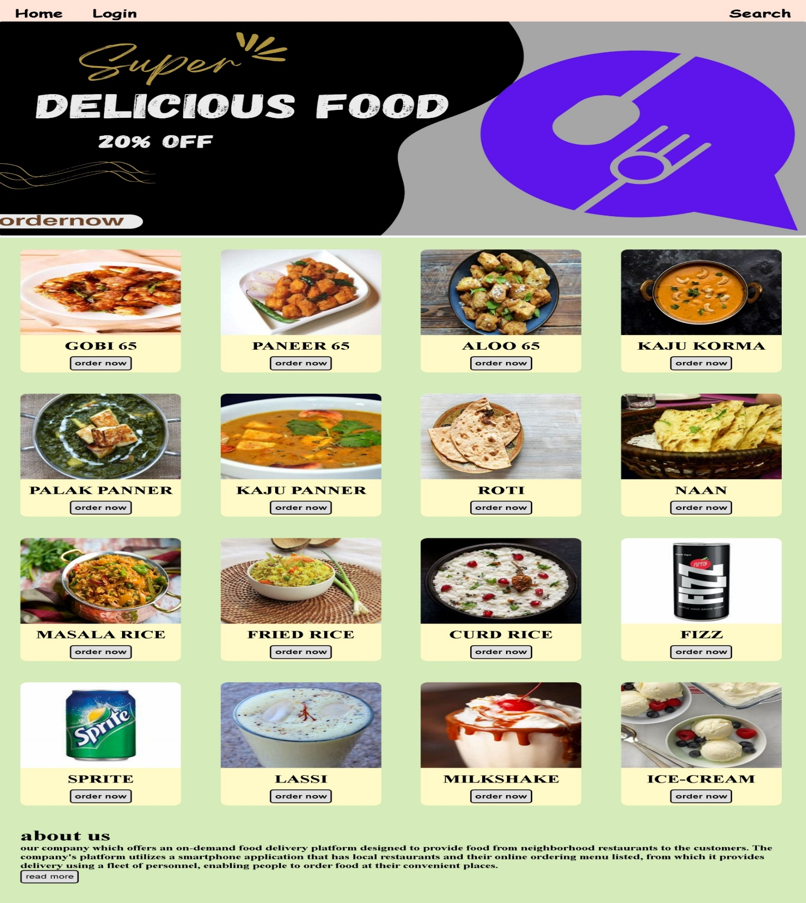

***Suggestion***

In the fastest world of today, most people are frequency order place on the customers of now days are attracted online food ordering system is very convenient. The most of restaurant have to show on food items and offered, lowest price and extremely simplified navigation for the order.

***Conclusion***

Food Billing system is done to help and solve one of the important problems of customer. Because Large number of customers can use the internet and phone. Various issues related to Mess/Tiffin Service will be solved by this system. Thus, implementation of Online Food Ordering system is done to help and solve one of the important problems of customer. It helps customer in making order easily and gives information needed in making order to customer place. The Food website application made for restaurant massive one help to receiving orders.