**DISTRIBUTION TRANSFORMER MONITORING SYSTEM**

**ABSTRACT**

This project involves the development of an IoT-based transformer monitoring system designed for single-phase AC transformers, with capabilities to measure current, voltage, oil level, and temperature. Utilizing an Arduino Nano and ESP8266 microcontroller, the system processes these critical parameters and transmits the data to the Adafruit io for remote monitoring.

The Adafruit io allows users to access real-time insights into transformer performance, and ensure efficient operation. This system enhances operational visibility, supports proactive maintenance, and improves overall transformer management by integrating real-time data monitoring with convenient remote access and control features.

|  |  |  |
| --- | --- | --- |
| **Content** | | |
| **Chapter No** | **Title** | **Page No.** |
| 1. | **Introduction** | **10** |
| 1.1 | Introduction | 10 |
| 1.2 | Literature Survey | 11 |
| 2. | **Working and Principle** | **12** |
| 2.1 | Problem statement | 12 |
| 2.2 | Need of project | 13 |
| 2.3 | Objective | 13 |
| 2.4 | Development system | 13 |
| 2.5 | Components requirement | 15 |
| 2.6 | Project Flow | 23 |
| 2.7 | Block Diagram | 24 |
| 2.8 | Flow Chart | 25 |
| 2.9 | Schematic Diagram | 26 |
| 2.10 | Hardware Setup | 27 |
| 2.11 | Interfacing description | 28 |
| 2.12 | Working Principle | 29 |
| **3** | **Advantages and Applications** | **32** |
| 3.1 | Advantages | 32 |
| 3.2 | Applications | 32 |
| **4** | **Result and Discussion** | **33** |
| 4.1 | Dashboard Output display | 33 |
| 4.2 | LCD Output display | 34 |
| **5** | **Conclusion** | **36** |
| 5.1 | Conclusion | 36 |
| **6** | **Future Enhancement and References** | **37** |
| 6.1 | Future Enhancement | 37 |
| **7** | **References** | **38** |

|  |  |  |
| --- | --- | --- |
| **LIST OF FIGURES** | | |
| **Fig No.** | **FIGURE NAME** | **PG No** |
| 2.5.1.1 | Arduino Nano | 15 |
| 2.5.2.1 | Transformer | 16 |
| 2.5.3.1 | Temperature Sensor | 16 |
| 2.5.4.1 | LCD Display | 17 |
| 2.5.5.1 | Voltage Sensor | 18 |
| 2.5.6.1 | Current Sensor | 19 |
| 2.5.7.1 | Ultrasonic Sensor | 20 |
| 2.5.8.1 | NODE MCU | 21 |
| 2.7 | Block Diagram | 24 |
| 2.8 | Flow Chart | 25 |
| 2.9 | Schematic Diagram | 26 |
| 2.10 | Hardware Setup | 27 |
| 4.1.1 | Dashboard Output | 33 |
| 4.1.2 | Feed Output | 33 |
| 4.2.1 | Current Value | 34 |
| 4.2.2 | Voltage Value | 34 |
| 4.2.3 | Temperature, Humidity Value | 35 |
| 4.2.4 | Oil Level | 35 |

**CHAPTER 1**

**Introduction**

**1.1 Introduction**

The Internet of Things is about connecting unconnected things. It allows for things accessible from the internet that historically have not been. The Internet of Things can improve the quality of life for everyone by taking advantage of these connected things and the data produced. The billions of m2m connections make everything possible in IoT. The process element leverages the connection between data and people to deliver the right information. To the right thing or person, at the right time, it is these billions of connections that add value. Distribution Transformers have a long life if they are operated under appraised conditions. However, their life is essentially decreased if they are overloaded, resulting in unexpected failures and loss of supply to an expansive number of customers hence affecting the system's unwavering quality. Overloading and ineffective cooling of transformers are the major reasons for failure in distribution transformers.

**1.2 Literature Survey:**

Electricity is an essential part of modern life, with every moment depending on its availability. The transformer, one of the most crucial components in electric power transmission and distribution, plays a key role in delivering electricity to users. However, transformers are prone to failure due to factors like overloading, overheating, and inadequate cooling, which can lead to unexpected system breakdowns, affecting the reliability of the entire power network. Ensuring the operational health of transformers is thus critical, as it can significantly extend their lifespan and reduce the risk of system failures.

Transformers, distributed over wide geographical areas, are difficult to manually monitor. This poses a challenge in detecting issues like overloading and abnormal temperature conditions promptly. As a result, there is a pressing need for an automated monitoring system to track and assess transformer performance in real-time. The Transformer Health Monitoring System (THMS), based on Internet of Things (IoT) technology, offers a solution by enabling the remote monitoring of transformer parameters such as temperature, current, and voltage.

The proposed system involves the use of sensors connected to an Arduino microcontroller, which gathers data from transformers installed in the field. These sensors monitor crucial parameters, and the data is transmitted over the internet using the wifi This enables proactive measures to be taken before a catastrophic failure occurs, reducing downtime and extending the operational life of the equipment.

In conclusion, the IoT-based Transformer Monitoring System ensures more efficient transformer operation by offering real-time monitoring, and remote data accessibility. By integrating IoT technology, this system allows for better utilization of transformers, reducing the risk of failure, and minimizing maintenance costs, all while improving overall power system reliability.

**CHAPTER 2**

**WORKING AND PRINCIPLE**

**2.1 Problem Statement**

Distribution transformers are as of now observed physically where a man must visit a transformer site for support and records parameters of significance. This type of monitoring cannot give data about incidental overload and overheating of transformer oil and windings. Every one of these variables can decrease transformer life.

Normal transformer measurement system detects a single transformer parameter, for example, control, current, voltage, and stage. While some ways could recognize multi-parameters, the time of acquisition and operation parameters is too long, and the testing pace is not sufficiently quick.

A monitoring system can only monitor the operation state or guard against stealing the power and is not able to monitor all useful data of distribution transformers to reduce costs. Auspicious detection data will not be sent to observing centers in time, which cannot judge distribution transformers ' phase equilibrium. The detection system itself is not reliable. The main principle execution is the device itself instability, poor anti-jamming capability, and low measurement accuracy of the data.

**2.2 Need of Project**

### Why it is important to develop a based Transformer Monitoring System?

To understand this, we need to find the drawbacks of the conventional transformer monitoring system and the biggest problem in the electricity distribution grid.Most of the distribution transformers are remotely located in a rural area, where regular monitoring by human observation is difficult to perform due to insufficient manpower.Our existing monitoring systems are not supported for real-time operations. There are too many transformer failure cases detected every day.Not allowed for planning operation downtime.Conventional system Don’t have any internal fault testing [incipient fault monitoring]To overcome the above drawbacks, we need a smart and reliable solution to monitor the distribution transformer parameter and send it to the IoT platforms in real-time. It enables the grid operator to define the performance of the unit. It also provides valuable information about transformer health. IoT Based Transformer Monitoring System will allow the utilities to optimally run the transformer and keep this equipment in operation for a longer period.

**2.3 Objective**

* The objective is to develop a remote Monitoring System for the Power Distribution Transformer of utilities.
* To do a Simulation for the same.
* To compare the accuracy in both the results I.e., on hardware and simulation.

**2.4 Development System**

**2.4.1. Existing System**

This presents the design and implementation of a mobile embedded system to monitor and record key operation indicators of a distribution transformer like load currents, transformer oil, and ambient temperatures. The proposed online monitoring system integrates a global service mobile (GSM) Modem, with a standalone single-chip microcontroller and sensor packages. It is installed at the distribution transformer site and the above-mentioned parameters are recorded using the built-in S-channel analog-to-digital converter (ADC) of the embedded system.

The acquired parameters are processed and recorded in the system memory. If there is any abnormality or an emergency the system sends SMS (short message service) messages to designated mobile telephones containing information about the abnormality according to some predefined instructions and policies that are stored on the embedded system EEPROM. Also, it sends SMS to a central database via the GSM modem for further processing. This mobile system will help the utilities to optimally utilize transformers and identify problems before any catastrophic failure.

**2.4.2. Demerits of Existing System**

1. It is purely based on SMS services. It does not include an Android application (Mobile App).

2. Practically at some points this system could not work efficiently. Since SMS will be based on carrier charge a d continues monitoring is made impossible.

3. Making it is too expensive.

**2.4.3. Proposed System:**

The primary objective of this project is to acquire real-time data from transformers remotely through the Internet using Internet of Things (IoT) technology. Transformers are vital components in power distribution networks, and continuous monitoring is essential to ensure their efficient and safe operation. Traditional monitoring methods involve manual checks, which are time-consuming and may not provide real-time insights. With IoT, it becomes possible to remotely monitor critical parameters such as temperature, current, voltage, oil level, and other parameters in real time. the focus is on gathering data from sensors attached to the transformer. These sensors will capture key parameters and relay them to a central system via the Wi-Fi module. The Wi-Fi module transmits the data wirelessly over the internet, where it can be monitored from any location. This real-time data acquisition helps to prevent failures and reduce downtime. Furthermore, the acquired sensor data will be displayed on an interactive dashboard through the Adafruit IO platform. By integrating the system will wirelessly transmit the live sensor readings to the cloud. A custom dashboard is created to visualize parameters. This dashboard allows users to remotely monitor transformers in real time, ensuring a cost-effective solution to prevent transformer failures and improve reliability.

**2.5 Components Required**

1. **Arduino Nano:**

The Arduino Nano is an open-source, prototyping platform based on the ATMEGA328 microcontroller. It is a quite simple and ideal platform,

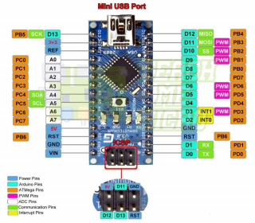

Fig 2.5.1.1 ATMEGA 328

**Features of Arduino**

* Compact Size: Small form factor, making it suitable for breadboard projects and compact applications.
* Microcontroller: Based on the ATmega328P microcontroller, providing a powerful and versatile platform.
* Digital I/O Pins: 14 digital input/output pins, with 6 capable of PWM (Pulse Width Modulation) output.
* Analog Inputs: 8 analog input pins for reading varying voltages.
* USB Interface: USB connection for programming and serial communication.
* Operating Voltage: 5V operating voltage with a recommended input voltage of 7-12V.
* Clock Speed: Operates at a clock speed of 16 MHz.
* Memory: 32 KB of flash memory, 2 KB of SRAM, and 1 KB of EEPROM.
* Breadboard Friendly: Designed to fit easily into breadboards for prototyping.
* Wide Compatibility: Supports various shields and modules, making it suitable for numerous projects in electronics and IoT.

1. **Transformer**

A step-down transformer is one whose secondary voltage is less than its primary voltage. It is designed to reduce the voltage from the primary winding to the secondary winding. This kind of transformer “steps down” the voltage applied to it. As a step-down unit, the transformer converts high-voltage, low-current power into low-voltage, high-current power. The larger-gauge wire used in the secondary winding is necessary due to the increase in current. The primary winding, which doesn’t have to conduct as much current, may be made of smaller-gauge wire.

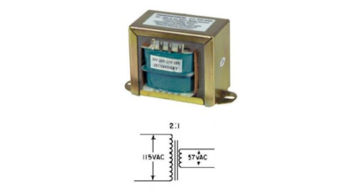

Fig 2.5.2.1 Transformer

1. **Temperature Sensor**

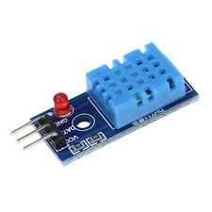

Fig 2.5.3.1 Temperature Sensor

The DHT11 sensor is a basic, low-cost digital sensor used to measure temperature and humidity. It combines a capacitive humidity sensor and a thermistor to measure the surrounding air, providing calibrated digital output. The DHT11 is easy to interface with microcontrollers such as Arduino and Raspberry Pi. It operates within a humidity range of 20-90% and a temperature range of 0-50°C with reasonable accuracy, though it's not suitable for precision applications requiring high accuracy.

* Measures both temperature and humidity
* Low-cost and easy to use
* Digital output for easy interfacing with microcontrollers
* Temperature range: 0°C to 50°C
* Humidity range: 20% to 90% RH
* Accuracy: ±2°C for temperature, ±5% RH for humidity
* Single-wire communication
* Compact and lightweight design
* Low power consumption

1. **LCD 16X2**

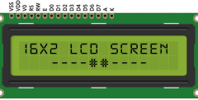

Fig 2.5.4.1 LCD Display

**Features of LCD**

* High-Resolution Display: Provides clear and sharp images and text.
* Low Power Consumption: More energy-efficient than traditional CRT displays.
* Thin and Lightweight: Space-saving design, making it suitable for portable devices.
* Wide Viewing Angles: Allows for good visibility from various angles.
* Fast Response Time: Suitable for displaying dynamic images and videos.
* Color Variability: Capable of displaying millions of colors, enhancing visual appeal.
* Durability: Typically more resistant to shock and vibration compared to CRTs.
* Versatile Applications: Used in various devices, including televisions, monitors, smartphones, and embedded systems.
* Backlighting Options: Available in different types of backlighting, such as LED, for improved visibility in low-light conditions.

1. **Voltage Sensor :**

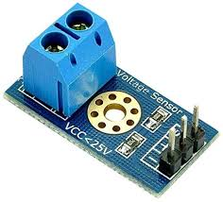

Fig 2.5.5.1 Voltage Sensor Module

The voltage sensor module is designed to measure DC voltage levels. It is used to read higher voltages safely using microcontrollers by scaling down the voltage to a lower range that can be read by an analog input pin.

**Features**

* Voltage Measurement Range: Typically measures voltages from 0 to 25V.
* Voltage Divider Circuit: Uses resistors to divide the input voltage, ensuring that the microcontroller can read voltages higher than its maximum input (usually 5V).
* Analog Output: Provides an analog output voltage proportional to the input voltage, which can be read by analog pins on microcontrollers.
* Easy Interface: Simple connection to microcontrollers like Arduino, making it user-friendly for beginners.
* Compact Design: Small size suitable for integration into various electronic projects and systems.
* Indicator LED: Often includes an LED to indicate power or signal status.
* Compatible with Multiple Microcontrollers: Works with various microcontrollers,

1. **ACS 712 Current Sensor:**

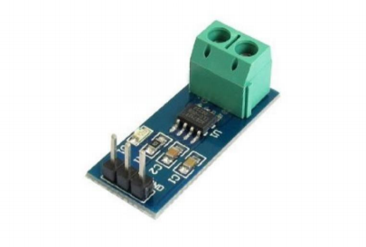

Fig 2.5.6.1 Current Sensor

The ACS712 is a Hall-effect-based linear current sensor that provides an analog voltage output proportional to the current flowing through it. It is widely used in various applications, including motor control, battery management systems, and power monitoring.

**Features:**

* Measurement Range: Designed to operate in a wide temperature range,
  + ACS712-05B: ±5A
  + ACS712-20A: ±20A
  + ACS712-30A: ±30A
* Output Voltage: The output voltage is centered around 2.5V
* Hall-Effect Sensor: Uses Hall-effect sensing technology, which allows for non-intrusive current measurement, reducing the risk of overheating and improving safety.
* Low Noise: Provides a low-noise output, making it suitable for precise current measurement.
* Compact Size: The ACS712 comes in a compact form factor.
* Simple Interface: The output is an analog voltage, which can be easily interfaced with microcontrollers or ADCs for further processing.

1. **Ultrasonic Sensor:**

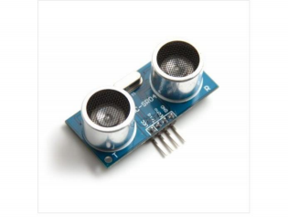

Fig 2.5.7.1 Ultrasonic Sensor

Ultrasonic Distance Sensor provides very short (2CM) to long-range (4M) detection and ranging. The sensor provides precise and stable non-contact distance measurements from about 2cm to 4 meters with very high accuracy. It can be easily interfaced with any Arduino, Raspberry Pi, or any other microcontroller.The module sends eight 40Khz square wave pulses and automatically detects whether it receives the returning signal. If there is a signal returning, a high-level pulse is sent on the echo pin. The length of this pulse is the time it took the signal from first triggering to the return echo.

**Features:**

* ∙ Sensor Type: Ultrasonic
* ∙ Output: Digital Sensor
* ∙ Voltage: 5VDC
* ∙ Detection distance: 2cm-400cm (0.02M - 4.0M)
* ∙ Static current: < 2mA
* ∙ Level output: high-5V
* ∙ High precision: up to 0.3cm

1. **Node MCU**

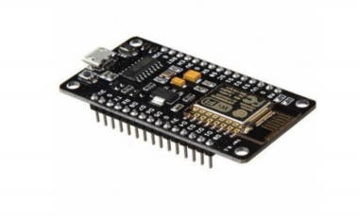

Fig 2.5.8.1 Node MCU

NodeMCU is an IoT Module based on the ESP8266 Wi-Fi module. NodeMCU uses Lua Scripting language and is an open-source Internet of Things (IoT)platform. This module has CH340g USB to TTL IC.

**Specification of Node-MCU IoT Module**

∙ The Development Kit based on ESP8266, integrates GPIO, PWM, IIC, 1-Wire, and ADC all in one board.

∙ Power your development in the fastest way combinating with NodeMCU Firmware!

∙ USB-TTL included, plug&play

∙ 10 GPIO, every GPIO can be PWM, I2C, 1-wire PCB antenna

**Features of Node-MCU IoT Module**

∙ Open source IoT Platform

∙ Easily Programmable

∙ Low cost & Simple to Implement

∙ WI-FI enabled**.**

**Most Popular IoT Platforms:**

**Adafruit:**

Adafruit.io is a cloud service that just means we run it for you and you don't have to manage it. You can connect to it over the Internet. It is meant primarily for storing and then retrieving data but it can do a lot more.

Adafruit IO:

* Display your data in real-time, online
* Make your project internet-connected: Control motors, read sensor data, and more.
* Connect projects to web services like Twitter, RSS feeds, weather services, etc.
* Connect your project to other internet-enabled devices
* The best part? All the above is doable for free with Adafruit IO.

**Arduino IDE**

Arduino IDE: The Arduino Uno can be programmed with the Arduino software. Select "Arduino Uno w/ATmega328'' from the Tools > Board menu (according to the microcontroller on your board) The ATmega328 on the Arduino Uno comes pre-burned with a bootloader that allows you to upload new code to it without the use of an external hardware programmer. It communicates using the original STK500 protocol.

**2.6 PROJECT FLOW**

**Algorithm**

* Step 1. Start
* Step 2. Initialize LCD, timer, interrupt, relay, and sensors.
* Step 3. Clear LCD
* Step 4. Display project name on LCD
* Step 5. Wait for 4sec
* Step 6. Clear LCD
* Step 7. Check fault
* Step 8. If a fault occurs, display fault on LCD, a message will be sent through WiFi
* Step 9. Else if check the next fault
* Step 10. If there is no fault, system health will be displayed on the LCD.
* Step 11. Sending all the data to Node MCU
* Step 12. Receiving the data on Node MCU
* Step 13. Checking the data and Putting On wifi
* Step 14. Sending the data to the Adafruit Server
* Step 15. Checking the Status of data either is successfully reached to the Adafruit Cloud.
* Step 16. Showing the success status on the Node MCU serial monitor

**2.7 Block Diagram:**

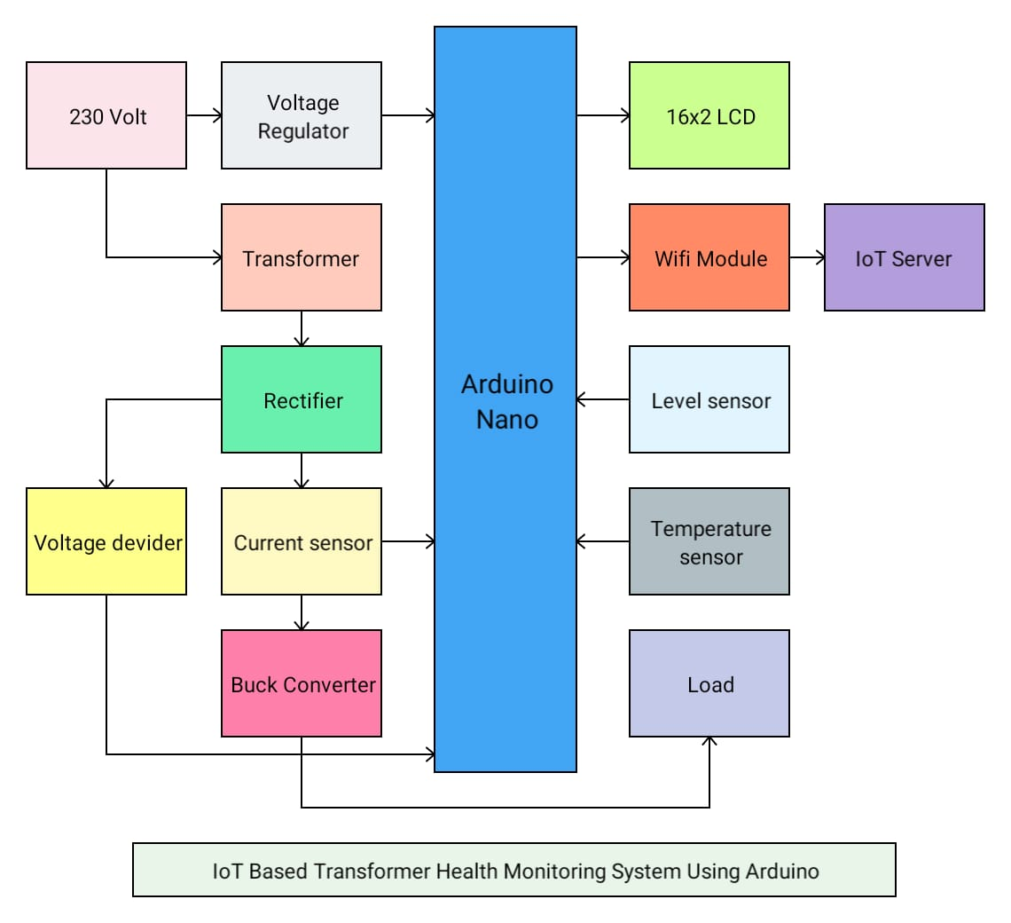

IoT-based transformer monitoring system

Fig 2.7 Block Diagram

**2.8 Flow Chart**

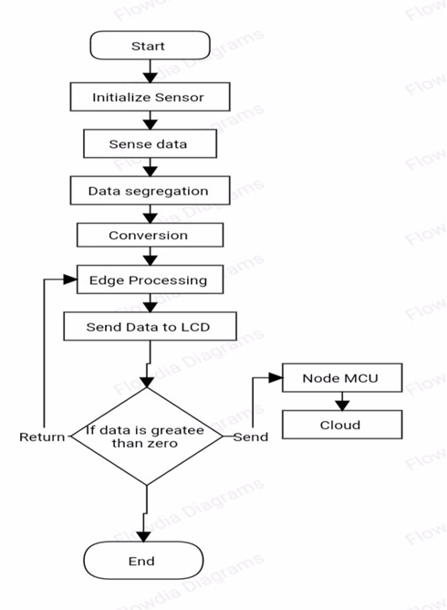

Fig 2.8 Flow Chart

**2.9 Schematic Diagram:**

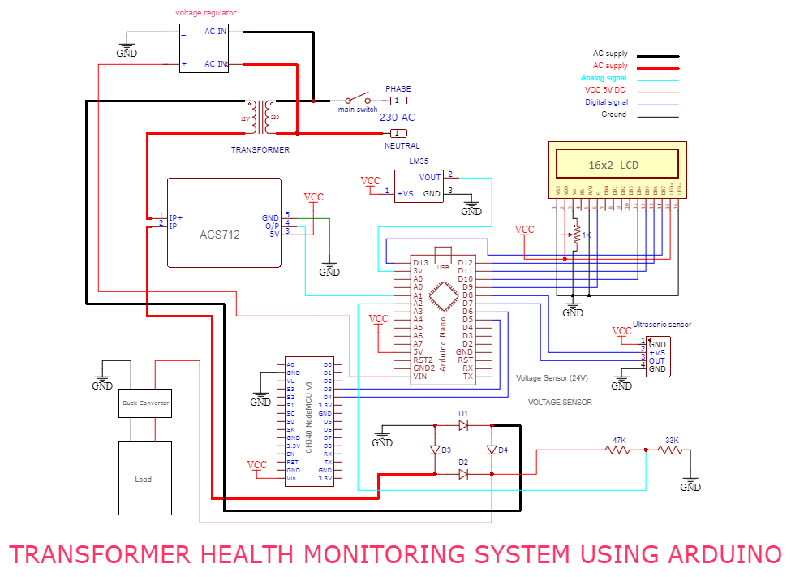

Iot based transformer monitoring system

Fig 2.9 Schematic Diagram

**2.10. Hardware Setup:**

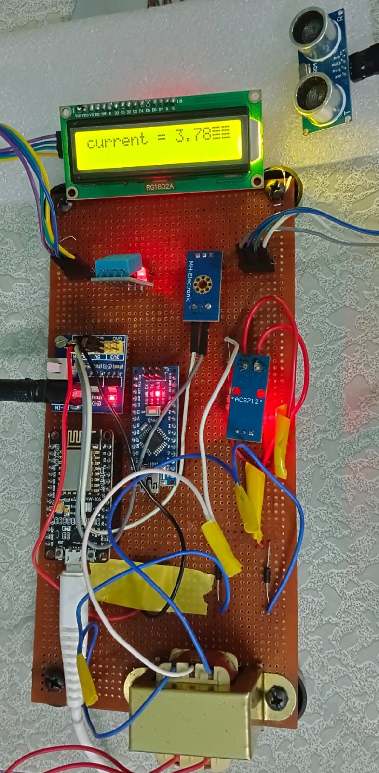

Fig 2.10 Hardware setup

**2.11 Interfacing description**

**Interfacing of LCD**

In the proposed system 16x2 LCD is used it has a total of 12 pins Vcc, GND, enable, Read-write, contrast (Vss), and 8 data pins,

In our case, the LCD is connected to the four-bit node Which requires only 4 data pins to run the LCD,

Data pin 4 is connected to the 13 pins of Arduino, data pin D5 is connected to the digital pin 12 of Arduino because it requires digital bits to run, also pins D6 and D7 are connected to the digital pins 11 and 10 of Arduino respectively, enable pin of LCD is used connect to the digital pin D8 of Arduino, also RS is connected to the digital pin 7 of Arduino,

**Interfacing of Ultrasonic sensor**

The ultrasonic sensor has a total of four pins of which two are used for supply and two pins are used to read the internal data of the sensor,

The ground pin of the sensor is connected to the ground and the VCC pin is connected to 5 volts of Arduino,

The origin is connected to the digital pin D3 and the echo pin is connected to the digital pin D2 of Arduino,

**Interfacing of DHT11,**

This sensor has a nice pin configuration, it has only three pins ground, VCC and output pin,

The ground pin goes to the ground of the Arduino board and VCC to 5 volts of Arduino and the output pin connects to the analogue pin A1 of Arduino,

**Interfacing of current sensor (ACS712)**

The ACS712 current sensor has only three pins which make this sensor super simple to use, it has group VCC and output pin, the ground pins are connected to the ground of Arduino VCC is connected to the 5-volt of Arduino and the output goes to the analogue pin A3 of Arduino as shown in the schematic diagram. For measuring the load, it has two input pins which have a hall effect sensor connected to it, we can choose any of the pins to the connect supply and load.

**Interfacing of Voltage circuitry,**

A supply is connected to the primary side of the transformer, at the secondary side there’s a voltage divider circuit is connected, one 10k, and 20k resistors are connected in series with each other, at the input side of the voltage divider circuit transformer is connected, and at the output side ground is connected, at the middle point of the divider circuit analogue channel A2 is connected to read the voltage value, we can also use capacitor of few microfarad value to avoid voltage fluctuations.

**2.12. Working principle of IoT-based Transformer Monitoring System**

The transformer is an especially important device for electrical power systems, the voltage variation for diverse types of load requirements is very essential, cause at over or under Voltage the electrical equipment may burn that’s why monitoring of Transformer is essential,

In this system, we are using a smart electronic sensor to measure the different parameters of the Transformer, load current, operating voltage, temperature of the transformer, and oil level.

**Working principle of the Voltage sensor**

In this proposed system were not use any specific voltage Sensor, we’ll just use the concept of electronics to convert the 230-volt AC to 5-volt DC, by Using the step-down transformer we just step down the AC voltage from 230 to 12 volts, but the ADC channel of Arduino is not suitable for 12 volts, so further we decrease the voltage Using the voltage divider circuit, it simply uses the 33k and 47k of the resistor and connects them into series, at one end we supply 12 voltage and other terminal is connected to ground, at the midpoint of the circuit we get the 5-volt max equivalent to the 12 volts, and after getting the 5 volts we can easily measure it using the Arduino, using the conversion code we get the ADC value of Arduino in the form of AC voltage, after getting adc value we just match it to the actual voltage using the formula, in this way we measure it.

**Working principle of Ultrasonic sensor**

The Sensor used in the proposed system is an ultrasonic sensor, which works based on ultrasonic waves, we can also other different logics to measure the oil level, but the ultrasonic sensor gives the fast out and has little maintenance compared to others, cause it doesn’t have any of the mechanical circuitry,

This sensor module has two parts, one is used to send the ultrasonic waves, and another circuit is used to detect the incoming waves after colliding with any object, it has a dedicated circuit to generate and receive the waves which makes our task easy, using the different timing function of code we just measure the time taken by the waves to go and come back, and using the conversion we get the time taken by the waves into the distance, this waves also reflect on the transformer oil surface,

**The working principle of the DHT11** **temperature sensor**

The DHT11 sensor works by measuring temperature and humidity through a combination of a capacitive humidity sensor and a thermistor. The humidity sensor consists of two conductive plates separated by a non-conductive polymer, which changes its capacitance in response to moisture levels in the air. The thermistor measures temperature by changing resistance based on ambient temperature. Upon receiving power, the DHT11 sends a start signal to the microcontroller, which then requests data. The sensor transmits digital signals containing two bytes for humidity and two bytes for temperature, allowing the microcontroller to interpret and display the readings accurately. This simple yet effective mechanism makes the DHT11 popular for various environmental monitoring applications.

**Working principle of Arduino**

It is a very smart device used to design anything like a robot, toys, in industrial applications like production Automation, lift elevators, and cars, etc., a microcontroller has ROM and RAM to store the data temporarily and permanently depending upon the need, Arduino uno has 4kb of rom and 1kb of ram, it can be clocked maximum at 24Mhz and it is usually used at 16MHz of performance, uno, this Microcontroller has 6 analog channel of 8 bit and 15 digital outputs, for the digital signals sensing and creating digital pins are used, and for variable quantity measurement analog channels are used, for code burning we use the USB to UART chip in the board, and there are some pins Available for the supply for different kinds of Sensor, using the different register available in its CPU it works so smarty and fast, there are many registers available in the chip, Arduino is based on Atmega 238p of Microcontroller, which is the product of Atmel and belongs to the AVR family of Microcontroller,

Arduino first at the time of starting it starts running the LCD and prints the data on the LCD like the name of the topic etc., it starts reading the sensor and actuators connected to it, and reading and responds to them according to the programming running in it, in our case it senses the adc value of all sensors and produces the equivalent output assignment with it, it also Communication to the other microcontroller using the Serial communication, like UART, i2c, spi and can, and talk to each other according to the requirement.

**Working on Wi-Fi module**

The Wi-Fi module is a device that is responsible for sending and receiving data and behaving according to it, there are several Wi-Fi modules available in the market like node MCU, esp8266, esp32, etc., we’re using the esp8266 in this project, this board has 13 GPIO pins which can be used for general purpose computing, esp8266 has 60kb of ram to store the cloud data in it, and works on Risc Architecture, esp8266 has 1 core, This board uses the same bootloader as Arduino so the developer can easily code it, using the JASON library, it takes the system data means the Sensor and actuators data and simple send it to the Wi-Fi Router, it has Wi-Fi 2.0 of functionality, according to the code it just passes the value to the server and also responds to the server according to the data coming from it,

Esp8266 works on a 3.3 voltage level, unlike the Arduino boards.

**CHAPTER 3**

**Advantages and Applications**

**3.1 ADVANTAGES**

If any fault occurs or all fault occurs at a time. This system can easily notice all faults on the LCD. Therefore troubleshooting is easy. ∙ Even if nobody is monitoring the system the person can get the status on his mobile through SMS.

1. Saves money i.e. travelling allowances etc.
2. Reduces man power.
3. Easily implementable

**3.2 APPLICATIONS**

Maintenance Department for troubleshooting faults. Fault Analysis of BTS tower.

* Quality Department for improvement.
* Quality and find the root cause of fault.

**CHAPTER 4**

**Results**

**4.1 Dashboard Output Display**

This system would eliminate the requirement for human power and thus provide efficiency and accuracy.

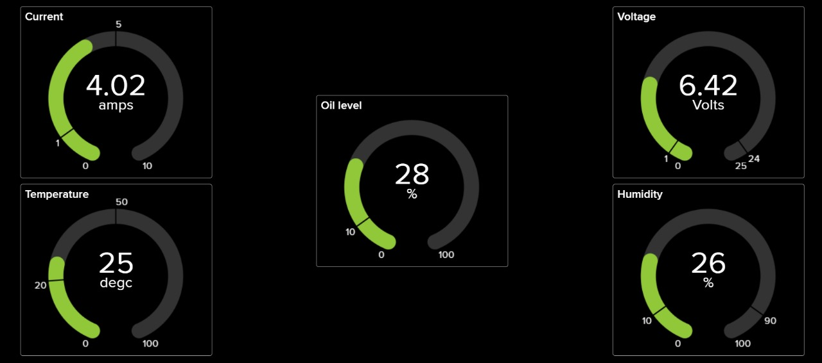

Fig 4.1.1 Dashboard Output

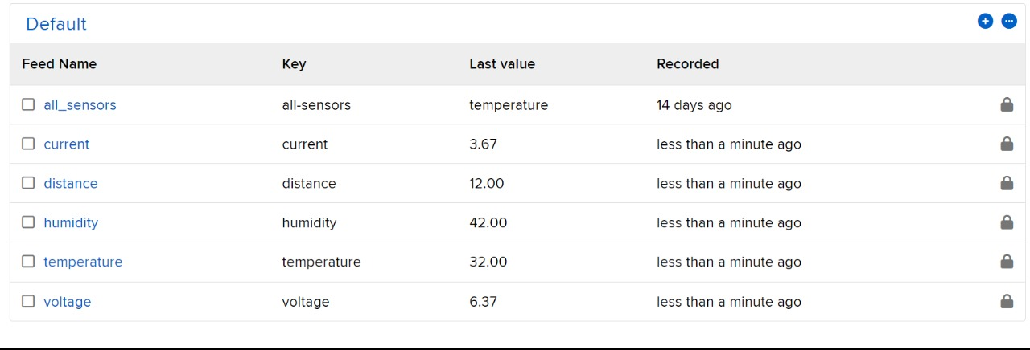

Fig 4.1.2 Feed Output

**4.2 LCD OUTPUT DISPLAY:**

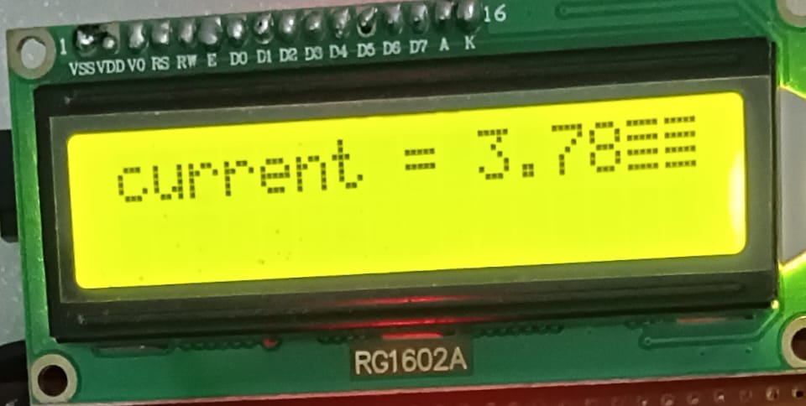

Fig 4.2.1 Current value o/p

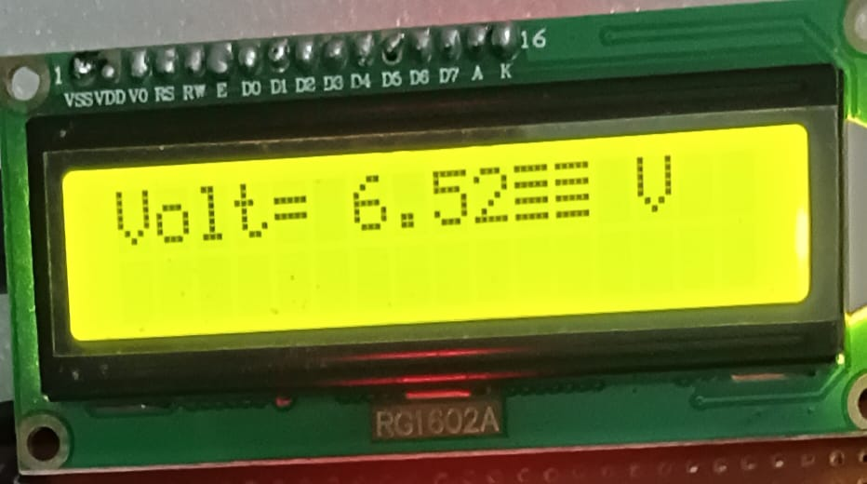

Fig 4.2.2 Voltage value o/p

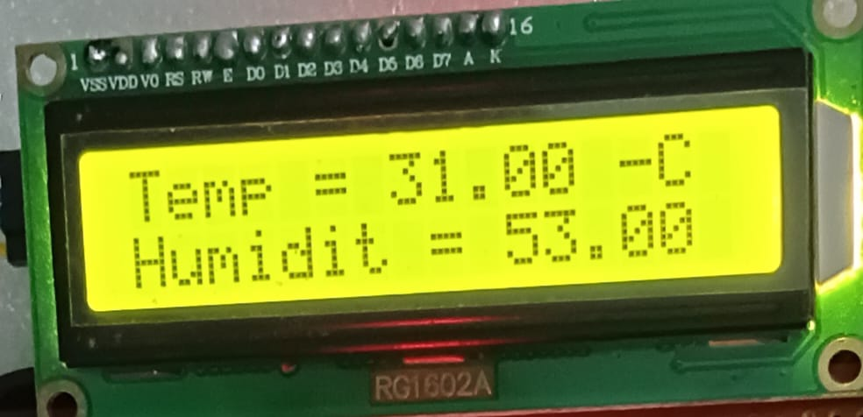

Fig 4.2.3 Temperature and Humidity value o/p

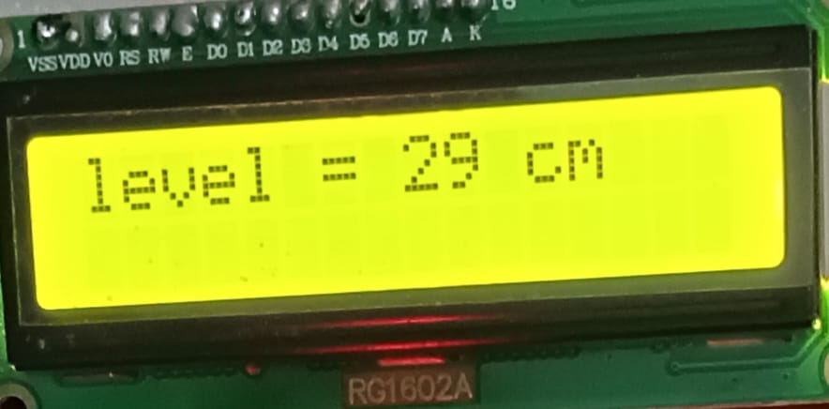

Fig 4.2.4 Oil level value o/p

**CHAPTER 5**

**Conclusion**

**5.1 CONCLUSION**

By using microcontrollers & latest technology like Wifi communication, maintenance of remote places is attended to properly in the shortest possible time. This system is highly intelligent for protection faults and to users for Power generators to serve as a reliable and efficient system. In this system, we can monitor and detect faults with specific adjustable variable pots. So, we can change the settings as per our requirements. The system provides effective monitoring and protection of the Power Generator by its oil level, oil quality, temperature, and operating voltage without involving human intervention.

* The IoT-based transformer monitoring system utilizes real-time data from the sensors and does predictive maintenance, allowing utilities to identify potential issues before they occur.
* This approach reduces downtime and maintenance costs while improving overall system efficiency.

**CHAPTER 6**

**Future Enhancement and References**

**6.1 FUTURE SCOPE**

* Mobile App Development: Creating a dedicated mobile app for more accessible real-time monitoring and alert notifications.
* Scalability for Large Networks: Expanding the system to monitor multiple transformers simultaneously across larger power grids.
* Connecting it to a Larger cloud and doing predictive maintenance.

## REFERENCES

* S. S. Rao et al., "Mobile Embedded System for Real-Time Monitoring of Distribution Transformers," in IEEE Sensors Journal, vol. 20, no. 10, pp. 5330-5338, May 2020.
* K. Singh et al., "Cloud-Based Monitoring System for Distribution Transformers Using Machine Learning," in IEEE Transactions on Industrial Informatics, vol. 16, no. 4, pp. 1741-1748, April 2020.
* J. Lee et al., "Wireless Sensor Network-Based Monitoring System for Distribution Transformers," in Journal of Electrical Engineering & Technology, vol. 15, no. 3, pp. 1031-1038, May 2020.
* J. Kim et al., "IoT-Based Monitoring System for Distribution Transformers Using Artificial Intelligence," in Journal of Intelligent Information Systems, vol. 56, no. 2, pp. 257-271, 2020.
* Y. Zhang et al., "Wireless Sensor Network-Based Monitoring System for Distribution Transformers," in Journal of Sensors, vol. 20, no. 10, pp. 1-12, 2020.
* S. K. Singh et al., "Machine Learning-Based Prediction of Remaining Life of Distribution Transformers," in Journal of Electrical Power Systems Research, vol. 181, pp. 106-115, 2020.
* K. Mishra et al., "Cloud-Based Monitoring System for Distribution Transformers," in Journal of Cloud Computing, vol. 9, no. 1, pp. 1-12, 2020.
* J. Lee et al., "Wireless Sensor Network-Based Monitoring System for Transformer Temperature and Vibration," in Journal of Sensors and Actuators A: Physical, vol. 301, pp. 111-120, 2020.
* S. S. Rao et al., "IoT-Based Monitoring System for Distribution Transformers Using Big Data Analytics," in Journal of Intelligent Information Systems, vol. 57, no. 1, pp. 1-15, 2021.
* J. Kim et al., "Machine Learning-Based Incipient Fault Detection in Distribution Transformers," in Journal of Electric Power Components and Systems, vol. 48, no. 1, pp. 1-12, 2020.