WEEK 1 TASK
PROJECT PLANNING AND ARCHITECTURE DESIGN
Java-Based Inventory Management System
Technology: Java | Layered Architecture | Relational Database

1. Introduction
The proposed project is a simple Inventory Management System designed for a small retail business. The system will help store owners and staff maintain product information, monitor stock levels, process customer orders, and generate useful reports. The purpose of this Week 1 activity is to create a practical technical plan that can guide implementation in later development stages.
The system is planned as a modular Java application. The architecture separates the user interface, business services, data-access components, and database. This separation improves maintainability because a change in one layer should have minimal impact on the others. For example, the application can initially use a console interface and later expose REST endpoints without rewriting the core inventory business rules.
The design follows separation of concerns, single responsibility, encapsulation, loose coupling, dependency inversion, validation, and clear module boundaries. Suitable patterns include layered/MVC-style separation, Service Layer, Repository/DAO, Factory, and Observer concepts.

2. Basic Requirements
Functional requirements include product management, stock control, low-stock monitoring, order processing, reporting, basic user access, and validation. Product management must support adding, updating, deleting, searching, and viewing products. Stock control must increase quantities when goods are received and decrease quantities when orders are completed. The system must reject operations that would make stock negative.
Order processing must create orders containing one or more products, calculate totals, validate stock, and update inventory. Reporting should provide current inventory, low-stock products, sales summaries, and product-wise information. A simple role distinction between administrator and staff can control sensitive operations.
Non-functional requirements include maintainability, reliability, reasonable performance for a small business, security, usability, testability, and future scalability. Database transactions should protect stock consistency, and database access should use parameterized queries or an ORM.

3. High-Level Architecture
The architecture uses a layered and modular approach. Users interact with a presentation layer. The presentation layer sends requests to application services. Services contain business rules and coordinate the Product, Stock, Order, and Reporting modules. These modules use repositories or DAOs for persistent data access. The repository layer communicates with a relational database.
This structure keeps database-specific code away from business logic and makes the application easier to test. A future web or REST interface can reuse the same services.

4. Module Descriptions
Product Management handles product master data. A Product entity can contain productId, name, category, price, supplierName, reorderLevel, and status. ProductService provides operations such as createProduct(), updateProduct(), deleteProduct(), getProductById(), and searchProducts(). Validation ensures that names are not blank, prices are positive, and reorder levels are not negative.
Stock Control manages inventory quantities. Operations include addStock(), reduceStock(), getCurrentStock(), and getLowStockProducts(). The module must not allow negative stock. A StockTransaction record can optionally maintain an audit trail of stock movements.
Order Processing represents customer purchases. An Order contains an ID, date, customer information, status, total amount, and a collection of OrderItems. Each OrderItem contains a product ID, quantity, unit price, and subtotal. OrderService validates the order, checks stock, calculates the total, saves the order, and updates inventory. These operations should be performed in one database transaction.
Reporting provides read-oriented information such as inventory reports, low-stock reports, sales summaries, and product-wise sales. Reports should not modify inventory.
User and Access Management can contain User information such as userId, username, passwordHash, and role. Roles such as ADMIN and STAFF can be represented by an enum. Passwords must never be stored as plain text.

5. Proposed Java Package Structure
A clean package structure keeps responsibilities together:
com.inventory
├── controller // Console or REST controllers
├── model // Product, Order, OrderItem, User, enums
├── service // ProductService, StockService, OrderService, ReportService
├── repository // ProductRepository, OrderRepository, StockRepository
├── factory // Report/service factories when required
├── observer // Low-stock notification mechanism
├── exception // Custom application exceptions
├── util // Validation and common utilities
└── config // Database and application configuration

6. Design Patterns and Rationale
Service Layer Pattern: The Service Layer provides an entry point for business operations. For example, OrderService.placeOrder() can validate items, check stock, calculate totals, save the order, and update inventory. This prevents controllers from containing complex business logic.
Repository/DAO Pattern: Repositories isolate persistence logic. ProductRepository can expose save(), findById(), findAll(), update(), and delete(). The service layer does not need to know whether data is stored using JDBC or JPA. This improves testability.
MVC / Layered Separation: Controllers handle interaction, models represent business data, and services contain application logic. This prevents UI code from becoming mixed with SQL and business rules.
Factory Pattern: A Factory can create different report types such as InventoryReport, SalesReport, or LowStockReport. It is useful when object creation varies, but should not be introduced unnecessarily.
Observer Pattern: When stock falls below the reorder level, a StockSubject can notify observers such as a console, email, or dashboard notifier. This separates notification logic from stock calculation.
Singleton Consideration: A singleton may be acceptable for immutable configuration, but services should not automatically be singletons because excessive global state makes testing harder. Dependency injection is preferable as the system grows.

7. Key Data Model
The initial relational database can contain:
PRODUCT(product_id, name, category, price, supplier_name, reorder_level, active)
STOCK(product_id, quantity, last_updated)
ORDERS(order_id, order_date, customer_name, status, total_amount)
ORDER_ITEM(order_item_id, order_id, product_id, quantity, unit_price, subtotal)
USER(user_id, username, password_hash, role)
STOCK_TRANSACTION(transaction_id, product_id, quantity_change, transaction_type, transaction_date)
ORDERS has a one-to-many relationship with ORDER_ITEM, while PRODUCT can appear in many ORDER_ITEM records. Foreign keys maintain referential integrity. BigDecimal should be used for monetary calculations instead of double because currency values require precise decimal arithmetic.

8. Code Scaffolding / Pseudocode
Example Java scaffolding:
class Product {
private long productId;
private String name;
private String category;
private BigDecimal price;
private int reorderLevel;
}
interface ProductRepository {
Product save(Product product);
Optional<Product> findById(long id);
List<Product> findAll();
void update(Product product);
void delete(long id);
}
class OrderService {
private ProductRepository productRepository;
private StockRepository stockRepository;
private OrderRepository orderRepository;
public Order placeOrder(List<OrderItem> items) {
validateItems(items);
for (OrderItem item : items) {
int available =
stockRepository.getQuantity(item.getProductId());
if (available < item.getQuantity()) {
throw new InsufficientStockException();
}
}
Order order = createOrderAndCalculateTotal(items);
orderRepository.save(order);
for (OrderItem item : items) {
stockRepository.reduce(
item.getProductId(), item.getQuantity());
}
return order;
}
}
The actual implementation should wrap the order save and stock reductions in a transaction.

9. Order Processing Flow
1. User selects products and quantities.
2. Controller passes the request to OrderService.
3. OrderService validates product IDs and quantities.
4. StockRepository checks availability.
5. Insufficient stock causes a clear error.
6. The service calculates item subtotals and the final total using BigDecimal.
7. OrderRepository stores the order and order items.
8. StockRepository decreases inventory.
9. The transaction commits only if all required operations succeed.
10. A low-stock observer can be notified if a product crosses its reorder threshold.
11. The controller displays the confirmation.

10. Error Handling and Validation
Custom exceptions should include ProductNotFoundException, InvalidProductException, InsufficientStockException, DuplicateProductException, and OrderProcessingException. Validation should occur before database operations. Database exceptions should be handled at appropriate boundaries and converted into meaningful application-level errors. Logging should record failures without exposing passwords or sensitive information.
Transactions are particularly important for order processing because an order and its stock updates must remain consistent. If saving an order fails, stock should not be reduced; if stock reduction fails, the order transaction should be rolled back.

11. Testing Strategy
Unit tests can test ProductService, StockService, and OrderService using mocked repositories. Important test cases include adding valid products, rejecting negative prices, reducing stock correctly, preventing orders from exceeding stock, calculating totals accurately, and identifying low-stock products. Repository integration tests can verify database queries. Controller or API tests can verify end-to-end request handling. Separating business logic from persistence makes testing simpler and faster.

12. Security and Future Scalability
Passwords should be securely hashed, database credentials should be kept outside source code, and SQL statements should be parameterized. Authorization should prevent ordinary staff users from performing administrative operations. If the application becomes a web application, HTTPS, authentication, secure sessions or tokens, input validation, and secure API practices should be introduced.
The architecture supports future features such as barcode scanning, supplier management, purchase orders, multiple store locations, REST APIs, web dashboards, email notifications, and cloud deployment. Modular boundaries allow these features to be added without redesigning the entire application.

13. Implementation Plan
Phase 1 – Create the Maven/Gradle project and package structure.
Phase 2 – Implement model classes, enums, validation, and custom exceptions.
Phase 3 – Create the database schema and repository interfaces.
Phase 4 – Implement ProductService and StockService.
Phase 5 – Implement OrderService with transactional order processing.
Phase 6 – Implement reporting queries and low-stock notification support.
Phase 7 – Add console or REST controllers.
Phase 8 – Write unit and integration tests.
Phase 9 – Improve security, logging, documentation, and deployment configuration.

14. Conclusion
The proposed Java Inventory Management System uses a practical layered architecture appropriate for a small retail business and suitable for a Junior Java Developer project. Product Management, Stock Control, Order Processing, Reporting, and User Access are separated into understandable modules. The Service Layer centralizes business rules, while Repository/DAO components isolate database operations.
The selected design patterns are intentionally practical. Service Layer and Repository are central to maintainability, Factory is useful where object creation varies, and Observer provides a clean approach to low-stock notifications. The design also considers transactions, validation, security, testing, and future scalability. Overall, this architecture provides a clear roadmap from planning to implementation and can evolve from a simple console application into a REST-based Java application without major restructuring.

Architecture Diagram
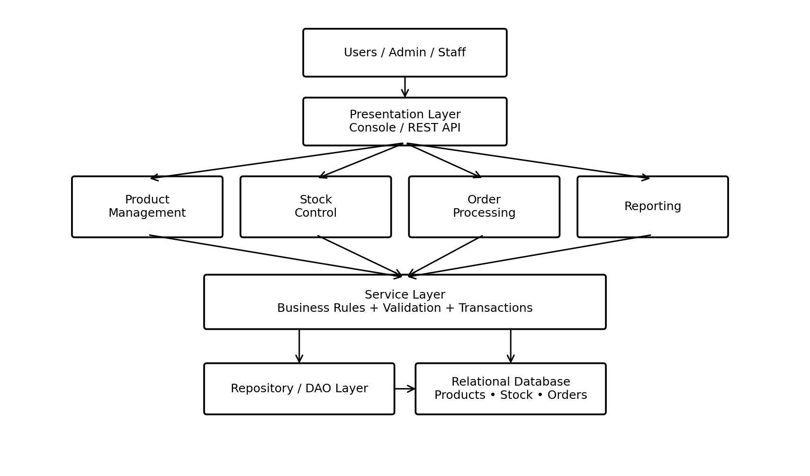
Figure 1: High-level architecture and module interactions.

