**PROBLEM:**

WAP to create three different colored buttons(BTN1,BTN2,BTN3) and one Rotate button. On click of the Rotate button, color of the buttons should rotate clockwise.

**REQUIREMENT:**

1. Create three buttons with red, green, yellow color respectively.
2. Create one button and name it as "Rotate".
3. On click of Rotate button the color of all the three buttons should be changed. Like, the color of 2nd button should be changed to color of 1st button, the color of 3rd button should be changed to color of 2nd button, and the color of 1st button should be changed to color of 3rd button.
4. Make sure with each click of Rotate button, the colors get rotated clockwise.

**EXPECTED RESULT:**

When clicked the red button, the color of the button changes to red,  
When clicked the green button, the color of the button chages to green  
When clicked on yellow button, the color of the button changes to yellow.  
When clicked on rotate button, the color of all the buttons should rotate in clockwise direction.

**CODE:**

<!DOCTYPE html>

<html lang="en">

  <head>

    <meta charset="UTF-8" />

    <meta name="viewport" content="width=device-width, initial-scale=1.0" />

    <title>Rotation</title>

  </head>

  <style>

    .red {

      background-color: red;

    }

    .green {

      background-color: green;

    }

    .yellow {

      background-color: yellow;

    }

    .tr {

      border: 2px solid blue;

    }

    button {

      font-size: 20px;

      border-radius: 10px;

      width: 10%;

    }

  </style>

  <body>

    <button class="yellow" id="colorChange">Yellow</button>

    <button class="red" id="colorChange">Red</button>

    <button class="green" id="colorChange">Green</button>

    <button class="rt" onclick="rotateColor()">Rotate</button>

  </body>

<script>

  function rotateColor() {

    let t = document.querySelectorAll("#colorChange");

    const colorList = [];

    t.forEach((e) => {

      colorList.push(e.classList[0]);

    });

    // We'll we needing index also for the rotation of color and name.

    t.forEach((e, i) => {

      colorList.forEach((i) => {

        e.classList.remove(i);

      });

      if (i === 0) {

        e.innerText = colorList[colorList.length - 1].toUpperCase();

        e.classList.add(colorList[colorList.length - 1]);

      } else {

        e.innerText = colorList[i - 1].toUpperCase();

        e.classList.add(colorList[i - 1]);

      }

    });

  }

</script>

</html>

**OUTPUT:**

**Initially**

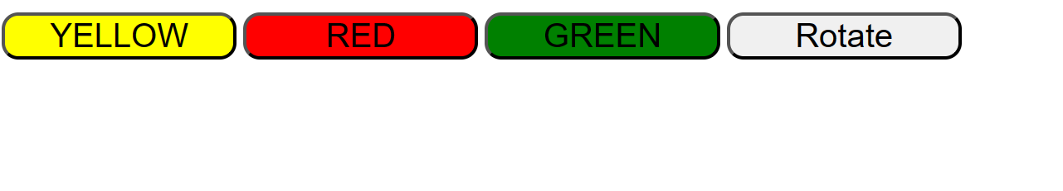

**After clicking the rotate button for the first time:**

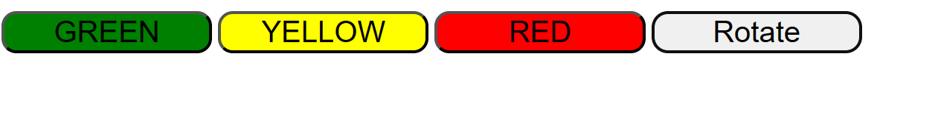

**After clicking the rotate button for the second time:**

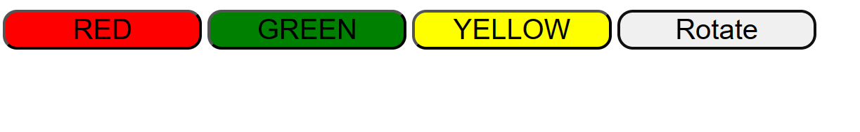

**After clicking the rotate button for the third time:**

