**REQUIREMENTS:**

* Make one input box for Number of walls : 5 ( user can enter any value )
* Make one input box for Height of walls : ( Enter values seprated by # ) 4#1#2#6#8
* Print walls visible to person seeing from right

And

* Print walls visible to person seeing from left
* Print Graphics

**OUTPUT:**

Test Case-1

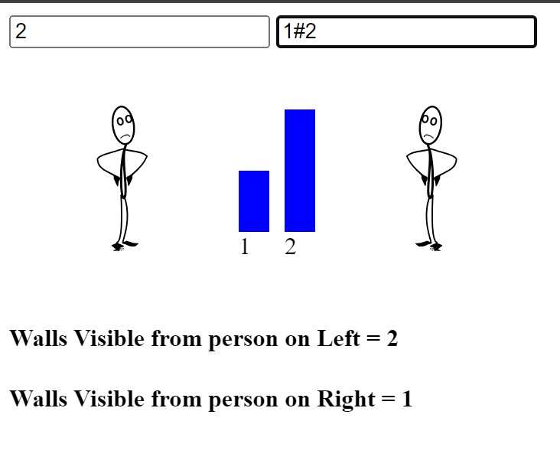

Test Case-2

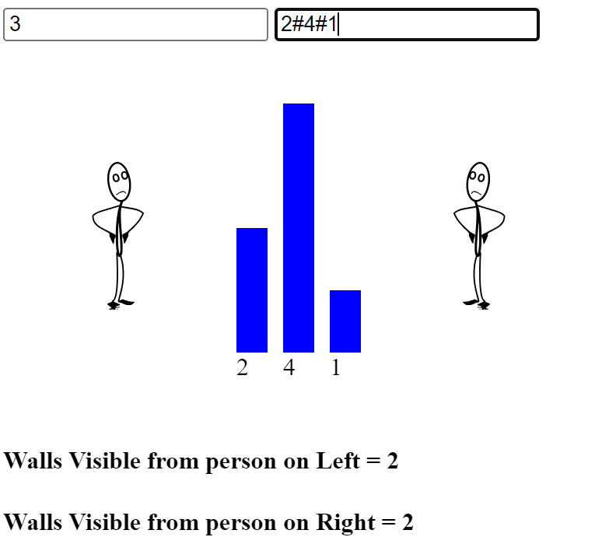

Test Case-3

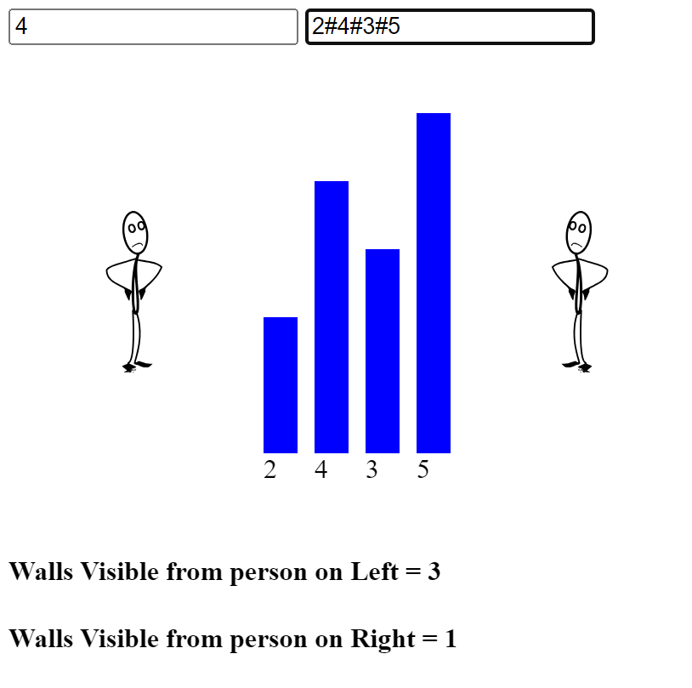

Test Case-4

