



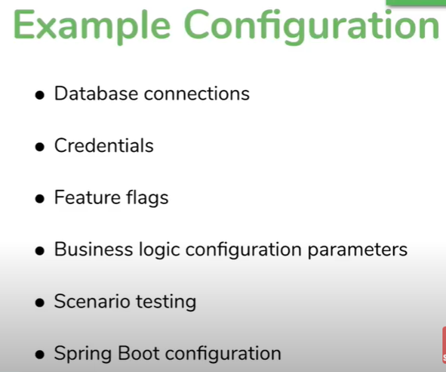

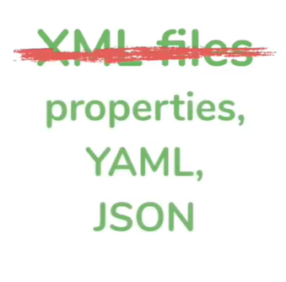

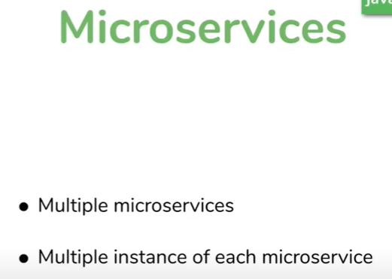

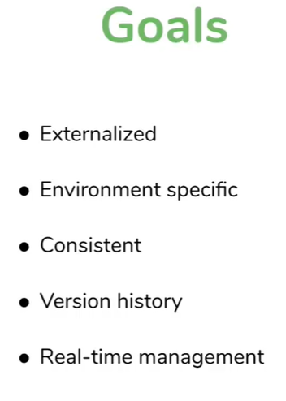

## Using @Value annotation

* Can access values from application.properties file by key
* Here the my.fullGreetDesc is injected into greetMsg
* Code
* *@RestController*
* public class Controller {
* *@Value*("${my.fullGreetDesc}")
* private String greetMsg;
* *@GetMapping*("/greet")
* public String getGreeting() {
* return greetMsg;
* }
* }

## Externalize the properties file

* Scenario
  + Suppose we create a jar file of application, we no longer able access application.properties file of application
  + In that case what we create a property file at target file. Now we can change value of any key externally and the application automatically pick the value from external property file instead of one which is within jar file
  + We can also pass value to key through command line as well

## Running jar file from cmd line