## Stream and lambda function

`D:\Spring\Demos\FunctionalProg` >> refer

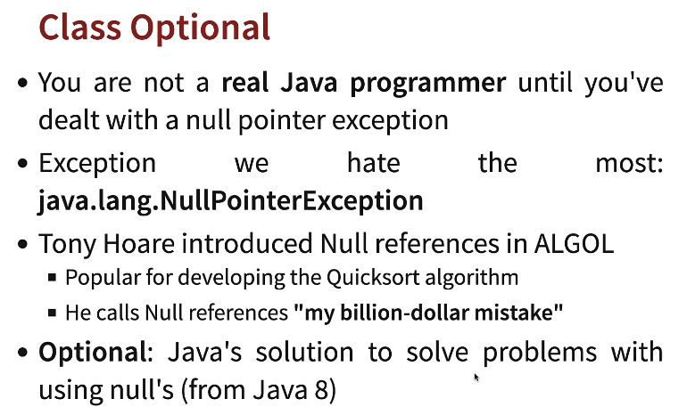

## JPA vs hibernate

java persistance api => specification

hibernate => implementation

## Setup

* 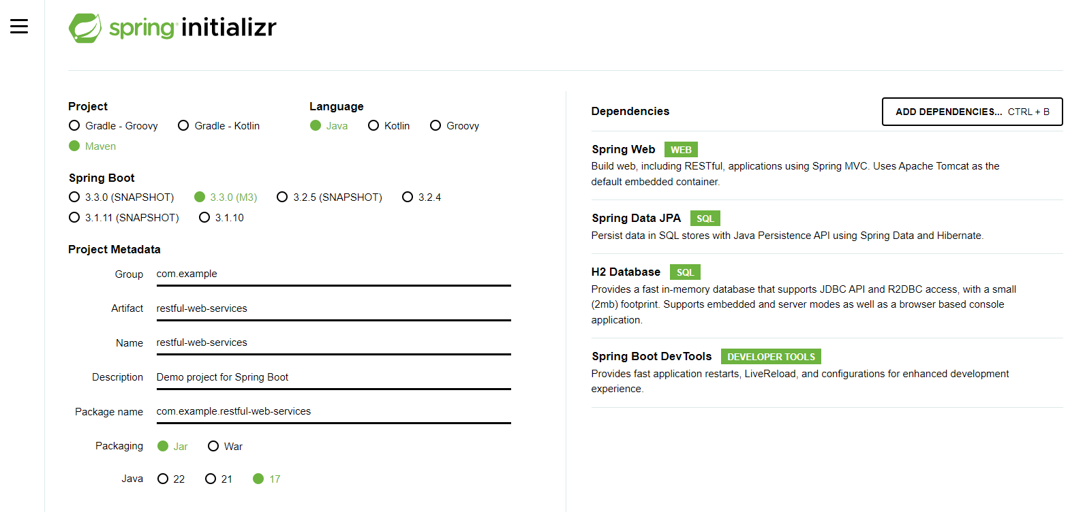
  + Avoid snapshot version as they are under development
* Extract zip file
* Open sts
* 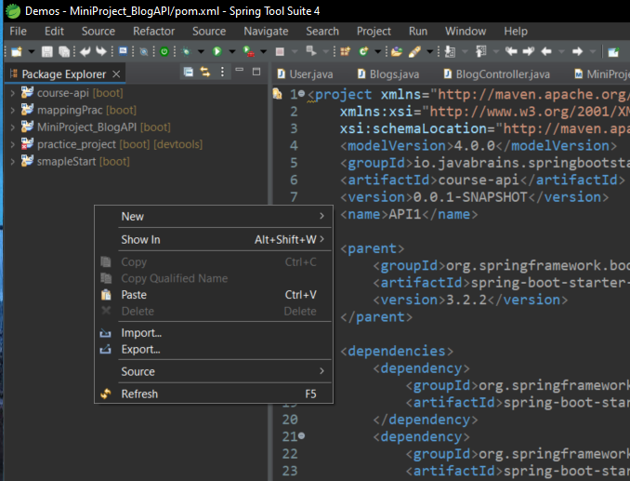
* Click import and select extracted folder out of zip file
* 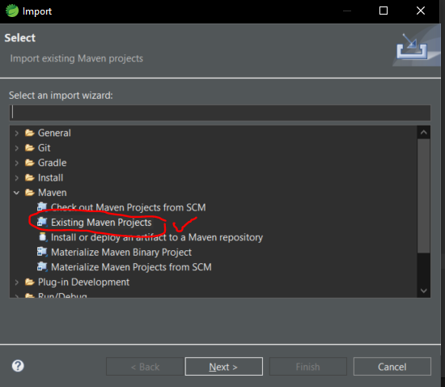

PUT - Update an existing resource

PATCH - Update part of a resource

## Response status

* 404 – Resource not found
* 500 – Server exception
* 400 – Validation error
* 200 – Success
* 201 – Created
* 204 – No Content
* 401 – Unauthorized
* 400 – Bad request (such as validation error)

## Exception handling

* Refer addUser in controller which returns 201 on saving user
* GetUser
  + 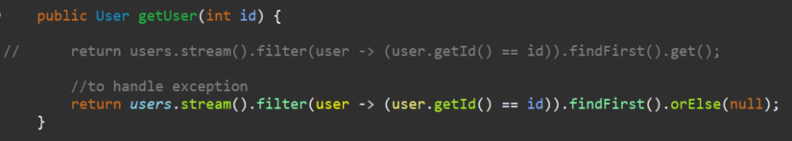
  + 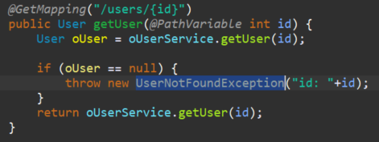
  + Why to extend UserNotFoundException to RuntimeException?
    - To make it unchecked

## Validation

Add spring-boot-starter-validation dependency

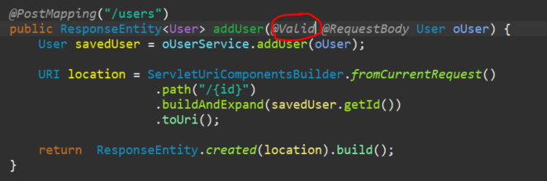

To manipulate response

## REST api documentation

1. Swagger
2. Open API

## Filtering

1. Static
2. Dynamic

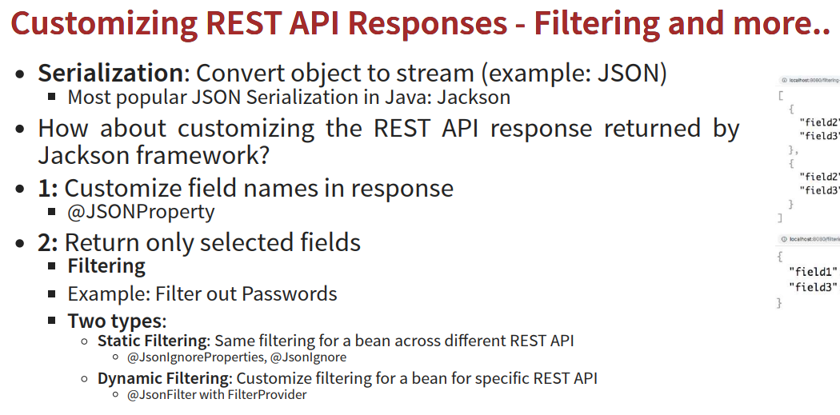

* Static filter  
  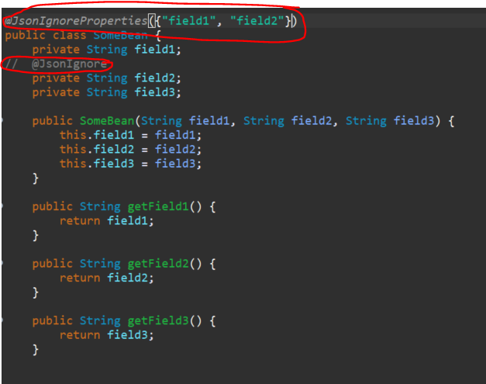
* Dynamic Filter

