DMS Next Architecture
Sponsor brief — user value, runtime design, portability and technology evidence

Engineering checkpoint • 2026-09-07
DMS Next • Sponsor and development use

Executive view
DMS Next is a provider-neutral driver-monitoring platform. The reusable C++ core converts timestamped visual observations into quality-gated calibration, eye/blink statistics and temporal driver-state decisions. Camera, inference runtime, operating-system loading, security storage and device telemetry remain replaceable target adapters.
Capability | Current checkpoint | Next product gate
Monitoring core | Implemented and deterministically tested | Representative target-camera accuracy and product thresholds
Display / processing ROI / statistics | Stage 24 engineering complete | Approve UI wording, rolling window and vehicle-specific ROI
CPU/core/memory evidence | Stage 23 Windows + Orin scope complete | Live driver comparison; Ubuntu x64 deferred
Driver identification | Offline interfaces, baseline and encrypted profile foundation | Separate biometric/PAD consent, private evaluation and threshold approval
TI AM62 | Enablement plan only | Board, camera, Processor SDK and target acceptance run

1. User workflow
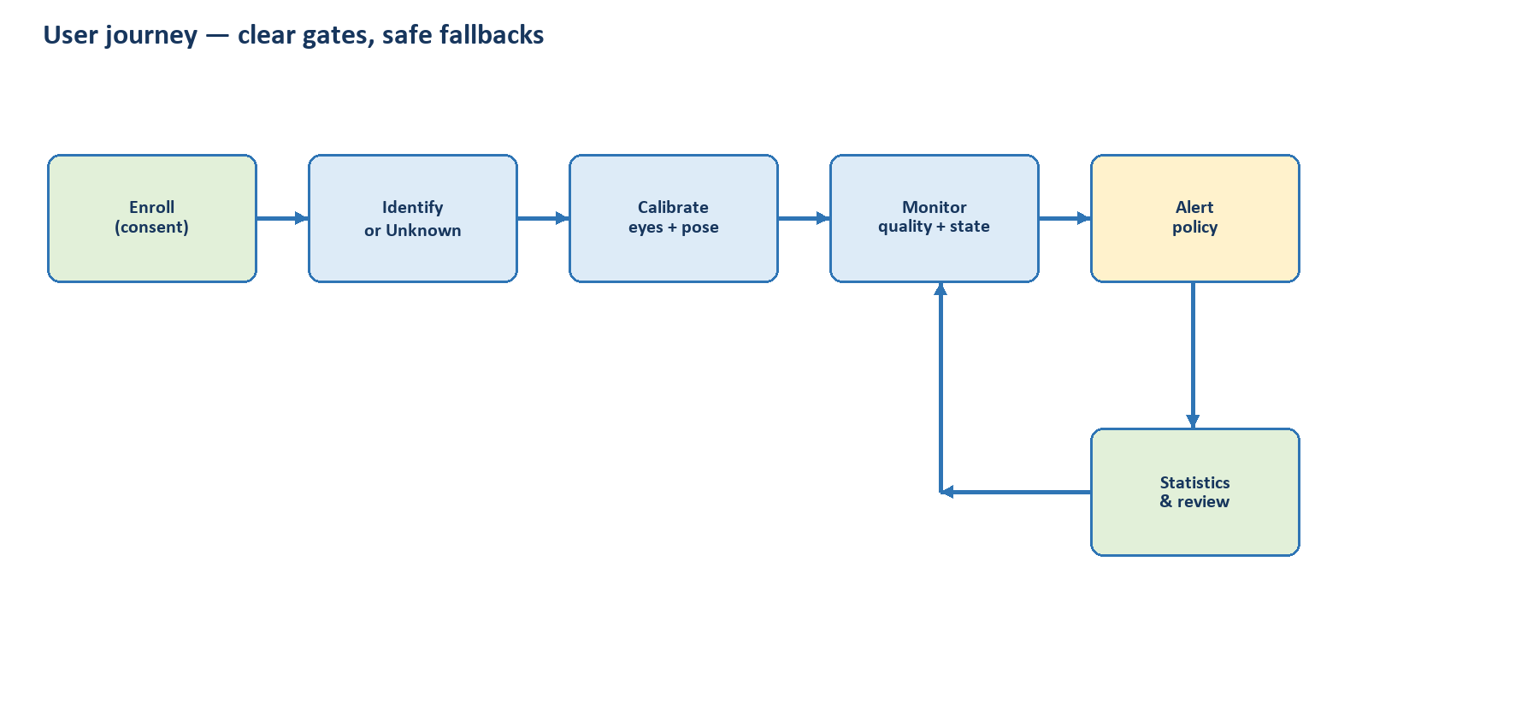
Enrollment and identity are gated; Unknown is a valid outcome. Calibration accepts only stable, usable evidence before monitoring and statistics begin.

2. Developer/runtime view
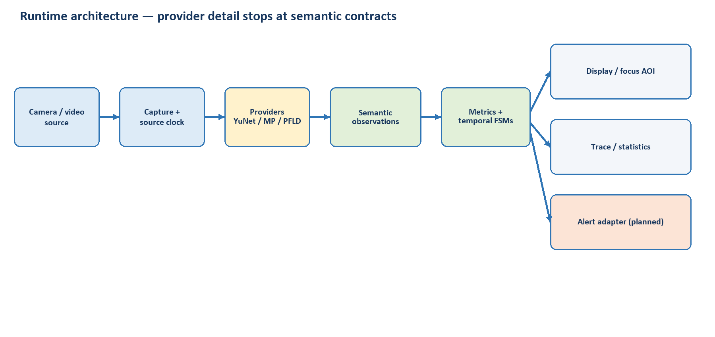
Provider-specific indices and SDK types stop before semantic observations. Temporal logic and presentation stay deterministic and independently testable.

3. Portability boundary
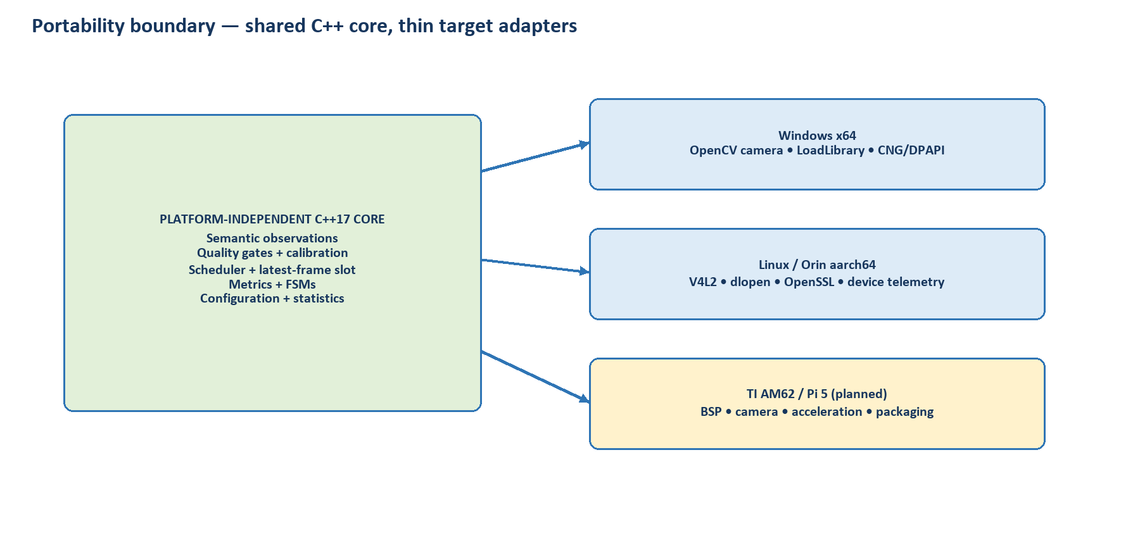
Platform independence starts at the C++ semantic core. Native camera, loader, cryptography, packaging and telemetry adapters are validated per target.

4. Technology and release evidence
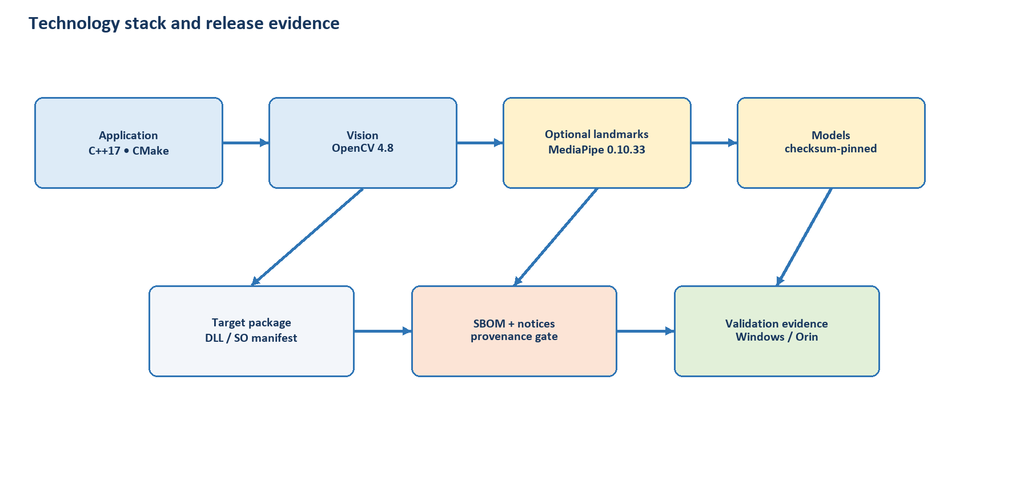
Versions and checksums support reproducibility; model provenance, notices and legal approval remain separate release gates.

Design principles

1. User workflow
- Explicit consent for biometric enrollment.
- Open-set recognition returns Unknown when evidence is insufficient.
- Driver change/long absence starts a new identity, calibration and statistics epoch.

2. Developer/runtime view
- Source-frame time—not inference or UI delay—drives events.
- Depth-one scheduling bounds latency by dropping superseded work.
- Occlusion and stale evidence enter Unknown/recovering states.

3. Portability boundary
- C++17 core and CMake build are shared.
- MediaPipe is an optional five-function runtime-loaded C ABI.
- Target support is claimed only after native build, camera, resource and accuracy gates.

4. Technology and release evidence
- OpenCV 4.8 is the validated baseline; MediaPipe is pinned to v0.10.33/commit.
- Model checksums prove byte identity, not redistribution rights.
- A release needs exact payload SBOM, notices, model provenance and owner/legal approval.

Platform and technology summary
Layer / component | Version / boundary | Platforms | License / release note
DMS application core | C++17; provider-neutral semantics | Windows x64, Ubuntu x64*, Orin aarch64 | Project license not yet declared; release blocked pending owner selection.
OpenCV + contrib | Validated baseline 4.8.0 | Windows, Linux x64/aarch64 | Apache-2.0 plus exact-build third-party notices.
MediaPipe bridge | 0.10.33; commit 3987048…; C ABI v1 | Packaged on Windows x64 and Orin | Apache-2.0 plus transitive dependency notices.
YuNet / LBF / Face Landmarker models | Repository checksum-pinned | Per provider/target evidence | Exact artifact provenance and redistribution terms remain release blockers.
Encrypted driver profiles | AES-256-GCM; PBKDF2-HMAC-SHA-256 | Windows CNG/DPAPI; Linux OpenSSL 3 | Identity processing remains separately consented and gated.
TI SK-AM62 | Planned adapter/package | Not yet validated | Select BSP/SDK and inventory TI/OSS terms before claim.
* Generic Ubuntu x64 was validated earlier for applicable core/provider work; the Stage 23 collector re-check is explicitly deferred because the available WSL image lacks a compiler.

Sponsor decisions requested
- Approve final display wording, five-minute rolling-window default and reset behavior at confirmed driver change.
- Provide a representative driver/camera session for live Windows and Orin measurements.
- For identification, approve separate biometric/PAD consent and later production thresholds after private results.
- For AM62, provide the physical SK-AM62, intended camera and selected Processor SDK.
- Select the project source license and authorize legal/release review when distribution is intended.

Claim boundary
This brief describes committed engineering evidence, not a safety-certified product, release authorization or production-accuracy claim. Merge, release, model training and threshold changes remain separately controlled.

