#include<iostream>
#include<conio.h>
#include<string.h>
using namespace std;
class BankAccount
{
int acctno;
char name[30],acttype,address[100];
float balance;
public:
void readdetails()
{
cout<<"\n Enter the Fisrt name: ";
cin>>name;
cout<<"\n Enter the account number: ";
cin>>acctno;
cout<<"\n Enter the account Type: ";
cin>>acttype;
cin.ignore();
cout<<"\n Enter the address: ";
cin.getline(address,30);
cout<<"\n Enter the balance: ";
cin>>balance;
}
void printdetails()
{
cout<<endl<<"Name: "<<name;
cout<<endl<<"Account number: "<<acctno;
cout<<endl<<"Account number: "<<acttype;
cout<<endl<<"Address: "<<puts(address);
cout<<"\n the reqiured Balance: "<<balance<<endl;
}
void deposit()
{
float x;
cout<<"\n Enter the amount to be deposited: "<<endl;
cin>>x;
balance+=x;
}
void withdraw()
{
float x;
cout<<"\n Enter the amount to be withdrawn: ";
cin>>x;
if(x<balance)
cout<<"\n No sufficient balance";
else
balance=balance-x;
cout<<endl<<"Balance: "<<balance;
}
};
int main()
{
cout<<"-----------------------------------------------------------------------";
cout<<"\n\t\t To display bank account using classes: ";
cout<<"\n------------------------------------------------------------------------";
BankAccount accnt1;
int x, n;
do
{
cout<<"\n1]Read Details \n2]Print details \n3]Deposit \n4]Withdraw \n5]Exit"<<endl<<"Enter the option: ";
cin>>n;
switch(n)
{
case 1: accnt1.readdetails();break;
case 2: accnt1.printdetails();break;
case 3: accnt1.deposit();break;
case 4: accnt1.withdraw();break;
case 5: break;
default: cout<<endl<<"Enter a valid number!! ";
}
}while(n!=5);
getch();

}

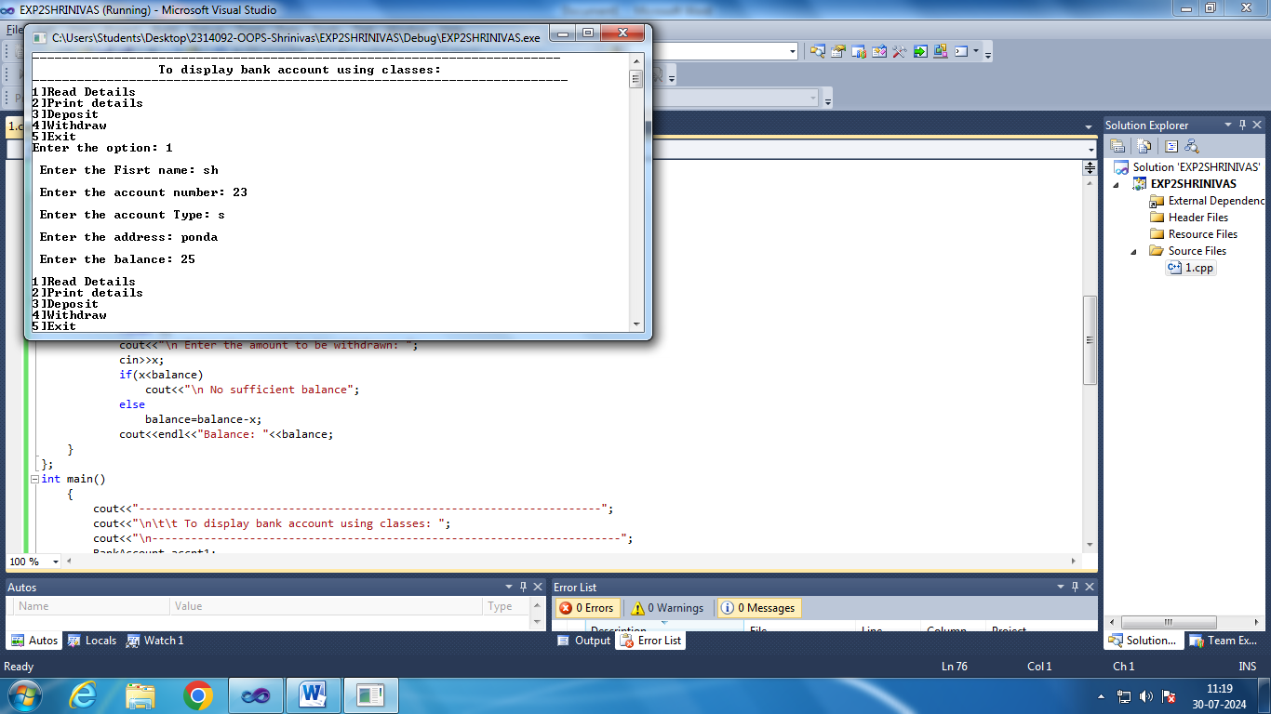

#include<iostream>
#include<conio.h>
#include<string.h>
using namespace std;
class Employee
{
int empid;
char empname[30],designation[100],address[100];
float salary;
public:
void readdetails()
{
cin.ignore();
cout<<"\n Enter the Fisrt name: ";
cin.getline(empname,30);
cout<<"\n Enter the Employee id : ";
cin>>empid;
cout<<"\n Enter the address: ";
cin>>address;
cout<<"\n Enter the designation: ";
cin>>designation;
cout<<"\n Enter the salary:";
cin>>salary;
}
void printdetails()
{
cout<<"\n Name: ";
cout<<"\n Employee id: ";
cout<<"\n address: ";
cout<<"\ designation: ";
cout<<"\n salary: ";
}

};
int main()
{
cout<<"-----------------------------------------------------------------------";
cout<<"\n\t\t To Display Employee details using classes: ";
cout<<"\n------------------------------------------------------------------------";
Employee accnt1;
int x, n;
do
{
cout<<"\n1]Read Details \n2]Print details \n3]Exit"<<endl<<"Enter the option: ";
cin>>n;
switch(n)
{
case 1: accnt1.readdetails();break;
case 2: accnt1.printdetails();break;
case 3: break;
default: cout<<endl<<"Enter a valid number!! ";
}
}while(n!=3);
getch();
}

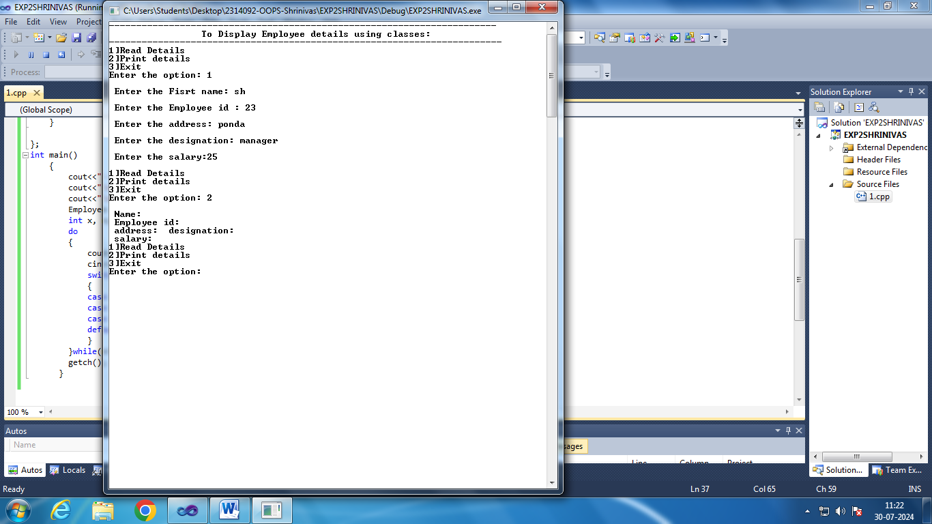

#include<iostream>
#include<conio.h>
using namespace std;
class Distance
{
int meter,inches;
public:
void readdistance()
{
cout<<"\n Enter in meters: ";
cin>>meter;
cout<<"\n Enter in inches: ";
cin>>inches;
}
void printdistance()
{
cout<<"\n Meters: "<<meter<<" Inches: "<<inches;
}
void addDistance()
{
float x,y;
cout<<"\n Enter in meters: ";
cin>>x;
cout<<"\n Enter in inches: ";
cin>>y;
meter+=x;
if((inches+y)>=(39.37))
{meter++;
inches=inches+y-39.37;}
else
inches=inches+y;

}
};
int main()
{
Distance D;
int n;
cout<<"-----------------------------------------------------------------------";
cout<<"\n\t\t To Display Employee details using classes: ";
cout<<"\n------------------------------------------------------------------------";
do{
cout<<"\n1)Read Distance \n2) Print Distance \n3) Add distanance \n4)Exit\nEnter Appropriate option: ";
cin>>n;
switch(n)
{
case 1: D.readdistance();break;
case 2: D.printdistance();break;
case 3: D.addDistance();break;
case 4: break;
default: cout<<"\nEnter Appropriate option!";
}
}while(n!=4);
}

