1. **Intern Evaluation Report**
2. Understanding of CRESCENT FOUNDRY
3. horizontal line

# Placeholder image

# Introduction

1. *REQUIREMENTS*
   1. Understanding of Cast Iron Manufacturing Processes
   2. Understanding automation of Tracking Software (e.g., SAP) and Document Management
2. *OVERALL ASSESSMENT:*
   1. Finetuning current models
      1. Vehicle AI
      2. CCTV Tracker
      3. Automated machine parts
   2. To solve the lost parts issue we can implement methods like:
      1. Kanban Board
      2. ERP SOFTWARES

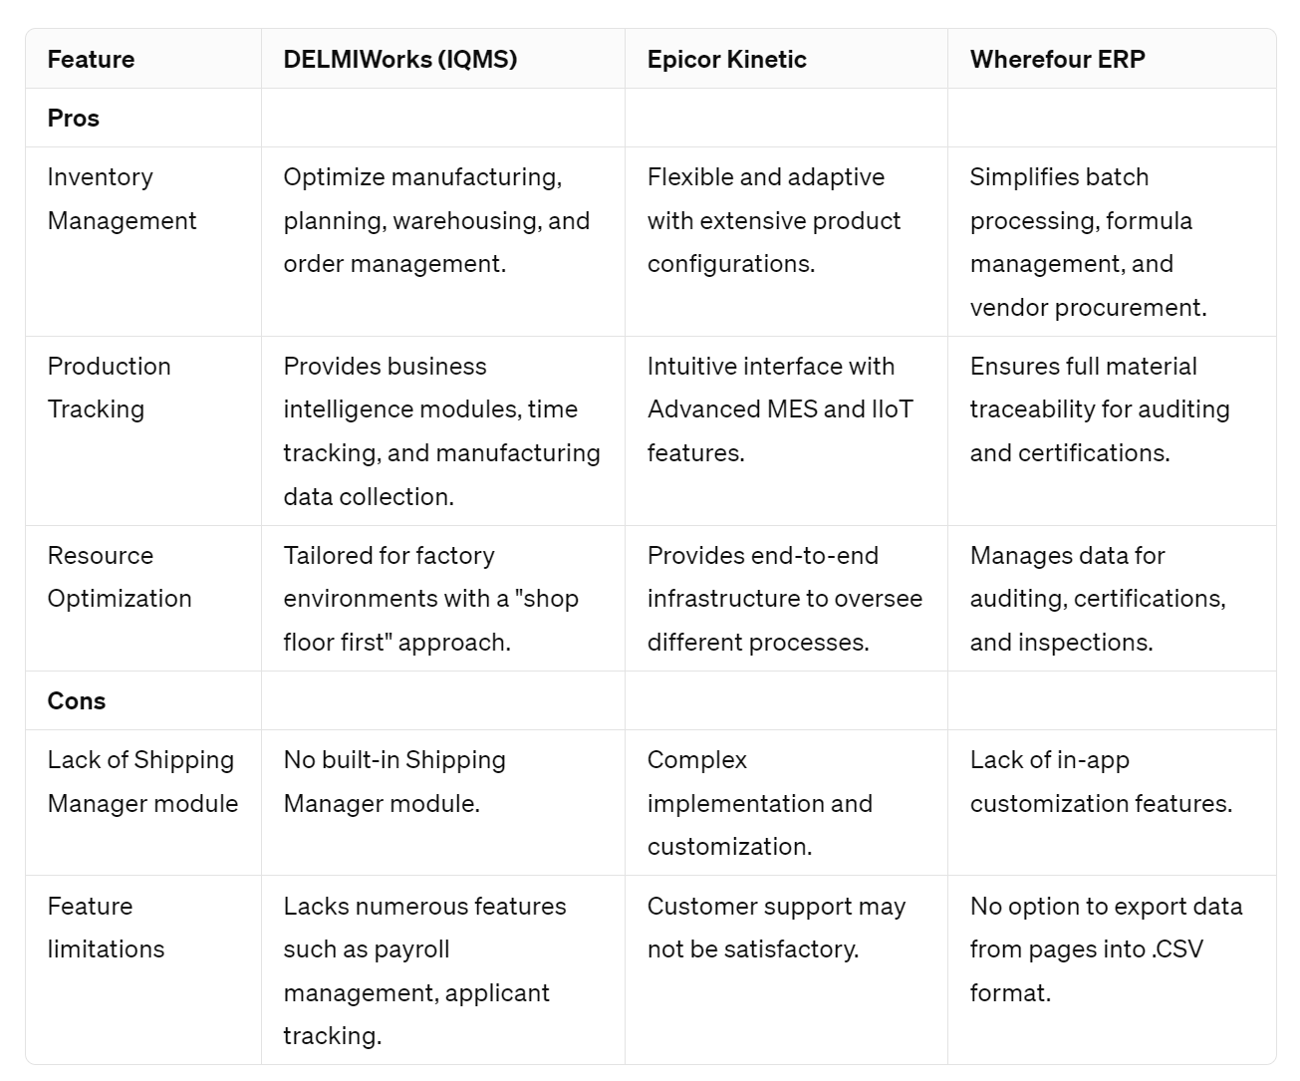

* 1. Document text Extraction - Suggested Solutions:
     1. Use external software such as Azure Docker Intelligence etc
     2. use NLP to fine tune a model according to requirements.