BANKING VOICE ASSISTANT
Dashboard User Guide

A plain-English guide to every screen in the web dashboard — how to place calls, test the bot by chat, run outbound campaigns, edit what the bot knows, and read the performance charts.
Figure 1 — The six areas of the dashboard, covered one by one in this guide.

Who this is for | Anyone using the dashboard — testers, business users, operations staff and demo presenters. No coding knowledge needed.
What it covers | Every tab and panel in the web interface, plus common tasks and what to do when something looks wrong.
Version | September 2026

Contents
1. What this application does
2. Getting started
3. The screen at a glance
4. Voice Mode — making and watching real calls
5. Chat Mode — testing by typing
6. Analytics — how the service is performing
7. Call Metrics — the detailed per-call table
8. Campaigns — calling a list of customers
9. Resources — server and GPU health
10. Session Logs panel
11. Tool Selector panel
12. Quick how-to
13. If something goes wrong

1. What this application does
The Banking Voice Assistant is an AI agent that talks to customers on the phone. It listens to what the caller says, understands the request, looks up the answer (from the bank's systems or from a knowledge base), and speaks the reply back in a natural voice.
It works in two directions:
- Inbound — a customer calls in and the bot answers — balance, transactions, blocking a card, general questions.
- Outbound — the bot calls the customer — EMI payment reminders, credit-card upgrade offers, forex transaction confirmations.
The dashboard described in this guide is the control room for all of that. From one browser window you can place calls, watch live conversations, chat-test the bot without a phone, upload a calling list, edit the bot's answers, and see how fast and how accurately it is performing.

2. Getting started

2.1 Opening the dashboard
Open a browser (Chrome or Edge recommended) and go to the dashboard address given to you by your team. It usually looks like one of these:
Address | What it is
http://<server-address>:3000 | The dashboard — the normal way in
http://<server-address>:5050 | The dashboard's backend service
http://<server-address>:5051 | Integration API, for other systems to connect to

Note If you are sitting at the machine that runs the system, replace <server-address> with localhost.

2.2 Logging in
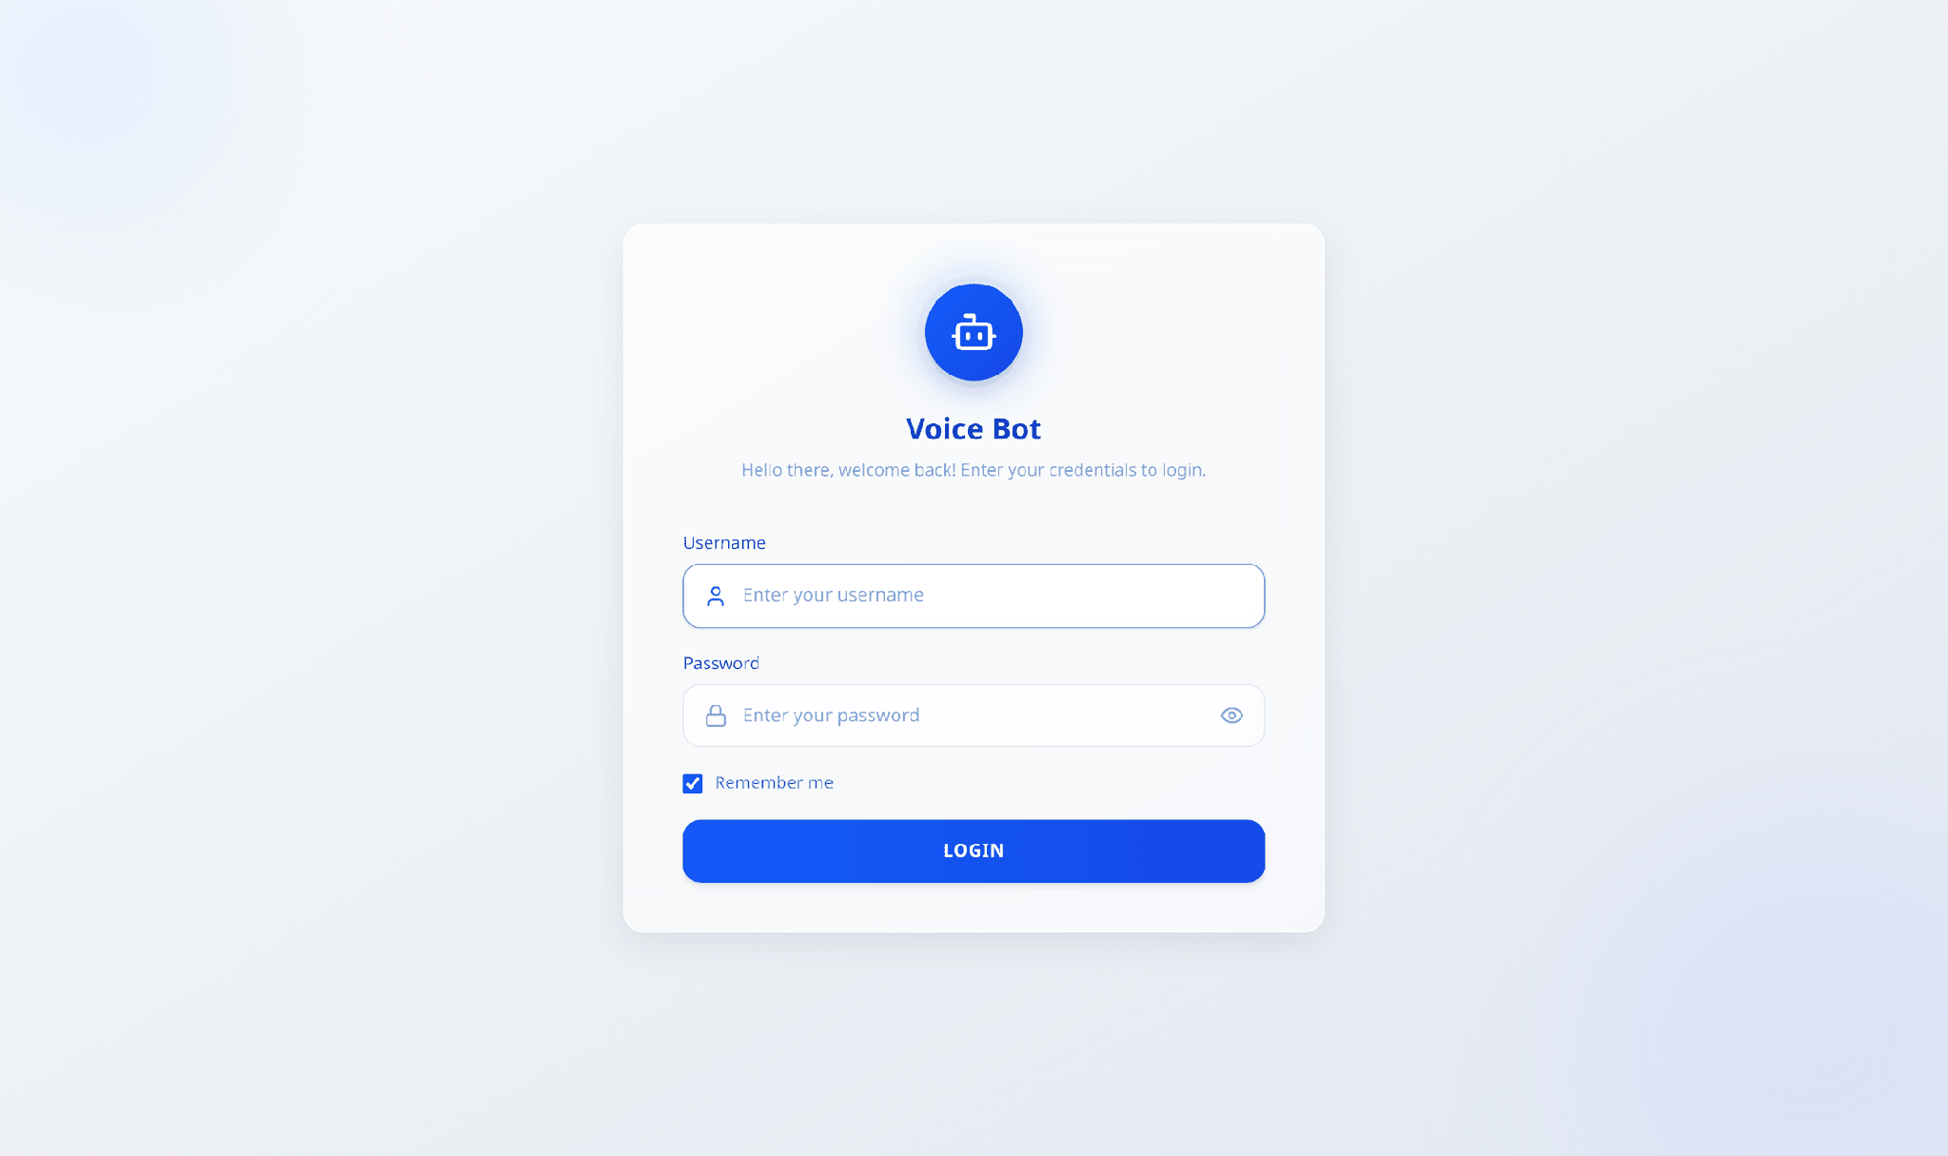
Figure 2 — The login screen.
- Enter your Username and Password.
- Tick Remember me if you want to stay signed in on this browser.
- Click LOGIN.
If the details are wrong you will see a red message under the form. If you see "Unable to connect to server", the system is not running — contact the person who administers it. To sign out, click Logout at the top-right.
Important Credentials are set by your administrator. The software ships with a default account, so make sure it has been changed before the system is used with real customer data.

3. The screen at a glance
Every page shares the same frame: a dark blue bar across the top, a row of tabs beneath it, and the working area below.
Figure 3 — The top bar and the tab row, always visible.

Top bar
Item | What it does
Banking Voice Assistant | The app name — always visible.
Langfuse | Opens the detailed AI tracing tool in a new tab. Only shown when tracing is switched on.
Logs | Slides open the Session Logs panel on the right (section 10).
Tools | Slides open the Tool Selector panel on the right (section 11).
Green / red dot | Green = the page is live and receiving updates. Red = the connection dropped; it retries by itself.
Logout | Signs you out.

Tab row
These six tabs are the main areas of the app. Each has its own section in this guide:
Tab | Use it to…
Voice Mode | Place a real phone call and watch the live conversation.
Chat Mode | Test the bot by typing, with no phone call involved.
Analytics | See call volume, response speed and quality charts.
Call Metrics | See a detailed, per-call table of timings; export to CSV.
Campaigns | Upload a list of numbers and let the bot call them all.
Resources | See how hard the servers and GPUs are working.

4. Voice Mode — making and watching real calls
This is the default screen. Use it to place a live call and follow the conversation as it happens.
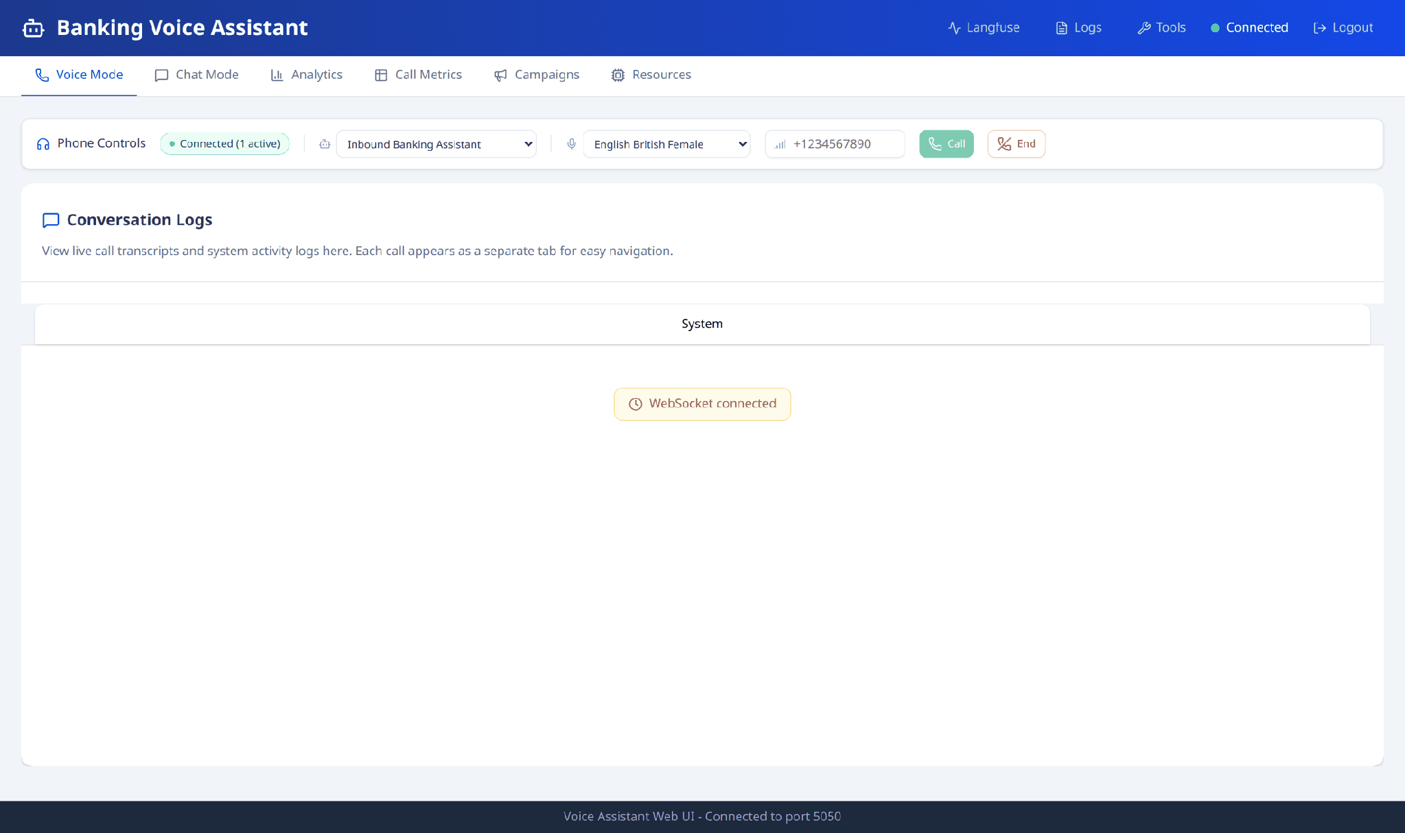
Figure 4 — Voice Mode: the controls row on top, Conversation Logs below.

4.1 The controls row
Figure 5 — Phone Controls, left to right.
Control | What it does
Status badge | Ready, Calling…, Connected, Ended or Error. When calls are live it shows how many are active.
Agent dropdown | Which persona answers or places the call — the inbound banking assistant, or an outbound one (EMI reminder, card upgrade, forex). Outbound agents are marked "→ outbound".
Voice dropdown | Which speaking voice the bot uses.
Phone number box | The number to dial, in international format, e.g. +233200000001.
Call (green) | Places the call. You can also just press Enter in the number box.
End (red) | Hangs up all live calls. Greyed out when nothing is running.

4.2 Placing a call
- Pick the agent you want from the Agent dropdown.
- Pick a voice (optional — the first one is used by default).
- Type the phone number, including the country code.
- Click Call.
A confirmation line appears in the conversation area with the call's reference (its SID). The phone rings, and as soon as someone answers the conversation starts appearing on screen.

4.3 Reading the conversation
The Conversation Logs area below shows the live transcript. Each call gets its own tab, so several calls can run side by side:
- System tab — general messages: connection notices, call confirmations, errors.
- One tab per call — the actual back-and-forth for that caller.
- The view automatically follows a new incoming call until you click a tab yourself. After that it stays where you put it, so your reading is never interrupted.
- Close a call tab with its × when you are finished with it. Clicking back to System turns automatic following on again.
Bot replies carry a small badge showing where the answer came from — a Tool (a live lookup in the bank's systems), the KB (the knowledge base), or the model itself — plus the timing for that reply.

5. Chat Mode — testing by typing
Chat Mode talks to exactly the same bot brain as a phone call, but by text. It is the fastest way to try a scenario, check a new answer, or demonstrate a flow without dialling anyone.
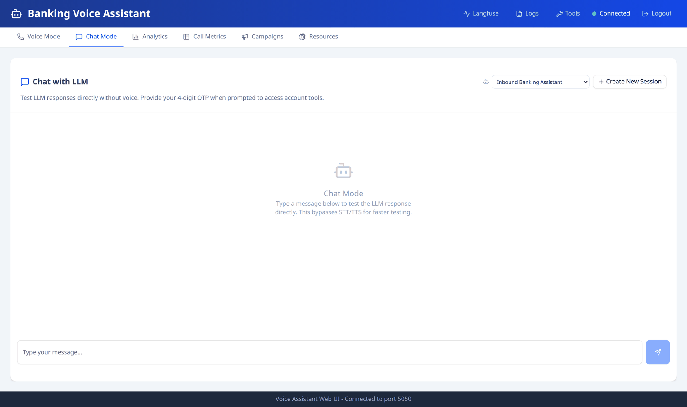
Figure 6 — Chat Mode, with the agent selector and Create New Session at the top right.

5.1 Using it
- Click Chat Mode.
- Choose an agent from the dropdown at the top-right of the chat panel.
- Type a message and press Enter (Shift+Enter starts a new line).
Points worth knowing:
- Picking an outbound agent starts the session straight away and the bot speaks first — exactly as it would on a real outbound call.
- Changing the agent ends the current conversation and starts a fresh one, because an agent is fixed for the length of a session, just like a real call.
- Create New Session clears the conversation and starts over. This is the only thing that resets the chat — switching to another tab and back keeps your history.
- For inbound agents a badge shows Not Authenticated / Authenticated, so you can see when the caller has passed the identity check. Provide the 4-digit OTP when the bot asks for it to reach the account tools. Outbound agents don't use that check, so no badge is shown.
- Each bot reply carries the same source badge as Voice Mode (Tool, KB or model), so you can see how the answer was produced.

6. Analytics — how the service is performing
Charts and headline numbers for the calls handled in a chosen period.
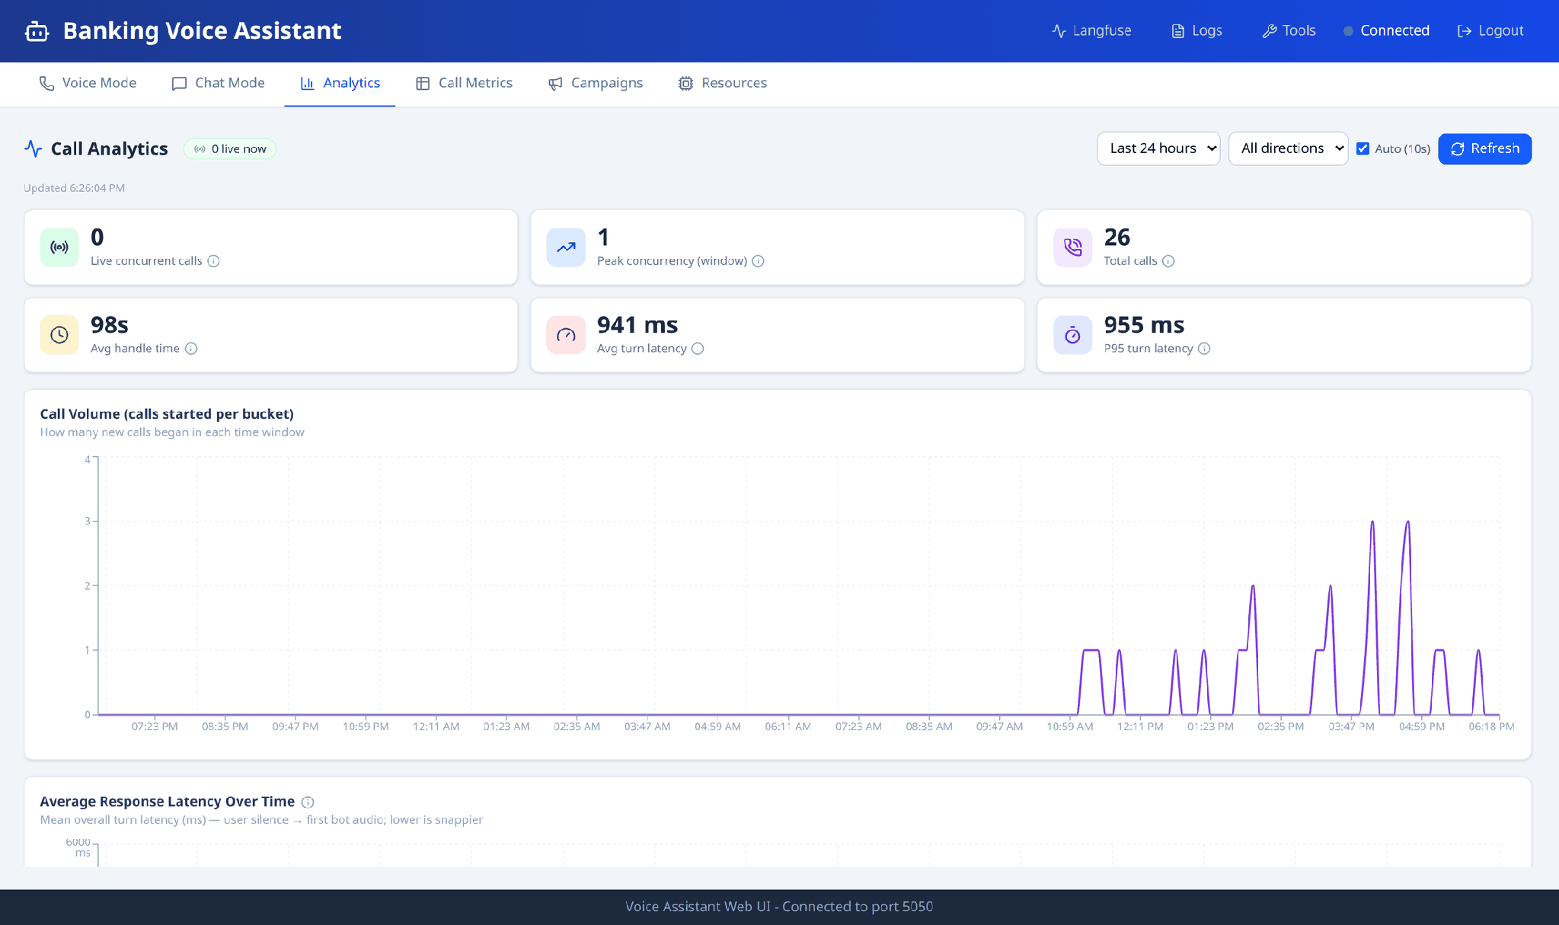
Figure 7 — Call Analytics: the six headline numbers, then the charts.

6.1 Controls
- Time window — the period to report on, e.g. Last 24 hours.
- Direction — all calls, inbound only, or outbound only.
- Auto (10s) — refreshes the page by itself every ten seconds.
- Refresh — updates now.
A green "live now" badge next to the title shows how many calls are in progress at this moment.

6.2 The six headline numbers
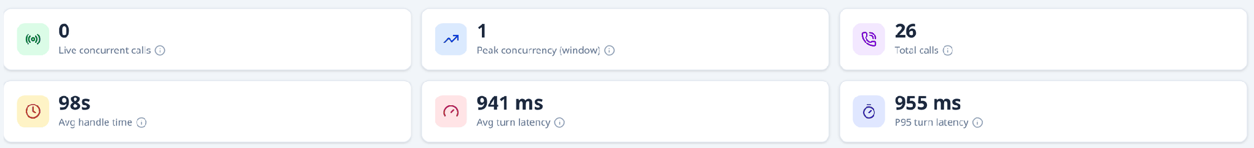
Figure 8 — The headline numbers, refreshed live.
Number | What it tells you
Live concurrent calls | Calls happening right now.
Peak concurrency | The busiest moment in the selected window.
Total calls | How many calls were handled.
Avg handle time | Average length of a call, in seconds.
Avg turn latency | Average wait between the customer finishing speaking and the bot starting to reply. Lower feels snappier.
P95 turn latency | The slow end: 95% of replies were faster than this.

6.3 The charts
- Call Volume — how many new calls started in each time slice.
- Average Response Latency Over Time — whether the bot is getting faster or slower through the day.
- Latency vs Concurrent Users — whether the bot slows down when many calls run at once. A rising line means it does.
- Per-Stage Latency & GPU Cost — where the time goes across the three AI stages: speech-to-text, the language model, and text-to-speech.
- Quality & Accuracy — how well the bot understood intent, resolved requests first time, and how good the speech recognition and generated speech were.
Note If you see "No call data yet for this selection", nothing was recorded in that window — widen the time window or place some calls.

7. Call Metrics — the detailed per-call table
One row per call, with the timing breakdown for each. Use it when you need the exact figures rather than a chart.
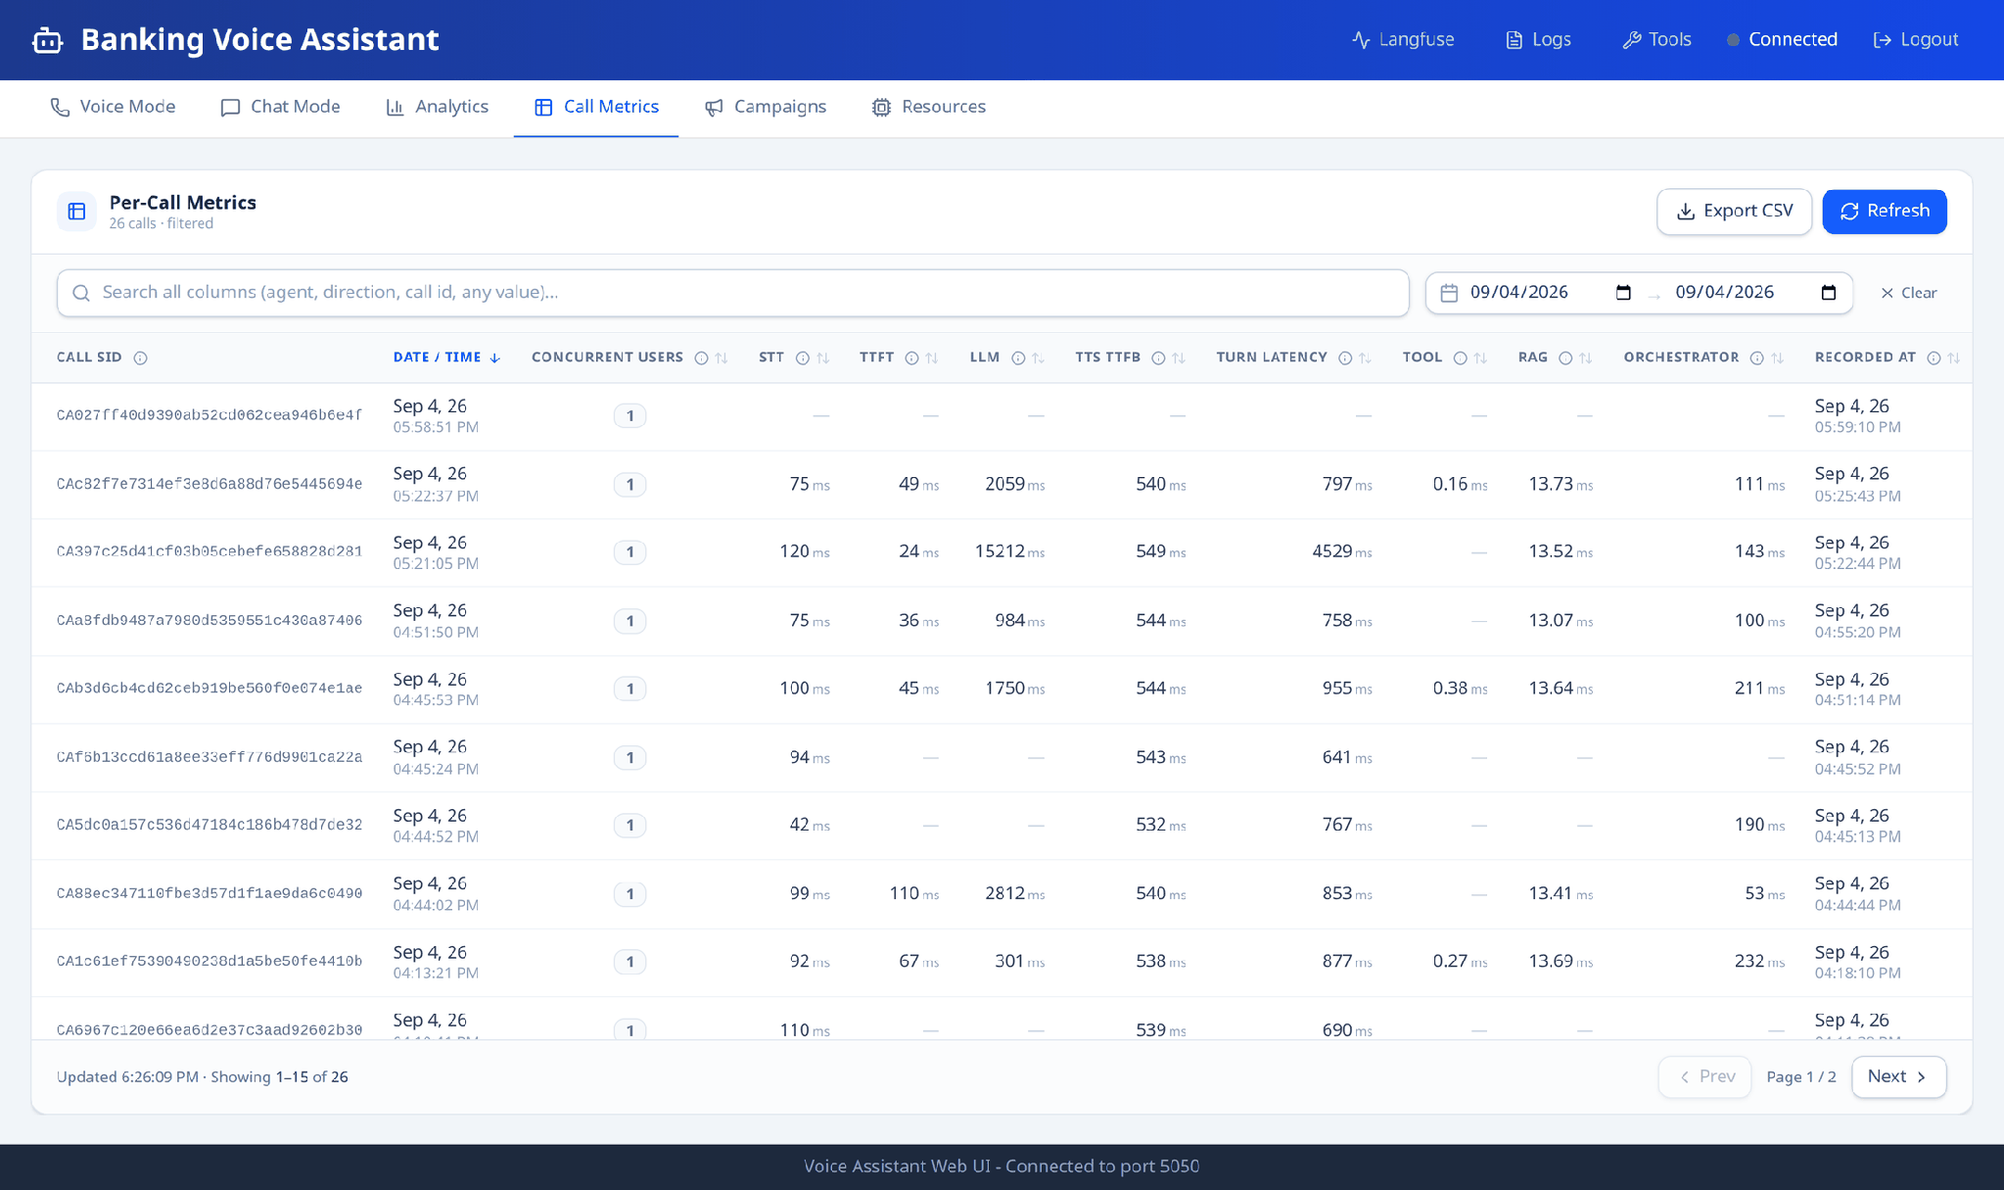
Figure 9 — Per-Call Metrics, sortable and searchable, with CSV export.

7.1 Working with the table
- Search box — type anything (agent, direction, call reference, any value) to filter the rows.
- Date range — narrow the table to a period; Clear resets it.
- Column headings — click to sort by that column.
- Export CSV — saves everything currently filtered, ready for Excel.
- Paging — Prev / Next at the bottom right move through the pages; the footer shows how many rows you are seeing out of the total.
- Small ⓘ marks — hover for an explanation of that column.

7.2 What the columns mean
Column | Meaning
Call SID | The unique reference for the call.
Date / Time | When the call started.
Concurrent Users | How many other calls were running at the same time.
STT | Speech-to-text: turning the caller's speech into words.
TTFT | Time to first token: how long the language model took to begin its answer.
LLM | Total time the language model spent producing the answer.
TTS TTFB | From a reply being ready to the first spoken audio.
Turn Latency | The number the caller actually feels: they stop speaking → the bot starts speaking.
Tool | Time spent looking things up in the bank's systems.
RAG | Time spent searching the knowledge base.
Orchestrator | Time spent deciding what to do — understanding the intent and planning the reply.
Recorded At | When these figures were saved.

All timings are in milliseconds (1,000 ms = 1 second) and are averaged over the turns in that call. A dash means that stage did not run on that call.

8. Campaigns — calling a list of customers
Upload a list of phone numbers and the system will call them all with the agent you choose, now or at a scheduled time.
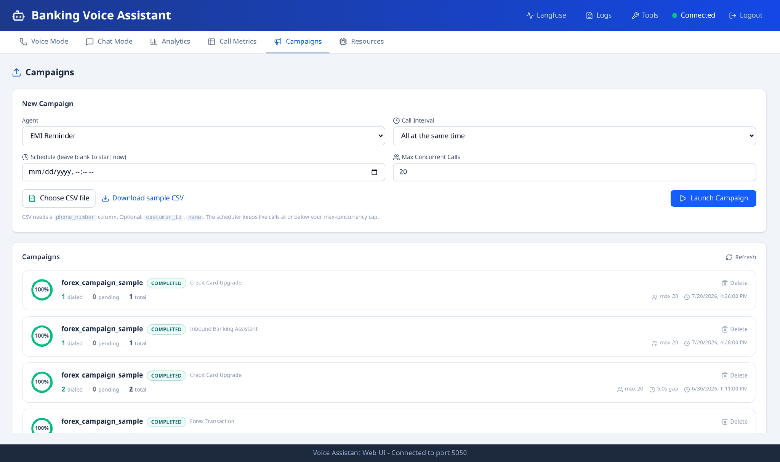
Figure 10 — The Campaigns tab: the form on top, past and running campaigns below.

8.1 Preparing the CSV file
The file needs one column called phone_number. Two more are optional: customer_id and name.
phone_number | customer_id | name
+233200000001 | CUST10001 | Kwame Mensah
+233200000002 | CUST10002 | Ama Owusu
+233200000003 | (blank) | Yaa Asantewaa

You don't have to build this by hand — click Download sample CSV and it gives you the right file for the agent you have selected.

8.2 Launching a campaign
- Click Campaigns.
- Agent — choose who makes the calls. Outbound and inbound agents are listed separately.
- Call Interval — how far apart to space the dials: all at once, or 2 / 4 / 5 / 10 / 30 seconds apart.
- Schedule — pick a date and time, or leave blank to start immediately.
- Max Concurrent Calls — the most calls allowed to run at the same time (1–50).
- Choose CSV file — pick your list.
- Click Launch Campaign.
A green confirmation shows the campaign name, how many contacts were loaded, and when it will run. A red message means something was wrong — usually a missing file or a bad CSV.

8.3 Watching progress
Each campaign appears in the list below the form with a circular completion gauge, how many numbers were dialled, are pending or failed, and its status:
Status | Meaning
SCHEDULED (amber) | Waiting for its start time.
RUNNING (blue) | Calls are being placed now.
COMPLETED (green) | Every contact has been attempted.
CANCELLED (grey) | Stopped before finishing.

The list refreshes by itself every few seconds. Use Cancel to stop a running or scheduled campaign, and Delete to remove one permanently (you'll be asked to confirm).
Important Start with a small test list and a low concurrency figure. The number of simultaneous calls your telephony account allows may be lower than the maximum this form accepts.

9. Resources — server and GPU health
A live view of the machine running the system. Useful when things feel slow, or before launching a large campaign.
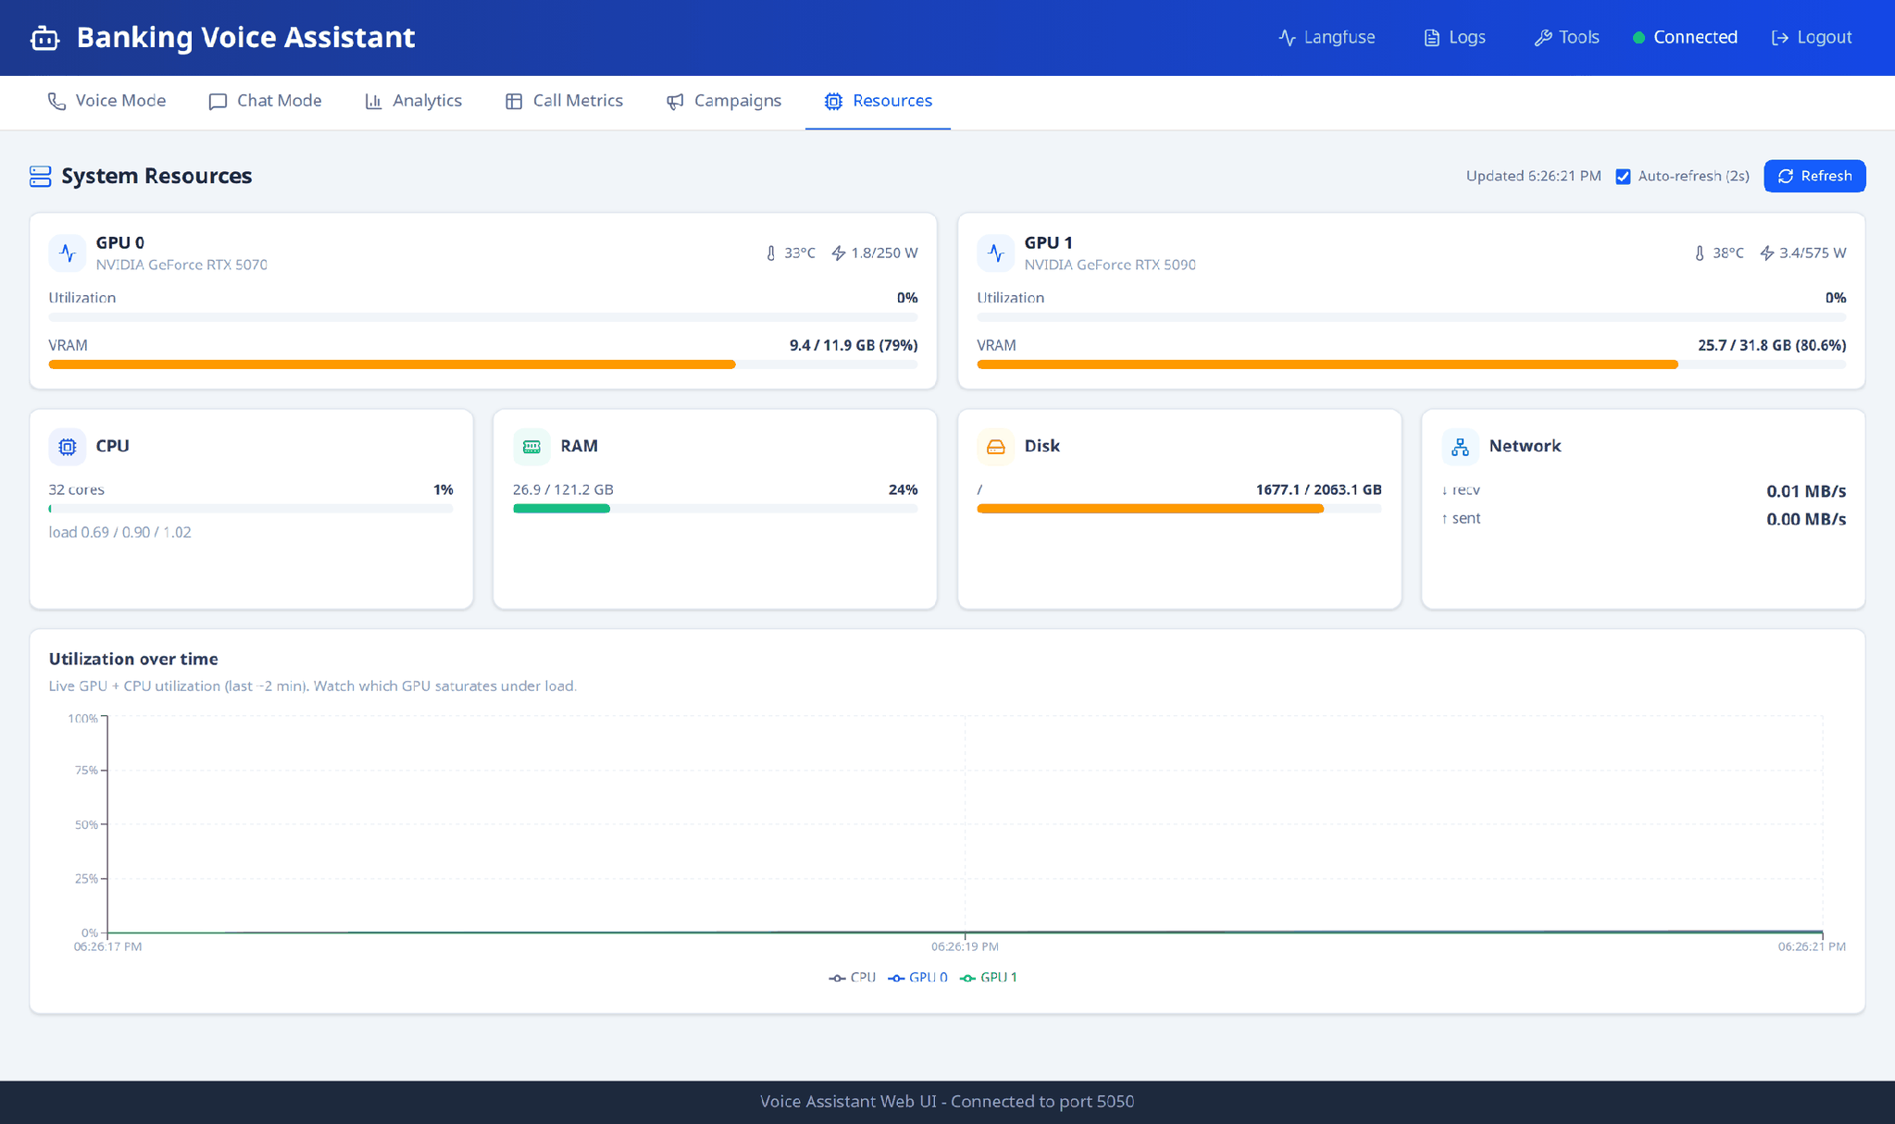
Figure 11 — System Resources: per-GPU cards, system totals, and a live trend chart.
- GPU cards — one per graphics card, showing how busy it is, how much memory is in use, its temperature and power draw. The AI models run here.
- CPU, RAM, Disk, Network — the usual system figures.
- Utilization over time — a chart of the last couple of minutes, so you can see which GPU saturates under load.
- Auto-refresh (2s) — keeps the numbers updating live; untick it to freeze the view.
Note If you see "GPU metrics unavailable", the dashboard hasn't been given access to the graphics cards. CPU, RAM and disk still work. This is a setup matter for your administrator.

10. Session Logs panel
Click Logs in the top bar to open a panel on the right showing, for one chosen session, exactly what happened behind each reply.
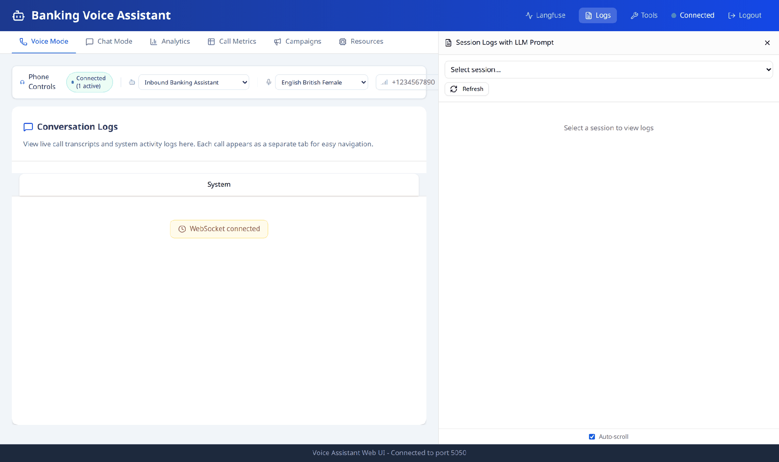
Figure 12 — The Session Logs panel, opened alongside Voice Mode.
- Pick a session from the dropdown (identified by the last part of its ID).
- Scroll through the interaction cards — one per exchange.
- Click a card to expand it and see the full detail.
Each card is tagged with how the answer was produced (knowledge-base search, a tool call, and so on) and can show the decision steps the bot took — which information it still needed, how it routed the request, and the final plan it acted on.
- Refresh — reloads the session list.
- Download — saves the selected session's log to a file. It appears once a session is selected.
- Auto-scroll — keeps the newest entry in view as the call continues.
This panel is mainly for troubleshooting: when a reply looks wrong, this is where you find out why.

11. Tool Selector panel
Tools are the bot's connections to real systems — checking a balance, listing transactions, blocking a card. Click Tools in the top bar to switch individual tools on and off.
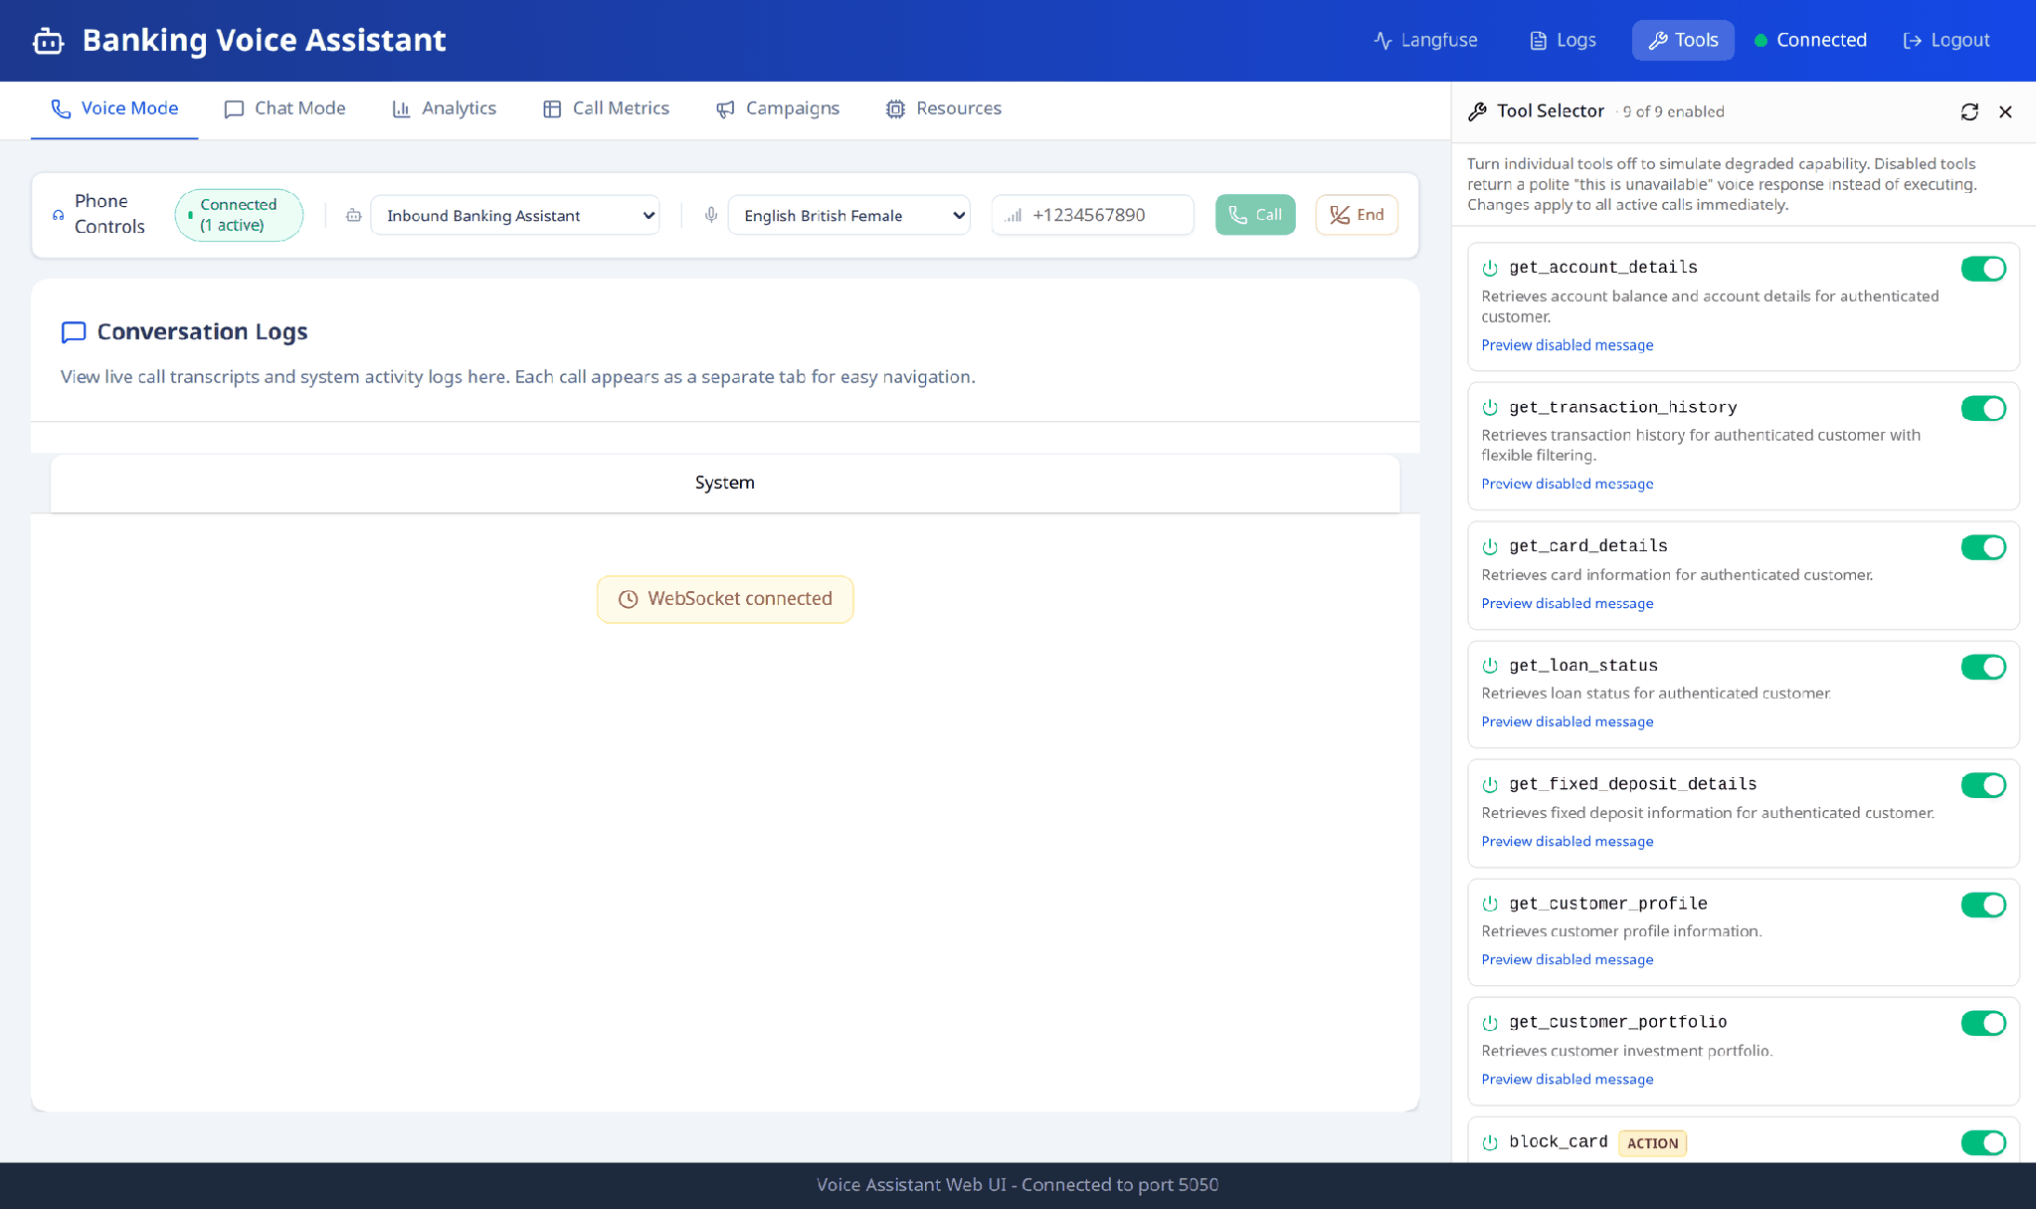
Figure 13 — The Tool Selector, showing each tool and its on/off switch.
- The header shows how many tools are enabled out of the total.
- Each tool shows its name, a short description, and an ACTION tag if it changes customer data. Those always ask the customer to confirm before doing anything.
- Switching a tool off makes the bot politely say that feature is unavailable instead of using it. Preview disabled message shows the exact wording the caller will hear.
- Changes apply immediately, to calls already in progress as well as new ones.
Important This is a testing feature — it lets you see how the bot copes when a banking system is down. Remember to switch tools back on afterwards.

12. Quick how-to
I want to… | Do this
Try the bot without calling anyone | Chat Mode → pick an agent → type a message.
Call one customer | Voice Mode → pick agent and voice → type the number → Call.
Call a list of customers | Campaigns → pick agent → choose your CSV → Launch Campaign.
Find out why the bot answered oddly | Logs panel → select the session → expand the interaction.
Check whether the bot is fast enough | Analytics for the overview; Call Metrics for exact per-call figures.
Export figures for a report | Call Metrics → filter if needed → Export CSV.
See if the servers are struggling | Resources.
Simulate a banking system being down | Tools panel → switch the relevant tool off.
Stop everything on the phones right now | Voice Mode → End (and Cancel any running campaign).

13. If something goes wrong
What you see | What it usually means
"Unable to connect to server" at login | The system isn't running. Contact your administrator.
Red dot / "Disconnected" in the top bar | The live connection dropped. It reconnects by itself; refresh the page if it doesn't.
You are suddenly back at the login screen | The session expired or the dashboard service restarted. Log in again.
Call fails immediately | Check the number format (country code, no spaces) and that the telephony account is active.
"No agents found" in a dropdown | The agent list couldn't be loaded — usually the orchestrator service is still starting.
"No call data yet for this selection" | No calls in that time window. Widen the window or place a call.
"GPU metrics unavailable" | The dashboard doesn't have access to the graphics cards — a setup item, not a fault in your work.
Campaign upload rejected | The CSV is missing the phone_number column, or no agent was selected.
The bot says a feature is unavailable | That tool may be switched off in the Tools panel.

Tip Still stuck? Note the call reference (Call SID) or session ID, take a screenshot, and pass both to the technical team — those two details make any problem far quicker to trace.

