 | G H Raisoni College of Engineering & Management, Pune (An Empowered Autonomous Institute Affiliated to Savitribai Phule Pune University)  --------------------------------------------------------------------------------------------------------------------------------------------------Department of Information Technology
Title: “ SkillBridge – A Smart Platform for Hiring Verified Skilled Professionals”
Project Review I
Presented by:
1) Shripal Rathod[BTechITC27]
2) Siddheshwar Vaidya [BTechITC30]
3) Vivek Devare [BTech ITC57]
Guided By: Mrs. Vaishali Anaspure

Contents
Problem Statement
Objectives
Literature Review
Proposed Methodology
System Architecture
Module-wise Breakdown
Use Case / System Flow
Tools & Technologies Used
Conclusion & Future Work
References

Problem Statement
Millions of skilled workers in India struggle to find consistent work due to lack of digital access, poor visibility, and dependence on middlemen. At the same time, people and businesses find it difficult to hire verified, nearby service providers. Most platforms today focus only on urban or white-collar jobs, leaving skilled trade workers behind. There’s a clear gap between skill availability and service demand. SkillBridge aims to bridge this gap with a smart, AI-powered platform that connects skilled individuals directly with real job opportunities.

Objectives
The primarygoal of the SkillBridge project is to create a functional and accessible digital ecosystem that empowers skilled manual workers and streamlines their connection with job providers. The project focuses not only on job discovery but also on promoting trust, transparency, and inclusivity in the informal labor sector
To achieve this, the specific objectives of the project are outlined below:
Objective 1 – Requirement Analysis & Platform Foundation To design and develop a digital platform that connects skilled manual workers with local job providers, reducing communication gaps and worker idle time.

Objective 2 – Core Functionality & User Experience
Toimplement essential system featuressuch asskill-based categorization, location- based search, job-type filtering, and real-time availability to enhance usability and efficiency.
Objective 3 – Trust & Reliability Mechanisms
Toestablish credibility within thesystemthrough profile verification, rating mechanisms, and review systems, ensuring reliable and transparent worker–employer interactions.
Objective 4 – Intelligent System Enhancement Using AI/ML
TointegrateAI andMachine Learning techniques for personalized job recommendations, feedback sentiment analysis, and dynamic trust scoring that improves over time.
Objective 5 – Accessibility, Scalability & Inclusivity
Toensure the platformis accessible touserswith low digital literacy through multilingual support, icon-driven and voice-assisted interfaces, while maintaining scalability for future regional and sectoral expansion.

Literature Review
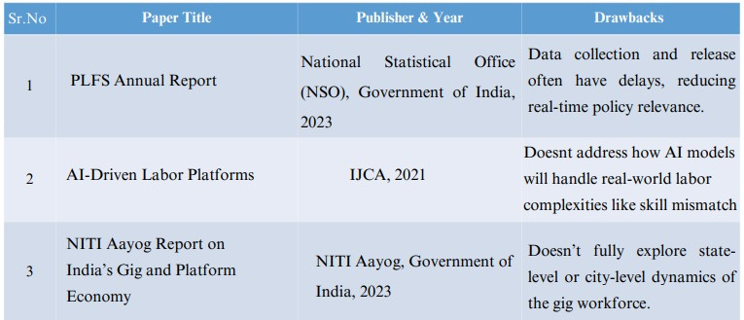

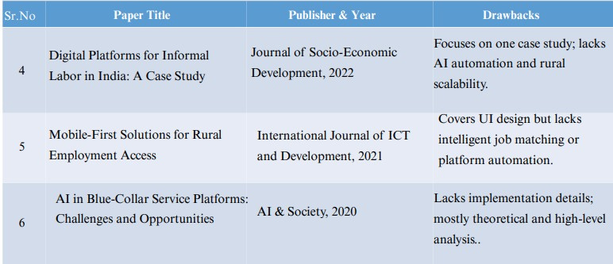

Proposed Methodology
Methodology Overview The SkillBridge system is developed using a phased and agile-based approach to ensure scalability, usability, and continuous improvement. The platform follows iterative development with regular validation and feedback integration.
Development Approach
Requirement Analysis & Planning
UI/UX Design (User-Centric & Accessible)
Frontend Development

Backend Development Database Integration AI/ML Integration  Testing & Validation | 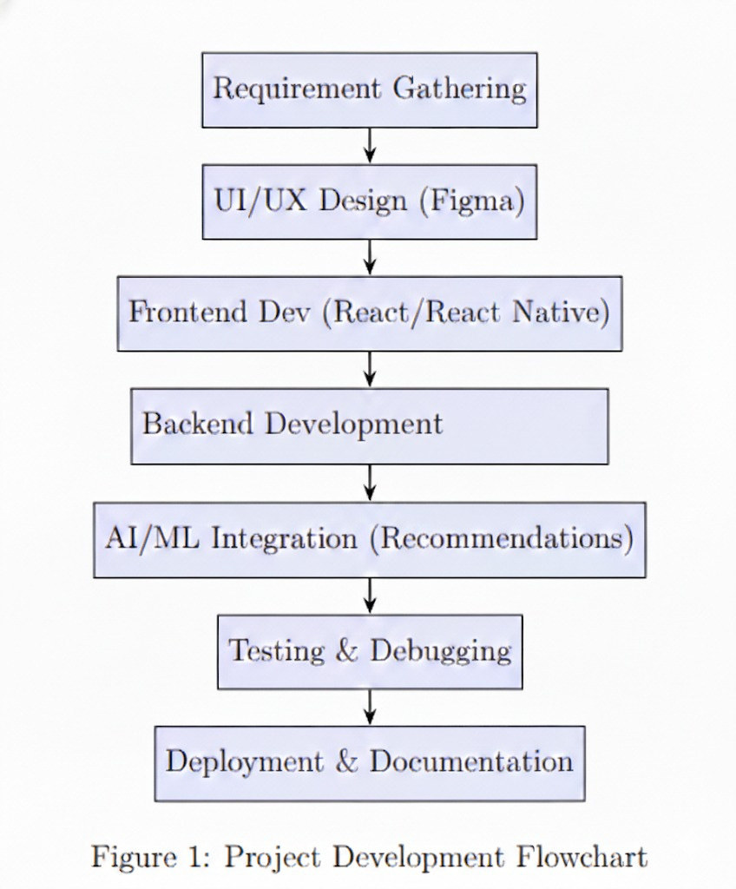

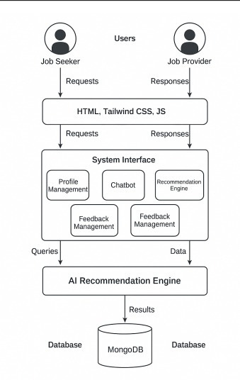
System Architecture :


Phase wise Implimentation Planning
Months Activities | Jan 26 | Feb 26 | March 26 | April 26

Problem Statement Identification | √ | √ | √ | √
Literature Review | √
Requirement Analysis | √
Designing |  | √
Experimental Analysis |  | √
Module Wise Implementation |  | √ | √
Testing And Debugging |  |  | √
Project Report Preperation |  |  |  | √

Use Case / System Flow
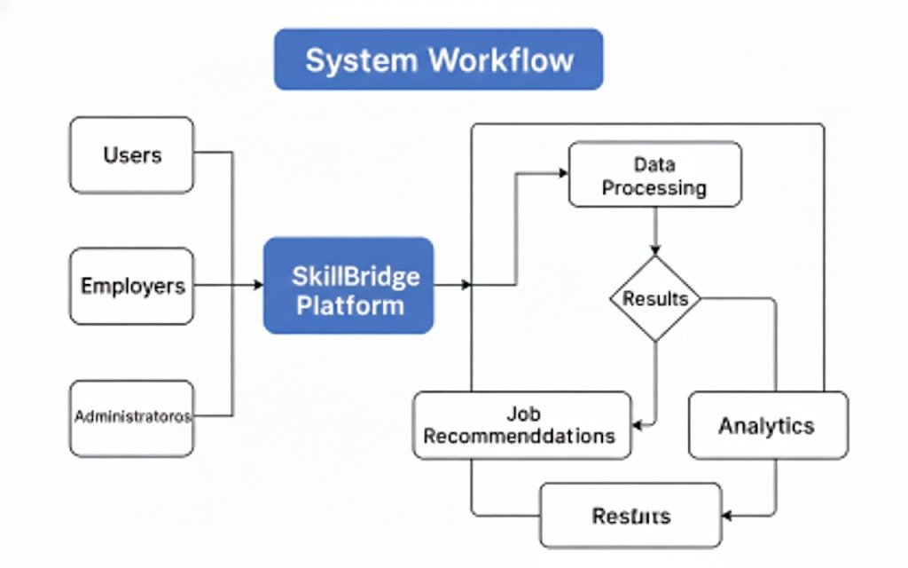

Conclusion
Skillbridge demonstrates the effective use of artificial intelligence in a service- based marketplace by connecting skilled workers with customers efficiently. Through AI-powered recommendations, location-based matching, sentiment- based feedback analysis, dynamic pricing, and secure face-recognition authentication, the platform offers a reliable, transparent, and smarter alternative to traditional service-matching systems.

References
[1] Ministry of Labour and Employment, Government of India, “Periodic Labour Force Survey (PLFS) 2022–23 Annual Report,”New Delhi, India, 2023.
[2] R. Kaur and P. Singh,
“AI-driven job platforms in India,”
Int. J. Comput. Appl. (IJCA), vol. XX, no. X, pp. XX–XX, 2021.
[3] NITI Aayog,
“India’s gig economy outlook,”
Government of India, New Delhi, India, 2023.

4] A. Mahajan and R. Gupta,
“Digital platforms for informal labor in India: A case study,”J. Socio-Economic Development, vol. XX, no. X, pp. XX–XX, 2022.
[5] S. Verma and P. Kulkarni,
“Mobile-first solutions for rural employment access,”Int. J. ICT Develop., vol. XX, no. X, pp. XX–XX, 2021.
[6] T. Sharma and N. Bose,
“AI in blue-collar service platforms: Challenges and opportunities,”AI & Society, vol. XX, no. X, pp. XX–XX, 2020.

Thank You..

Transport Department
Government of Maharashtra
e-Receipt For Online Driving License Application
Office Name | DY.RTO, KARAD | Receipt Date | 04-07-2025
Applicant Name | SHRIPAL DINESH RATHOD | Receipt No | MH25Y/3235081
Date of Birth | 14-10-2003 | Bank / Gateway | c-SBIe
Application Date | 04-07-2025 | Bank Reference No | 555148601875
Application No | 2652284925 | Transaction ID | MH2025Y0025473255
NA NA

Transaction  Name | Class of Vehicles |  | Fee Amount | Additional Fee / Fine | Total
ISSUE NEW LL | Motor Cycle with Gear(Non Transport),LIGHT MOTOR VEHICLE |  | 289.26 | 0.00 | 289.26
LLTEST |  |  | 50.00 | 0.00 | 50.00
E-Sign charge |  |  | 0.00 | 0.00 | 0.00
SERV.CHARGE-LL | Motor Cycle with Gear(Non Transport),LIGHT MOTOR VEHICLE |  | 12.74 | 0.00 | 12.74
Total Amount |  |  |  |  | 352.00
Total Amount (In Words) |  | Three Hundred Fifty Two Rupees only
Note: Visit the Concerned Office with Required Forms and Documents along with this Receipt

SOWRCP001

