NIMH All-Disabilities Dataset
Data Insights & Identified Patterns
Prepared for Leadership Review
August 2026
Dataset Scope | Value
Valid student records analysed | 20,422
Clinical assessment sheets covered | 9 of 23 (case history, family & development history, DST/DQ, VSMS/SQ, medical, speech-language, cognitive)
Data quality note | ~20,437 blank/placeholder rows excluded from analysis

Executive Summary
This report analyses the NIMH registration and clinical assessment dataset to surface patterns that connect a child's background, developmental history, and clinical scores to their eventual disability classification and severity. Nine of the most data-rich sheets — Registered Students, Family History, Development History, DST (IQ/DQ) Test, VSMS (Social Maturity) Test, Medical Assessment, Speech & Language, Cognitive Assessment, and Case History — were joined on Registration Number to build these findings.
The core message for leadership: Intellectual Disability dominates the caseload (89.6%), boys are registered far more often than girls yet girls present with more severe profiles, speech/language milestones are the earliest and strongest delay signal we capture, and roughly half of all families served are economically weaker section (non-paying) cases concentrated in just three districts. Each finding below is paired with the exact numbers behind it and a chart.

Snapshot of Findings
- 89.6% of classified cases are Intellectual Disability — the dataset is heavily skewed toward one category.
- Boys outnumber girls 2.6-to-1 in registrations, but girls show a higher rate of Severe/Profound classification (20.4% vs 15.2%) — a possible late-identification pattern for girls.
- Speech/language milestones (first words, phrases, sentences) show 65–84% delay rates — nearly double the delay rate seen in motor milestones (38–48%).
- Two independent clinical scales (DST-based DQ and VSMS-based SQ) agree exactly for 66% of children and land within one severity band for 98% — strong cross-validation of the assessment process.
- Only ~2–3% of families report consanguinity or known hereditary history — most registered cases are not linked to a reported family/genetic pattern.
- 55% of families are in the Non-Paying (economically weaker) category, and 3 districts (Hyderabad, Ranga Reddy, Medchal–Malkajgiri) account for 48% of all registrations.

Finding 1 — Case Mix is Dominated by Intellectual Disability
Of the 20,422 valid registrations, 18,300 (89.6%) are classified under Intellectual Disability. Multiple Disabilities (including deaf-blindness) is a distant second at 6.7%. All other categories — Specific Learning Disabilities, Speech & Language, Locomotor, Hearing Impairment, and rarer conditions — together make up under 4% of cases.
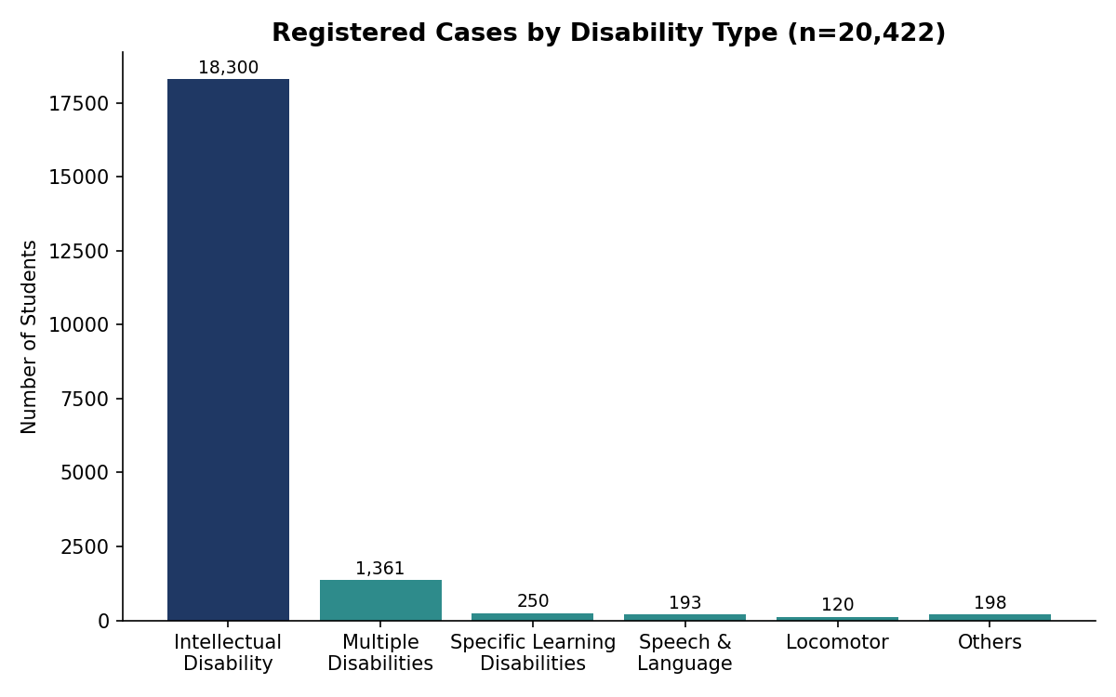
Figure 1: Registered cases by disability type (n = 20,422)
🔎 Identifying relation
If a child is registered at this centre, the overwhelming prior probability (~9 in 10) is that the eventual diagnosis is Intellectual Disability. Program planning, staffing, and resource allocation should be built primarily around ID case management, with smaller dedicated tracks for the next two categories (Multiple Disabilities and Specific Learning Disabilities).

Finding 2 — Gender Gap in Registration, Reversed Gap in Severity
Among students with recorded gender, 14,615 (72%) are male and 5,658 (28%) are female — a 2.6:1 ratio. This alone suggests boys are brought in for assessment far more often than girls in this population.
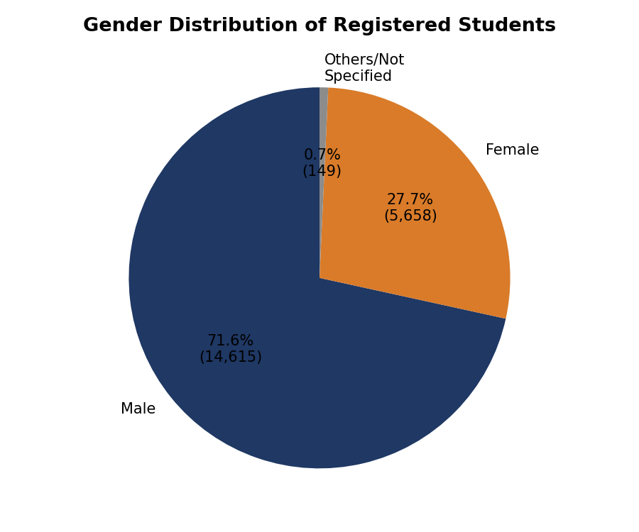
Figure 2: Gender split of registered students
But when we look at severity (DQ category from the DST test) by gender, the pattern flips: 20.4% of assessed girls fall in the Severe/Profound band, versus 15.2% of boys.
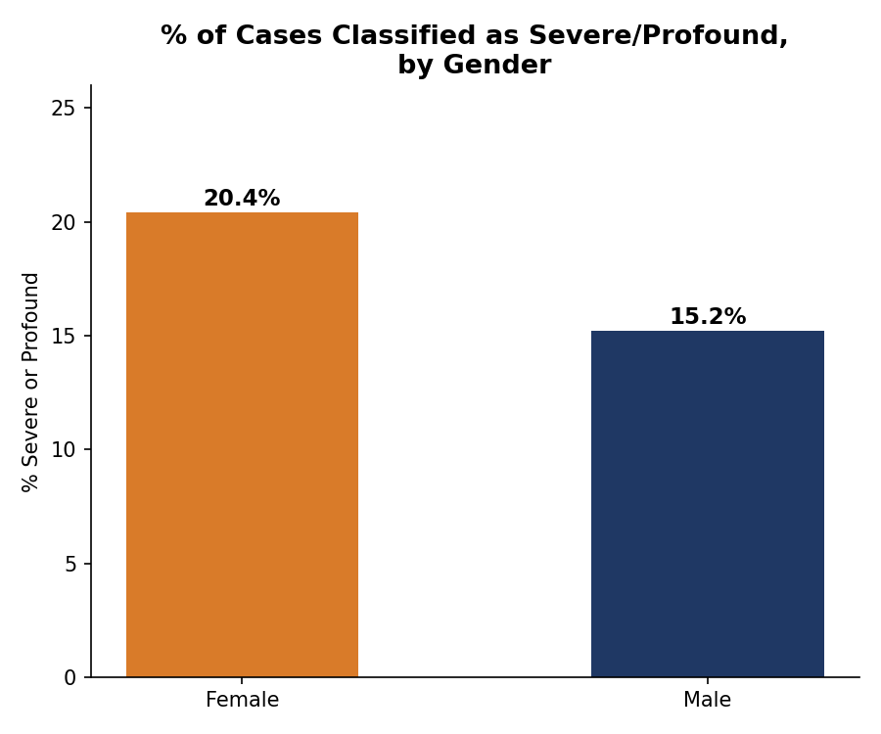
Figure 3: % of assessed students classified Severe or Profound, by gender
🔎 Identifying relation
If registration numbers for girls are low but the girls who do get registered skew more severe, this is consistent with a known pattern in disability service data: milder cases in girls go unreported or unregistered, and families tend to seek help only once a girl's condition is more visible/severe. This is worth flagging to directors as a possible outreach and early-detection gap for girls, not a biological difference in prevalence.

Finding 3 — Severity Mix Skews Moderate-to-Mild, Not Profound
Across 5,133 students with a recorded DQ/IQ category from the DST test, the distribution is centred on Moderate (30.5%) and Mild (23.4%), with Borderline intelligence at 18.1%. Severe and Profound together make up only 16.7% of assessed cases.
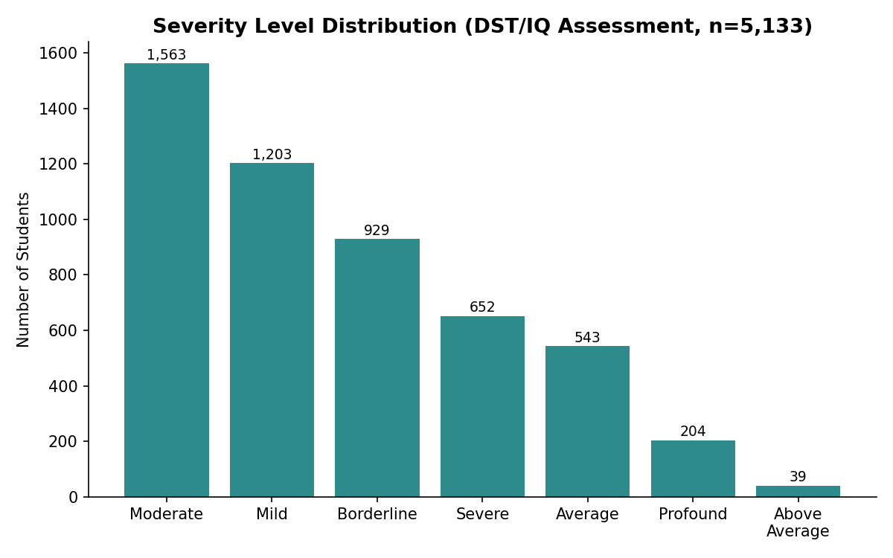
Figure 4: Severity level distribution from DST/DQ assessment (n = 5,133)
🔎 Identifying relation
The majority of children served need Moderate/Mild-intensity intervention plans (special education, functional skills training) rather than intensive Severe/Profound-level care. This has direct implications for how therapy staff time and special-education slots should be distributed. We also found that average age at assessment rises with severity (Severe ≈ 10.7 yrs vs Mild ≈ 6.9 yrs vs Borderline ≈ 6.7 yrs) — consistent with more severe cases needing repeat or later-stage assessment, or being identified later in some cases.

Finding 4 — Speech & Language Milestones Are the Strongest Early Signal
The Development History sheet records whether each child hit 11 standard milestones on time or late. Language-related milestones show dramatically higher delay rates than motor milestones:
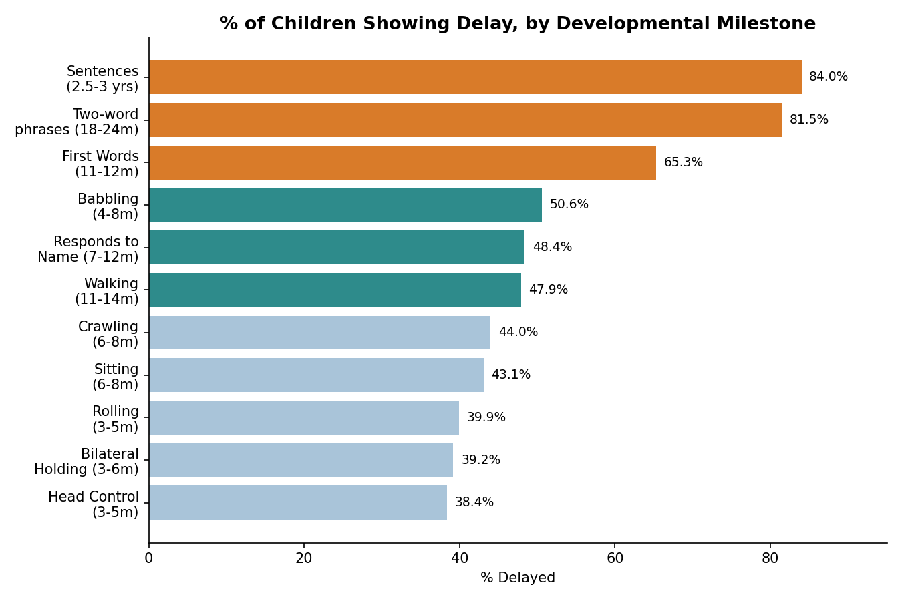
Figure 5: % of children showing delay, by developmental milestone
🔎 Identifying relation
If a child is delayed on 'Sentences (2.5–3 yrs)' or 'Two-word phrases (18–24 months)', that is delayed for 8 out of 10 children in this dataset — the single most common early flag. Motor milestones (head control, rolling, crawling) are delayed in fewer than half of cases. This means speech/language milestones are a more sensitive — and earlier — screening signal than motor milestones for this population, and front-line staff/parents should be trained to watch language milestones most closely for early referral.
Across all disability categories with sufficient data, 84–92% of children show at least one delayed milestone overall — confirming developmental delay is close to a universal marker at intake, but the language-specific milestones are where the signal is strongest and earliest.

Finding 5 — The Two Clinical Scales Agree, Validating the Assessment Process
The dataset captures two independently-administered instruments: the DST test (giving a DQ / 'IQ Category') and the VSMS test (giving an SQ / social-maturity category). For 4,837 students with both recorded, the two scales exactly agree on severity band 66% of the time, and are within one adjacent band 98% of the time. Only 2% of cases disagree by two or more severity levels.
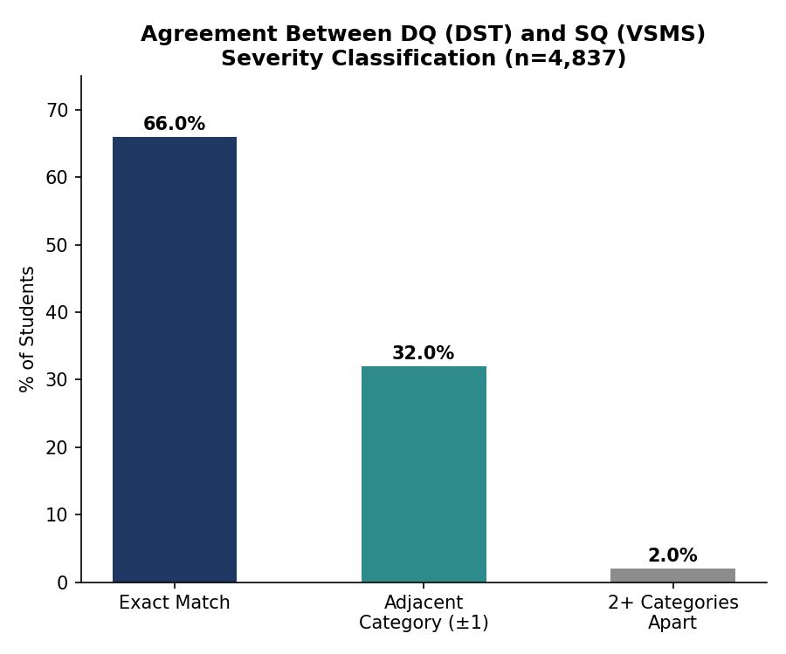
Figure 6: Agreement between DQ (DST) and SQ (VSMS) severity classification
🔎 Identifying relation
High agreement between two different clinical tools (cognitive DQ vs. functional/social SQ) is a strong internal validity check — it means the severity labels in this dataset are trustworthy and not an artifact of a single test. The small share of large mismatches (2%) is a good watch-list for case review, since a big DQ–SQ gap can flag either a scoring error or a child whose cognitive and adaptive/social functioning genuinely diverge (worth a second look clinically).

Finding 6 — Reported Hereditary/Family Link Is Low
Family History records include a specific 'Any Family history of delay/disability/disorder' field and a separate Consanguinity field. Among students with a recorded disability, only about 3.0% of Intellectual Disability families and 2.6% of Multiple Disability families report a positive family history of a similar condition. Reported consanguineous marriage is similarly low, at 1.9%–3.4% across disability types.
🔎 Identifying relation
Based on what is captured in this dataset, the large majority of cases do not have a documented hereditary or consanguinity link — most appear to be sporadic rather than clearly familial. This should be read as a data-completeness caveat, not a clinical conclusion: family history in this sheet is self-reported at intake and may be under-captured. If directors want a firmer genetic-risk story, family history intake forms may need a more structured, prompted set of questions rather than free text.

Finding 7 — Service Reach: Who We Serve and Where
55% of families with a recorded payment category are Non-Paying (economically weaker section), against 45% Full Paying — showing the centre serves a majority economically weaker population, consistent with a subsidized-service mission.
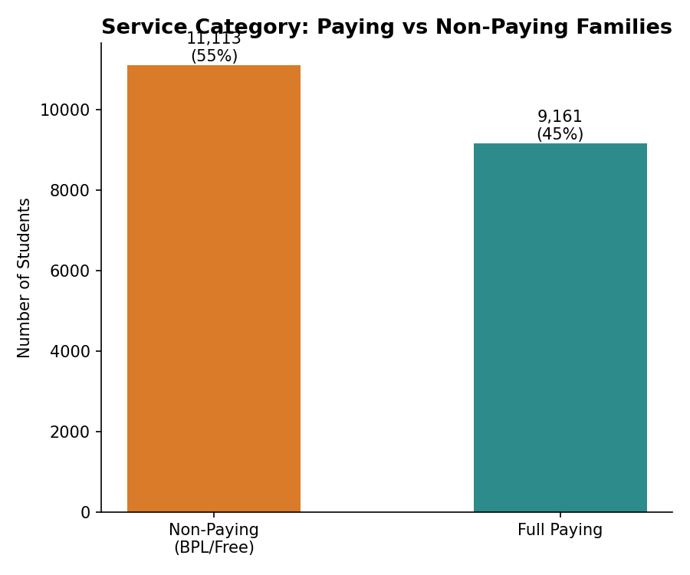
Figure 7: Paying vs. non-paying families
Geographically, registrations are heavily concentrated: Hyderabad, Ranga Reddy, and Medchal–Malkajgiri together account for 48% of all valid registrations, with the next five districts (Secunderabad, Mahabubnagar, Warangal, Nalgonda, Medak) contributing a further 18%.
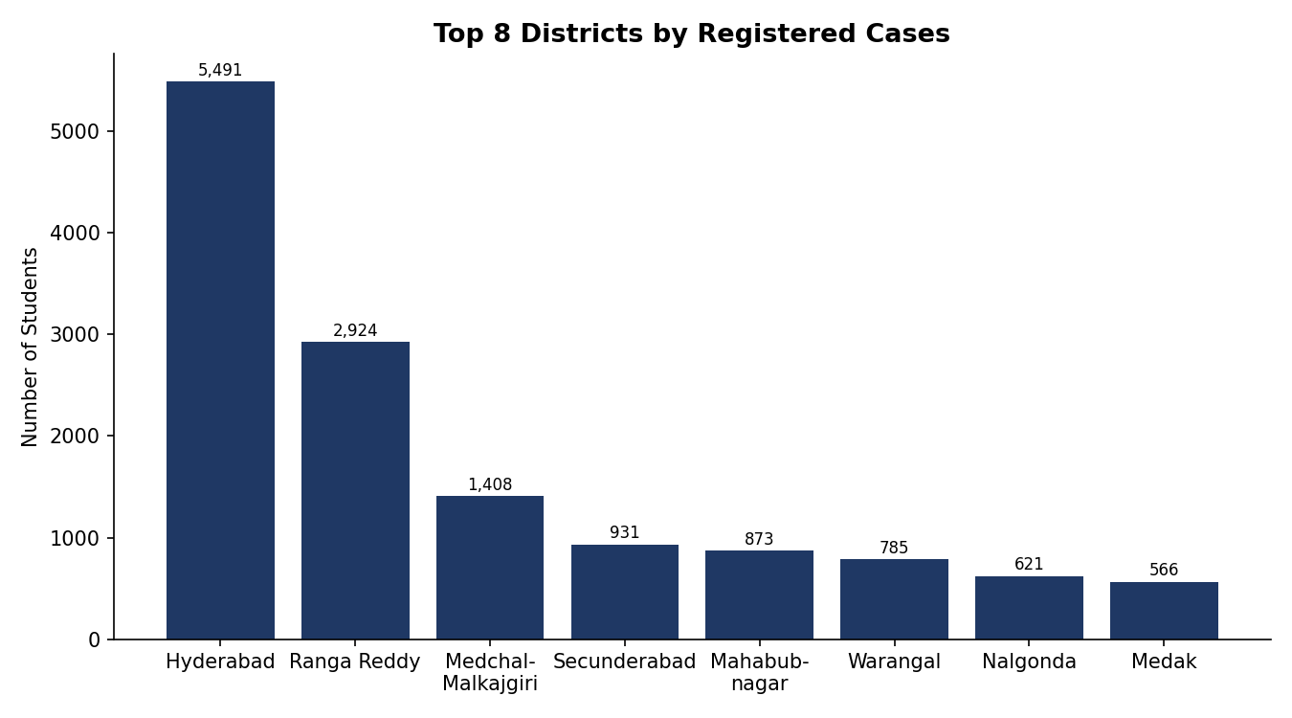
Figure 8: Top 8 districts by number of registered cases
🔎 Identifying relation
If a family is registering from outside the top 3 districts, they are already an outlier relative to the current catchment — meaning outreach, satellite clinics, or telehealth screening in mid-tier districts (Warangal, Nalgonda, Medak, Karimnagar) could unlock currently under-served demand rather than just growing volume in already-saturated districts.

Data Quality Note
The raw file contains 40,859 rows in the Registered_Students sheet, but 20,437 of these are entirely blank (no name, ID, or any field populated) — essentially formatting artifacts from the export, not real records. All figures in this report are based on the 20,422 rows that contain an actual student name. We recommend this be cleaned at source (or at least flagged) before any headcount, budget, or staffing calculation is done directly off row counts in the raw Excel file, since a naive COUNT() on the raw sheet overstates caseload by roughly 2x.

Recommendations
- Prioritise Moderate/Mild-intensity program capacity, since this is where 54% of assessed cases fall — while keeping a dedicated but smaller track for Severe/Profound cases.
- Train intake staff and parents to treat delayed speech milestones (first words, two-word phrases, sentence formation) as the earliest and strongest red flag for referral, ahead of motor milestones.
- Investigate the girl-registration gap: consider targeted outreach so girls with milder symptoms are identified and registered earlier, rather than only when severe.
- Treat the DQ–SQ 2%+ mismatch cases as a clinical review queue — these are the students where two independent tests disagree substantially.
- Strengthen the Family History intake form with structured (not free-text) questions if a genetic/hereditary risk analysis is a priority for future reporting.
- Consider outreach or satellite screening camps in mid-tier districts (Warangal, Nalgonda, Medak, Karimnagar) to reach families currently under-represented relative to the top 3 districts.
- Fix the data-entry pipeline so blank placeholder rows are not exported alongside real records, to avoid inflated headcount metrics in future reporting.

