SANJIVANI UNIVERSITY, KOPARGAON
Department of Artificial Intelligence & Machine Learning
DevOps – Unit 1 Mini Project Report
Enterprise Student Record and Academic Management Platform – Design Thinking and Product Planning
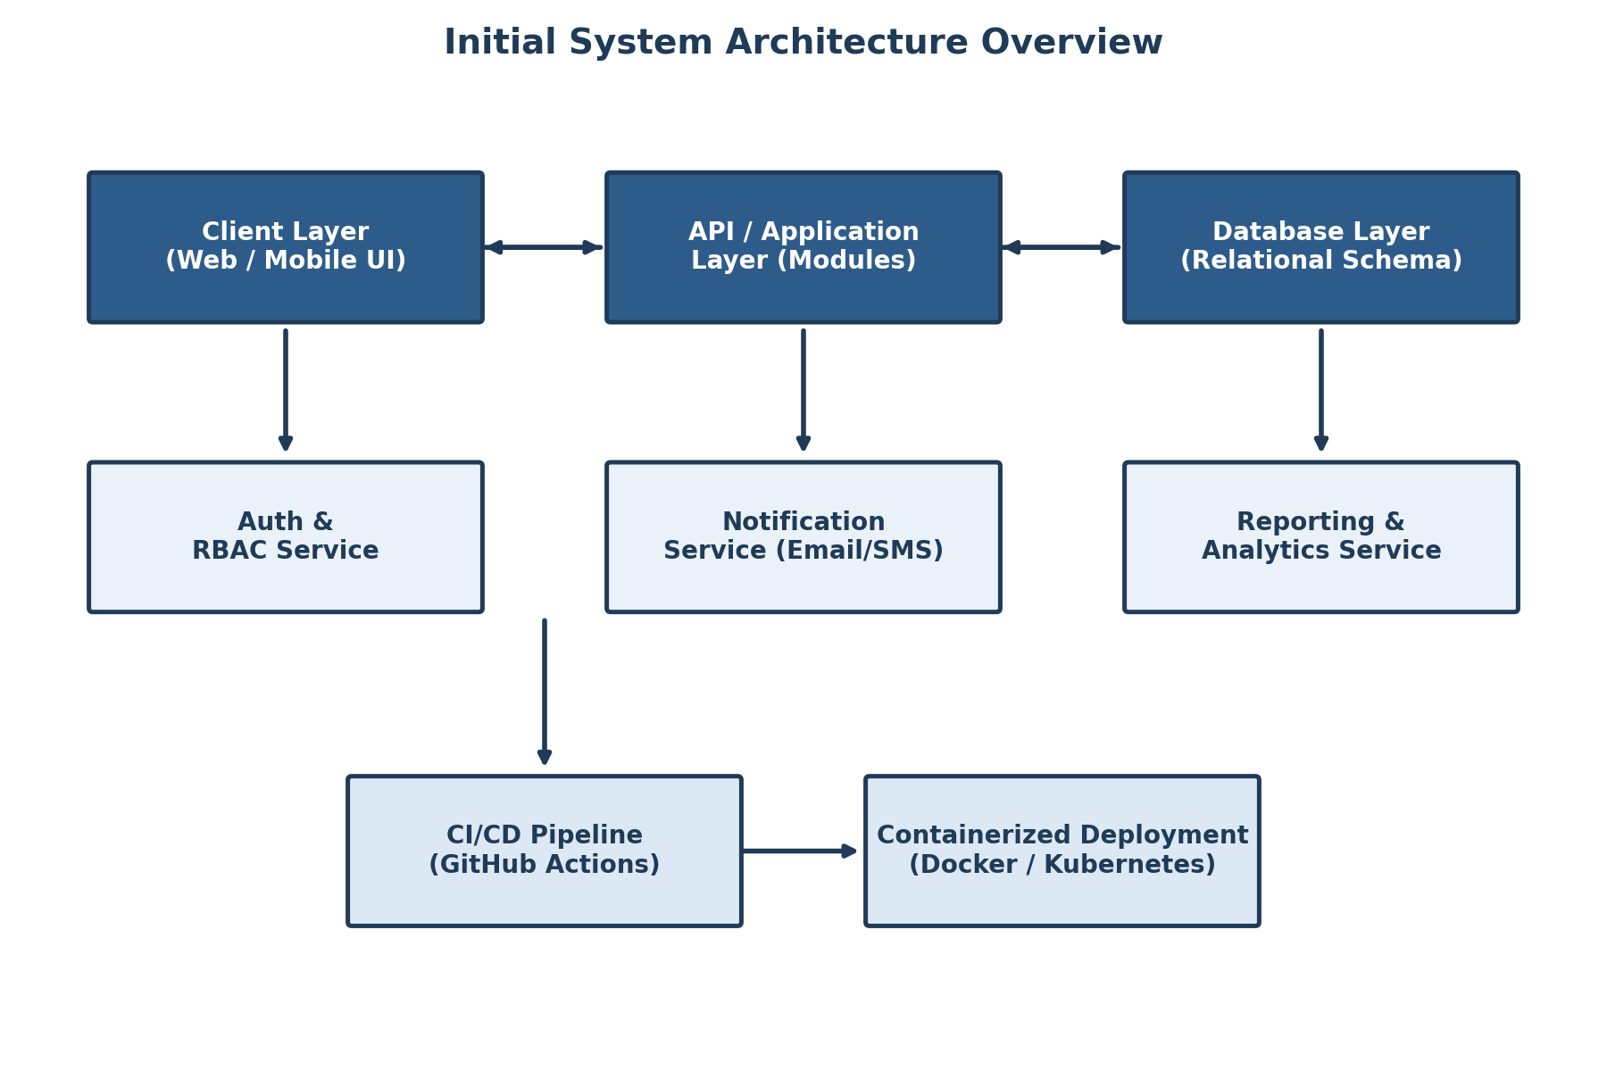

Student Name: | Shriraj Kamble
PRN: | 2125UMLM1030
Department / Class: | SY AIML (Second Year – Artificial Intelligence & Machine Learning)
Course: | DevOps – Unit 1: Product Engineering & Design Thinking
Project Title: | Enterprise Student Record and Academic Management Platform
Submitted To: | Careertiq Training & Engineering Division

Table of Contents
1. Introduction to Software Product Development
2. Business Understanding: Academic Management in Higher Education
3. Introduction to Design Thinking
4. Applying the Five Stages of Design Thinking
5. Enterprise Expansion: IBM Design Thinking
6. The IBM Loop Engine
7. Stakeholder User Personas
8. Stakeholder Matrix
9. Requirements Engineering Specification
10. Product Vision & Minimum Viable Product (MVP) Scope
11. Enterprise Engineering Roadmap
12. System Architecture & Repository Structure
13. Student Deliverables Checklist
14. Conclusion

1. Introduction to Software Product Development
In modern educational institutions, software products such as academic management platforms are built using structured engineering frameworks rather than ad-hoc programming. Coding is only one execution phase within a much larger engineering lifecycle that spans research, architecture, user experience design, quality assurance, automated deployment, and continuous monitoring. This report documents the independent application of the Design Thinking methodology — as demonstrated for the Library Management Platform case study — to a new domain: the Enterprise Student Record and Academic Management Platform for a higher education institution.

1.1 Comparative Analysis: Programming vs. Software Engineering
Before designing the platform, it is important to distinguish between writing code and engineering a product. The table below summarises the key differences that guided the approach taken in this project.
Dimension | Programming / Coding | Software Product Engineering
Primary Goal | Translating logic/algorithms into executable code syntax. | Building scalable, maintainable, and valuable systems for end users (students, faculty, administrators).
Scope | Isolated functions, micro-tasks, or single scripts (e.g., a grade calculator). | Full lifecycle (SDLC): architecture, CI/CD, database schemas, security, and compliance.
Success Metric | Code compiles and passes basic test inputs. | Adoption by students/faculty, high availability, fast result-processing, improved academic efficiency.
Mindset | Technology-Centric (“How do I write this function?”). | Product-Centric (“What core problem are we solving for students and administrators?”).

1.2 Root Causes of Academic Software Project Failures
Software projects in the education sector rarely fail because of poor syntax. Analysis of common failure patterns in campus software identifies the following major risk factors, which this project explicitly seeks to avoid:
- Misaligned Requirements: Building modules (e.g., elaborate analytics dashboards) that students and faculty do not actually need, while ignoring core pain points such as slow result declaration.
- Technology-Centric Bias: Selecting frameworks based on industry trends rather than suitability for academic workflows such as semester-based attendance and examination cycles.
- Communication Silos: Separation between the examination cell, academic administrators, and the engineering/DevOps team building the platform.
- Lack of Iterative Feedback: Delaying feedback from students and faculty until late in development, making changes to registration or attendance logic prohibitively expensive.

1.3 System Development Lifecycle (SDLC)
The platform is engineered through a six-stage lifecycle that begins with domain understanding and ends in a continuous observability loop, ensuring the product keeps improving after release.
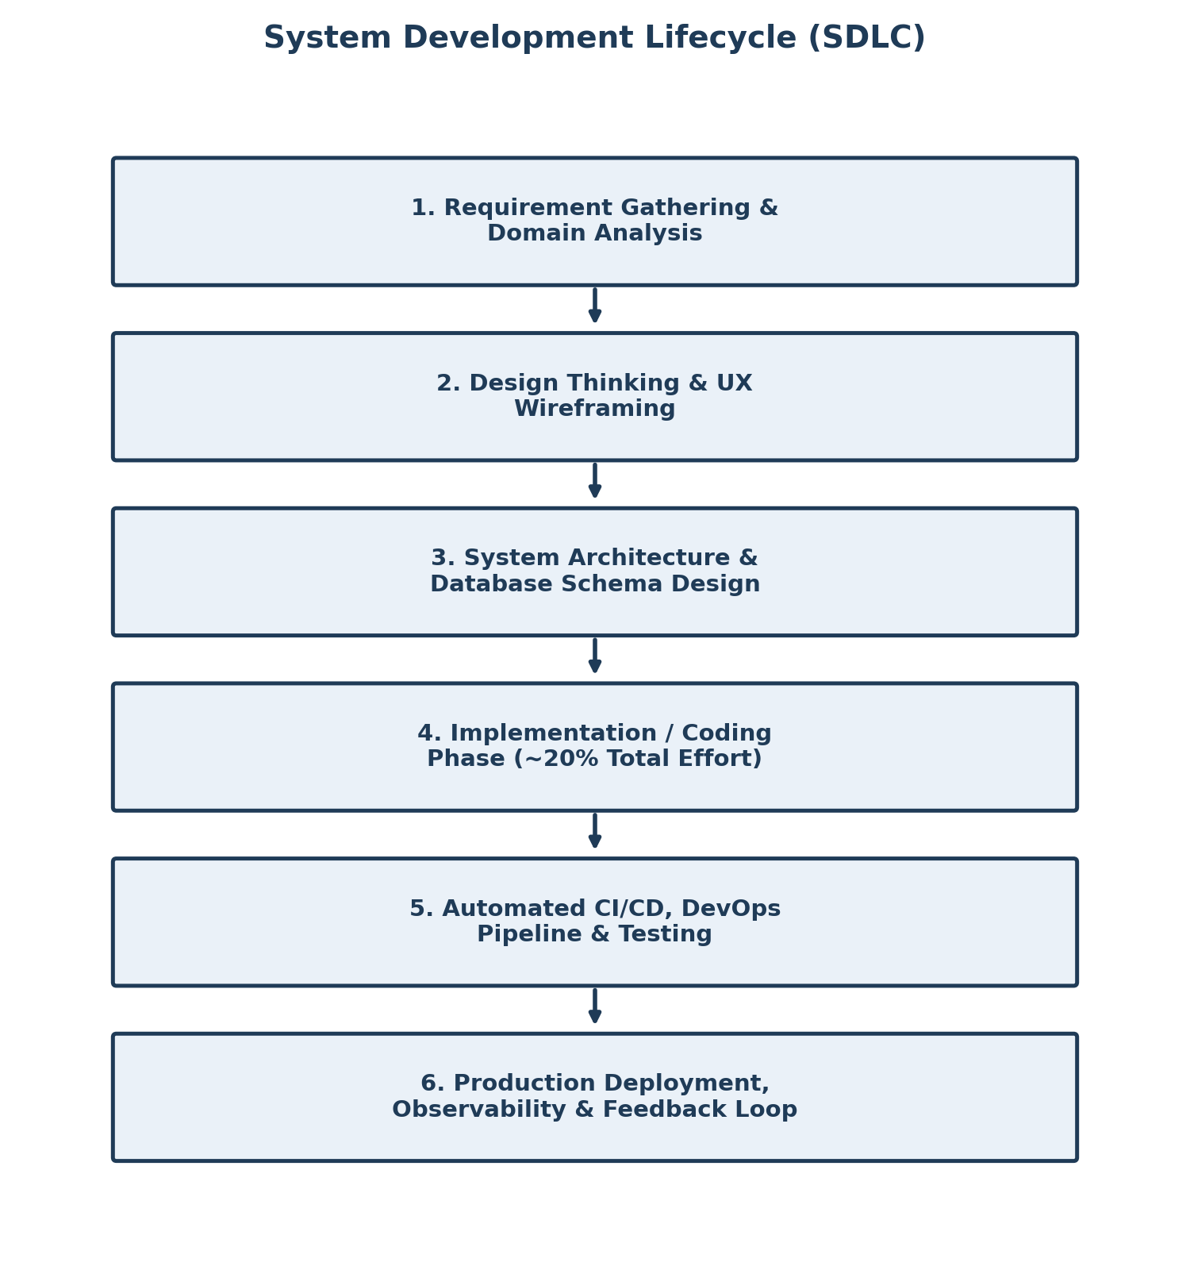
Figure 1: System Development Lifecycle followed for the Academic Management Platform

2. Business Understanding: Academic Management in Higher Education
Before writing code or provisioning infrastructure, engineers must master the business operations of the target environment. For this project, the target environment is the academic administration process of a higher-education institution, covering everything from a student's admission to the declaration of final results.

2.1 Core Operations in Academic Administration
- Student Admissions & Record Creation: Capturing student demographic data, prior academic records, PRN allocation, and enrolment into a department and class (e.g., SY AIML).
- Course Registration: Allowing students to register for semester subjects and electives, and mapping them to faculty and timetables.
- Attendance Management: Recording day-wise / lecture-wise attendance and computing eligibility percentages for examinations.
- Examination & Result Management: Scheduling internal and semester-end examinations, capturing marks, and generating grade cards and transcripts.
- Administrative Reporting: Generating compliance reports, defaulter lists, department-wise performance analytics, and audit trails for accreditation bodies.

2.2 Manual Process Challenges vs. Automated Platform Solutions
The comparative analysis below (modelled on the Careertiq Library Management case study) identifies how automation directly improves measurable academic outcomes.
Manual Operational Bottleneck | Automated Platform Solution | Business Outcome Metric
Paper-based admission forms and physical record folders per student. | Centralised digital student record database with structured schema. | Admission processing time reduced from days to minutes.
Manual attendance registers maintained per subject by faculty. | Digital attendance capture with automated percentage calculation. | Attendance defaulter identification improved by over 70%.
Hand-tabulated marks and manually typed grade cards. | Automated result-processing engine with grade computation. | Result declaration time reduced from weeks to under 48 hours.
Fragmented data across departments, prone to human error. | Relational database with strict integrity constraints and RBAC. | Record accuracy brought close to 99.9%.

3. Introduction to Design Thinking
Design Thinking is an iterative, human-centred problem-solving framework that prioritises deep empathy for users — in this case, students, faculty, and academic administrators — before evaluating technological constraints.

Core Principles Applied in This Project
- Human-Centred Innovation: Designing the registration and attendance workflows around how students and faculty actually behave, rather than forcing them into rigid administrative software.
- Creative Problem-Solving & Ideation: Encouraging a broad solution space (e.g., mobile attendance, auto-generated transcripts) before committing to technical implementation.
- Iterative Prototyping: Failing early and cheaply using wireframes of the registration and result-dashboard screens before writing backend code.

4. Applying the Five Stages of Design Thinking
The five-stage Design Thinking process — Empathize, Define, Ideate, Prototype, and Test — was applied to the Student Record and Academic Management Platform as follows.
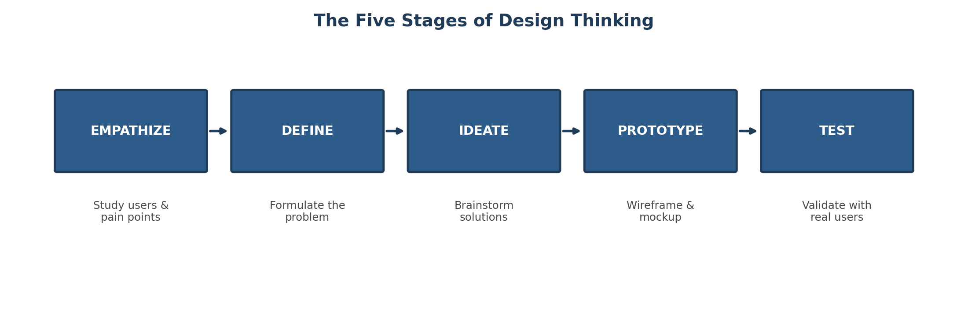
Figure 2: The Five Stages of Design Thinking applied to academic management

Stage 1: Empathize
The engineering team studied users in their natural academic workflow. Key user categories analysed include: Students, Faculty Members, Academic Administrators, Examination Cell Staff, and IT Support Personnel.

Stage 2: Define
Data collected during empathy building was organised into a definitive core problem statement:
“Students and faculty experience significant delays and errors in registration, attendance tracking, and result processing due to fragmented manual record-keeping. Academic administrators lack centralised, real-time visibility into student performance and compliance data, leading to reporting errors, delayed decision-making, and reduced institutional efficiency.”

Stage 3: Ideate
Unconstrained brainstorming produced a wide range of high-value capabilities: automated attendance-shortage alerts, digital ID/QR-based verification, self-service course registration, real-time result dashboards for parents and faculty, and automated compliance report generation.

Stage 4: Prototype
Low-fidelity wireframes were sketched for the core UI modules: Student Login & Dashboard, Course Registration Portal, Faculty Attendance & Marks Entry Screen, and the Administrator Analytics Panel.

Stage 5: Test
Paper prototypes were conceptually validated against student and faculty workflows to evaluate navigation flow, layout clarity, and task-completion speed prior to any frontend engineering work.

5. Enterprise Expansion: IBM Design Thinking
IBM Design Thinking scales human-centred design for large-scale enterprise delivery through three core pillars, each mapped below to the academic management context.
- 1. Focus on User Outcomes: Shifting technical goals to measurable human outcomes.
Feature Goal: “Build a student attendance database table.”
Outcome Focus: “Enable faculty to mark attendance for an entire class in under 60 seconds.”
- 2. Restless Reinvention: Treating continuous deployment (CD) as an ongoing refinement cycle — constantly analysing production usage (e.g., peak registration load) to improve UI layout and backend response speed.
- 3. Diverse Empowered Teams: Cross-functional collaboration across Academic Coordinators, UX Designers, Software Engineers, QA, Database Administrators, and DevOps Engineers.

6. The IBM Loop Engine
The platform is engineered using the continuous cycle of Observe → Reflect → Make, ensuring the product keeps evolving after its first release based on real usage from students, faculty, and administrators.
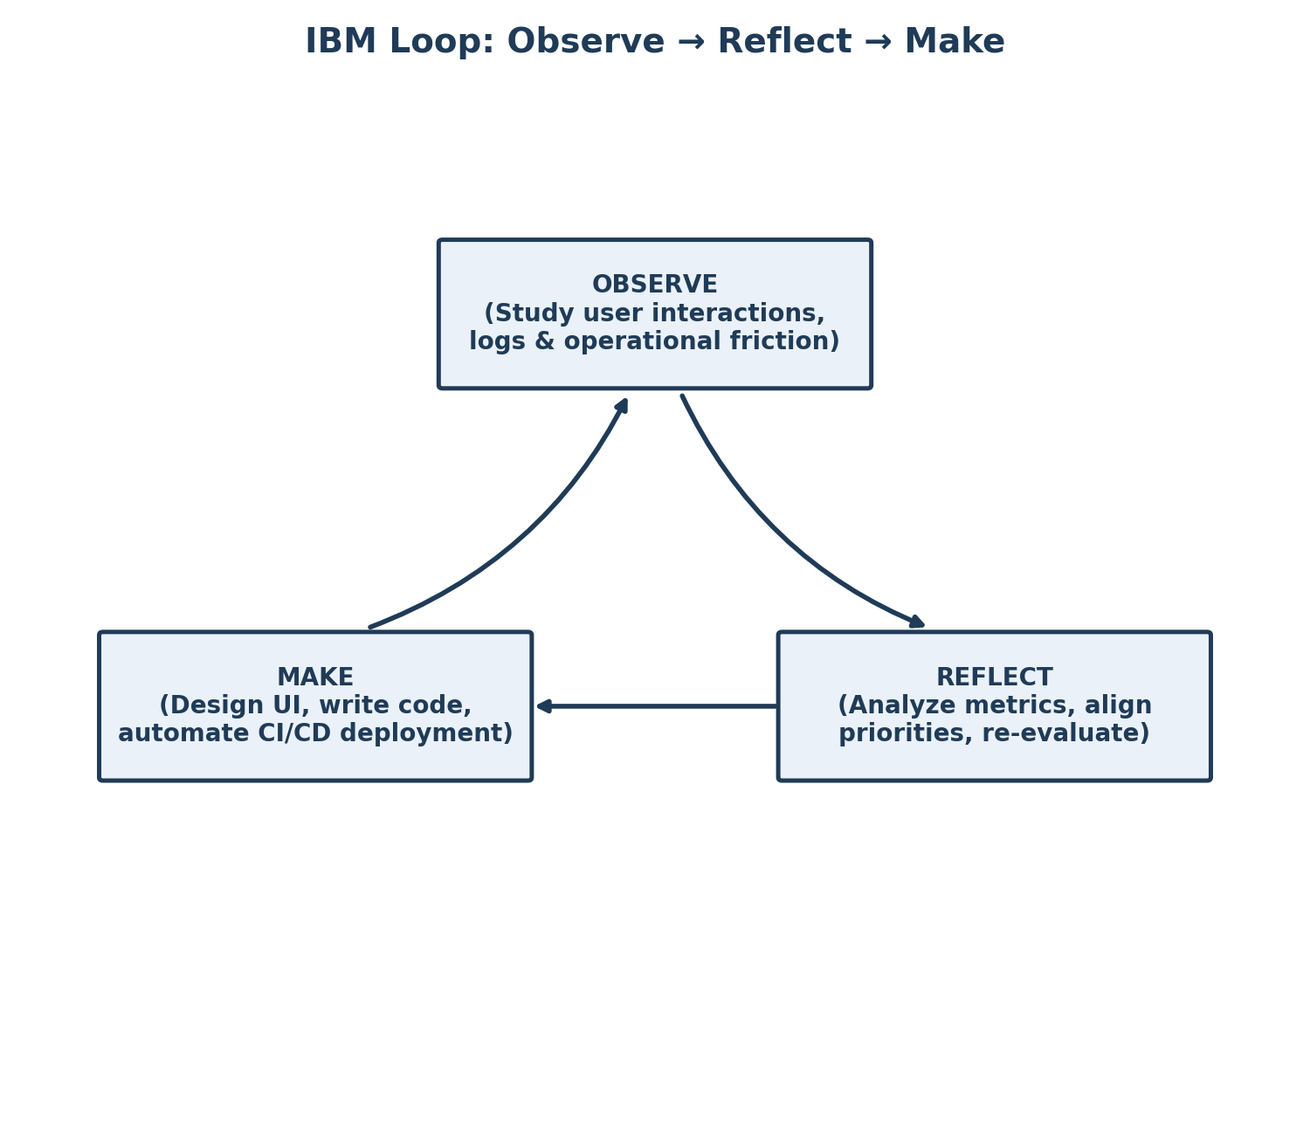
Figure 3: IBM Loop — Observe, Reflect, Make cycle for continuous product improvement

7. Stakeholder User Personas
Three representative personas were developed to guide feature prioritisation, capturing the goals, frustrations, and target platform features of each core user group.
User Persona | Primary Objectives | Key Frustrations & Pain Points | Target Platform Feature
Isha (Student) | Register for courses quickly; track attendance and results in real time. | Long queues for registration; delayed result declaration; no visibility into attendance percentage. | Self-service registration portal, live attendance & result dashboard.
Prof. Deshmukh (Faculty) | Mark attendance and enter marks quickly; monitor class performance. | Manual attendance registers; error-prone mark entry; no consolidated class view. | Digital attendance & marks-entry interface with class analytics.
Dr. Kulkarni (Academic Administrator) | Monitor institutional compliance; generate accreditation and defaulter reports. | Lack of real-time data; manual report compilation taking days. | Executive analytics dashboard with 1-click report export.

8. Stakeholder Matrix
Stakeholders were grouped into three categories, mirroring the structure used in enterprise product engineering, so that responsibilities and expectations are clearly separated.
Stakeholder Group | Key Roles | Responsibilities & Project Expectations
Business Stakeholders | College Management, Academic Administrators, Students, Faculty | Define the business vision, validate functional usability, ensure academic-policy compliance.
Engineering Stakeholders | Software Developers, UI/UX Designers, QA Engineers | Architect the codebase, build responsive frontends, write unit tests, and ensure high quality.
Operations Stakeholders | DevOps Engineers, Database Administrators, Security Team | Provision infrastructure, maintain database integrity, and automate CI/CD pipelines.

9. Requirements Engineering Specification

9.1 Functional Requirements (FRS)
- FR-01 Authentication: Secure Role-Based Access Control (RBAC) for Admin, Faculty, Student, and Examination Cell roles.
- FR-02 Student Record Management: Full CRUD operations for student profiles, admission data, and academic history.
- FR-03 Course Registration Engine: Self-service registration for semester subjects with real-time seat/eligibility validation.
- FR-04 Attendance Engine: Digital attendance capture with automated percentage calculation and shortage alerts.
- FR-05 Examination & Result Engine: Marks entry, automated grade computation, and transcript/report-card generation.
- FR-06 Notification System: Triggered email/SMS alerts for attendance shortage, exam schedules, and result declaration.

9.2 Non-Functional Requirements (NFRS)
- NFR-01 Security: Password hashing (Bcrypt/Argon2), JWT-based session management, and HTTPS encryption for all student data.
- NFR-02 Performance: Sub-500ms API response time for record and attendance queries under concurrent user load during peak registration periods.
- NFR-03 Availability & Scalability: Containerised deployment targeting 99.9% uptime with horizontal pod autoscaling during examination and result-declaration windows.
- NFR-04 Maintainability: Infrastructure as Code (IaC) modularity and clear separation of academic modules (admissions, attendance, results).
- NFR-05 Usability: Simple, mobile-responsive interfaces usable by students and faculty with minimal training.
- NFR-06 Reliability: Automated backups and audit trails to prevent loss of academic records.

10. Product Vision & Minimum Viable Product (MVP) Scope

Product Vision Statement
“To deliver a modern, automated, and cloud-native Student Record and Academic Management Platform that eliminates manual administrative overhead, streamlines registration, attendance, and result workflows, and delivers a transparent, real-time academic experience for students, faculty, and administrators.”

Mission Statement
“To empower every academic stakeholder — from first-year students to senior administrators — with reliable, real-time access to accurate academic data, reducing administrative overhead and improving institutional decision-making.”

Success Criteria & Business Objectives
- Reduce course-registration processing time from days to minutes.
- Achieve real-time attendance visibility for over 95% of active students.
- Cut result-declaration turnaround time by at least 70%.
- Maintain 99.9% platform uptime during peak academic periods (registration and examinations).

MVP Release Scope (Sprint 1–4)
To maintain agility, non-essential capabilities (such as AI-based academic performance prediction or third-party fee-payment gateways) are deferred to later releases. The MVP includes:
- Student & Faculty Login with Role-Based Access Control
- Student Record Creation and Profile Management
- Course Registration Module
- Attendance Capture and Percentage Calculation
- Basic Result Entry and Report Card Generation

11. Enterprise Engineering Roadmap
The roadmap phases the delivery of the platform from domain analysis through to production monitoring, aligning each phase with progressive DevOps maturity.
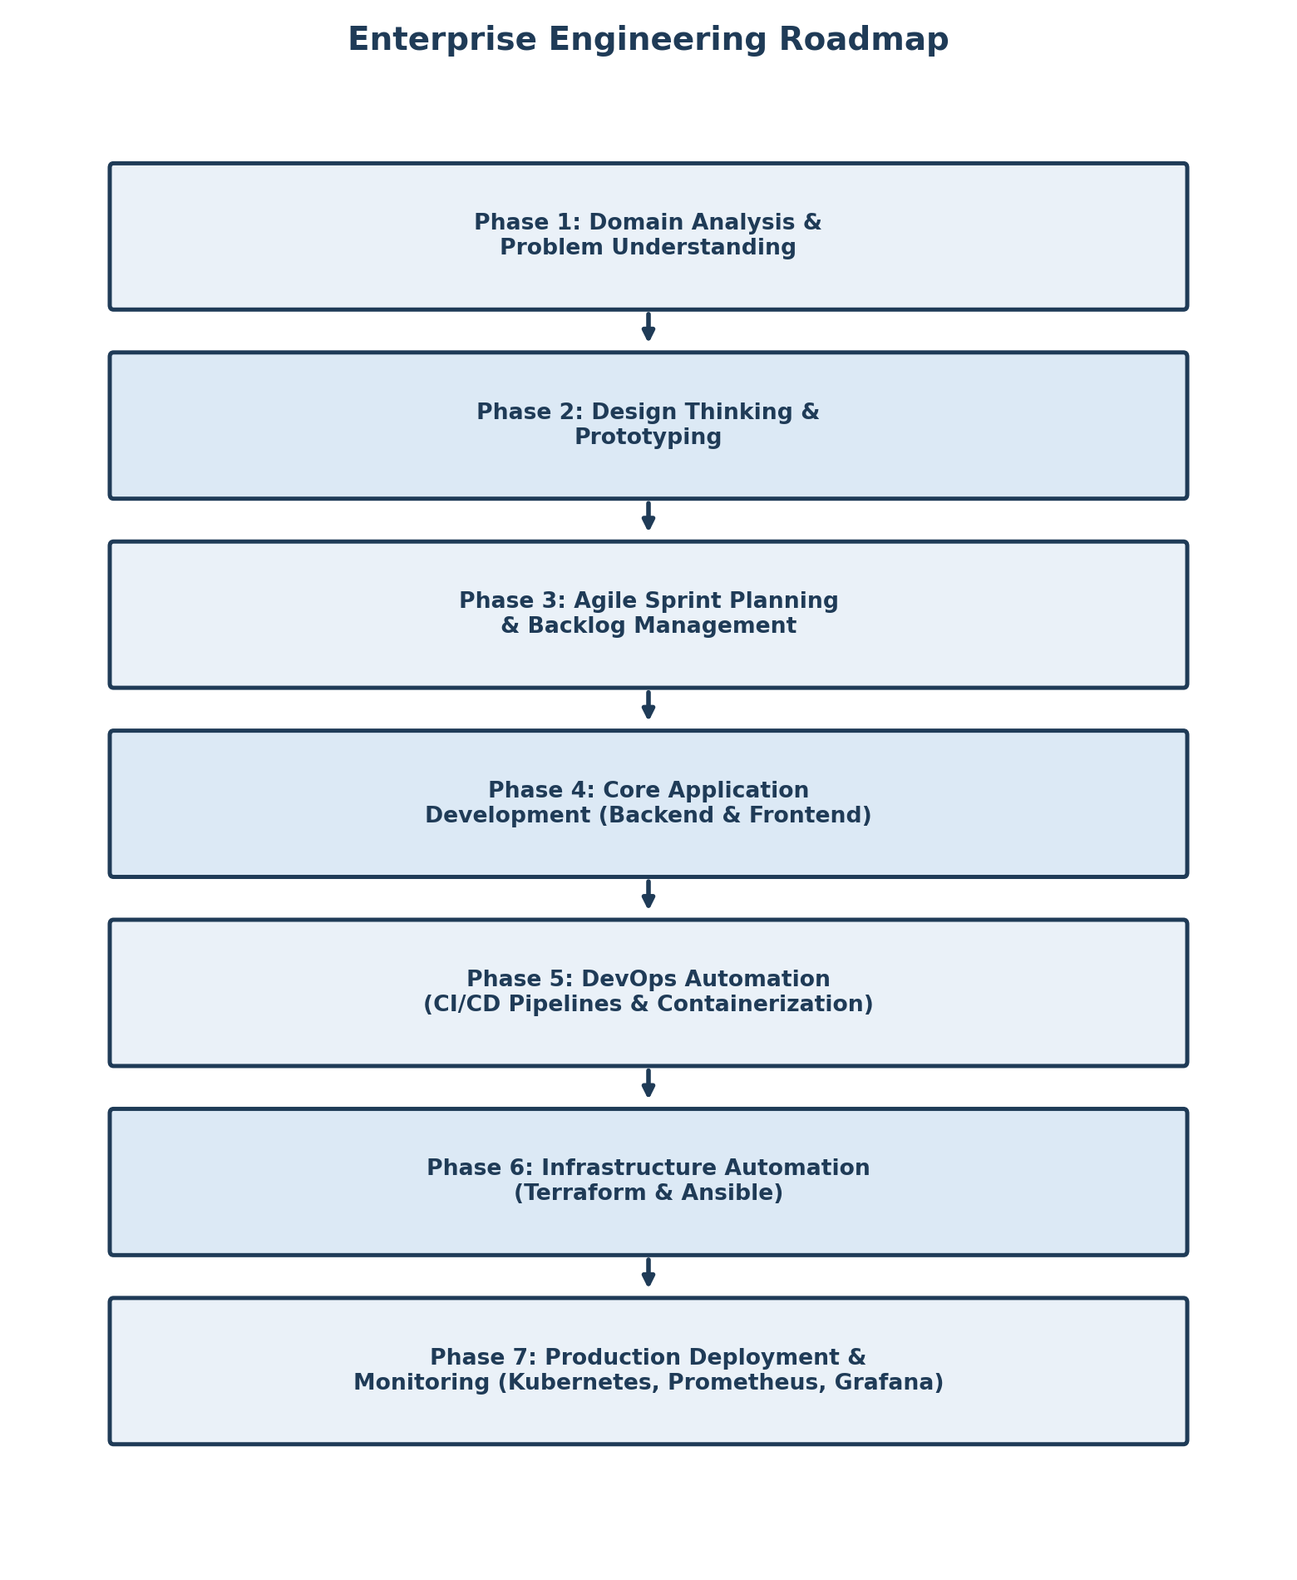
Figure 4: Enterprise Engineering Roadmap for the Academic Management Platform

12. System Architecture & Repository Structure
The initial system architecture separates the platform into a client layer, application/service layer, and database layer, with dedicated services for authentication, notifications, and reporting — all delivered through an automated CI/CD pipeline into a containerised runtime.

Figure 5: Initial System Architecture Overview

Repository Hierarchy
student-academic-platform/
├── .github/ # CI/CD Workflows (GitHub Actions)
├── app/ # Application Source Code
│ ├── modules/ # Business Logic (Students, Attendance, Results)
│ ├── database/ # Schemas, Migrations & ORM Models
│ └── tests/ # Automated Unit & Integration Tests
├── docs/ # Architecture Diagrams & FRS/NFRS Specs
├── docker/ # Dockerfiles & Multi-Container Compose Setup
├── kubernetes/ # K8s Manifests (Deployments, Services, Ingress)
├── terraform/ # Cloud Infrastructure Provisioning Scripts
├── ansible/ # Configuration Management Playbooks
├── monitoring/ # Prometheus & Grafana Dashboard Configs
└── README.md # Project Onboarding & Setup Instructions

Project Charter (Summary)
Item | Detail
Project Name | Enterprise Student Record and Academic Management Platform
Prepared By | Shriraj Kamble (PRN: 2125UMLM1030), SY AIML
Project Sponsor | Careertiq Training & Engineering Division
Objective | Design a Design-Thinking-driven product plan for academic record management prior to Agile development.
Key Milestones | Domain Analysis → Design Thinking → Requirements → MVP Definition → Roadmap → Repository Initialization
Repository Status | Git repository initialised with standardised folder architecture (see structure above).

13. Student Deliverables Checklist
The following deliverables, as specified in the Unit 1 Mini Project brief, have been completed and are documented within this report:
☑ Business Requirements Document (BRD)
☑ Product Vision Document
☑ Stakeholder Analysis Report
☑ User Persona Report
☑ Functional Requirements Specification (FRS)
☑ Non-Functional Requirements Specification (NFRS)
☑ Design Thinking Report
☑ IBM Design Thinking Report
☑ IBM Loop Documentation
☑ MVP Definition
☑ Product Roadmap
☑ Initial System Architecture Diagram
☑ Project Charter
☑ Project Repository Initialization
☑ Project Folder Structure

14. Conclusion
This mini project applied the complete Design Thinking and enterprise product-engineering methodology — demonstrated through the Library Management Platform case study — to an independent domain: the Enterprise Student Record and Academic Management Platform. By empathising with students, faculty, and administrators before writing any code, the project produced a validated problem statement, a clear product vision, a prioritised MVP, and a phased engineering roadmap. This structured foundation ensures that subsequent units — covering Agile sprint planning, backend/frontend development, and DevOps automation — can proceed with a well-understood domain, clear requirements, and an initialised repository, minimising the risk of the misaligned-requirement and communication-silo failures discussed in Section 1.

