**Experiment 1:**

**<!DOCTYPE html>**

**<HTML>**



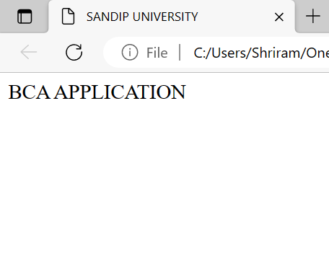**<HEAD>**



**<TITLE>**

**SANDIP UNIVERSITY**

**</TITLE>**

**</HEAD>**

**<BODY>**

**BCA APPLICATION**

**</BODY>**

**</HTML>**

**Experiment 2:**

**<!DOCTYPE html>**

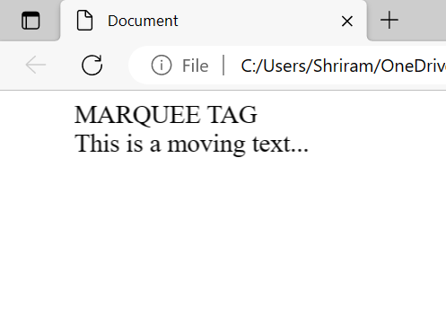**<html>**

**<head>**

**<title>Document</title>**

**</head>**

**<body>**

**<marquee>**

**MARQUEE TAG <br>**

**This is a moving text...**

**</marquee>**

**</body>**

**</html>**

**Experiment 3:**

**<!DOCTYPE html>**

**<html>**

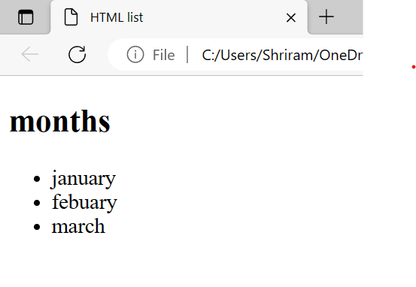**<head>**

**<title>HTML list</title>**

**</head>**

**<body>**

**<h2>months</h2>**

**<ul>**

**<li>january</li>**

**<li>febuary</li>**

**<li>march</li>**

**</ul>**

**<body>**

**<html>**

**Experiment 4:**

**<!DOCTYPE html>**

**<html>**

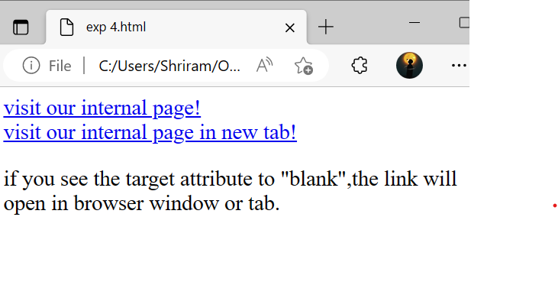**<body>**

**<a href="extrenal.html">visit our internal page!</a>**

**<br>**

**<a href="external.html"target="-blank">visit our internal page in new**

**tab!</a>**

**<p>if you see the target attribute to "blank",the link will open in browser window or tab.</p>**

**</body>**

**</html>**

**Experiment 5:**

**<!DOCTYPE html>**

**<html>**

**<td>Physics</td>**

**<td>Chemistry</td>**

**<td>English</td>**

**<td>Computer Science</td>**

**</tr>**

**<tr>**

**<td>10:00 AM - 11:00 AM</td>**

**<td>Physics</td>**

**<td>Chemistry</td>**

**<td>English</td>**

**<td>Computer Science</td>**

**<td>Mathematics</td>**

**</tr>**

**<tr>**

**<td>11:00 AM - 12:00 PM</td>**

**<td>Chemistry</td>**

**<td>English</td>**

**<td>Computer Science</td>**

**<td>Mathematics</td>**

**<td>Physics</td>**

**</tr>**

**</table>**

**</body>**

**</html>**

**<head>**

**<title>College Timetable</title>**

**<style>**

**table {**

**border-collapse: collapse;**

**}**

**th, td {**

**border: 1px solid black;**

**padding: 10px;**

**}**

**</style>**

**</head>**

**<body>**

**<h1>College Timetable</h1>**

**<table>**

**<tr>**

**<th>Time/Day</th>**

**<th>Monday</th>**

**<th>Tuesday</th>**

**<th>Wednesday</th>**

**<th>Thursday</th>**

**<th>Friday</th>**

**</tr>**

**<tr>**

**<td>9:00 AM - 10:00 AM</td>**

**<td>Mathematics</td>**

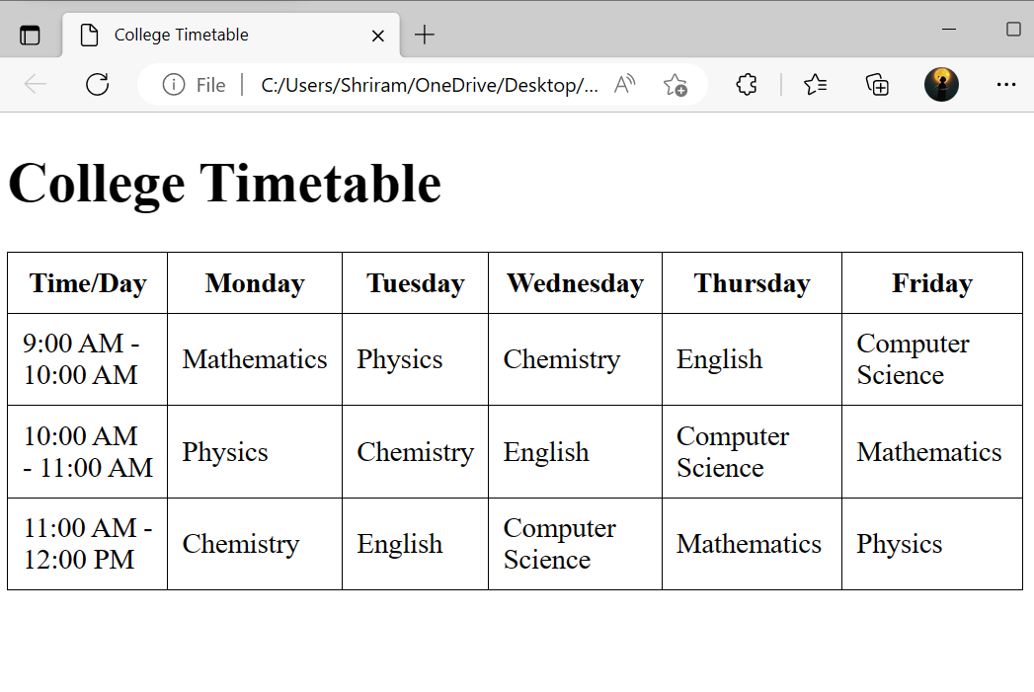

**Experiment 6:**

<html>

<head>

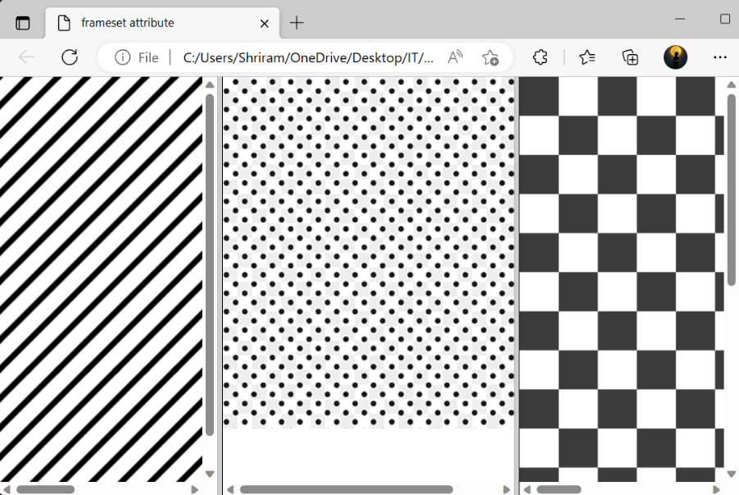 <title>frameset attribute</title>

</head>

<frameset cols="30%, 40%, 30%">

<frame name="top" src="line.png" />

<frame name="main" src="dot.png" />

<frame name="bottom" src="square.png" />

<noframes>

<body>The browser you are working does

not support frames.</body>

</noframes>

</frameset>

</html>

**Experiment 7:**

**<DOCTYPEhtml>**

**<html>**

**<head>**

**<title>**

**Registration form**

**</title>**

**</head>**

**<body bgcolor="lightyellow">**

**<form>**

**<lable>First Name</lable>**

**<input type="text" name="First Name" size="15" /><br><br>**

**<lable>Middle Name</lable>**

**<input type="text" name="Middle Name" size="15" /><br><br>**

**<lable>Last Name</lable>**

**<input type="text" name="Last Name" size="15" /><br><br>**

**<lable>**

**course:**

**</lable>**

**<select>**

**<option value="Course">Course</option>**

**<option value="BCA">BCA</option>**

**<option value="BBA"> BBA</option>**

**<option value="B.TECH">B.TECH</option>**

**<option value="MCA">MCA</option>**

**<option value="MBA">MBA</option>**

**<option value="MBA">OTHER</option>**

**<option value="MBA">NONE OF THIS</option>**

**<option value="M.TECH">M.TECH</option>**

**</select>**

**<br><br>**

**<lable>**

**Gender:**

**</lable><br><br>**

**<input type="radio" name="male" />Male<br><br>**

**<input type="radio" name="female" />Female<br><br>**

**<input type="radio" name="other" />Other<br><br>**

**<lable>**

**Phone:**

**</lable><br><br>**

**<input type="text" name="Country Code" value="+91" size="2" />**

**<input type="text" name="phone" size="10" /><br><br>**

**Address:**

**<br>**

**<textarea cols="80" rows="5" value="address">**

**</textarea>**

**<br><br>**

**Email:**

**<input type="email" id="email" name="email" /><br><br>**

**Password:**

**<input type="password" id="pass" name="pass"><br><br>**

**<input type="button" value="Submit" />**

**</form>**

**</body>**

**<html>**

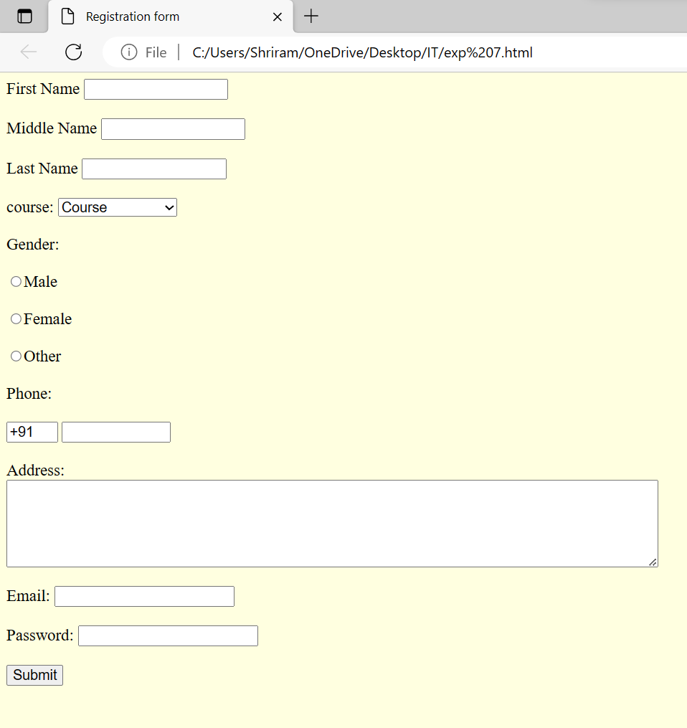

**Experiment 8:**

**<!DOCTYPE html>**

**<html>**

**<head>**

**<title>Display Larger Number</title>**

**<script>**

**function displayLargerNumber() {**

**var num1 = parseInt(document.getElementById('num1').value);**

**var num2 = parseInt(document.getElementById('num2').value);**

**var largerNumber;**

**if (num1 > num2) {**

**largerNumber = num1;**

**} else if (num2 > num1) {**

**largerNumber = num2;**

**} else {**

**largerNumber = 'Both numbers are equal.';**

**}**

**document.getElementById('output').textContent = 'The larger number is: ' + largerNumber;**

**}**

**</script>**

**</head>**

**<body>**

**<h1>Display Larger Number</h1>**

**<label for="num1">First Number:</label>**

**<input type="number" id="num1"><br>**

**<label for="num2">Second Number:</label>**

**<input type="number" id="num2"><br>**

**<button onclick="displayLargerNumber()">Find Larger Number</button>**

**<p id="output"></p>**

**</body>**

**</html>**

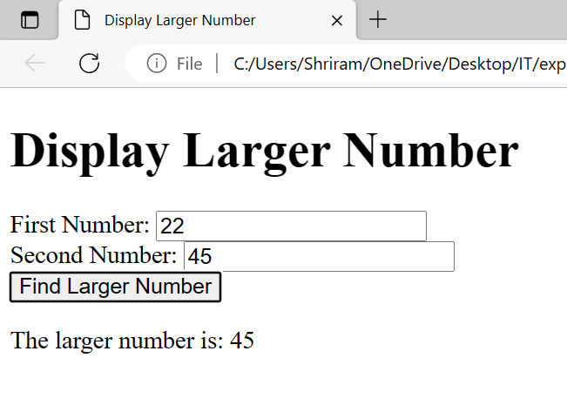

**Experiment 9:**

**<!DOCTYPE html>**

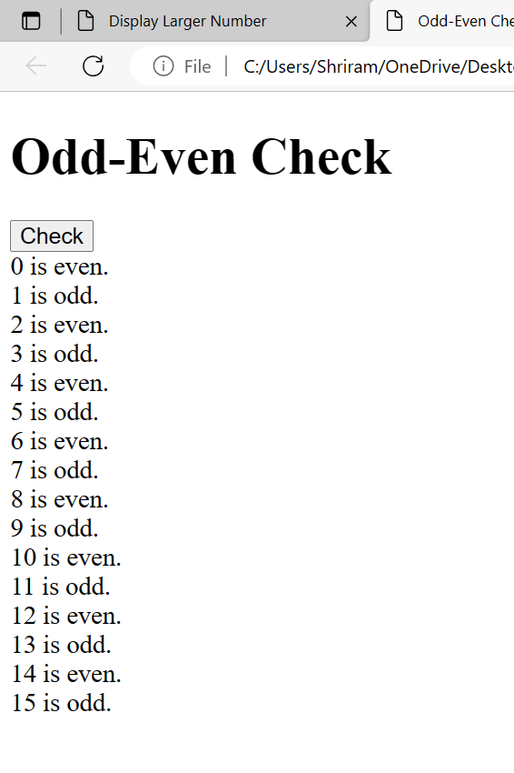**<html>**

**<head>**

**<script>**

**function checkOddEven() {**

**var result = "";**

**for (var i = 0; i <= 15; i++) {**

**if (i % 2 === 0) {result += i + " is even.<br>";} else {result += i + " is odd.<br>";}}**

**document.getElementById('output').innerHTML = result;}**

**</script>**

**</head>**

**<body>**

**<h1>Odd-Even Check</h1>**

**<button onclick="checkOddEven()">Check</button>**

**<div id="output"></div>**

**</body>**

**</html>**

**Experiment 10:**

**<!DOCTYPE html>**

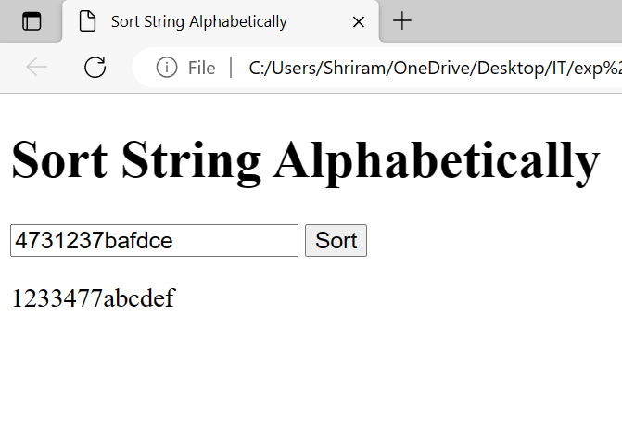**<html>**

**<head>**

**<title>Sort String Alphabetically</title>**

**<script>**

**function sortStringAlphabetically(inputString) {**

**const characters = inputString.split('');**

**const sortedCharacters = characters.sort();**

**const sortedString = sortedCharacters.join('');**

**return sortedString;**

**}**

**function handleSortButtonClick() {**

**const inputString = document.getElementById('input').value;**

**const sortedString = sortStringAlphabetically(inputString);**

**document.getElementById('output').textContent = sortedString;**

**}**

**</script>**

**</head>**

**<body>**

**<h1>Sort String Alphabetically</h1>**

**<input type="text" id="input" placeholder="Enter a string">**

**<button onclick="handleSortButtonClick()">Sort</button>**

**<p id="output"></p>**

**</body>**

**</html>**

**Experiment 11:**

**<!DOCTYPE html>**

**<html>**

**<head>**

**<title>Join Array Elements</title>**

**<script>**

**function joinArrayElements() {**

**const mycolor = ['red', 'green', 'white', 'black'];**

**const joinedString = mycolor.join(', ');**

**document.getElementById('result').textContent = joinedString;**

**}**

**</script>**

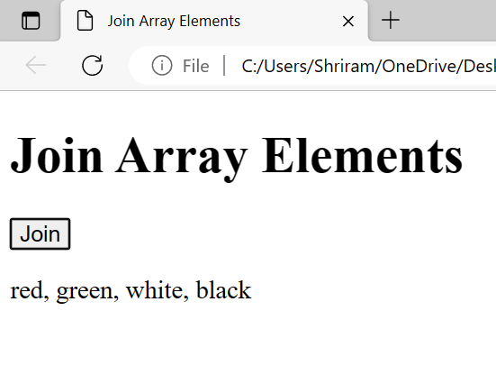**</head>**

**<body>**

**<h1>Join Array Elements</h1>**

**<button onclick="joinArrayElements()">Join</button>**

**<p id="result"></p>**

**</body>**

**</html>**