SE LAB 04
NAME:SHRIRAM CHANDRASEKAR
SRN:PES2UG24CS495

PROMPT’S:

TASK1:
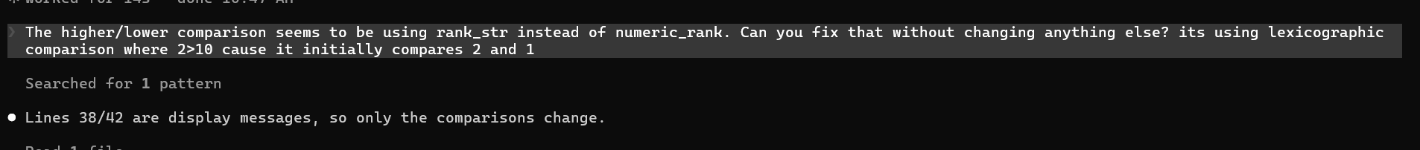
TASK2: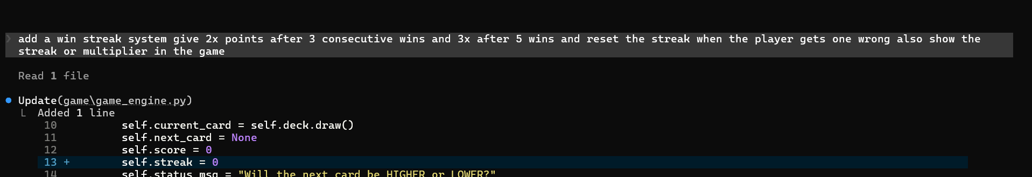
TASK3:
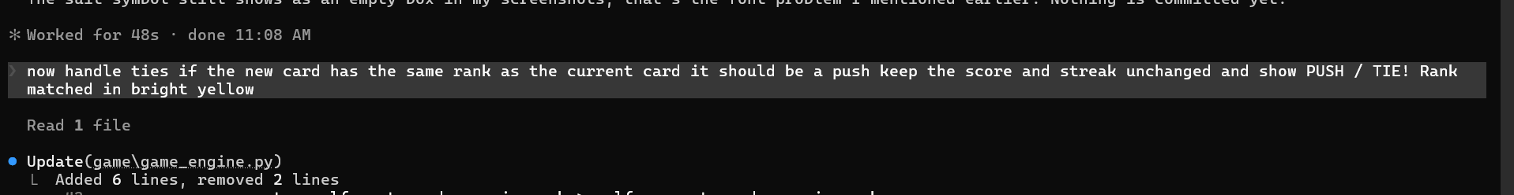
TASK4:

