Abstract -238 words

Introduction - 2000

Literature Review and Technology Assessment - 2500

Execution – 2500

Evaluation and Discussion - 2500

Conclusions – 1000

1000 words to play with

# Abstract

Mobile application development has seen huge increases in recent years due to the front row seat that mobile devices have taken in modern life and the constant push to streamline it. Location services have been one of the area’s driving trends; with the ability to accurately locate an individual indoors being a large new emerging wish from users and has been looked into for some time with most technologies requiring specific hardware or being too inaccurate. Indoor positioning systems are becoming an important investment for many organizations or groups of individuals with one such being students for finding class rooms quickly. The ability to base an indoor positioning system to function with existing technology and installed infrastructure would help benefit these groups in the roll out of such systems.

This develop and test project investigated how accurate an indoor positioning system can be using only WIFI signals from router points on an android mobile device. To evaluate the project an android application was developed application that could show a user’s position on a virtual map of the building. The accuracy of the application was determined from field testing known locations against the applications location points. The results from the testing provided evidence that supports that a WiFi based indoor location system is feasible to an extent with an average overall accuracy of within 10 meters which could be developed further in the future to provide more accuracy results.

# Acknowledgements

I would like to thank Iain Lambie, project supervisor, for the help and guidance to bring this project to fruition through both development and write-ups.

Additionally, I would also like to show my appreciation to Aaron and Lola Whitter’s for their role in proof reading and providing support to the project.

# Introduction

## Project Background

Mobile devices have become more and more prevalent in our modern life with almost 92% of the world’s population now owning a mobile device (Grimus & Ebner, 2015) and the actual use of smartphones has become so integrated that it is one of the first and last things we use each day with 36% - 40% of smartphone users checking their phone within 5 minutes of waking up and going to bed (Montag et al., 2015). The ever presence of these devices has led to a constant strive to develop applications that can help streamline everyday life and make as many services available to users as possible. This potential for life integrated use of mobile applications was even shown by head of state figures such as the then President Obama, who’s pledge to have two public services available through mobile phones at his speech in 2012 (Rakestraw et al., 2012) was a further boost for the industry. The constant boom of the mobile market has given rise to a number of application trends and their integration into everyday life. This boom has given way to a huge sector for developing application with many methods and different languages that can be used to implement applications on different platforms. This sector is also seeing a number of driving trends that users are becoming more and more aware of.

One of these driving trends in application development and the mass market currently is location positioning and location based services (Fedorychak, 2018). While not a new technology, with the first appearance of location based services appearing in 2001 (Michael, 2004), it is the advancement in technology and growth of the mobile market that has given way to the ability to integrate location positioning into many applications, from direction applications like Google maps to even gaming such as the handheld game PokemonGo, as shown in figure 1. The wide implementation of location services into many different products has led to one third of all mobile searches being location related (Ramaswamy, 2016).

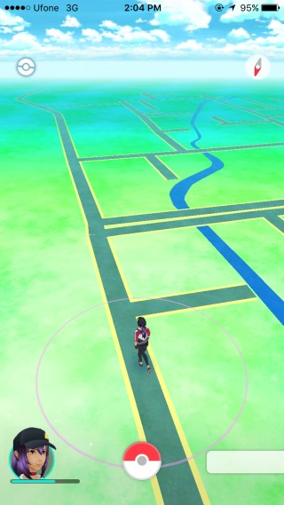

Figure - PokemonGo Location Game (Niantic, 2018)

Location services have also found implementation in applications that are not even directly linked to location. Social media applications have adopted location services to show users the friends in their proximity or even filter content to show relevant nearby information (Scassa, Sattler 2011). Large adoption of location services has mainly remained in the outdoor or world position. These integrations have created a major market because of the convenience they cause for users whether it is getting them from point A to point B quicker or giving them the quick glance at how near they are to a desired person or product. In terms of games they have also found the novelty of exploration and use of exploration in location games helps with enjoyment and learning (Wake, 2013) but in recent years the market for location based systems has seen a large increase in interest for indoor localization as well; this can be due to the performance and abilities of outdoor positioning being already established (Mautz, 2012) and the mass market already currently utilizing it. Indoor location positioning is a natural advancement in positioning technology that has generated interest from users and researchers helping shift potential from outdoors to indoor positioning (Nhlanhla, Adeyeye-Oshin et al. 2017)

The current potential for the utilization of indoor positioning is also leading its growth within applications as it opens the ability for a plethora of different purposes that cover a large technology area to be developed. Companies in the Internet of Things area can utilize it for asset tracking indoors (Hui Liu, Darabi, Banerjee & Jing Liu, 2007), universities could implement a system that provides indoor positioning for students – particularly those with disabilities i.e. to find the most accessible route (G. Delnevo et al., 2018) or in a landmark setting where visitors and tourists can be shown their position in an area and nearby points of interest. Further potentials for indoor positioning could be the progression from standard standalone positioning in a building to the ability to show users paths to a specified destination indoors or even the ability to calculate the time it will take to get between two points in a building. The progression of the technology has many knock on affects that it can solve such as cutting down time getting lost in airport terminals or getting lost between classes at an institute of education. While systems for the previous examples exist in static maps and diagrams are readily available it is an analogue system that many people still find access to difficult and it can be time consuming to locate themselves on or to find the best route through.

Even with the ability to adhere this technology to many possible helpful everyday systems, the emergence of systems like these has been slow, in part due to the problems that currently affect indoor localization - the largest problem being a reliable set technology that is easily applied. Global Positioning System (GPS) is the main technology used for world positioning (Montenbruck, Ramos-Bosch 2008) and is used by Google to position users in their Google Maps application (Garude, Haldikar 2014). While GPS can also obtain a position indoors it is often obscured by walls and building material which make it too inaccurate to be used (Farid, Nordin & Ismail, 2013) this has required other technologies to be developed to allow a more accurate indoor positioning system to be feasible.

The various current technologies include Bluetooth sensors, Ultrasonic positioning, Radio Frequency Identification (RFID), and Wi-Fi (He Xu et al., 2017). RFID currently has numerous implementations but the consistent set up is to have the individual wear appropriate RFID tags since most modern mobile devices use Near-Field Communication (NFC) instead which only has a range of 4 inches (Chandler, 2012). The RFID tags would interact with RFID scanners in the building which relay the interaction back to a server from which the mobile phone would be connected giving a user their position (Y Ortakci, E Demiral, U Atila & I R Karas, 2015). This method brings many downsides which have been witnessed in its already widespread use - in areas such as supermarkets, it may be unfeasible to provide every individual in the building the required RFID tag to wear and it can become costly. Amazon has set up a supermarket that tracks products and individuals in a store to provide a checkout free experience using many cameras and RIFD tags (Likhitha, Anusha et al. 2018). This shows the real life implications are more than possible despite the downsides but the accuracy of such a system relies on many RFID scanners placed within the building which is expensive and not viable for smaller enterprises looking to adopt an indoor localization system as this also does not encompass the labour or installation costs. Amazon’s store also uses the camera systems to aid the RIFD detections in this process which would stem for a complex and bulky system to maintain. One of the reasons RFID tags have wide spread use, especially in the agriculture area, is due to the robustness of the tags in a harsh environment (Ruiz-Garcia, Lunadei 2011) yet such robustness would typically not be needed in an indoor setting.

Currently the largest growing technology for indoor positioning is Bluetooth Low Energy (BLE) beacons. This rapidly developing technology has seen uptake due to its use of Bluetooth Low Energy which can have high throughput whilst having a more power efficient operation compared to other device communication protocols (Rondón, Gidlund & Landernäs, 2017). Usual set ups for beacon based indoor positioning systems as exemplified in figure 2 are consisted of multiple BLE beacons in an area that will interact with a mobile application which may use an external database to receive the stored data positions of the beacons and triangulate its own position (infsoft, 2015). Many companies are providing easy to use software to develop systems like this due to its prevalence and ability to be used beyond just positioning systems. Problems still arise with a positioning system based on this concept however due to, once again, high costs and labour time to fit a building with beacons. Currently Bluetooth also has to be active to allow this system to work whereas only 60% of mobile users have their Bluetooth active (Coombs, 2017) meaning users can still be missed out in this system. Another factor holding back beacons from dominating the indoor positioning development productions is that beacons have certain security issues that have yet to be ironed out like piggybacking (Gąsiorek, 2016) where users tailgate with another person’s data. This goes against current trends to ensure all produced applications for mobile devices are secure (KHARCHENKO, 2017).

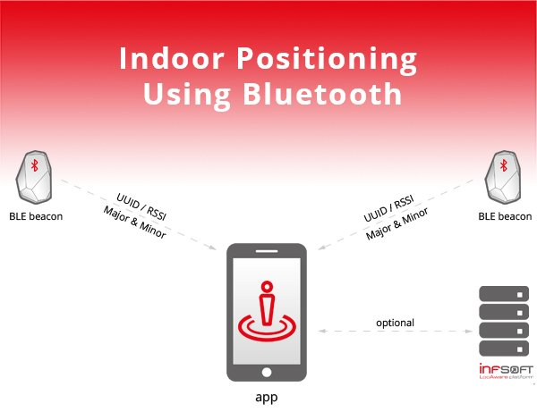

Figure - BLE beacon positioning system (infsoft, 2015)

Costly and labour intensive technologies such as these have led to investigations into the possible use of an already established system such as Wi-Fi signals from already installed router points in a building which would connect to a device instead of using proprietary hardware. Making use of the potentials of Wi-Fi and router technology with such a system would save an organization valuable time and money because of the use of an already installed and operating system to provide the indoor localization. This would also allow the integration of an indoor positioning system in any building that had an existing router network by allowing the received Wi-Fi signals to be received to a device and location determined through a trilateration technique (Bianca Bobescu & Marian Alexandru, 2015) such as the one shown in figure 3. Most major public buildings have Wi-Fi installed due to continuing public expectations of readily available Wi-Fi with almost 40% of people considering no Wi-Fi as a deal breaker when booking a hotel (boostandco, 2017). This expectation means the adoption of such a technology could be greatly accomplished due to the existence of an already popular platform which could potentially solve the problem of costly and sometimes inaccurate indoor positioning that other systems currently provide.. While this shows a clear benefit to a Wi-Fi signal based system compared to other technologies there will still have to be investigations into the accuracy of this particular technology to ensure it is a feasible method of positioning an individual indoors as well as ensuring it can be as accurate as other forms of indoor positioning.

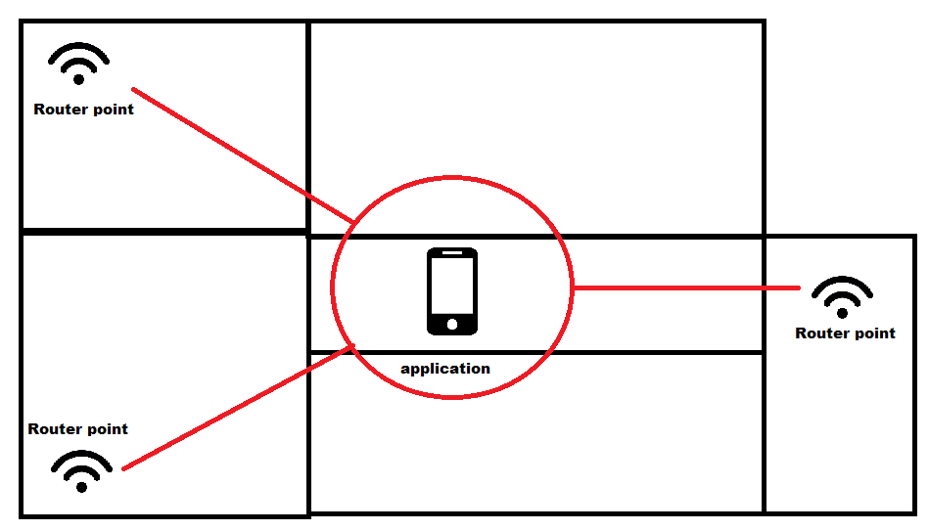

Figure - Trilateration of signals from router points

## Project Outline

This section further details the explicit aim of this project and the research question that it aims to answer. It will also provide the list of research objectives that will build up the main literature review and provide a hypothesis.

### Project Aim and Method

This project aims to determine the feasibility of an indoor positioning system using received Wi-Fi signals from router points and using it for mass market Android applications with the results having the potential to open up the already established technology in new directions without the addition of specialised hardware or labour intensive installations. The project was executed by developing an application and testing it to allow full access to the potential feasibility.

The application developed was android based and would allow a user to view the test building and the application would determine their current location within it by using the received WiFi signals from the existing router infrastructure. The location aspects of the project made it clear that android would be an ideal platform as there is a plethora of android mobile devices and it has a large support base and open source-esque quality. The testing was initially devised as group user testing but was changed as it was out of scope for the project and instead the application was tested within the test building with results taking the foreground. The test environment chosen was a university building due to the real life relevance such an environment would have. The project only sought to test the application on the top three floors of the building in the quite evening time as this allowed for less signal interference giving the testing results more weight on the technology which was more relevant to the project. Testing sought to look at the application and technologies ability to position a user accurately in terms of both floor situation and XY position on that floor, additional abilities such as room positioning was also marked for supplementary evidence.

The research question that will drive this project is:

**How accurate can an indoor positioning system be using the received Wi-Fi signals from access points by an Android mobile device?**

### Project Method

### Objectives

This section highlights both the secondary research objectives and the primary research objections that will make up this project. These objectives will be further explored in more detail within this report.

**Objectives to be completed by the way of a main literature review:**

SO1: Examine the accuracy of other forms of indoor positioning

The project’s examination of the feasibility of Wi-Fi accuracy has to be done against the accuracy of other systems such as the aforementioned BLE or RFID. While those systems are impractical in an installation manner, the accuracy of those systems should be examined to compare against the accuracy of Wi-Fi indoor positioning.

SO2: Investigate Wi-Fi and signal technology.

Due to the project’s reliance on received Wi-Fi signals and device interaction with routers, it is important to research an overview of Wi-Fi, Router and Network technology to gain a confident understanding of the systems that will allow the application to determine the device’s location.

SO3: Investigate Android application development.

A deep understanding of Android application development will be needed as a whole for the development of the project. Investigations into current language trends, technology usage and software related configurations are a priority for the project since it relies on the development of an Android application. All parts of this investigation will be used in practical implementation and will be utilised for a smooth development stage.

## Hypothesis

Testing the hypothesis would involve testing the application in specified areas and mark how accurate the application is in determining their position then comparing this accuracy against other forms of indoor positioning. The hypothesis for this project is:

The feasibility of using received Wi-Fi signals from access point by an Android device for an indoor positioning system will be accurate to an extent but will be less so than other forms of indoor positioning systems while also coming with its own forms of restrictions.

Justification for this hypothesis comes from the ability of Wi-Fi signals to fluctuate (Bai, Wu et al. 2014) which may affect the positioning of the application. This may not affect the accuracy as much however as the presence of multiple access points sending signals may offset this.

## Project Structure

This section gives a brief description and overview of the following sections covered within this project.

### Literature Review and Technology Assessment

The application developed was android based and would allow a user to view the test building and the application would determine their current location within it by using the received WiFi signals from the existing router infrastructure. The location aspects of the project made it clear that android would be an ideal platform as there is a plethora of android mobile devices and it has a large support base and open source-esque quality. The testing was initially devised as group user testing but was changed as it was out of scope for the project and instead the application was tested within the test building with results taking the foreground. The test environment chosen was a university building due to the real life relevance such an environment would have. The project only sought to test the application on the top three floors of the building in the quite evening time as this allowed for less signal interference giving the testing results more weight on the technology which was more relevant to the project. Testing sought to look at the application and technologies ability to position a user accurately in terms of both floor situation and XY position on that floor, additional abilities such as room positioning was also marked for supplementary evidence.

### Execution

The application developed was android based and would allow a user to view the test building and the application would determine their current location within it by using the received WiFi signals from the existing router infrastructure. The location aspects of the project made it clear that android would be an ideal platform as there is a plethora of android mobile devices and it has a large support base and open source-esque quality. The testing was initially devised as group user testing but was changed as it was out of scope for the project and instead the application was tested within the test building with results taking the foreground. The test environment chosen was a university building due to the real life relevance such an environment would have. The project only sought to test the application on the top three floors of the building in the quite evening time as this allowed for less signal interference giving the testing results more weight on the technology which was more relevant to the project. Testing sought to look at the application and technologies ability to position a user accurately in terms of both floor situation and XY position on that floor, additional abilities such as room positioning was also marked for supplementary evidence.

### Evaluation and Discussions

The application developed was android based and would allow a user to view the test building and the application would determine their current location within it by using the received WiFi signals from the existing router infrastructure. The location aspects of the project made it clear that android would be an ideal platform as there is a plethora of android mobile devices and it has a large support base and open source-esque quality. The testing was initially devised as group user testing but was changed as it was out of scope for the project and instead the application was tested within the test building with results taking the foreground. The test environment chosen was a university building due to the real life relevance such an environment would have. The project only sought to test the application on the top three floors of the building in the quite evening time as this allowed for less signal interference giving the testing results more weight on the technology which was more relevant to the project. Testing sought to look at the application and technologies ability to position a user accurately in terms of both floor situation and XY position on that floor, additional abilities such as room positioning was also marked for supplementary evidence.

### Conclusions

The application developed was android based and would allow a user to view the test building and the application would determine their current location within it by using the received WiFi signals from the existing router infrastructure. The location aspects of the project made it clear that android would be an ideal platform as there is a plethora of android mobile devices and it has a large support base and open source-esque quality. The testing was initially devised as group user testing but was changed as it was out of scope for the project and instead the application was tested within the test building with results taking the foreground. The test environment chosen was a university building due to the real life relevance such an environment would have. The project only sought to test the application on the top three floors of the building in the quite evening time as this allowed for less signal interference giving the testing results more weight on the technology which was more relevant to the project. Testing sought to look at the application and technologies ability to position a user accurately in terms of both floor situation and XY position on that floor, additional abilities such as room positioning was also marked for supplementary evidence.

# 2. Literature Review and Technology Assessment

This section makes up a large portion of the report and is required to achieve a base line of understanding which will be used to complete the project and gather the findings for the research question. The literature review section is undertaken by examining relevant work and research produced by others that will provide knowledge that can be carried forward into the primary research methods.

The literature review will explore the following research objectives (previously mentioned in section 1.2.3):

* Examine the accuracy of other forms of indoor positioning
* Investigate Wi-Fi and Router technology
* Investigate Android application development.

## 2.1. Examine the accuracy of other forms of indoor positioning

The project background briefly overviewed downfalls of current existing indoor positioning systems but it is also crucial to understand them further as well as examine how accurate these forms of indoor positioning can be so that proper comparisons can be made between them and Wi-Fi positioning indoors. Examining other forms of indoor positioning will give a clear indication of their ability and accuracy which will be useful for determining this technology and its potential feasibility once compared to them.

### 2.1.1. Bluetooth Low Energy Beacons

As previously mentioned in the project background, BLE beacons are a fast evolving technology that has seen massive uptake by a wide variety of sectors from retail to aviation with “84% of global airports… running a pilot or implementing beacon technology by 2019” (unacast, 2016). Part of this adoption can be due to the expanded possibilities of BLE beacons but this examination will focus on their indoor positioning aspects. BLE beacons work by emitting packets of data which can be detected by a smartphone where a connection can be established (Park, Noh et al., 2016).The most common positioning method being the received signal strengths of the beacons surrounding the device which are used to fingerprint the devices location based on them. The accuracy of these beacons has been tested in many studies with one study finding that an accuracy of localization being 74% with a margin of error of 1 meter (Huh, Seo, 2017). This was conducted in a single room with a floor space of only 28.8 meters² and a placement of 7 beacons in this area. The high density of beacons in such a small area skews the results and is not a true representation of how the use would be in a tradition commercial area. In a more reflective examination of beacons where the testing environment was a 50m ² apartments and had only two beacons separated by 5 meters, it was found that distances from the beacons that were greater than 3 meters gave results that were incorrect by over 2 meters, the full extent of which can be seen in figure 4 (Herrera Vargas, 2016). A contributing reason the second and more realistic study found less accurate results can be due to that BLE beacons initial conception was designed for proximity detection rather than exact distance calculating (lemberg, 2014). The beacons also can have lag in connections because of the power conservation as many of them were designed to run only on batteries which was possible due to BLE’s low power consumption (lemberg, 2014). While this is useful for cable-less operating it makes the BLE beacons delayed in detecting and positioning a moving individual and the repositioning of an individual who has just stopped moving.

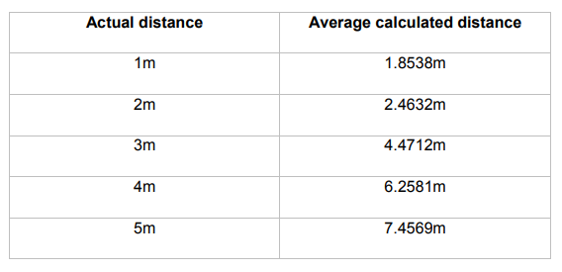

Figure - Comparison of real life distance and calculated distance in a testing of a BLE beacon indoor positioning system. (Herrera Vargas, 2016).

The BLE beacons are highly accurate when a large density of them are present but become less so when there are fewer beacons in an area. This gives companies the decision to spend more on hardware installation or present a less accurate system to their customers. While beacons are cheap, in high numbers the cost can inflate greatly, especially in maintenance costs as the cheaper beacons are often battery powered meaning constant upkeep. This paired with the potential delay of positioning means that BLE beacons can have inaccuracies and downsides that this project hopes the investigation of Wi-Fi positioning will provide an alternate to.

### 2.1.2. Ultrasonic

Ultrasonic is seen as a more complicated implementation of an indoor positioning system and there are many examples of implementation which have been researched since the turn of the century. The most common researched and the most focused on in this review is a process of which individuals will carry nodes that have both radio frequency (RF) and ultrasonic capabilities. The nodes use the RF capabilities to synchronise with installed hardware which when synced will listen for an ultrasonic pulse from the node and when received can be used to calculate and relay the individuals position (Priyantha, Chakraborty et al., 2000). Figure 5 shows a diagram of a version of this but an RF Transmitter is used to initially give each the receiver and transmitter an RF identity (Chakraborty, 2000). Initially from assumptions it would be logical to think such a positioning system would be obsolete due to the fact that ultrasonic waves cannot penetrate walls and thick infrastructure (Gifford, 2018) but this can be seen as one of ultrasonic technologies strong points. The inability to penetrate walls means that the room a particular individual is in is clearer cut and the system will provide a definite room location whereas with BLE beacons the signal attenuation can confuse individuals between rooms or floors (Gifford, 2018). Studies showed that system set ups like this can provide results with “a median error of less than 5cm” when used to track a moving model train around a room with 5 receiving sensors (Smith, Balakrishnan et al., 2004). Indoor positioning with accuracy so high is exceptionally impressive especially when tracking a moving object in a room, this can be due to the fast disperse and receive that such a system has, due to quick properties of ultrasonic sound waves. Downfalls become apparent when research into scaled versions of the technology takes place and due to the limits and propriety of the hardware, a lack of full scale research has been done. A reason for this can be found in the main benefit of the system, the inability to penetrate walls; this is because every room or enclosed area requires its own set of sensors which in larger builds with rooms can become expensive. This hardware is often at times bespoke, being made for the purpose of such a system so it pushes up the cost and the time required for manufacturing the hardware. Much like the BLE beacons, a single room may require several receiving nodes installed and in rooms with extremely tall ceilings this becomes a large issue (Gifford, 2018). These pitfalls hinder ultrasonic from becoming more refined and give way for newer technologies to take its place. Even if a system could be implemented on scale it still suffers downfalls that are similar to RFID where individuals have to carry a device which also emits the ultrasonic pulse. This adds more hardware that is required for each user of the system and while investigations were made into the potential of cell devices receiving ultrasonic pulses from transmitting beacons, it was less accurate and less reproducible (Smith, Balakrishnan et al., 2004).

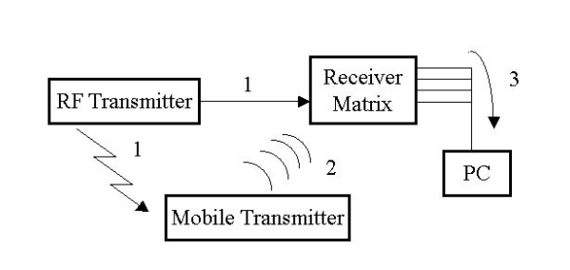

Figure - Diagram of an ultrasonic indoor positioning system (Chakraborty, 2000)

While easier to position users within a specific room and accurate at plotting their point in that room, on scale an ultrasonic system is unfeasible as it is too bespoke and cumbersome to implement and execute. These downfalls may be answered by an Wi-Fi based positioning system that uses standard router hardware that many areas have installed.

## 2.2. Investigate Wi-Fi and Signal Technology

The projects aim to find the feasibility of Wi-Fi indoor positioning dictates that an examination of the base core concepts of Wi-Fi and router technology is explored as well as the signals and methods of processing them. This research will give bases to see the potential of the technology and explore how positioning may be determined from it.

### 2.2.1. Wi-Fi and Routers Applications

Since the introduction of the Wi-Fi 802.11 standard by the Institute of Electrical and Electronics Engineers (IEEE) in 1997 (Tambe, 2015) and its initial introduction to homes in 1999 (Thomas, 2014) Wi-Fi has boomed and “there are now more Wi-Fi devices in use than there are people on earth” (Farnell element14, 2017). The growth of the technology has led to affordable and integrated hardware that is an often expected facility provided by companies or necessary utility in households. Growing demands and further developments of the technology have provided improvements to the 802.11 standards; the improvements can be seen in figure 6: (Farnell element14, 2017).

Figure 6 shows that each release of the 802.11 standard improves upon the previous and that 802.11n, one of the most used in terms of commercial hardware, provides a drastic increase in theoretical speed and more importantly - range. This has opened the potential use for Wi-Fi from just internet connection to other areas such as enabling wireless intranets to be utilized or the large role Wi-Fi plays in the Internet of Things (IoT). A 2017 study into the potential to create a low cost home automation system using Wi-Fi and the IoT found that it was possible to do so with less than 100 USD (Vikram, Harish et al., 2017). The findings of this study show that the ability to utilize Wi-Fi in previously unpredicted ways is possible and that its ability to allow the communication of many different devices on a network can be done so affordably. The study used a smartphone as the basis of the control hub for controlling the wireless sensors on the network, this relates directly to the proposed project as an Android smartphone will be used to gather the received Wi-Fi signals for positioning. The study does fail to mention potential downsides to the open communications of Wi-Fi such as the susceptibility to interference. Wi-Fi signals produced by routers and other transmitters are still a radio technology and can be affected by a wide range of interference such as multiple wireless networks that use the same 2.4 or 5GHz frequency in close proximity to one another. An example of this could be a multiple office building with separate networks. The more populated an area is by objects can also affect the reliability of Wi-Fi signals, especially when metal objects are close to the transmitter (Wiegand, n.d.). This interference is known and attempted to be compensated for when installing wireless networks by having the access points higher and not obstructed. Bluetooth also uses radio waves and experiences the same possibility for interference meaning Wi-Fi is not alone when considering this downside. The examination of Wi-Fi and its potential shows that the increases in the Wi-Fi standards have allowed further applications of Wi-Fi to exist which gives good relevance for this proposed project. While interference can occur, this is true with any existing radio technology and common place abilities to limit this are well known.

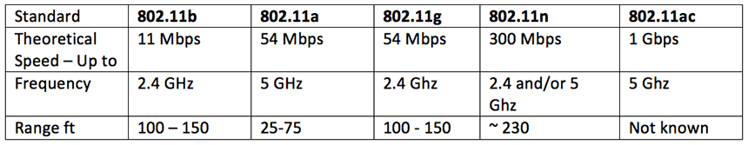

Figure - Comparison table of capabilities of some of the most recent amendments to the 802.11 standard for Wi-Fi (Farnell element14, 2017).

### 2.2.2. RSSI fingerprinting

Received Signal Strength Indicator (RSSI) is often used in localization technology in order to “estimate the distance between the transmitting and receiving devices” (Zhang, Yuan et al., 2015), this distance could be used to determine an approximate location but often alone is not enough due to the ability to receive signals at different angles from the transmitting device. RSSI can relate to any type of signal strength such as Wi-Fi or Bluetooth. The introduction of fingerprinting makes the location determining much more possible. Typically location fingerprinting has two stages, an offline and an online stage (Alikhani, Amirinanloo et al., 2017). In the offline stage the RSSI and location of known reference points are stored in a database (Alikhani, Amirinanloo et al., 2017). In the online stage, pattern matching algorithms are used with the fingerprints and the user’s data to determine a location (Alikhani, Amirinanloo et al., 2017). RSSI fingerprinting has been used with Wi-Fi signals and GPS before in a 2008 research paper to implement an outdoor localization system (Li, Quader et al., 2008). The paper aimed to increase accuracy in urban areas, as GPS is less effective when blocked by larger buildings, by using Wi-Fi from surrounding buildings and areas to narrow down the GPS position. Initially the accuracy was poor but upon refinement of the fingerprinting algorithm it was able to acquire accurate positioning within 35 meters and had potential for further investigation (Li, Quader et al., 2008). While it is largely useful in obtaining much more accurate results, RSSI fingerprinting does come with potential setbacks. The potential requirement for different algorithms to be run to get a more accurate result means that more computations has to be done and makes the RSSI fingerprinting resource heavy when running on older devices (Xia, Liu et al., 2017). This also means that RSSI fingerprinting may be slower on mobile devices that have less computation power which is an aspect that this project should take into account when choosing how to determine a localization method. Yet the potential for a higher accuracy location position and low cost of which still makes this a seemingly beneficial method of producing localization.

### 2.2.3. Trilateration

Compared to RSSI fingerprinting, trilateration is a simpler approach to determining a position with received signals. Trilateration is performed by having a minimum of three points that have known positioning, with the distance to each point being calculated, the distance is used to determine radius circles around the three points and the place where the three meet is the determined location (Li, Quader et al., 2008). A clear example of this can be seen in figure 7 (Li, Quader et al., 2008). In instances where the signals received are of signal strength rather than an exact distance the distance will have to be calculated before being able to be triangulated (Li, Quader et al., 2008). Trilateration is the geometrical approach to positioning that seems to require less computation and set up than RSSI fingerprinting as there is no need to acquire a database of fingerprints beforehand to reference to, instead the position can be determined from the position of the signal points themselves. A 2016 conference proceeding explored the use of trilateration in an ultrasound positioning system and found that the method provided good basis for future research as the static and dynamic position testing both had relatively small amounts of errors (Nguyen, Huynh,2016). The study shows the clear potential for trilateration to be used in positioning systems, especially with the benefit of less set up for the algorithm. On the other hand, trilateration does require the minimum of three specific signal points to work meaning that it is not possible to use this method in implementations with less than three points. While this can be relatively restrictive it can be noted that most systems viewed so far work with implementations that have a basis of multiple signal points to get an accurate position so this downfall of trilateration is less noticeable. This point is also true in that larger areas where a positioning system is required will generally have the need for more signal points or in the case of this project, more router points in order to cover the entire area. Keeping these considerations in mind, trilateration is still a viable option for this project and the choice between RSSI fingerprinting and trilateration may be more blurred as both may be used for a potentially more accurate outcome.

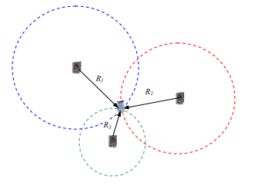

Figure - Trilateration diagram (Li, Quader et al., 2008).

## 2.3. Investigate Android application development

Trends in Android application development were briefly mentioned in the project background and it will be beneficial for the production of the project to examine these trends and methods in more detail to get a better understanding of industry motivations and processes. It is also beneficial to understand how development on Android differs to other operating systems so that the limitations and features of the operating system (OS) are understood which will be helpful when developing the application to test this project.

### 2.3.1. Android development compared to other mobile operating systems

The two largest mobile platforms currently are Android and IOS(Goyal, Bhatheja et al., 2016) with 85.9% of “global mobile OS market share, in terms of sales to end users” being to Android and 14.1% to IOS in the first quarter of 2018 (Statista, 2018). The mass adoption and differences in market to both of the operating systems has led to a difference in development for each platform. The initial differences between the systems are that Android is open source and was developed by Google whereas IOS was exclusively designed by Apple to run on Apple hardware (Perzyński, Pietruszczak et al., 2018).

These initial differences run deep in the technical development for each with production of IOS applications following the restrictive nature set by Apple on the platform. Up until 2014 Apple set the restriction that any application developed had to be done in Objective C and by extension C/C++ (Wells, 2015). This was opened after interest in development outside of these languages become promenade to include other languages - the most prominent being Swift which was developed by Apple and designed to be used in IOS and other Apple operating systems (Wells, 2015). The largest intergraded development environment (IDE) for IOS applications also has significant emphasis on being Apple’s own software Xcode. Android development is similar in that Google has put a large amount of emphasis on its own Android Studio but this software was originally based from InteliJ IDEA by JetBrains (Furlan, 2018). It differs in that the languages used for Android are more open with Java being the largest language used. Google has given first party support to Kotlin by JetBrains but the adoption has been slow due to the large amount of freedom around using Java and other languages. The technical approach to each platform has given a clear cut split in how each is developed with IOS development being a much more Apple supported and focused process compared to the openness of the Android OS.

The differences also delve into the focus during development and the applications produced. The openness of Android means it “has diverse set of UI available and different capabilities which are carrier specific and are ported into the OS by various carriers” (Mohamed, Patel, 2015). This can lead to the original look and feel of the base Android user interface (UI) being lost and manipulated differently which gives each application developed for it a distinct feel and self-contained aspect to it. IOS on the other hand is known for a focus on UI and this is supported by the Cocoa Touch API for IOS development (Mohamed, Patel, 2015). This familiar and guided UI design gives a more streamlined and cohesive feel to each third party application for IOS and at times can give cross platform applications an extra element of thought during to development so that the single application can feel the same on both platforms. Security is also focused on and handled differently on each platform. IOS is considered one of the most secure OS’s which is due to it having a strict control over hardware and application software access (Wukkadada, Nambiar et al., 2015). This can give developers the added benefit of less penetration areas in their application with applications being isolated by design from the OS software. Android being more open based means that developers can be the sole responsible individual for ensuring that applications are isolated and secure on this level(Goyal, Bhatheja et al., 2016). The independent security monitoring has also helped to make users more cautious and in turn has made developers keep it in the fore front when designing applications. These reasons have helped security become a driving trend in applications in Android more so than any other mobile OS (KHARCHENKO, 2017).

Understanding that different mobile platforms focus on different issues and development areas than one another will aid the execution of this project so that necessary design and implementation aspects are taken to ensure testing the feasibility of the indoor positioning technology has the best possible testing platform to be evaluated on.

### 2.3.2. Android Specific Development Processes and Trends

Viewing the difference in development for the Android OS opens the door to look at the knock on effect of these differences to platform specific trends and processes. Base handling of security is different as stated previously, giving a higher demand for secure applications on the Android platform. It is recommended that developers now spend more time and resources when testing their applications because security can “play a vital role in the success/failure of an app” (Inukollu, Keshamoni et al., 2014). With this trend growing, it has lead its way to numerous processes and best practises being used to satisfy customers wants as well as limiting the number of applications with security vulnerabilities being produced. The Android developer documentations have grown to include best practice guides on security, testing and other areas (Google, 2018). Security is also linked into other trends in Android Development such as location services, as previously mentioned in the project background. Emphasis has been on keeping sensitive data such as geo-location contained and to always inform users of any tracking of this data, even if it is not being stored and instead being used for live processes (Future of Privacy Form, Centre for Democracy & Technology, 2011). The potential for security to be compromised by improper use of sensitive data like geo-location means that proper care will be required when producing the testing application for this project.

The use of Kotlin is a further growing trend in applications. Kotlin is a programming language that runs on the Java Virtual Machine and was developed by JetBrains before being adopted by Google as the primary language for Android development. This primary adoption and change from Java by Google has given rise to a growing number of developer’s adopting it for their application development (Jangid, 2017). Kotlin can be used interchangeably with Java in certain code files but cannot be interlaced explicitly. The interchangeability has helped the uptake of Kotlin as more and more developers move to the language and port code over in an effort to keep up with development standards. While many are changing, a large core base still uses Java. Google still provides Java solutions in all of the Android development documents (Google, 2018) as well as first hand support for the language. Java has been the most popular language since 2013 as tracked by the TIOBE index (TIOBE, 2018) and has widespread use outside of the Android world unlike Kotlin, this means that the Java community is far larger and more supported. Being a popular language with more support also gives Java an edge in that an abundance of resources outside of those produced by Google are available which mean the majority of developers are still sticking to Java for Android development. The conclusion that can be drawn is that while Kotlin is gaining traction, Java is a more tried and tested language with more support that most of the major developers still currently use for producing Android applications and will suit this project more.

Examining the trends in Android development has shed light on the necessity for security especially given its links into other trends such as positioning technology which is the main aspect of this project. Investigations have also shown that Java is still the main development language on Android.

# Execution

This section will provide an account and justification of the development of the primary search artefact as well as the chosen development styles, lifecycles and programs as helped identified by the literature review section.

## Lifecycle

The lifecycle of the development was based upon a waterfall model that included an iterative implementation stage. It is understood that that the majority of software based projects use an agile approach to development with even 80% of USA federal government projects being described as agile in 2017 (Viechnicki and Kelkar, 2017). This was decided to be the wrong approach for this project due to the reliance of agile to be applied to development in teams (Choudhary, Rakesh 2016) and multiple member developments whereas this is not the case for this project. The project also contains a large amount of write-ups before, throughout and after development which does not lend well to agile development due to its large focus on incremental delivery. An iterative waterfall model, shown in figure 8, was chosen due to its ability to allow a clear planning stage and methodical follow through like in traditional waterfall models but has the added benefit of revisiting previous stages in a loop to allow for constant iterative and therefore incremental development where the system is built upon (Mihai Liviu 2014).

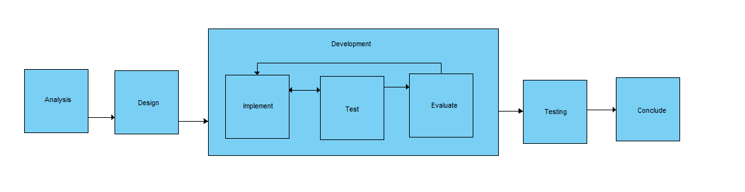

Figure – Lifecycle used for Development

This allowed the development to follow the usual steps of investigation and analysis of the project where clear requirements are determined and documented. Following this stage an iterative development of design, implement and testing happens where systems are incrementally produced. This ensures the system is robust before being added to and limits the inclusion of bugs in the final stage which is deployment. In this project deployment will be the final project testing and drawing of conclusions. Each iteration was used to build upon the previous ones developed artefact and improve it before reaching the final project. This is further outlined in the implementation section of this report.

## Analysis and Design

The initial aspect of the execution was to analysis the system and using knowledge from the literature review, determines the problems that may be faced for execution and how to achieve the artefact of an android application that can determine a user’s position using WiFi, as laid out in the project aims.

The initial worries for the project where outlined in an brainstorming document seen in appendix X. This helped show that areas that could hinder development or where crucial to the project was the way the application displayed the map and user position as well as the algorithm used to determine a user’s position. The identification of these problems was important for the requirements specification outlining and to be kept in mind throughout the project. Investigations in the literature review section also helped with these identified problems especially the WiFi investigations with helped to narrow down an algorithm to use. Using the brainstorm it was also determined that certain elements should be used such as Android Studio with android investigations in the literature review backing this up. Its clear due to the findings that android studio is the most supported platform for Android development. The features and ability to use emulators helped make it a natural choice and was the most powerful development environment that could be provided. This also helped to refine the development language to Java as for the same reasons, it was largely the most supported and the other choice, Kotlin, was having teeth problems since initial release.

Analysis of the requirement specifications as seen in appendix X was carried out to help give a clear definition of what the application was required to do which also in turn helped to be goals to work towards in each iteration of the implementation. The requirements gathered where not all accurate however as the requirement of having the application updates the user’s location periodically was not able to implement due to android changing the premised number of scans done for a WiFi for security and battery. In mind of this, it was still an important step that gave way to a clear design stage.

The design stage of the application was built upon from the analysis stage with large focus being given towards the functionality of the application as this was the main aspect that would be used to test against the research question. There was scope for having a clear UI for the application as well due to the need to have a user’s position displayed upon a map and initial wireframes where implemented as seen in figure 9. The ability to visualize what the application may look like also helped to further provide flesh to the functionality as it could be in turn, looked at how this could be achieved. The design did not change much from refined wireframes as seen in appendix X and then onto final UI as seen in appendix X. This clear initial design was important to the project as it helped to keep development and refinement time down in later stages. Design diagrams were also produced for the same reasons and can be seen in appendix X with the production of diagrams such as a use case or sequence diagrams being able to provide an insight into the project and helped to ensure the focus was clear throughout as limited resources for the project meant that there should be no slippage in time or man power.

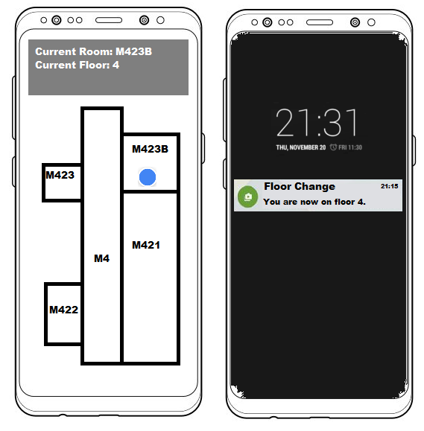

Figure 9- Initial Mock-up of Device UI

## Implementation

The programming language and IDE where both explained for their choices in the Analysis section but this section will give further flesh to these choices as well as explain more specific choices in regards to the specific requirement elements such as the positioning algorithm and the front end map display.

### Lifecycle Iterations

The projects lifecycle iterations where broken down so that development could become gradual and be building upon the working application without worrying about tackling every requirement from the start.

The initial iterations of development largely regarded getting basic functionality working on a small scale. It would have been too much interference and set up to attempt to implement , test and evaluate the application in the early stages in the final testing building of the university so a small testing environment appendix X was set up. This consisted of a 5 room flat with 3 router points positioned within it. This allowed the first iterations to attempt to be able to determine a user’s position by testing algorithms and using a basic 2D graphic to display the information on.

Through each iteration, functionality was built upon and a better refined algorithm was determined with the testing ground being finally moved to the testing building.

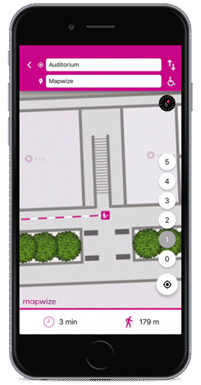

Figure - MapWize Example (Mapwize.io, 2019)

### Indoor Map Display

The UI element of the map was implemented to fulfil the requirements that allow a user to be able to see their current position within in the building. This was an important aspect of determining the feasibility of the application since the inability to translate a received position onto a visual map would affect the potential feasibility of the technology. The implementation of an indoor map was originally implemented as a 2D graphic during the first iterations of the project as shown in appendix X. This largely served the initial iterations purposes of getting the basic functionality working but soon became clear that moving to a larger environment would be difficult if 2D graphics had to be produced for each floor and used for positioning.

It was determined that the best solution to use to implement a map system that allowed an indoor position to be displayed with ease of transference to a larger space would be to use a framework .The framework identified that would allow this was MapWize. Looking into MapWize, it was a clear runner for the project as it was a dedicated indoor mapping platform (Mapwize.io, 2019). MapWize provides the ability to set up blueprints and overlays as indoor maps called venues which can be showed when a user zooms in close enough to them. An example of a MapWize application is shown in figure 9. An individual sets up an online account and configures an indoor location known as a venue through the web application then is able to important the MapWize framework into their program which then allows a normal map view to use the MapWize style. The way this is done is very simply as shown in the following line of code:

**mapView**.setStyleUrl(**"http://outdoor.mapwize.io/styles/mapwize/style.json?key="** + AccountManager.*getInstance*().getApiKey());

The framework uses your provided API key to import your venue which can then be used to place it on the map. In this projects implementation a venue was created just after the initial iterations which was of the same 5 room flat for continued testing within the area to ensure that the application worked the same way. Once this was deemed acceptable the final venue was modelled with the online software by importing blueprints of the university buildings for each of the floors that would be tested and mapping out the router points for each floor.

## Algorithm Implementation

The implementation of the algorithm was the largest focus during the implementation stage and required a large amount of time to ensure the accurate results were being implemented so to not affect the potential outcome. The findings of the literature review helped to provide the potential algorithm that would suite the project more which was trilateration. This was chosen over the other investigated, RSSI fingerprinting as fingerprinting could largely require machine learning to ensure it was implemented correctly witch would be difficult on a mobile device and was out of scope to have a server do it for the application. Trilateration was also found to be the simplest method of positioning which was in line with the project as the alternative of WiFi positioning was to include the potential to look at how easy it could be implemented and to be run on a host of devices.

### Router Set Up

The choice of trilateration meant that before real implementation could be done for the application, gathering of router points Latitude and Longitude positions within the building had to be gathered as well as the MAC address which would act as a unique identifier. This was done for the test building as well as done small scale during the initial iterations for the smaller environment to simulate how it would work in the test building. The application would set up a collection data structure containing a custom RouterMap class object that had the position and MAC address stored in it. This was useful to ensure that access to the data did not have to be written or read from a database and was stored in memory, which while can be resource heavy, was not measured in this project as it was out of scope. The data collection of known router points was used to ensure that any other detected router points where ignored and that once areas WiFi was scanned, the nearby routers could be determined by their MAC address then their coordinates received. This was all necessary as the trilateration method required known points to be able to position a user against them.

### WiFi Scan and Distance calculation

The next stage of implementation was to allow the application to be able to detect nearby router points

Viechnicki, P. and Kelkar, M. (2017). *Agile by the numbers*. [online] Deloitte Insights. Available at: https://www2.deloitte.com/insights/us/en/industry/public-sector/agile-in-government-by-the-numbers.html#endnote-5 [Accessed 11 Apr. 2019].

Mapwize.io. (2019). *Indoor mapping & Wayfinding for Smart Buildings*. [online] Available at: https://www.mapwize.io/ [Accessed 11 Apr. 2019].