

**Honours Project (CCIS)**

**INTERIM REPORT**

**2018-2019**

**Submitted for the Degree of:**

**BSc Computing**

**Project Title: LOCATION AWARENESS WITHIN BUILDINGS USING AN INSTALLED WI-FI NETWORK AND AN ANDROID**

**Name: DARYL MCALLISTER**

**Programme: Software Engineering Suite**

**Matriculation Number: S1222204**

**Project Supervisor: Iain Lambie**

**Second Marker: Richard Holden**

**“Except where explicitly stated, all work in this report, is my own original work and has not been submitted elsewhere in fulfilment of the requirement of this or any other award”**

**Signed by Student:___YA BOY___ Date: ____________**

Table of Contents

Table of Figures 3

List of Abbreviations 3

1. Introduction 4

1.1. Project Background 4

1.2. Project Outline 7

1.2.1. Project Aim 7

1.2.2. Project Objectives 8

1.3. Hypothesis 9

2. Literature Review and Technology Assessment 10

2.1. Examine the accuracy of other forms of indoor positioning 10

2.1.1. Bluetooth Low Energy Beacons 10

2.1.2. Ultrasonic 11

2.2. Investigate Wi-Fi and Signal Technology 12

2.2.1. Wi-Fi and Routers Applications 12

2.2.2. RSSI fingerprinting 13

2.2.3. Trilateration 14

2.3. Investigate Android application development 15

2.3.1. Android development compared to other mobile operating systems 15

2.3.2. Android Specific Development Processes and Trends 16

3.0. Methods 18

3.1. Research Method 18

3.2. Develop the Android Application 18

3.2.1. Development Environment and Options 18

3.2.2. Development Lifecycle 19

3.3. Obtain Participants for evaluation 20

3.3.1. Ethical Considerations 20

3.4. Conduct testing of application accuracy 21

3.5. Draw conclusions and evaluate accuracy 21

3.7. Remaining Tasks 22

4. References 23

# Table of Figures

Figure 1 - PokemonGo Location Game (Niantic, 2018) 4

Figure 2- BLE beacon positioning system (infsoft, 2015) 6

Figure 3 - Trilateration of signals from router points 7

Figure 4 - Comparison of real life distance and calculated distance in a testing of a BLE beacon indoor positioning system. (Herrera Vargas, 2016). 11

Figure 5 - Diagram of an ultrasonic indoor positioning system (Chakraborty, 2000) 11

Figure 6 - Comparison table of capabilities of some of the most recent amendments to the 802.11 standard for Wi-Fi (Farnell element14, 2017). 13

Figure 7 - Trilateration diagram (Li, Quader et al., 2008). 14

Figure 8 - Incremental Model (istqbexamcertification.com, 2017) 19

# List of Abbreviations

BLE – Bluetooth Low Energy

GHz – Gigahertz

GPS – Global Positioning System

IDE – Integrated Development Environment

IEEE - Institute of Electrical and Electronics Engineers

IOT – Internet of Things

NFC – Near-field Communication

OS – Operating System

RF – Radio Frequency

RFID – Radio-frequency Identification

RSSI – Received Signal Strength Indication

UI – User Interface

USD – United States Doller

# 1. Introduction

This section serves to introduce the topic and present a background of indoor and outdoor positioning systems and mobile applications to the reader. It also informs the reader of various indoor positioning technologies that exist with possible positives and shortcomings. The section also contains descriptions of the projects aim, type and objectives.

## 1.1. Project Background

Mobile devices have become more and more prevalent in our modern life with almost 92% of the world’s population now owning a mobile device (Grimus & Ebner, 2015) and the actual use of smartphones has become so integrated that it is one of the first and last things we use each day with 36% - 40% of smartphone users checking their phone within 5 minutes of waking up and going to bed (Montag et al., 2015). The ever presence of these devices has led to a constant strive to develop applications that can help streamline everyday life and make as many services available to users as possible. This potential for life integrated use of mobile applications was even shown by head of state figures such as the then President Obama, who’s pledge to have two public services available through mobile phones at his speech in 2012 (Rakestraw et al., 2012) was a further boost for the industry. The constant boom of the mobile market has given rise to a number of application trends and their integration into everyday life. This boom has given way to a huge sector for developing application with many methods and different languages that can be used to implement applications on different platforms. This sector is also seeing a number of driving trends that users are becoming more and more aware of.

One of these driving trends in application development and the mass market currently is location positioning and location based services (Fedorychak, 2018). While not a new technology, with the first appearance of location based services appearing in 2001 (Michael, 2004), it is the advancement in technology and growth of the mobile market that has given way to the ability to integrate location positioning into many applications, from direction applications like Google maps to even gaming such as the handheld game PokemonGo, as shown in figure 1. The wide implementation of location services into many different products has led to one third of all mobile searches being location related (Ramaswamy, 2016).

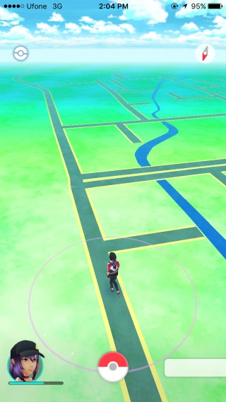

Figure - PokemonGo Location Game (Niantic, 2018)

Location services have also found implementation in applications that are not even directly linked to location. Social media applications have adopted location services to show users the friends in their proximity or even filter content to show relevant nearby information (Scassa, Sattler 2011). Large adoption of location services has mainly remained in the outdoor or world position. These integrations have created a major market because of the convenience they cause for users whether it is getting them from point A to point B quicker or giving them the quick glance at how near they are to a desired person or product. In terms of games they have also found the novelty of exploration and use of exploration in location games helps with enjoyment and learning (Wake, 2013) but in recent years the market for location based systems has seen a large increase in interest for indoor localization as well; this can be due to the performance and abilities of outdoor positioning being already established (Mautz, 2012) and the mass market already currently utilizing it. Indoor location positioning is a natural advancement in positioning technology that has generated interest from users and researchers helping shift potential from outdoors to indoor positioning (Nhlanhla, Adeyeye-Oshin et al. 2017)

The current potential for the utilization of indoor positioning is also leading its growth within applications as it opens the ability for a plethora of different purposes that cover a large technology area to be developed. Companies in the Internet of Things area can utilize it for asset tracking indoors (Hui Liu, Darabi, Banerjee & Jing Liu, 2007), universities could implement a system that provides indoor positioning for students – particularly those with disabilities i.e. to find the most accessible route (G. Delnevo et al., 2018) or in a landmark setting where visitors and tourists can be shown their position in an area and nearby points of interest. Further potentials for indoor positioning could be the progression from standard standalone positioning in a building to the ability to show users paths to a specified destination indoors or even the ability to calculate the time it will take to get between two points in a building. The progression of the technology has many knock on affects that it can solve such as cutting down time getting lost in airport terminals or getting lost between classes at an institute of education. While systems for the previous examples exist in static maps and diagrams are readily available it is an analogue system that many people still find access to difficult and it can be time consuming to locate themselves on or to find the best route through.

Even with the ability to adhere this technology to many possible helpful everyday systems, the emergence of systems like these has been slow, in part due to the problems that currently affect indoor localization - the largest problem being a reliable set technology that is easily applied. Global Positioning System (GPS) is the main technology used for world positioning (Montenbruck, Ramos-Bosch 2008) and is used by Google to position users in their Google Maps application (Garude, Haldikar 2014). While GPS can also obtain a position indoors it is often obscured by walls and building material which make it too inaccurate to be used (Farid, Nordin & Ismail, 2013) this has required other technologies to be developed to allow a more accurate indoor positioning system to be feasible.

The various current technologies include Bluetooth sensors, Ultrasonic positioning, Radio Frequency Identification (RFID), and Wi-Fi (He Xu et al., 2017). RFID currently has numerous implementations but the consistent set up is to have the individual wear appropriate RFID tags since most modern mobile devices use Near-Field Communication (NFC) instead which only has a range of 4 inches (Chandler, 2012). The RFID tags would interact with RFID scanners in the building which relay the interaction back to a server from which the mobile phone would be connected giving a user their position (Y Ortakci, E Demiral, U Atila & I R Karas, 2015). This method brings many downsides which have been witnessed in its already widespread use - in areas such as supermarkets, it may be unfeasible to provide every individual in the building the required RFID tag to wear and it can become costly. Amazon has set up a supermarket that tracks products and individuals in a store to provide a checkout free experience using many cameras and RIFD tags (Likhitha, Anusha et al. 2018). This shows the real life implications are more than possible despite the downsides but the accuracy of such a system relies on many RFID scanners placed within the building which is expensive and not viable for smaller enterprises looking to adopt an indoor localization system as this also does not encompass the labour or installation costs. Amazon’s store also uses the camera systems to aid the RIFD detections in this process which would stem for a complex and bulky system to maintain. One of the reasons RFID tags have wide spread use, especially in the agriculture area, is due to the robustness of the tags in a harsh environment (Ruiz-Garcia, Lunadei 2011) yet such robustness would typically not be needed in an indoor setting.

Currently the largest growing technology for indoor positioning is Bluetooth Low Energy (BLE) beacons. This rapidly developing technology has seen uptake due to its use of Bluetooth Low Energy which can have high throughput whilst having a more power efficient operation compared to other device communication protocols (Rondón, Gidlund & Landernäs, 2017). Usual set ups for beacon based indoor positioning systems as exemplified in figure 2 are consisted of multiple BLE beacons in an area that will interact with a mobile application which may use an external database to receive the stored data positions of the beacons and triangulate its own position (infsoft, 2015). Many companies are providing easy to use software to develop systems like this due to its prevalence and ability to be used beyond just positioning systems. Problems still arise with a positioning system based on this concept however due to, once again, high costs and labour time to fit a building with beacons. Currently Bluetooth also has to be active to allow this system to work whereas only 60% of mobile users have their Bluetooth active (Coombs, 2017) meaning users can still be missed out in this system. Another factor holding back beacons from dominating the indoor positioning development productions is that beacons have certain security issues that have yet to be ironed out like piggybacking (Gąsiorek, 2016) where users tailgate with another person’s data. This goes against current trends to ensure all produced applications for mobile devices are secure (KHARCHENKO, 2017).

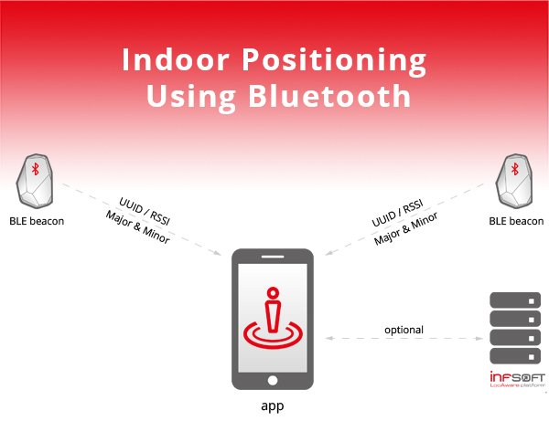

Figure - BLE beacon positioning system (infsoft, 2015)

Costly and labour intensive technologies such as these have led to investigations into the possible use of an already established system such as Wi-Fi signals from already installed router points in a building which would connect to a device instead of using proprietary hardware. Making use of the potentials of Wi-Fi and router technology with such a system would save an organization valuable time and money because of the use of an already installed and operating system to provide the indoor localization. This would also allow the integration of an indoor positioning system in any building that had an existing router network by allowing the received Wi-Fi signals to be received to a device and location determined through a trilateration technique (Bianca Bobescu & Marian Alexandru, 2015) such as the one shown in figure 3. Most major public buildings have Wi-Fi installed due to continuing public expectations of readily available Wi-Fi with almost 40% of people considering no Wi-Fi as a deal breaker when booking a hotel (boostandco, 2017). This expectation means the adoption of such a technology could be greatly accomplished due to the existence of an already popular platform which could potentially solve the problem of costly and sometimes inaccurate indoor positioning that other systems currently provide.. While this shows a clear benefit to a Wi-Fi signal based system compared to other technologies there will still have to be investigations into the accuracy of this particular technology to ensure it is a feasible method of positioning an individual indoors as well as ensuring it can be as accurate as other forms of indoor positioning.

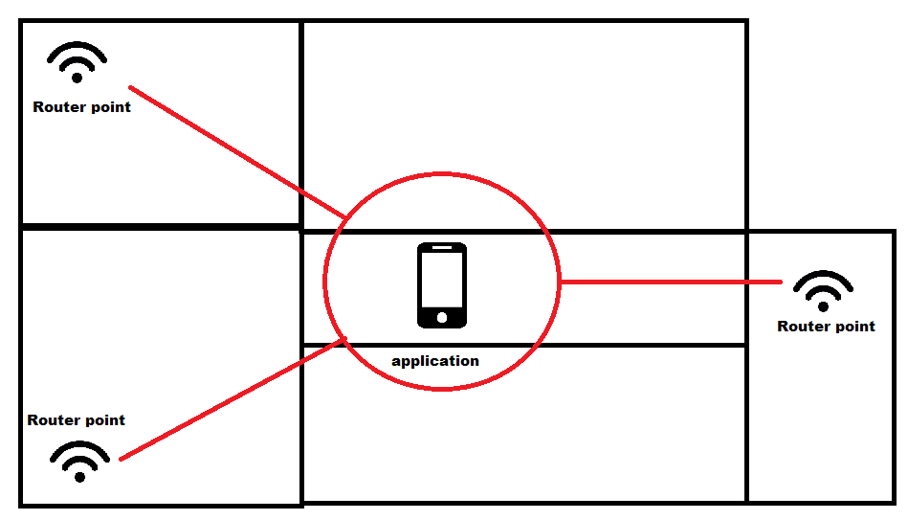

Figure - Trilateration of signals from router points

## 1.2. Project Outline

This section further details the explicit aim of this project and the research question that it aims to answer. It will also provide the list of research objectives that will build up the main literature review and provide a hypothesis.

### 1.2.1. Project Aim

This project aims to determine the feasibility of an indoor positioning system using received Wi-Fi signals from router points and using it for mass market Android applications with the results having the potential to open up the already established technology in new directions without the addition of specialised hardware or labour intensive installations. It is envisioned the project will be executed by developing an application and testing it to full access the feasibility. The research question that will drive this project is:

**How accurate can an indoor positioning system be using the received Wi-Fi signals from access points by an Android mobile device?**

### 1.2.2. Project Objectives

This section highlights both the secondary research objectives and the primary research objections that will make up this project. These objectives will be further explored in more detail within this report.

**Objectives to be completed by the way of a main literature review:**

SO1: Examine the accuracy of other forms of indoor positioning

The project’s examination of the feasibility of Wi-Fi accuracy has to be done against the accuracy of other systems such as the aforementioned BLE or RFID. While those systems are impractical in an installation manner, the accuracy of those systems should be examined to compare against the accuracy of Wi-Fi indoor positioning.

SO2: Investigate Wi-Fi and signal technology.

Due to the project’s reliance on received Wi-Fi signals and device interaction with routers, it is important to research an overview of Wi-Fi, Router and Network technology to gain a confident understanding of the systems that will allow the application to determine the device’s location.

SO3: Investigate Android application development.

A deep understanding of Android application development will be needed as a whole for the development of the project. Investigations into current language trends, technology usage and software related configurations are a priority for the project since it relies on the development of an Android application. All parts of this investigation will be used in practical implementation and will be utilised for a smooth development stage.

**Objectives to be completed by the way of (in) the primary research phase:**

PO1: Develop the Android Application

Development of the specified application will be undertaken so that the project may use it to gather test data from which the research question will be evaluated. This development will be undertaken using the knowledge gained through research to ensure the application is as suitable as possible.

PO2: Obtain Participants for Evaluation

Participants will be required for successful testing as the accuracy of a system will help determine the overall feasibility of it and the gathering of these participants will be an important step due to selective and non-bias nature that is needed.

PO3: Conduct Testing of Application Accuracy

The application will be used to test the accuracy of Wi-Fi as a position system by comparing the position a participant is in versus the shown position on the application.

PO4: Draw Conclusions and Evaluate Accuracy

Conclusions will be drawn from the testing data which will be used to produce the final report and answer the research question fully.

## 1.3. Hypothesis

Testing the hypothesis would involve having human participants go to specified areas and mark how accurate the application is in determining their position then comparing this accuracy against other forms of indoor positioning. The hypothesis for this project is:

The feasibility of using received Wi-Fi signals from access point by an Android device for an indoor positioning system will be accurate to an extent but will be less so than other forms of indoor positioning systems while also coming with its own forms of restrictions.

Justification for this hypothesis comes from the ability of Wi-Fi signals to fluctuate (Bai, Wu et al. 2014) which may affect the positioning of the application. This may not affect the accuracy as much however as the presence of multiple access points sending signals should offset this.

## 2. Literature Review and Technology Assessment

This section makes up a large portion of the report and is required to achieve a base line of understanding which will be used to complete the project and gather the findings for the research question. The literature review section is undertaken by examining relevant work and research produced by others that will provide knowledge that can be carried forward into the primary research methods.

The literature review will explore the following research objectives (previously mentioned in section 1.2.3):

* Examine the accuracy of other forms of indoor positioning
* Investigate Wi-Fi and Router technology
* Investigate Android application development.

## 2.1. Examine the accuracy of other forms of indoor positioning

The project background briefly overviewed downfalls of current existing indoor positioning systems but it is also crucial to understand them further as well as examine how accurate these forms of indoor positioning can be so that proper comparisons can be made between them and Wi-Fi positioning indoors. Examining other forms of indoor positioning will give a clear indication of their ability and accuracy which will be useful for determining this technology and its potential feasibility once compared to them.

### 2.1.1. Bluetooth Low Energy Beacons

As previously mentioned in the project background, BLE beacons are a fast evolving technology that has seen massive uptake by a wide variety of sectors from retail to aviation with “84% of global airports… running a pilot or implementing beacon technology by 2019” (unacast, 2016). Part of this adoption can be due to the expanded possibilities of BLE beacons but this examination will focus on their indoor positioning aspects. BLE beacons work by emitting packets of data which can be detected by a smartphone where a connection can be established (Park, Noh et al., 2016).The most common positioning method being the received signal strengths of the beacons surrounding the device which are used to fingerprint the devices location based on them. The accuracy of these beacons has been tested in many studies with one study finding that an accuracy of localization being 74% with a margin of error of 1 meter (Huh, Seo, 2017). This was conducted in a single room with a floor space of only 28.8 meters² and a placement of 7 beacons in this area. The high density of beacons in such a small area skews the results and is not a true representation of how the use would be in a tradition commercial area. In a more reflective examination of beacons where the testing environment was a 50m ² apartments and had only two beacons separated by 5 meters, it was found that distances from the beacons that were greater than 3 meters gave results that were incorrect by over 2 meters, the full extent of which can be seen in figure 4 (Herrera Vargas, 2016). A contributing reason the second and more realistic study found less accurate results can be due to that BLE beacons initial conception was designed for proximity detection rather than exact distance calculating (lemberg, 2014). The beacons also can have lag in connections because of the power conservation as many of them were designed to run only on batteries which was possible due to BLE’s low power consumption (lemberg, 2014). While this is useful for cable-less operating it makes the BLE beacons delayed in detecting and positioning a moving individual and the repositioning of an individual who has just stopped moving.

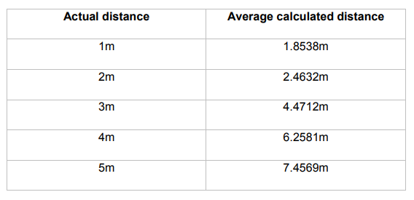

Figure - Comparison of real life distance and calculated distance in a testing of a BLE beacon indoor positioning system. (Herrera Vargas, 2016).

The BLE beacons are highly accurate when a large density of them are present but become less so when there are fewer beacons in an area. This gives companies the decision to spend more on hardware installation or present a less accurate system to their customers. While beacons are cheap, in high numbers the cost can inflate greatly, especially in maintenance costs as the cheaper beacons are often battery powered meaning constant upkeep. This paired with the potential delay of positioning means that BLE beacons can have inaccuracies and downsides that this project hopes the investigation of Wi-Fi positioning will provide an alternate to.

### 2.1.2. Ultrasonic

Ultrasonic is seen as a more complicated implementation of an indoor positioning system and there are many examples of implementation which have been researched since the turn of the century. The most common researched and the most focused on in this review is a process of which individuals will carry nodes that have both radio frequency (RF) and ultrasonic capabilities. The nodes use the RF capabilities to synchronise with installed hardware which when synced will listen for an ultrasonic pulse from the node and when received can be used to calculate and relay the individuals position (Priyantha, Chakraborty et al., 2000). Figure 5 shows a diagram of a version of this but an RF Transmitter is used to initially give each the receiver and transmitter an RF identity (Chakraborty, 2000). Initially from assumptions it would be logical to think such a positioning system would be obsolete due to the fact that ultrasonic waves cannot penetrate walls and thick infrastructure (Gifford, 2018) but this can be seen as one of ultrasonic technologies strong points. The inability to penetrate walls means that the room a particular individual is in is clearer cut and the system will provide a definite room location whereas with BLE beacons the signal attenuation can confuse individuals between rooms or floors (Gifford, 2018). Studies showed that system set ups like this can provide results with “a median error of less than 5cm” when used to track a moving model train around a room with 5 receiving sensors (Smith, Balakrishnan et al., 2004). Indoor positioning with accuracy so high is exceptionally impressive especially when tracking a moving object in a room, this can be due to the fast disperse and receive that such a system has, due to quick properties of ultrasonic sound waves. Downfalls become apparent when research into scaled versions of the technology takes place and due to the limits and propriety of the hardware, a lack of full scale research has been done. A reason for this can be found in the main benefit of the system, the inability to penetrate walls; this is because every room or enclosed area requires its own set of sensors which in larger builds with rooms can become expensive. This hardware is often at times bespoke, being made for the purpose of such a system so it pushes up the cost and the time required for manufacturing the hardware. Much like the BLE beacons, a single room may require several receiving nodes installed and in rooms with extremely tall ceilings this becomes a large issue (Gifford, 2018). These pitfalls hinder ultrasonic from becoming more refined and give way for newer technologies to take its place. Even if a system could be implemented on scale it still suffers downfalls that are similar to RFID where individuals have to carry a device which also emits the ultrasonic pulse. This adds more hardware that is required for each user of the system and while investigations were made into the potential of cell devices receiving ultrasonic pulses from transmitting beacons, it was less accurate and less reproducible (Smith, Balakrishnan et al., 2004).

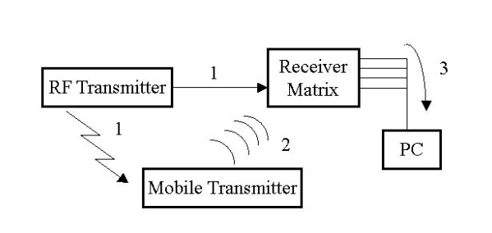

Figure - Diagram of an ultrasonic indoor positioning system (Chakraborty, 2000)

While easier to position users within a specific room and accurate at plotting their point in that room, on scale an ultrasonic system is unfeasible as it is too bespoke and cumbersome to implement and execute. These downfalls may be answered by an Wi-Fi based positioning system that uses standard router hardware that many areas have installed.

## 2.2. Investigate Wi-Fi and Signal Technology

The projects aim to find the feasibility of Wi-Fi indoor positioning dictates that an examination of the base core concepts of Wi-Fi and router technology is explored as well as the signals and methods of processing them. This research will give bases to see the potential of the technology and explore how positioning may be determined from it.

### 2.2.1. Wi-Fi and Routers Applications

Since the introduction of the Wi-Fi 802.11 standard by the Institute of Electrical and Electronics Engineers (IEEE) in 1997 (Tambe, 2015) and its initial introduction to homes in 1999 (Thomas, 2014) Wi-Fi has boomed and “there are now more Wi-Fi devices in use than there are people on earth” (Farnell element14, 2017). The growth of the technology has led to affordable and integrated hardware that is an often expected facility provided by companies or necessary utility in households. Growing demands and further developments of the technology have provided improvements to the 802.11 standards; the improvements can be seen in figure 6: (Farnell element14, 2017).

Figure 6 shows that each release of the 802.11 standard improves upon the previous and that 802.11n, one of the most used in terms of commercial hardware, provides a drastic increase in theoretical speed and more importantly - range. This has opened the potential use for Wi-Fi from just internet connection to other areas such as enabling wireless intranets to be utilized or the large role Wi-Fi plays in the Internet of Things (IoT). A 2017 study into the potential to create a low cost home automation system using Wi-Fi and the IoT found that it was possible to do so with less than 100 USD (Vikram, Harish et al., 2017). The findings of this study show that the ability to utilize Wi-Fi in previously unpredicted ways is possible and that its ability to allow the communication of many different devices on a network can be done so affordably. The study used a smartphone as the basis of the control hub for controlling the wireless sensors on the network, this relates directly to the proposed project as an Android smartphone will be used to gather the received Wi-Fi signals for positioning. The study does fail to mention potential downsides to the open communications of Wi-Fi such as the susceptibility to interference. Wi-Fi signals produced by routers and other transmitters are still a radio technology and can be affected by a wide range of interference such as multiple wireless networks that use the same 2.4 or 5GHz frequency in close proximity to one another. An example of this could be a multiple office building with separate networks. The more populated an area is by objects can also affect the reliability of Wi-Fi signals, especially when metal objects are close to the transmitter (Wiegand, n.d.). This interference is known and attempted to be compensated for when installing wireless networks by having the access points higher and not obstructed. Bluetooth also uses radio waves and experiences the same possibility for interference meaning Wi-Fi is not alone when considering this downside. The examination of Wi-Fi and its potential shows that the increases in the Wi-Fi standards have allowed further applications of Wi-Fi to exist which gives good relevance for this proposed project. While interference can occur, this is true with any existing radio technology and common place abilities to limit this are well known.

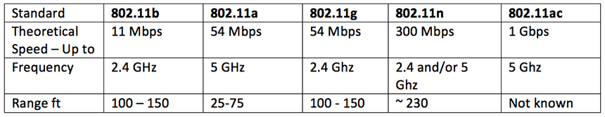

Figure - Comparison table of capabilities of some of the most recent amendments to the 802.11 standard for Wi-Fi (Farnell element14, 2017).

### 2.2.2. RSSI fingerprinting

Received Signal Strength Indicator (RSSI) is often used in localization technology in order to “estimate the distance between the transmitting and receiving devices” (Zhang, Yuan et al., 2015), this distance could be used to determine an approximate location but often alone is not enough due to the ability to receive signals at different angles from the transmitting device. RSSI can relate to any type of signal strength such as Wi-Fi or Bluetooth. The introduction of fingerprinting makes the location determining much more possible. Typically location fingerprinting has two stages, an offline and an online stage (Alikhani, Amirinanloo et al., 2017). In the offline stage the RSSI and location of known reference points are stored in a database (Alikhani, Amirinanloo et al., 2017). In the online stage, pattern matching algorithms are used with the fingerprints and the user’s data to determine a location (Alikhani, Amirinanloo et al., 2017). RSSI fingerprinting has been used with Wi-Fi signals and GPS before in a 2008 research paper to implement an outdoor localization system (Li, Quader et al., 2008). The paper aimed to increase accuracy in urban areas, as GPS is less effective when blocked by larger buildings, by using Wi-Fi from surrounding buildings and areas to narrow down the GPS position. Initially the accuracy was poor but upon refinement of the fingerprinting algorithm it was able to acquire accurate positioning within 35 meters and had potential for further investigation (Li, Quader et al., 2008). While it is largely useful in obtaining much more accurate results, RSSI fingerprinting does come with potential setbacks. The potential requirement for different algorithms to be run to get a more accurate result means that more computations has to be done and makes the RSSI fingerprinting resource heavy when running on older devices (Xia, Liu et al., 2017). This also means that RSSI fingerprinting may be slower on mobile devices that have less computation power which is an aspect that this project should take into account when choosing how to determine a localization method. Yet the potential for a higher accuracy location position and low cost of which still makes this a seemingly beneficial method of producing localization.

### 2.2.3. Trilateration

Compared to RSSI fingerprinting, trilateration is a simpler approach to determining a position with received signals. Trilateration is performed by having a minimum of three points that have known positioning, with the distance to each point being calculated, the distance is used to determine radius circles around the three points and the place where the three meet is the determined location (Li, Quader et al., 2008). A clear example of this can be seen in figure 7 (Li, Quader et al., 2008). In instances where the signals received are of signal strength rather than an exact distance the distance will have to be calculated before being able to be triangulated (Li, Quader et al., 2008). Trilateration is the geometrical approach to positioning that seems to require less computation and set up than RSSI fingerprinting as there is no need to acquire a database of fingerprints beforehand to reference to, instead the position can be determined from the position of the signal points themselves. A 2016 conference proceeding explored the use of trilateration in an ultrasound positioning system and found that the method provided good basis for future research as the static and dynamic position testing both had relatively small amounts of errors (Nguyen, Huynh,2016). The study shows the clear potential for trilateration to be used in positioning systems, especially with the benefit of less set up for the algorithm. On the other hand, trilateration does require the minimum of three specific signal points to work meaning that it is not possible to use this method in implementations with less than three points. While this can be relatively restrictive it can be noted that most systems viewed so far work with implementations that have a basis of multiple signal points to get an accurate position so this downfall of trilateration is less noticeable. This point is also true in that larger areas where a positioning system is required will generally have the need for more signal points or in the case of this project, more router points in order to cover the entire area. Keeping these considerations in mind, trilateration is still a viable option for this project and the choice between RSSI fingerprinting and trilateration may be more blurred as both may be used for a potentially more accurate outcome.

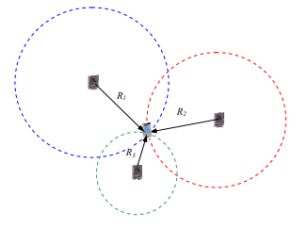

Figure - Trilateration diagram (Li, Quader et al., 2008).

## 2.3. Investigate Android application development

Trends in Android application development were briefly mentioned in the project background and it will be beneficial for the production of the project to examine these trends and methods in more detail to get a better understanding of industry motivations and processes. It is also beneficial to understand how development on Android differs to other operating systems so that the limitations and features of the operating system (OS) are understood which will be helpful when developing the application to test this project.

### 2.3.1. Android development compared to other mobile operating systems

The two largest mobile platforms currently are Android and IOS(Goyal, Bhatheja et al., 2016) with 85.9% of “global mobile OS market share, in terms of sales to end users” being to Android and 14.1% to IOS in the first quarter of 2018 (Statista, 2018). The mass adoption and differences in market to both of the operating systems has led to a difference in development for each platform. The initial differences between the systems are that Android is open source and was developed by Google whereas IOS was exclusively designed by Apple to run on Apple hardware (Perzyński, Pietruszczak et al., 2018).

These initial differences run deep in the technical development for each with production of IOS applications following the restrictive nature set by Apple on the platform. Up until 2014 Apple set the restriction that any application developed had to be done in Objective C and by extension C/C++ (Wells, 2015). This was opened after interest in development outside of these languages become promenade to include other languages - the most prominent being Swift which was developed by Apple and designed to be used in IOS and other Apple operating systems (Wells, 2015). The largest intergraded development environment (IDE) for IOS applications also has significant emphasis on being Apple’s own software Xcode. Android development is similar in that Google has put a large amount of emphasis on its own Android Studio but this software was originally based from InteliJ IDEA by JetBrains (Furlan, 2018). It differs in that the languages used for Android are more open with Java being the largest language used. Google has given first party support to Kotlin by JetBrains but the adoption has been slow due to the large amount of freedom around using Java and other languages. The technical approach to each platform has given a clear cut split in how each is developed with IOS development being a much more Apple supported and focused process compared to the openness of the Android OS.

The differences also delve into the focus during development and the applications produced. The openness of Android means it “has diverse set of UI available and different capabilities which are carrier specific and are ported into the OS by various carriers” (Mohamed, Patel, 2015). This can lead to the original look and feel of the base Android user interface (UI) being lost and manipulated differently which gives each application developed for it a distinct feel and self-contained aspect to it. IOS on the other hand is known for a focus on UI and this is supported by the Cocoa Touch API for IOS development (Mohamed, Patel, 2015). This familiar and guided UI design gives a more streamlined and cohesive feel to each third party application for IOS and at times can give cross platform applications an extra element of thought during to development so that the single application can feel the same on both platforms. Security is also focused on and handled differently on each platform. IOS is considered one of the most secure OS’s which is due to it having a strict control over hardware and application software access (Wukkadada, Nambiar et al., 2015). This can give developers the added benefit of less penetration areas in their application with applications being isolated by design from the OS software. Android being more open based means that developers can be the sole responsible individual for ensuring that applications are isolated and secure on this level(Goyal, Bhatheja et al., 2016). The independent security monitoring has also helped to make users more cautious and in turn has made developers keep it in the fore front when designing applications. These reasons have helped security become a driving trend in applications in Android more so than any other mobile OS (KHARCHENKO, 2017).

Understanding that different mobile platforms focus on different issues and development areas than one another will aid the execution of this project so that necessary design and implementation aspects are taken to ensure testing the feasibility of the indoor positioning technology has the best possible testing platform to be evaluated on.

### 2.3.2. Android Specific Development Processes and Trends

Viewing the difference in development for the Android OS opens the door to look at the knock on effect of these differences to platform specific trends and processes. Base handling of security is different as stated previously, giving a higher demand for secure applications on the Android platform. It is recommended that developers now spend more time and resources when testing their applications because security can “play a vital role in the success/failure of an app” (Inukollu, Keshamoni et al., 2014). With this trend growing, it has lead its way to numerous processes and best practises being used to satisfy customers wants as well as limiting the number of applications with security vulnerabilities being produced. The Android developer documentations have grown to include best practice guides on security, testing and other areas (Google, 2018). Security is also linked into other trends in Android Development such as location services, as previously mentioned in the project background. Emphasis has been on keeping sensitive data such as geo-location contained and to always inform users of any tracking of this data, even if it is not being stored and instead being used for live processes (Future of Privacy Form, Centre for Democracy & Technology, 2011). The potential for security to be compromised by improper use of sensitive data like geo-location means that proper care will be required when producing the testing application for this project.

The use of Kotlin is a further growing trend in applications. Kotlin is a programming language that runs on the Java Virtual Machine and was developed by JetBrains before being adopted by Google as the primary language for Android development. This primary adoption and change from Java by Google has given rise to a growing number of developer’s adopting it for their application development (Jangid, 2017). Kotlin can be used interchangeably with Java in certain code files but cannot be interlaced explicitly. The interchangeability has helped the uptake of Kotlin as more and more developers move to the language and port code over in an effort to keep up with development standards. While many are changing, a large core base still uses Java. Google still provides Java solutions in all of the Android development documents (Google, 2018) as well as first hand support for the language. Java has been the most popular language since 2013 as tracked by the TIOBE index (TIOBE, 2018) and has widespread use outside of the Android world unlike Kotlin, this means that the Java community is far larger and more supported. Being a popular language with more support also gives Java an edge in that an abundance of resources outside of those produced by Google are available which mean the majority of developers are still sticking to Java for Android development. The conclusion that can be drawn is that while Kotlin is gaining traction, Java is a more tried and tested language with more support that most of the major developers still currently use for producing Android applications and will suit this project more.

Examining the trends in Android development has shed light on the necessity for security especially given its links into other trends such as positioning technology which is the main aspect of this project. Investigations have also shown that Java is still the main development language on Android.

# 3.0. Methods

This section will outline the steps and requirements that will have to be undertaken for the project to be completed. It will highlight the practical aspects of the project as well as how they will be accomplished so that the final research question may be answered. The methods of the project will be built upon the research done in the literature review.

## 3.1. Research Method

This project is to be undertaken using a “develop and test” research methodology from which an application will be developed. It is from the data gathered during the testing of this implemented application that the research question can be answered as the conclusions that are drawn from this testing data will be sufficient to answer the question. The “develop and test” method suits this project well as the project is envisioned as a practical project that requires an active process to answer the question. The “develop and test” will also allow a single system to be used to test multiple cases. This will lead to a more reliable method rather than a testing round using multiple systems on multiple devices that could provide inconclusive data (A. Zandbergen, 2012). This testing will provide the generated data from which evaluations can be drawn and concluded. This data set is most likely to be the mentioned accuracy of the project. The accuracy will be the set benchmark of location data from the domain area in the form of quantitate data that can be evaluated in charts and graphs.

The produced development from this method will be an Android application which uses WI-FI signals from nearby access points inside a building to implement an Indoor Positioning System that will display a user’s position on a map of the building. This “develop and test” project style will allow for the investigation and evaluation of the accuracy of Wi-Fi signals in an Indoor Positioning System, as well as showing how accurate they can be in a practical setting.

## 3.2. Develop the Android Application

Development of the Android application will be conducted with findings from the literature review section which will help provide a more cohesive and accurate testing platform for which evaluations will be conducted.

### 3.2.1. Development Environment and Options

The application to be developed is an Android application, with the investigations into Android development in the literature review it is clear that this will be done through Google’s Android Studio and the language will be Java. The choices for these are clear as the most common support and resources available for Android application development are for these aspects. While Kotlin was considered, the investigations in the literature review proved that Java was still the larger choice and the open source nature of Java also allows for the use of many libraries to help aid in the development and will not bottleneck the project. Android studio was chosen in part for its large selection of emulators and native help tools over alternatives like InteliJ IDEA by JetBrains. While the project acknowledges that Android Studio was adapted from IntelJ IDEA it is clear that Android Studio has become more user friendly over the course of its updates and thus suits the project better.

Since the testing area for the application will be a university campus building with many access points available the project will focus on using a trilateration positioning technique to position individuals. Investigations into trilateration show that it is an easier task to implement than RSSI fingerprinting which provides a great benefit in this project, especially given the limited time for completion. While RSSI fingerprinting was shown to be accurate, the findings for trilateration methods were also accurate and mean that no aspects will be lost upon choosing this method over the other.

### 3.2.2. Development Lifecycle

Due to the project having a large reliance on the development of the system, it is imperative that the correct software development lifecycle methodology is also chosen. For the development, an iterative-incremental methodology has been chosen. While Android application projects often use agile and in particular agile scrum, this was determined to be unsuitable for this development as agile largely concerns development in teams (Choudhary, Rakesh 2016) and multiple member developments whereas this is not the case for this project. The project also contains a large amount of write-ups before, throughout and after development which does not lend well to agile development due to its large focus on incremental delivery. An iterative-incremental model, like the example in figure 8, was chosen due to its ability to allow a clear planning stage and methodical follow through like in traditional waterfall models but has the added benefit of revisiting previous stages in a loop to allow for constant iterative and therefore incremental development where the system is built upon (Mihai Liviu 2014).

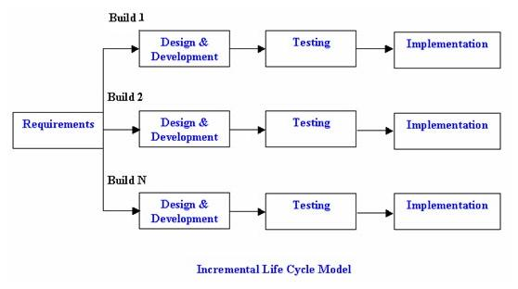

Figure - Incremental Model (istqbexamcertification.com, 2017)

This will allow the development to follow the usual steps of investigation and analysis of the project where clear requirements are determined and documented. Following this stage an iterative development of design, implement and testing happens where systems are incrementally produced. This ensures the system is robust before being added to and limits the inclusion of bugs in the final stage which is deployment. In this project deployment will be the final project testing and drawing of conclusions.

The iterative-incremental life cycle for implementation will be more successful if the system is planned accordingly beforehand. The final requirements and functionality of the system will be determined to get a clear working goal of what is to be developed and allow for a clear focus during development so that the project does not overrun on time. Final design of the application in the form of wireframes and mock-ups like in figure 9 will be produced in detail to help achieve this.

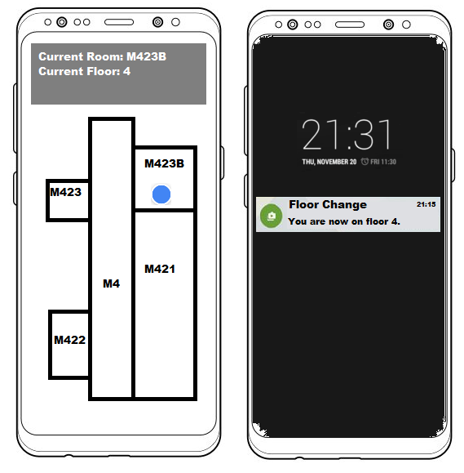

Figure 9- Initial Mock-up of Device UI

The final mobile application will be distinctly developed and based from previous prototypes and UI documentation.

## 3.3. Obtain Participants for evaluation

Obtaining participants for the evaluation will be done by volunteers who have an Android mobile device. Five or six volunteers will be recruited from a fourth year computer science cohort at the university where the testing will take place.

### 3.3.1. Ethical Considerations

The use of human participants raises ethical considerations and it is identified that they will have to be informed of the project, its aims and submit to the allowance of use of their personal device and the installation of a third party software. Participants will obtain the application by installing it onto their own mobile device only for the duration of the testing and removing it when testing is finished. The participants will also have to be made aware that during testing their location will be tracked and recorded but no other aspect of their situation or information from their device will be recorded. This gives rise to ethical considerations of personal data that will be on their personal device as well as their location. Application design will be appropriately done to ensure that only the required information, such as Wi-Fi signal strength, is gathered by the system. Despite this approach, participants will be required to give ethical approval and sign an approval document to submit the specified data. Participants will not be able to be identified by information they provide on the test sheet. Test sheets will be given randomly to participants with a set of pre-determined areas and instructions for testing the application. Conclusions drawn from this process of testing will be exclusively for determining the feasibility of the technology used and will not draw from the direct activity of participants.

## 3.4. Conduct testing of application accuracy

Research testing will happen after the application has been developed and participants have been acquired. The participants will use a range of Android devices to test the application across the testing area of the university building. The accuracy of positions will be marked and recorded as test data; this will be done by having test applications being given a set of pre-determined locations from which they will mark the actual location as well as the applications stated location.

## 3.5. Draw conclusions and evaluate accuracy

The testing data will be gathered and evaluated against the actual positions of the participants which will give a guide to how close the system was. The difference in meters of how accurate the application was will be determined and used to show overall accuracy and error percentage. From this set of data the research question will be able to be answered and documented by comparing it against other indoor positioning technologies’ accuracy and implementations. As seen in the literature review, other forms of indoor positioning systems exist and can be accurate so the comparisons against these will also add to the feasibility of the technology. These conclusions will be used in the writing of the final report for the project.

## 3.6. Remaining Tasks

This section details the overarching tasks of the project that are ongoing and remaining until completion. Each task will be outlined as well as a rough end date provided to keep track of the project overall, any task prerequisite will be described as well.

**Initial Application Prototypes – Ongoing – Complete by 2nd December**

Numerous working basic prototypes of the application are going to be developed throughout the project as a form of constant skill refinement. The production and refinement of numerous prototypes will also strengthen the use of the technologies and Android development style in later prototypes leading to an iterative learning process as well.

**Application Design – Ongoing – Complete by 2nd December**

Wireframes, mock-ups and non-functional prototypes will have to be produced in detail to ensure the look and feel of the application can be used by any user and that the entire system has a cohesive and unified design across it. This is to be completed at the same time as the prototypes so that development may begin.

**Application Iterative Development – Starting 2nd December**

Upon the completion of prototypes and a final design the final mobile application will be developed. Like the prototypes it will be developed incrementally with basic functionality testing throughout before the final usability testing in the end.

**Obtain Participants – Starting March 2019**

Participants will be recruited and given ethical consent forms. Following this they will be briefed and prepared for testing.

**Conduct Testing – Starting March 2019**

The formal testing will take place when participants are obtained and prepared. The testing will follow the outlined testing phase and will revolve around participants’ free time.

**Final Report Write Up – Starting February 2019**

The final report write up will start early February and will be the final documentation of all stages of the project and conclusions. While starting in February, it is predicted to last until April. This stage will be fully concluded with a presentation of the project.

# 4. References

BAI, Y.B., WU, S., RETSCHER, G., KEALY, A., HOLDEN, L., TOMKO, M., BORRIAK, A., HU, B., WU, H.R. and ZHANG, K., (2014). A new method for improving Wi-Fi-based indoor positioning accuracy. Journal of Location Based Services, 8(3), pp. 135-147.

BIANCA BOBESCU & MARIAN ALEXANDRU, (2015). MOBILE INDOOR POSITIONING USING WI-FI LOCALIZATION. Review of the Air Force Academy. (1), pp. 119.

BOOSTANDCO, (2017), six Wi-Fi trends that show why it’s the internet’s growth business. Available from: <https://boostandco.com/news/wifi-trends-2017/> [viewed 11/10/18].

CHAKRABORTY, A., (2000). A Distributed Architecture for Mobile,  
Location-Dependent Applications, Massachusetts Institute of Technology.

CHANDLER,N., (2012). What's the difference between RFID and NFC? March, Available from: <https://electronics.howstuffworks.com/difference-between-rfid-and-nfc.htm>. [Viewed April, 5, 2018].

CHOUDHARY, B. and RAKESH, S.K., (2016). An approach using agile method for software development, 2016, IEEE, pp. 155-158.

COOMBS, J., (2017). More Straight Goods on Location: Bluetooth and Location Permission Opt-in Rates. Jun 8, [viewed April 5, 2018]. Available from: <https://m.rover.io/more-straight-goods-on-location-bluetooth-and-location-permission-opt-in-rates-cd4361acf3bc>.

FARID, Z., NORDIN, R. & ISMAIL, M., (2013). Recent Advances in Wireless Indoor Localization Techniques and System. Journal of Computer Networks and Communications. 2013, pp. 1-12

FARNELL ELEMENT14, 1 November, (2017), Wi-Fi Architecture, Implementation and Applications. Available: <https://uk.farnell.com/wi-fi-architecture-implementation-and-applications> [Viewed 29/10/18].

FEDORYCHAK, V., (2018). Top 9 Mobile App Development Trends for 2018. January, 4, [viewed April, 5, 2018]. Available from: <https://lvivity.com/app-development-trends-2018>.

FURLAN, A., September 4, (2018)-last update, Android Development Tools List. Available: <http://www.businessofapps.com/guide/android-development-tools/> [Viewed 22/10/18].

FUTURE OF PRIVACY FORM and CENTER FOR DEMOCRACY & TECHNOLOGY, (2011). Best Practices for Mobile Application Developers. Future of Privacy Form. [Viewed 23/10/18].

G. DELNEVO, L. MONTI, F. VIGNOLA, P. SALOMONI&S. MIRRI. , (2018). 2018 15th IEEE annual consumer communications & networking conference (CCNC) In: Anonymous 2018 15th IEEE Annual Consumer Communications & Networking Conference (CCNC) 1-6.

GARUDE, M. and HALDIKAR, N., (2014). Real Time Position Tracking System Using Google Maps API V3. International Journal of Scientific and Research Publications, 4(9).

GĄSIOREK, A., (2016). Beacons Are Vulnerable; It’s Time We Made Beacons Secure. April 11, Available from: <https://kontakt.io/blog/beacon-security/>. [Viewed April 5, 2018].

GOOGLE, (2018), App security best practices. Available: <https://developer.android.com/topic/security/best-practices> [Viewed 23/10/18].

GOYAL, V., BHATHEJA, A. and AHUJA, D., (2016). Survey Paper on Android Vs. IOS. International Journal of Latest Engineering Research and Applications, 1(3), pp. 1.

GRIMUS, M. & EBNER, M., (2015). Learning and teaching with mobile devices. International Journal of Mobile and Blended Learning. 7(2), pp. 17-32.

HE XU, YE DING, PENG LI, RUCHUAN WANG & YIZHU LI, (2017). An RFID Indoor Positioning Algorithm Based on Bayesian Probability and K-Nearest Neighbor. Sensors. 17(8), pp. 1806.

HERRERA VARGAS, M., (2016). Indoor navigation using Bluetooth Low Energy (BLE) beacons, Turku University of Applied Sciences.

HUH, J. and SEO, K., (2017). An Indoor Location-Based Control System Using Bluetooth Beacons for IoT Systems. Sensors, 17(12),

HUI LIU, DARABI, H., BANERJEE, P. & JING LIU, (2007). Survey of Wireless Indoor Positioning Techniques and Systems. IEEE Transactions on Systems, Man, and Cybernetics, Part C (Applications and Reviews). 37(6), pp. 1067-1080.

INFSOFT (2015). BLE beacon positioning system. [image] Available at: https://www.infsoft.com/blog-en/articleid/41/indoor-navigation-indoor-positioning-using-bluetooth# [viewed 5 Apr. 2018].

INUKOLLU, V.N., KESHAMONI, D.D., KANG, T. and INUKOLLU, M., (2014). Factors Influencing Quality of Mobile Apps:Role of Mobile App Development Life Cycle. International Journal of Software engineering & Applications, 5.

ISTQBEXAMCERTIFICATION.COM (2017). Incremental Life Cycle Model. [image] Available at: http://istqbexamcertification.com/what-is-incremental-model-advantages-disadvantages-and-when-to-use-it/ [Accessed 3 Apr. 2018].

KHARCHENKO, N., (2017). 5 Hot Android App Development Trends. February 8, Available from: <https://www.upwork.com/hiring/for-clients/5-hot-android-app-development-trends/>. [Viewed April 5, 2018].

L. RAKESTRAW, T., V. EUNNI, R. & R. KASUGANTI, R., (2012). The mobile apps industry: A case study. Journal of Business Cases and Applications. 9, pp. 11-21

LEMBERG. (2014). iBeacon: The Pros And Cons &amp; Where to Begin With Programming. Dec 09 2014, Available from: <https://blog.lemberg.co.uk/ibeacon-pros-and-cons-where-begin-programming>. [Viewed April 5, 2018].

LI, B., QUADER, I.J. and DEMPSTER, A.G., (2008). On outdoor positioning with Wi-Fi. Journal of Global Positioning Systems, 7(1), pp. 18-26.

LIKHITHA, C., ANUSHA, N.K., ANNAPURNA, R. and PROF. SAVITA B PATIL .U G STUDENT, (2018). Just Walk Out Technology Using RFID, Computer Vision and Sensor Fusion. International Journal of Innovative Research in Science, Engineering and Technology, 7(6).

MAUTZ, R., (2012). Indoor Positioning Technologies. ETH Zurich, Department of Civil, Environmental and Geomatic Engineering, Institute of Geodesy and Photogrammetry

MICHAEL, K., (2004). Location-Based Services: a vehicle for IT&T convergence. Location-Based Services: a vehicle for IT&T convergence.

MOHAMED, I. and PATEL, D., Apr (2015). Android vs iOS Security: A Comparative Study, Apr 2015, IEEE, pp. 725-730.

MONTAG, C., KANNEN, C., LACHMANN, B., SARIYSKA, R., DUKE, É, REUTER, M. & MARKOWETZ, A., (2015). The importance of analogue zeitgebers to reduce digital addictive tendencies in the 21st century. Addictive Behaviours Reports. 2, pp. 23-27.

MONTENBRUCK, O. and RAMOS-BOSCH, P., (2008). Precision real-time navigation of LEO satellites using global positioning system measurements. GPS Solutions, 12(3), pp. 187-198.

NHLANHLA, M., ADEYEYE-OSHIN, M. and SAKPERE, W., (2017). A State-of-the-Art Survey of Indoor Positioning and Navigation Systems and Technologies. South African Computer Journal, 29(3).

NIANTIC (2018). Screenshot of location based game PokemonGo. [image] Available at: https://www.pokemongo.com [viewed 5 Apr. 2018].

PARK, H., NOH, J. and CHO, S., (2016). Three-dimensional positioning system using Bluetooth low-energy beacons. International Journal of Distributed Sensor Networks, 12(10).

PERZYŃSKI, T., PIETRUSZCZAK, D. and ZIÓŁEK, G., (2018). Analysis of selected operating systems in mobile devices. AUTOBUSY – Technika, Eksploatacja, Systemy Transportowe, 19(6), pp. 649-654.

PRIYANTHA, N., CHAKRABORTY, A. and BALAKRISHNAN, H., (2000) The Cricket location-support system, Aug 1, 2000, ACM, pp. 32-43.

RAMASWAMY, S., (2016). Ads and analytics innovations for a mobile-first world. Available: <https://www.blog.google/products/ads/ads-and-analytics-innovations-for-a-mobile-first-world/> [viewed 09/10/18].

RONDÓN, R., GIDLUND, M. & LANDERNÄS, K., (2017). Evaluating Bluetooth Low Energy Suitability for Time-Critical Industrial IoT Applications. International Journal of Wireless Information Networks. 24(3), pp. 278-290.

RUIZ-GARCIA, L. and LUNADEI, L., (2011). The role of RFID in agriculture: Applications, limitations and challenges. Computers and Electronics in Agriculture, 79(1), pp. 42-50.

SCASSA, T. and SATTLER, A., (2011). Location-based services and privacy. Canadian Journal of Law & Technology, 9(1-2), pp. 99.

SMITH, A., BALAKRISHNAN, H., GORACZKO, M. and PRIYANTHA, N., (2004).Tracking Moving Devices with the Cricket Location System, Proceedings of the 2Nd International Conference on Mobile Systems, Applications, and Services 2004, ACM, pp. 190-202.

STATISTA, August, (2018)-last update, Global mobile OS market share in sales to end users from 1st quarter 2009 to 2nd quarter 2018. Available: <https://www.statista.com/statistics/266136/global-market-share-held-by-smartphone-operating-systems/> [viewed 22/10/18].

TAMBE, S., (2015). wireless technology in networks. International Journal of Scientific and Research Publications, 5(7).

THOMAS, J.,(2014)-lastupdate,The History of WiFi. Available: <https://purple.ai/blogs/history-wifi/> [Viewed 29/10/18].

TIOBE, (2018) -last update, TIOBE Index. Available: <https://www.tiobe.com/tiobe-index/> [Viewed 25/10/18].

UNACAST, (2016). Proximity marketing  
in airports & transportation. The Proxbook Report: proximity.directory.

VIKRAM, N., HARISH, K.S., NIHAAL, M.S., UMESH, R. and KUMAR, S.A.A., Jan (2017). A Low Cost Home Automation System Using Wi-Fi Based Wireless Sensor Network Incorporating Internet of Things (IoT), Jan 2017, IEEE, pp. 174-178.

WAKE, J., (2013). Mobile, location-based games for learning. Developing, deploying and evaluating mobile game technology in education, University of Bergen.

WELLS, G., (2015). The Future of iOS Development: Evaluating the Swift Programming Language. Technical Services Quarterly, 32(2), pp. 230-232.

WIEGAND, N., (n.d.). The Effects of Metal on Wireless Routers. Available: <https://smallbusiness.chron.com/effects-metal-wireless-routers-73559.html> [Viewed 29/10/2018].

WUKKADADA, B., NAMBIAR, R. and NAIR, A., (2015). Mobile Operating System: Analysis and Comparison of Android and iOS. International Journal of Computing and Technology, 2(7), pp. 77.

XIA, S., LIU, Y., YUAN, G., ZHU, M. and WANG, Z., (2017). Indoor Fingerprint Positioning Based on Wi-Fi: An Overview. ISPRS International Journal of Geo-Information, 6(5), pp. 135.

Y ORTAKCI, E DEMIRAL, U ATILA & I R KARAS, (2015). Indoor navigation design integrated with smart phones and rfid devices. ISPRS Annals of the Photogrammetry, Remote Sensing and Spatial Information Sciences. II(2), pp. 223-226.

ZANDBERGEN, A. (2012). Comparison of WiFi positioning on two mobile devices. Journal of Location Based Services, 6(1), pp.35-50.

ZHANG, A., YUAN, Y., WU, Q., ZHU, S. and DENG, J., (2015). Wireless Localization Based on RSSI Fingerprint Feature Vector. International Journal of Distributed Sensor Networks, 11(11).