NC State University
Department of Electrical and Computer Engineering
ECE 463/563: Fall 2017
Project #3: Dynamic Instruction Scheduling

by

<< SHRIRANG DESHPANDE >>

NCSU Honor Pledge: "I have neither given nor received unauthorized aid on this test or assignment."

Student’s electronic signature: Shrirang Deshpande
(sign by typing your name)

Course number: 563
(463 or 563 ?)

GCC trace
N=1

 | S
 | 8 | 16 | 32 | 64 | 128 | 256
IPC | 0.99 | 1.00 | 1.00 | 1.00 | 1.00 | 1.00

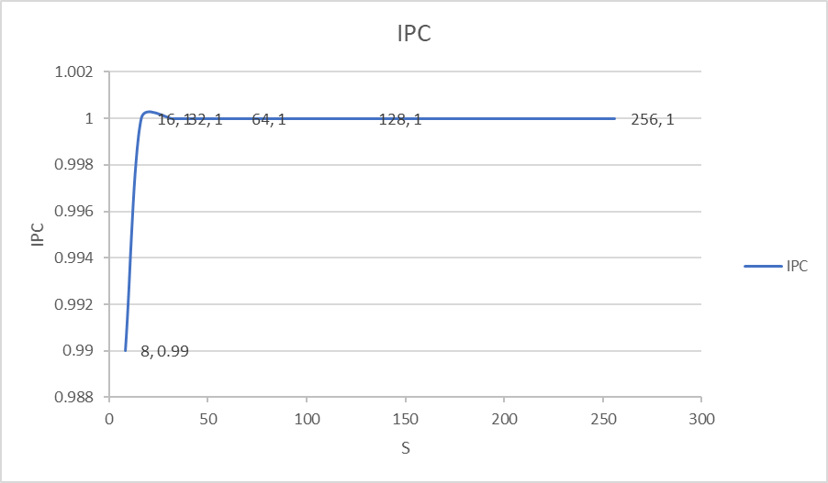

N=2

 | S
 | 8 | 16 | 32 | 64 | 128 | 256
IPC | 1.88 | 1.99 | 1.99 | 1.99 | 1.99 | 1.99

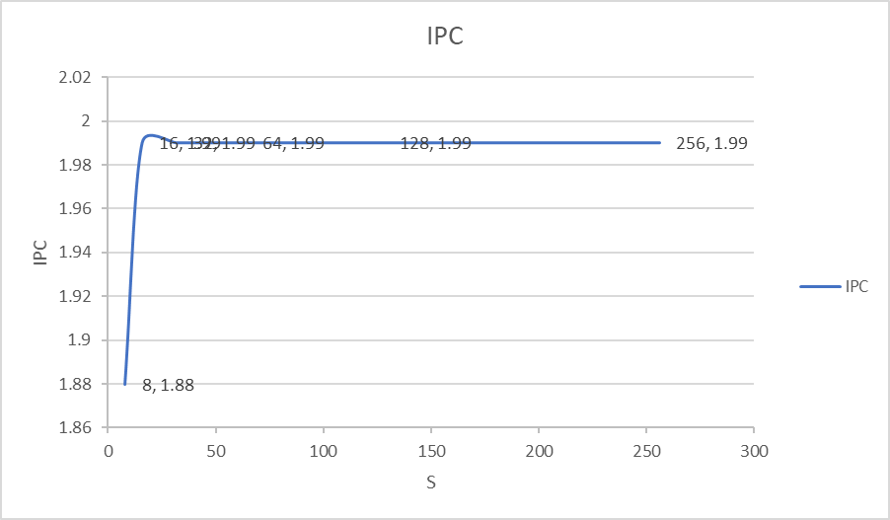

N=4

 | S
 | 8 | 16 | 32 | 64 | 128 | 256
IPC | 2.67 | 3.54 | 3.90 | 3.97 | 3.97 | 3.97

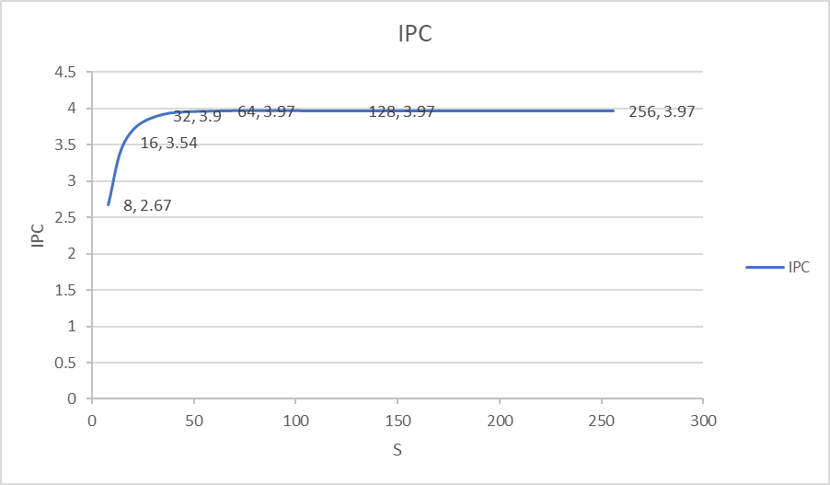

N=8

 | S
 | 8 | 16 | 32 | 64 | 128 | 256
IPC | 2.82 | 4.54 | 6.48 | 7.52 | 7.83 | 7.83

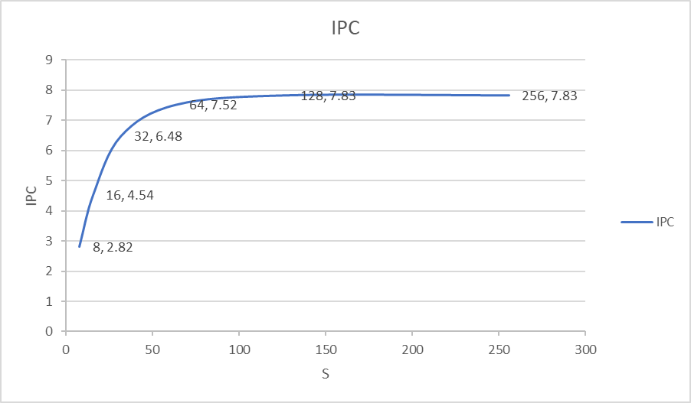

Analysis
For the gcc_trace benchmark, for a constant N, the instruction per cycle {IPC} count increases as the S increases. But this increase is saturated at IPC tending to N. This is the expected behavior because N is superscalar bandwidth. It’s the maximum number of instructions that can be processed in a cycle simultaneously. Therefore, N is the maximum IPC we can get for any configuration.
For the gcc_trace benchmark, for a constant S, the instruction per cycle {IPC} count increases as the N increases. This can be explained by the fact that N is superscalar bandwidth. It’s the maximum number of instructions that can be processed in a cycle simultaneously. As N increases, more instructions can be performed simultaneously increasing the IPC. This increase is significant for larger values of S. As the S along with N increases, the independent nature of more instructions can be identified, and the instructions can be performed out of order, increasing IPC and efficiency.
S is the size of schedule queue while N is the superscalar bandwidth. For the better efficiency the S should always be greater than N. As this allows more instruction that can be processed simultaneously to be checked for independent nature and to be executed. But increasing the S and N is very costly.

Perl

N=1

 | S
 | 8 | 16 | 32 | 64 | 128 | 256
IPC | 0.98 | 1.00 | 1.00 | 1.00 | 1.00 | 1.00

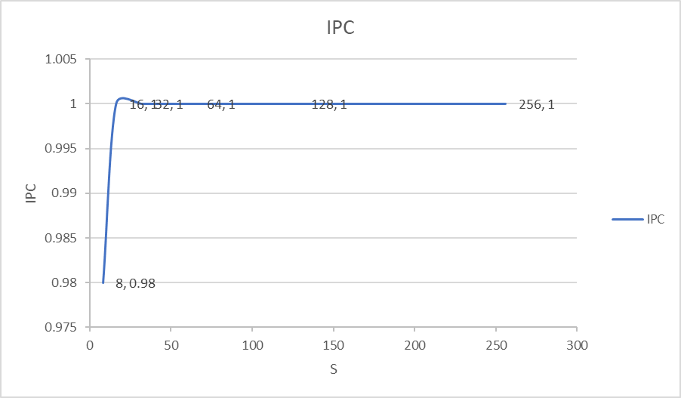

N=2

 | S
 | 8 | 16 | 32 | 64 | 128 | 256
IPC | 1.68 | 1.89 | 1.98 | 1.98 | 1.98 | 1.98

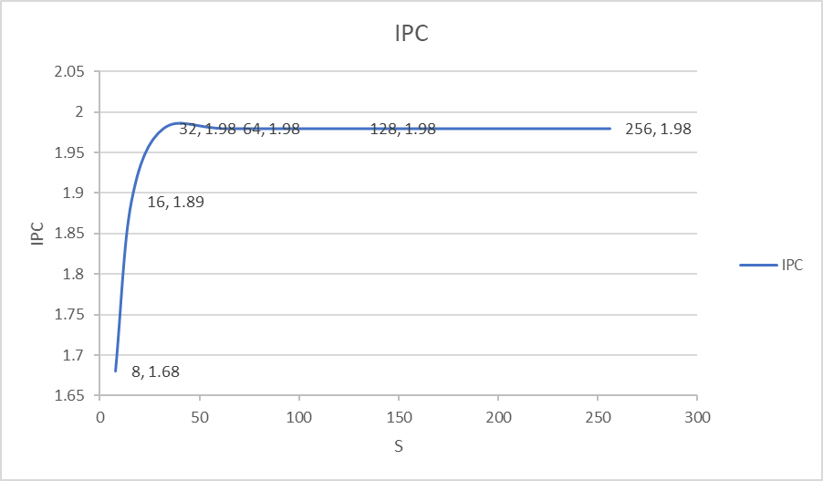

N=4

 | S
 | 8 | 16 | 32 | 64 | 128 | 256
IPC | 2.18 | 2.91 | 3.68 | 3.91 | 3.94 | 3.94

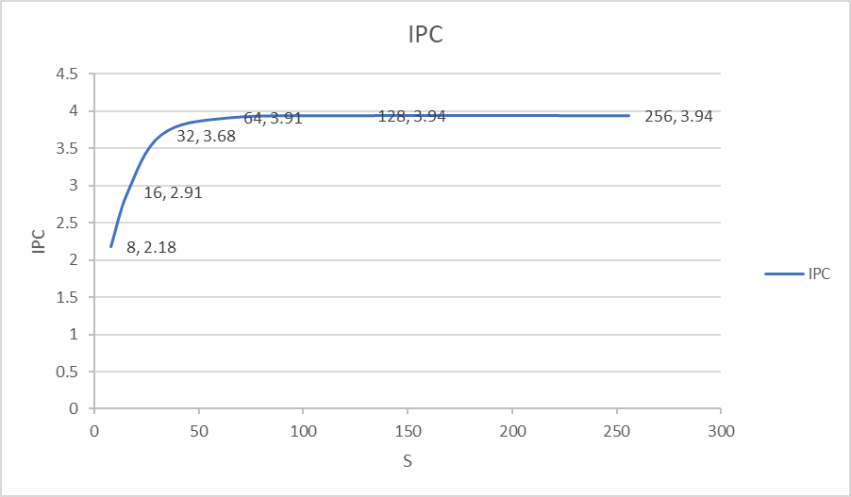

N=8

 | S
 | 8 | 16 | 32 | 64 | 128 | 256
IPC | 2.28 | 3.37 | 5.18 | 6.95 | 7.61 | 7.75

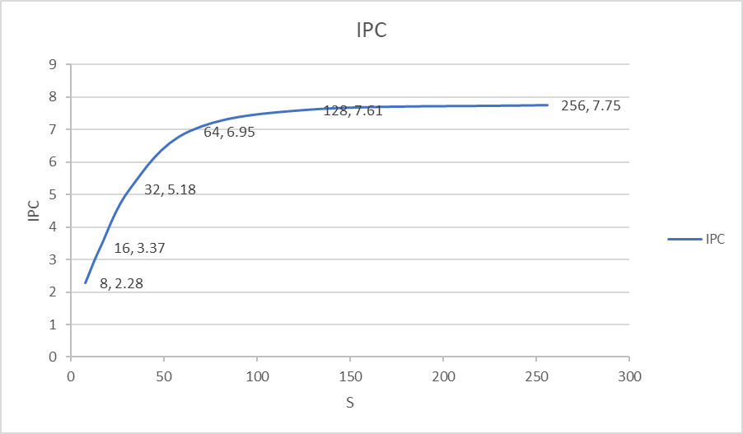

Analysis
For the perl_trace benchmark, for a constant N, the instruction per cycle {IPC} count increases as the S increases. But this increase is saturated at IPC tending to N. This is the expected behavior because N is superscalar bandwidth. It’s the maximum number of instructions that can be processed in a cycle simultaneously. Therefore, N is the maximum IPC we can get for any configuration.
For the perl_trace benchmark, for a constant S, the instruction per cycle {IPC} count increases as the N increases. This can be explained by the fact that N is superscalar bandwidth. It’s the maximum number of instructions that can be processed in a cycle simultaneously. As N increases, more instructions can be performed simultaneously increasing the IPC. This increase is significant for larger values of S. As the S along with N increases, the independent nature of more instructions can be identified, and the instructions can be performed out of order, increasing IPC and efficiency.
S is the size of schedule queue while N is the superscalar bandwidth. For the better efficiency the S should always be greater than N. As this allows more instruction that can be processed simultaneously to be checked for independent nature and to be executed. But increasing the S and N is very costly.
When both gcc_trace and perl_trace is compared, the IPC for gcc_trace is slightly more than that for perl_trace. But the values don’t differ significantly. The difference could be because in gcc_trace there might be more independent instructions than in perl_trace.

