HOMEWORK 5 – DEEP NEURAL NETWORKS (CS/DS 541)

DONE BY –

1. SHRISHAILYA CHAVAN
2. UDAY SANKAR
3. GOWRI SHANKAR SAI MANIKANDAN

Problem 1) Implementing a Neural Network with TensorFlow

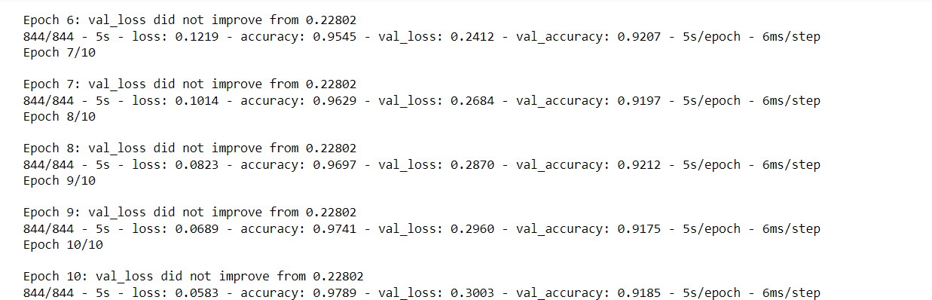

FIGURE: - GRADIENT UPDATES

Problem 2) Representing a Convolutional Neural Network as a fully Connected Neural Network

Figure 2 – Modified Model Summary

Figure 3 - Prediction Model