Secure Communication
Encrypted File Vault
Project Documentation & User Guide
X25519 ECDH · AES-256-GCM · SHA-256 · Argon2
A secure file storage & transfer web application
Repository: github.com/Shrishanth02/Secure-communication-project
August 2026

Contents
1. Introduction — What is this project? 3
2. Why this project matters 3
3. Key features at a glance 4
4. How it works, explained simply 4
5. The technology inside 6
6. The upgrade: before vs. after 6
7. Getting started — installation & running 7
8. How to use — a step-by-step walkthrough 7
8.1 The home page 8
8.2 Create an account 10
8.3 Log in 11
8.4 Upload & encrypt a file 12
8.5 Download your files 13
8.6 Check a file’s integrity 13
8.7 Log out 14
9. Testing & verification (done live) 14
10. Security & penetration-testing summary 15
11. Putting it online (deployment) 15
12. Troubleshooting 16
13. Frequently asked questions 16
14. Future scope & possible improvements 18
15. Glossary — words explained simply 18
16. Conclusion 19

1. Introduction — What is this project?
Imagine a personal safe in your home. You put something valuable inside, close the door, and lock it. Even if someone walked off with the whole safe, they still couldn't see what's inside without the key. Secure Communication is that safe, but for your digital files, and it lives online so you can reach it from anywhere.
It is a web application (a website you use through your browser) where you create your own private account and log in. Once you're in, you can upload any file you want to keep safe. The moment a file arrives, the app automatically locks it, a process called encryption, which scrambles the file so it becomes unreadable to anyone who doesn't have the key. This happens on its own; you don't need to know anything about how the lock works.
Every file is tied to you and only you. Other people who use the app cannot see or open your files, and even someone who managed to copy a file straight off the server would find nothing but scrambled data. When you want a file back, you log in and download it, and the app unlocks it for you so it comes back exactly as it was. You can also ask the app to check a stored file's unique fingerprint, a small code that would change if even one tiny part of the file were altered, to confirm nothing has been tampered with.
In short, it's a private locker for sensitive files: simple to use on the surface, with serious, real security engineering doing the work underneath. Here is what you can do with it:
- Create your own account and log in to your private space.
- Upload a file, which is automatically locked (encrypted) and stored, giving you a confirmation with a unique fingerprint.
- Download your files, which only you can retrieve and unlock.
- Check a stored file's integrity to confirm it hasn't been secretly changed.
- Log out when you're done, keeping your space private.

2. Why this project matters
Most of us keep important files on a computer or a phone and assume they are safe. But ordinary storage does very little to actually protect them. If a file sits in a normal folder, anyone who gets to that folder can open it and read every word. Think of a student who keeps a scanned copy of their passport and bank details on a shared laptop, or a professional who saves a signed contract on a work server. If that machine is lost, borrowed, hacked, or simply copied by someone with access, the file is wide open. Deleting it later does not help, and a password on your login screen only guards the door, not the file itself.
There is a second, quieter danger: a file can be changed without you noticing. Imagine you email a supplier an agreement, and somewhere along the way a number in it is quietly altered. The document still looks normal, still opens fine, and you have no easy way to tell that even a single character was swapped. For anything that matters, being able to prove a file is exactly as you left it is just as important as keeping it private.
Secure Communication was built to close both of these gaps. When you upload a file, it is automatically locked (encrypted) so that even someone who copies it straight off the server sees only scrambled data, not your real content. Only you, after logging into your own account, can download and unlock your own files, and no one can peek into anyone else's space. On top of that, the app keeps a unique fingerprint of each file, so you can check at any time that a stored file has not been secretly tampered with. In short, it turns ordinary storage into a private, tamper-evident locker, without asking you to understand any of the cryptography underneath.
Who it is for
- Students and professionals who need to store or hand off sensitive files, such as ID scans, contracts, or personal records, and want them kept private.
- Anyone who needs proof that a stored file has not been altered.
- A learner or evaluator looking at this as a portfolio or college project, since it demonstrates real, working security engineering rather than a toy example.

3. Key features at a glance
Everything below works today and has been tested end to end. You do not need any technical knowledge to use the application.
- Private accounts — sign up and log in to your own space; no one else can see your files.
- Automatic encryption — every uploaded file is locked (scrambled) the moment it is stored.
- Owner-only download — only you can retrieve and unlock your own files.
- Integrity check — confirm at any time that a stored file has not been secretly changed.
- Tamper-evident storage — any change to a stored file is detected and the file is refused on download.
- Safe passwords — passwords are stored scrambled (hashed), never as plain text.
- Runs anywhere — no separate database server needed; it uses a built-in file database.
- Production-ready — hardened settings, security headers, and HTTPS support for real deployment.

4. How it works, explained simply
Think of Secure Communication as a private online locker for your files. You create your own account, sign in, and drop files inside. The moment a file goes in, it gets locked automatically. From that point on, only you hold the key to open it again.
Signing in to your private space
First you make an account and log in. Everyone who uses the app gets their own separate space, and you can only ever see your own files. Your password is never kept as plain readable text. Instead it is scrambled into a jumble that cannot be turned back into the original, so even someone who peeked at the storage would not learn your password.
Uploading and locking a file
When you upload a file, the app locks it right away, the way you would lock something valuable inside a safe. This locking is called encryption. Once locked, the file is scrambled so nobody can read it, not even someone who copies it straight off the server. Along with the lock, the app seals the file so any secret change would be spotted later.
After the upload, you get a confirmation that includes a unique fingerprint of your file. A fingerprint is a short string of characters that stands in for the exact contents of that file. If even a single letter inside the file changed, the fingerprint would change too, so it is a reliable way to tell that your file is still exactly as you left it.
Downloading and unlocking
When you want a file back, you download it and the app unlocks it for you. This unlocking is called decryption, and it is simply the reverse of the lock. Only you, signed in to your own account, can retrieve and unlock your own files. The file that comes back is identical to the one you put in. The stored files live in a private folder that the website never hands out on its own; they only come out through you, the logged-in owner.
Checking that nothing changed
At any time you can run an integrity check. The app looks at the file's current fingerprint and compares it to the one from when you uploaded. If the two match, you know the file has not been tampered with. If they ever differ, you would know something was altered. It is a quick way to prove a stored file is still trustworthy.
Logging out
When you are done, you log out and your private space closes behind you. Nothing is left open for the next person at the computer.
A little more technical (optional)
For those who want the real names behind the plain words: X25519 is the method that lets two sides agree on a secret key without ever sending the key itself. AES-256-GCM is the actual lock that scrambles each file and adds a tamper seal so any change is detected. SHA-256 is the modern fingerprint used to confirm a file has not changed. Argon2 is the method that scrambles passwords into secure hashes so they are never stored as plain text.
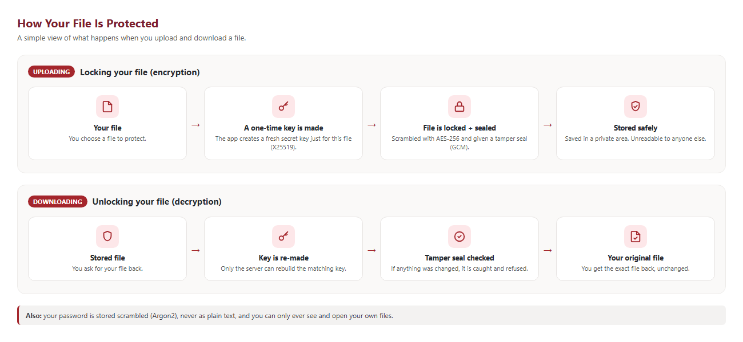
Figure 1 — How your file is protected when uploading and downloading.

5. The technology inside
For readers who want the specifics, here are the real building blocks the app uses and what each one does. Each is a modern, widely trusted standard.
Building block | What it does | In plain words
X25519 ECDH | Key agreement | Two sides agree on a secret key without ever sending the key.
HKDF-SHA256 | Key strengthening | Turns that secret into a strong 256-bit key, tied to the file’s owner and name.
AES-256-GCM | Encryption + seal | Scrambles the file and adds a tamper seal so any change is caught.
SHA-256 | Integrity fingerprint | A short code that changes if the file changes — used to prove nothing was altered.
Argon2id | Password protection | Stores passwords as a secure scramble that cannot be reversed.
Django + SQLite | App & storage | The web framework and a built-in database — no extra server to install.

Encrypted files are kept in a private folder that the website never serves directly — they can only be retrieved by the logged-in owner. A diagram of the full flow is shown in Figure 1 above.

6. The upgrade: before vs. after
This project began as a college major project whose original version looked impressive on paper but was insecure underneath. It was rebuilt so the security is real. The table below summarises what changed.
Area | Before (original) | After (this project)
Key exchange | Fake tiny-number method (only 23 possibilities) | Real X25519 elliptic-curve key exchange
Encryption | One reused setting + a password written in the code | AES-256-GCM with a fresh random value every time
Database access | Vulnerable to injection attacks | Safe, parameterised database layer
Passwords | Stored as plain readable text | Stored as Argon2id scrambled hashes
Access control | None — anyone could see everyone’s files | Real logins; each user sees only their own files
Integrity check | Old, weak SHA-1 fingerprint | Modern SHA-256 plus a built-in tamper seal
Setup | Needed a separate MySQL server | Runs anywhere on a built-in database (SQLite)
Configuration | Debug mode and secrets left switched on | Production-safe settings, security headers, HTTPS

7. Getting started — installation & running
You only need Python installed (version 3.10 or newer). The following steps get the app running on your own computer. Type each command into a terminal (Command Prompt on Windows) from inside the project folder.
Step 1 — Install the required packages
pip install -r requirements.txt
Step 2 — Set up the database (first time only)
python manage.py migrate
Step 3 — Start the application
On Windows you can simply double-click run.bat, or run:
set DJANGO_DEBUG=True
python manage.py runserver
Step 4 — Open it in your browser
Go to the address below. The home page (Figure 2) will appear.
http://127.0.0.1:8000/index.html

8. How to use — a step-by-step walkthrough
This section walks through every screen with a picture. Follow it in order the first time.

8.1 The home page
When you open the app you see the welcome page. It introduces what the app does and gives you two buttons: Create account and Sign in. Use the top menu to move around.
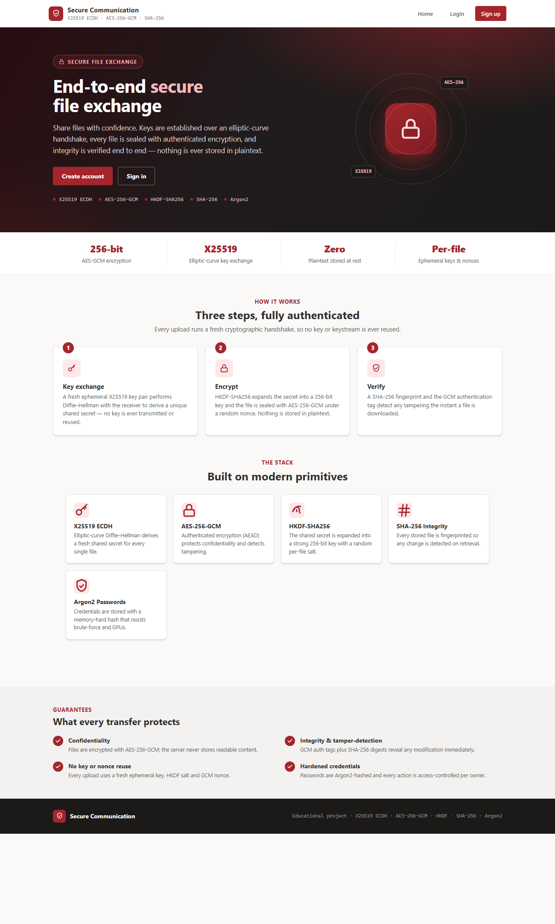
Figure 2 — The home page.

8.2 Create an account
Click "Sign up". Fill in a username, a password (at least 8 characters and not too common), your contact number, gender, email, and address. Then click Submit.
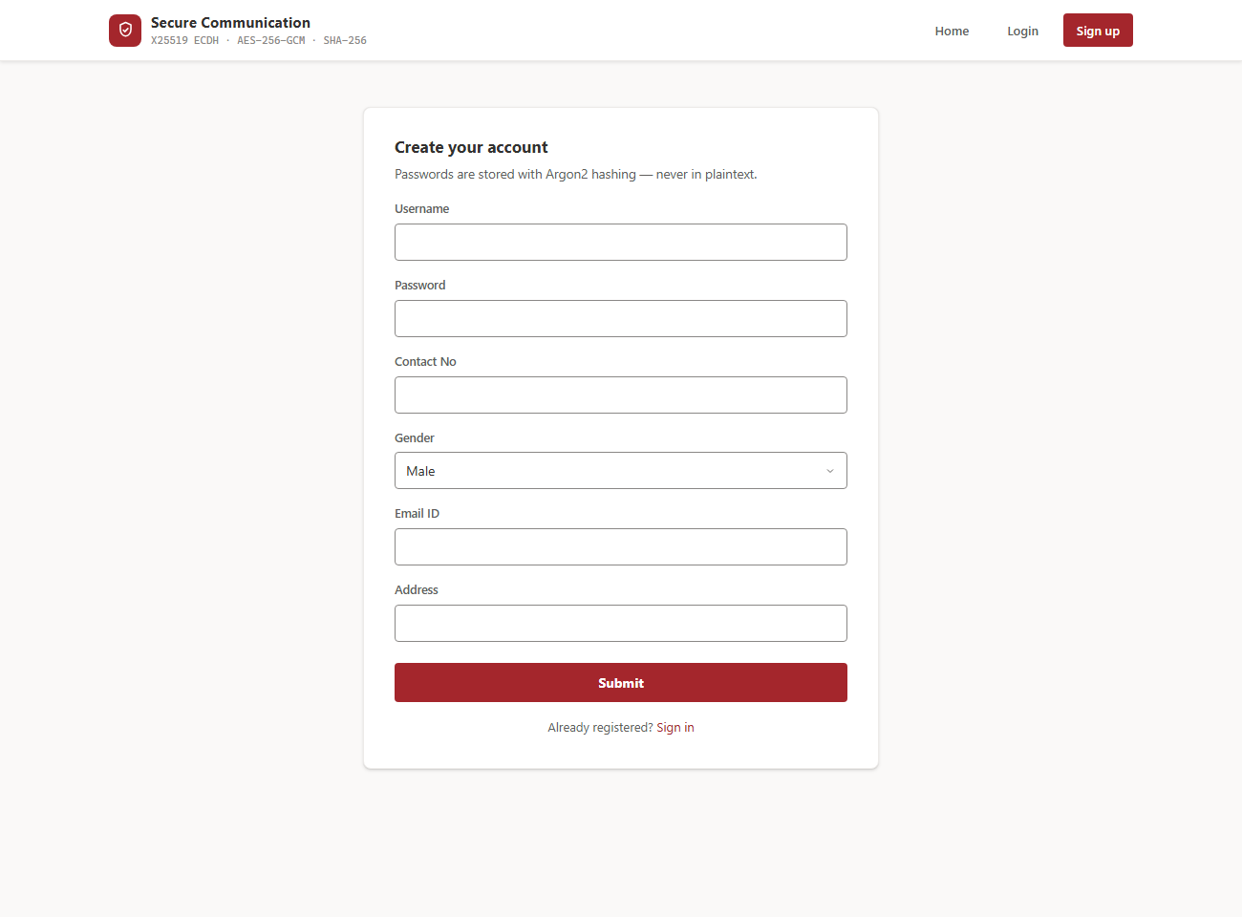
Figure 3 — The sign-up form.
If everything is fine, you see a confirmation that your account was created.
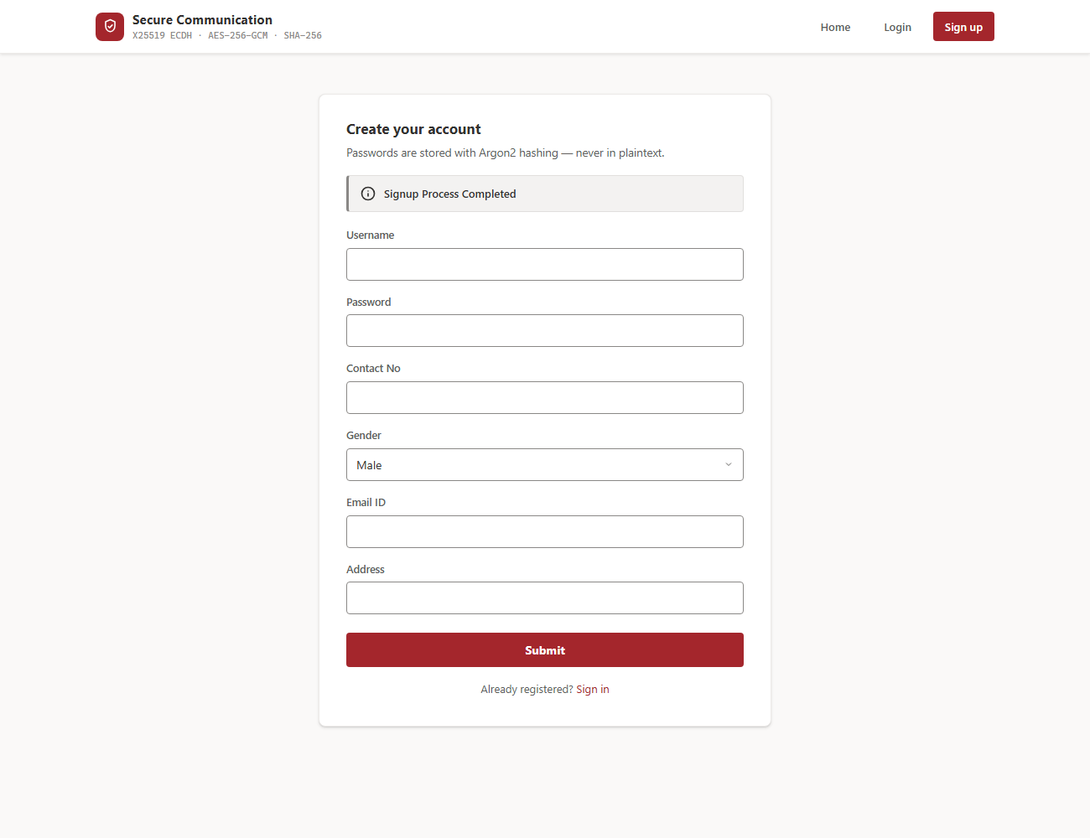
Figure 4 — Account created successfully.

8.3 Log in
Click "Login", enter your username and password, and click Login. If the details are wrong, the app simply says "login failed" — and after several wrong tries it briefly pauses further attempts to stop guessing attacks. When you log in successfully, you arrive at your dashboard.
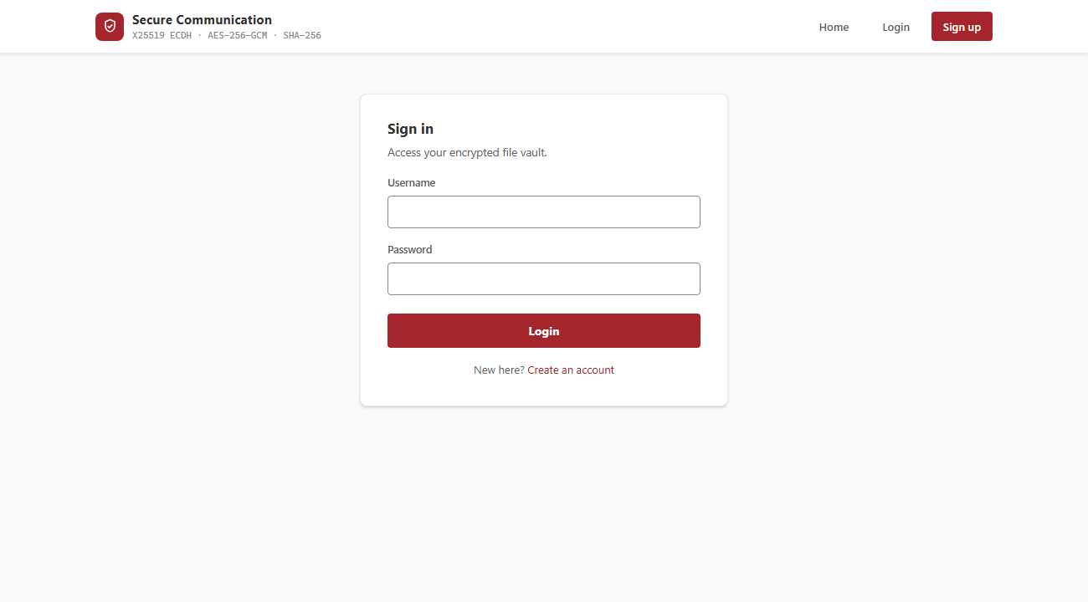
Figure 5 — The login screen.
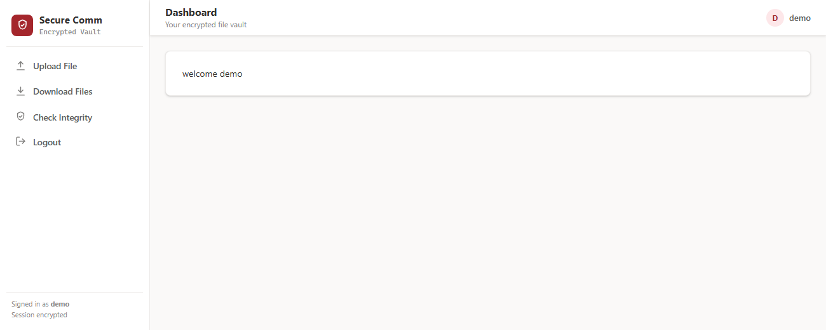
Figure 6 — Your dashboard after logging in, with the menu on the left.

8.4 Upload & encrypt a file
Choose "Upload File" from the left menu, click "Choose a file", pick a file, and click "Upload & Encrypt". The app locks the file and shows a green confirmation that includes the file’s unique SHA-256 fingerprint.
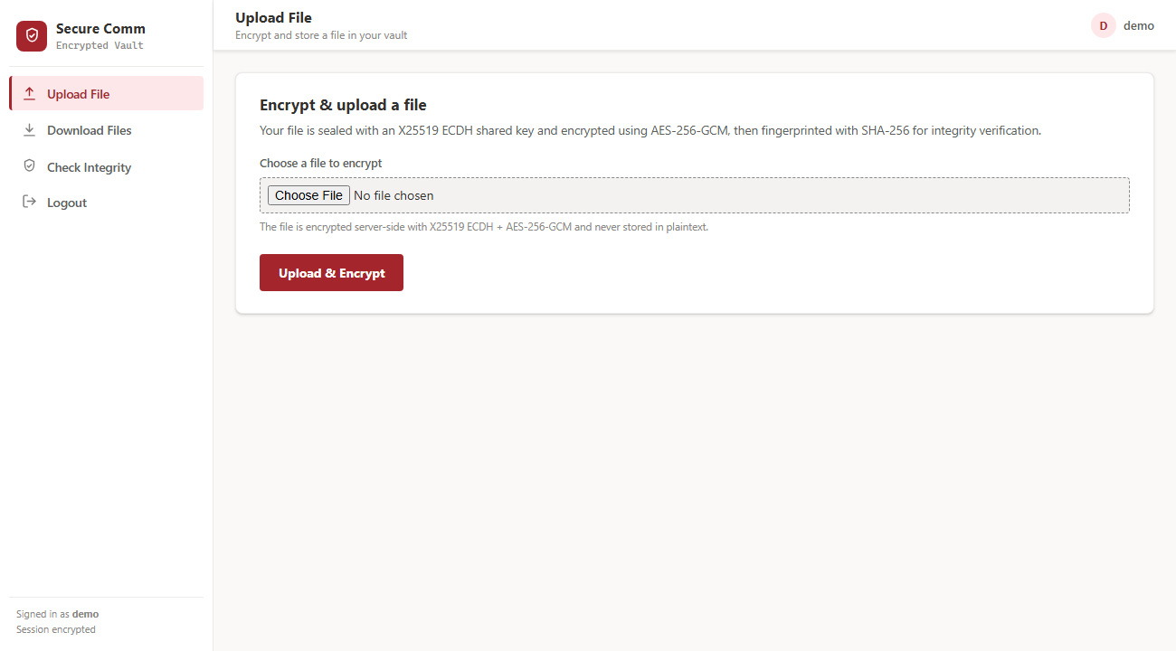
Figure 7 — The upload screen.
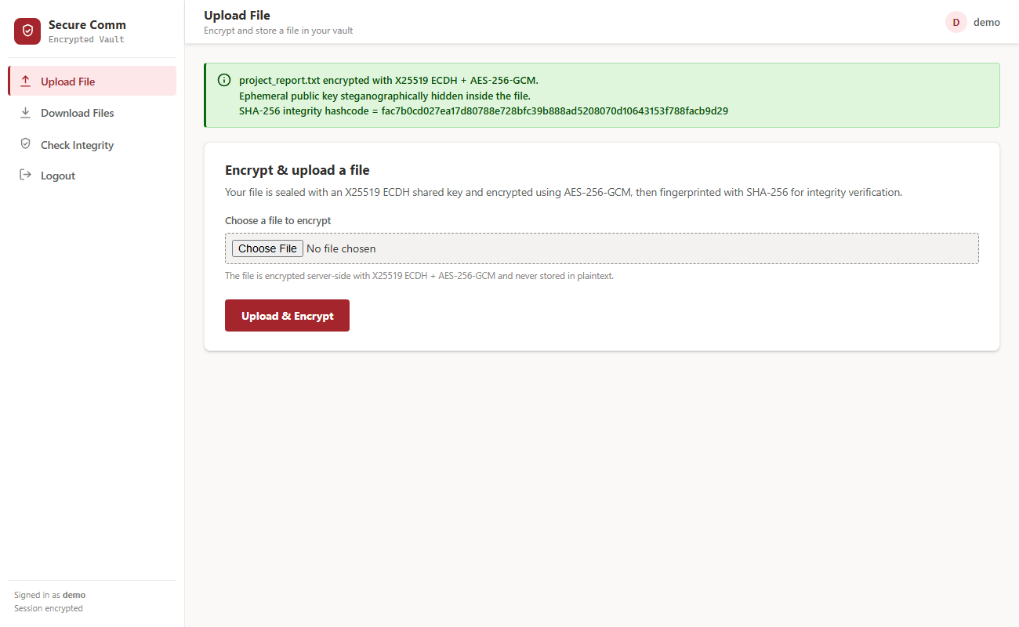
Figure 8 — A file uploaded and encrypted, with its integrity fingerprint.

8.5 Download your files
Choose "Download Files" to see the files you have stored. Click "Click Here" in the Download column to retrieve and unlock a file — it comes back exactly as you uploaded it. You only ever see your own files here.
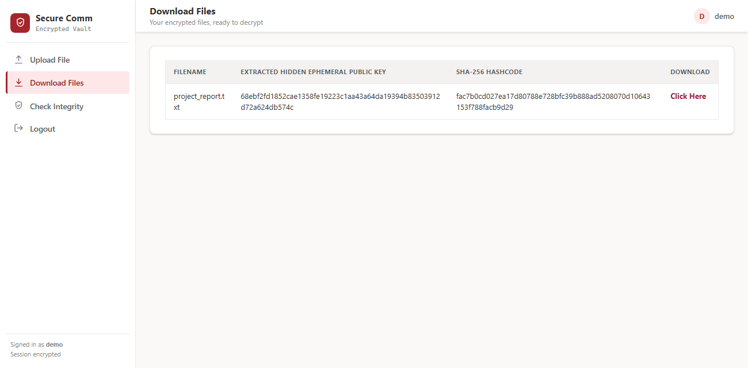
Figure 9 — Your stored files, ready to download and decrypt.

8.6 Check a file’s integrity
Choose "Check Integrity" and click "Click Here" next to a file. The app compares the file’s current fingerprint with the original.
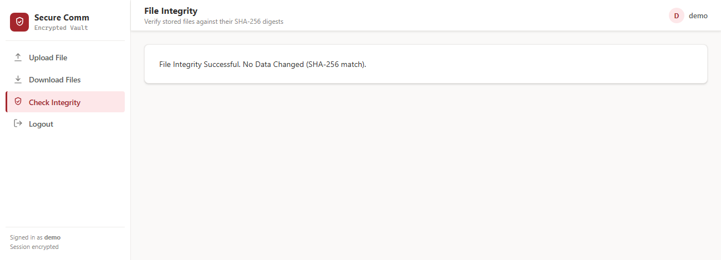
Figure 10 — Integrity check passed: the file has not changed.
If a stored file had been altered in any way, the check reports a failure — as shown below (this was produced during testing by deliberately changing a stored file).
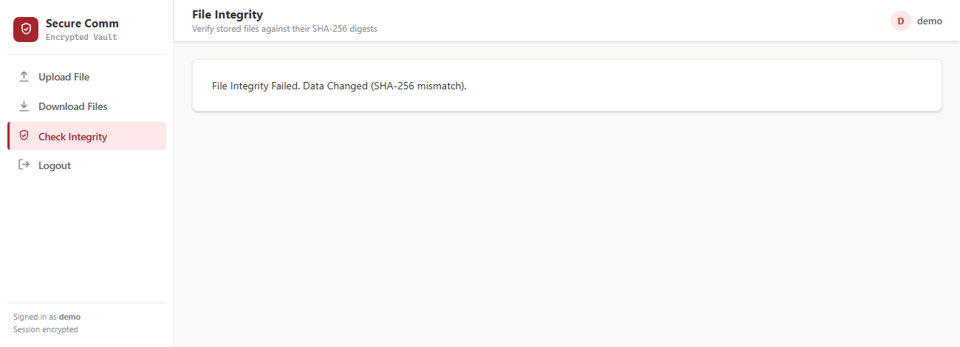
Figure 11 — Integrity check failed: tampering detected.

8.7 Log out
Click "Logout" in the left menu to close your private space. This is done safely so that simply visiting a link cannot log you out by accident.

9. Testing & verification (done live)
The application was run and tested in real time. Two kinds of tests were carried out: functional tests (does it do what it should?) and security tests (does it resist attacks?). Every test below passed.
Functional tests — does everything work?
Test | What we did | Result
Sign up | Created a new account | Account created
Log in | Logged in with correct details | Reached the dashboard
Upload / encrypt | Uploaded a file | Encrypted & stored; fingerprint shown (Fig. 8)
Download / decrypt | Downloaded the file back | Returned identical to the original
Integrity (clean) | Checked an untouched file | Passed (Fig. 10)
Integrity (tampered) | Changed a stored file, then checked | Failure detected (Fig. 11)

Security tests — does it resist attacks?
Attack tried | Result
Login bypass by injection (typing tricky text into the form) | Blocked
One user trying to open another user’s file | Denied
Forged form submission from another site (CSRF) | Blocked
Malicious file name (e.g. hidden code or folder tricks) | Made harmless
Secretly changing a stored file | Detected and refused
Repeated wrong-password guessing | Temporarily blocked
Reading an encrypted file straight off the server | Only scrambled data — unreadable

10. Security & penetration-testing summary
Beyond normal testing, the app was put through a structured security review — a "red team" exercise that deliberately looks for weaknesses, the way an attacker would. Eighteen possible issues were examined. Sixteen were fixed and two were minor, low-risk items that were reviewed and accepted. None were severe.
The protections now in place include:
- Strong, modern encryption tied to each file’s owner, so a file cannot be swapped between accounts.
- Passwords stored as Argon2 hashes, with strength rules and a limit on repeated login attempts.
- A fresh session each time you log in, and a safe, deliberate log-out.
- Files kept outside the public area of the website and served only to their owner.
- Protection against tricky file names and folder-escape attempts.
- Web security headers, HTTPS support, and production-safe settings that refuse to start unsafely.
Full technical details are recorded in the project’s SECURITY.md and PENTEST.md files.

11. Putting it online (deployment)
The app is ready to be hosted on the internet. In short, a real deployment involves: setting a few environment values (a strong secret key, turning debug mode off, and listing the website address), collecting the static files, and running it behind a secure (HTTPS) web address. A full, step-by-step guide is included in the project’s DEPLOYMENT.md file.
The one step that needs a human decision is choosing where to host it (for example a cloud server or a hosting service). Everything else is already prepared and documented.

12. Troubleshooting
If you see... | What to do
"Please login first" | You are not logged in. Go to Login and sign in first.
The page has no styling / looks plain | Make sure DJANGO_DEBUG=True for local use (run.bat sets this), then refresh.
"Too many failed attempts" | Wait a few minutes — this is the anti-guessing protection. Then try again.
"File too large" | The limit is 10 MB per file. Use a smaller file.
App refuses to start in production | A secret key must be set. See DEPLOYMENT.md and .env.example.

13. Frequently asked questions
Is my file safe if someone steals the server?
Yes. Every file is locked (encrypted) before it is stored, so what actually sits on the server is scrambled and unreadable. If someone copied a file straight off the machine, they would only get the scrambled version, not your real document. The lock we use is called AES-256-GCM, a strong, modern method of scrambling data. Without your account and the key tied to it, the stored file cannot be unlocked.
Can another user see or open my files?
No. Each person has their own private space, and you only ever see your own files. The app checks who is logged in before showing or releasing any file, so one user cannot list, open, or download another user's files. This was specifically tested: one user trying to reach another user's files is blocked.
How exactly is my file locked?
When you upload a file, the app creates a strong 256-bit key that is tied to you and to that file's name. It then scrambles the file with that key using AES-256-GCM. This method does two jobs at once: it hides the contents, and it adds a tamper seal so any later change to the file can be detected. A fresh random value is used every single time, so no two locks are ever the same.
What is the unique fingerprint I get after uploading?
After a successful upload you receive a short fingerprint of your file, produced by a method called SHA-256. Think of it as a unique summary of the file's contents. If even one small part of the file changes, the fingerprint changes too. This is what lets the app later confirm your stored file is still exactly the one you uploaded.
What happens if a stored file is changed or tampered with?
The app will detect it. Because each file carries a tamper seal from the lock, and because you can check its fingerprint at any time, a secret change to a stored file does not go unnoticed. In testing, altering a stored file was correctly caught. So you can trust that a file that passes the integrity check is unchanged since you uploaded it.
How can I check that my file has not been tampered with?
The app has a built-in integrity check. It compares the file's current fingerprint against the one recorded when you uploaded it. If they match, the file is untouched. If they do not match, you know something changed. This is a simple way to prove a stored file is still trustworthy.
What if I forget my password?
For safety, passwords are never stored as plain readable text. They are scrambled (hashed) using a method called Argon2id, which means even the app cannot read your original password back to you. This is exactly what keeps your account secure if the database is ever exposed. The trade-off is that a forgotten password cannot simply be looked up, so please keep your password somewhere safe.
Does it need the internet or a special database to run?
No special setup is required. The app runs on SQLite, a simple built-in database, so there is no separate database server to install and configure. This makes it easy to run on an ordinary computer. It is a web application, so you use it through a browser, but it does not depend on any heavy external system.
Is my password protected against repeated guessing attacks?
Yes. If someone tries many wrong passwords in a row, the app temporarily blocks further attempts. This makes it much harder for an attacker to guess a password by trying thousands of combinations. There are also password strength rules when you sign up, so weak passwords are discouraged from the start.
Was this project properly tested and reviewed?
Yes, and all the tests passed. The full journey works end to end: sign up, log in, upload and encrypt, download and decrypt, and the file comes back identical. Security tests confirmed that fake logins are blocked, users cannot open each other's files, forged form submissions are stopped, and malicious file names are made harmless. An independent 'red team' review checked 18 possible weaknesses; 16 were fixed and 2 were low-risk and accepted, with none rated severe.
This was rebuilt from an older version — what actually improved?
The original was a broken, toy version, and this rebuild replaces its weak parts with real security. A fake key exchange with only a handful of possibilities became genuine X25519 key agreement, where two sides agree on a secret without ever sending it. A password hidden in the code and a reused lock setting became a fresh random lock every time. Passwords stored as plain text became Argon2id hashes, an old weak SHA-1 fingerprint became modern SHA-256, and unsafe database queries were replaced with Django's safe database layer. Proper logins now make sure each person sees only their own files.
Is this used in the real world, or is it a demonstration project?
This is a portfolio and college major project built to demonstrate real security engineering, not a commercial product in wide use. That said, the security building blocks it uses (X25519, AES-256-GCM, SHA-256, Argon2id) are the same trusted, real-world methods used to protect sensitive data. It is meant to safely store or hand off sensitive files for students and professionals, and to show that the underlying work is genuine, not just for show.

14. Future scope & possible improvements
The current app already does the hard part: it locks your files with real, modern security and makes sure only you can open them. The ideas below are natural next steps. Each one builds on what is already working, and none of them requires throwing away the existing design. Together they would turn a solid single-user locker into something a small team or a real product could rely on every day.
- Per-user encryption keys — give every account its own private key instead of one shared master key, so each person's files are sealed with a lock that is truly their own.
- File sharing with permissions — let an owner safely hand a file to another user, and choose whether they can only view it or also pass it on.
- Delete and rename features — allow owners to tidy their space by removing files they no longer need and giving files clearer names.
- Store the master key in a hardware or secret manager — keep the most important key in a dedicated, tamper-resistant vault rather than on the regular server, so it is much harder to steal.
- Cloud deployment — host the app online so it is reachable from anywhere, with automatic backups and room to grow as more people use it.
- Two-factor login — add a second check at sign-in (such as a code from your phone), so a stolen password alone is not enough to get in.
- Mobile-friendly polish — refine the screens so the app is comfortable to use on a phone or tablet, not just a computer.
- Stronger rate-limiting with Redis — use a faster, shared memory system to block repeated login attacks reliably, even when the app runs on several servers at once.
- Activity log for owners — show each person a simple history of their uploads, downloads, and integrity checks, so anything unexpected is easy to spot.
- Automatic file expiry — let owners set a file to delete itself after a chosen time, which is handy for one-time or short-lived handoffs.

15. Glossary — words explained simply
This project uses a few technical words that may be new to you. Here is what each one means, in everyday language. You do not need to memorise these -- just glance back at this table whenever a term comes up elsewhere in the document.
Term | Meaning in plain words
Encryption | Scrambling a file so that nobody can read it unless they have the right key to unlock it.
Decryption | The reverse of encryption -- turning the scrambled file back into the readable original.
Key | A secret value, like a digital key, that locks a file when saving it and unlocks it when the owner opens it.
Password hashing (Argon2id) | A way of storing your password as a scrambled code instead of plain text, so nobody can read it even if they see the database.
X25519 / ECDH | A clever method that lets two sides agree on the same secret key without ever sending that key over the network.
AES-256-GCM | The actual lock used on your files -- it scrambles the file and also adds a tamper seal so any change is noticed.
HKDF | A step that turns the shared secret into a strong 256-bit key, tied to who owns the file and its name.
SHA-256 / fingerprint | A short unique code calculated from a file, used to check that nothing about the file has changed.
Session | The period you stay logged in after signing in, so the app remembers it is really you between clicks.
CSRF | A trick where a malicious site tries to make actions on your behalf without you knowing -- the app blocks it.
Steganography | Hiding one piece of information inside another; here, a public (non-secret) key is tucked invisibly inside a stored file as a demonstration.
Ciphertext | The scrambled, unreadable version of a file after it has been encrypted.
Integrity | The assurance that a stored file is still exactly as it was, with nothing secretly added or changed.
Server | The central computer where the app runs and where your encrypted files are safely kept.

16. Conclusion
Secure Communication takes an everyday need — keeping files private and provably unchanged — and meets it with real, modern security, while staying simple enough for anyone to use. It has been rebuilt from a broken original into a hardened, tested, production-ready application, and every part of it has been verified working. Whether you are a user who just wants a safe place for important files, or an evaluator judging the engineering behind it, the same thing is true: what it promises on the surface is genuinely delivered underneath.

