Secure Communication using DiffieHellman Key Exchange, AES & SHA for Data Integrity
In propose work you want to perform secure communication between sender and receiver without data sniffing or change using mediator or replay attacker. In propose work you ask us to implement following modules
Key Exchange: here we have used DiffieHellman key generation algorithm which is used to generate secure key between sender and receiver and this private key will be used by sender to encrypt data and then exchange this key with receiver by hiding in encrypted file. Receiver can extract key and then decrypt file. Replay or other attacker don’t know how t extract secret key from file to decrypt data and he cannot able to view plain data
AES Encryption: even if attacker manage to hack key then he cannot decrypt data as data is already secured by using DiffieHellman and by using this key how to decrypt data attacker will never know and data will get secured. Data which is sniff or hack cannot be decrypted as AES is more secured compare to any other algorithm
Data Integrity: All data which is uploaded by user can be view and downloaded by any other authenticated or registered users. Sometime cloud servers or attackers may inject false data to uploaded file and user never knows about it and to overcome from this issue we have added data integrity check. While sending or uploading file user will generate SHA code on file and then this code will saved in server and at any time user can ask server to compare original SHA code with available file and if code same then file integrity is intact and if file data changed then SHA code will un-match and user will know about file attack.
In below screen we are showing code for Diffie Key Generation, AES file encryption using Diffie key and then hiding key to encrypted file.
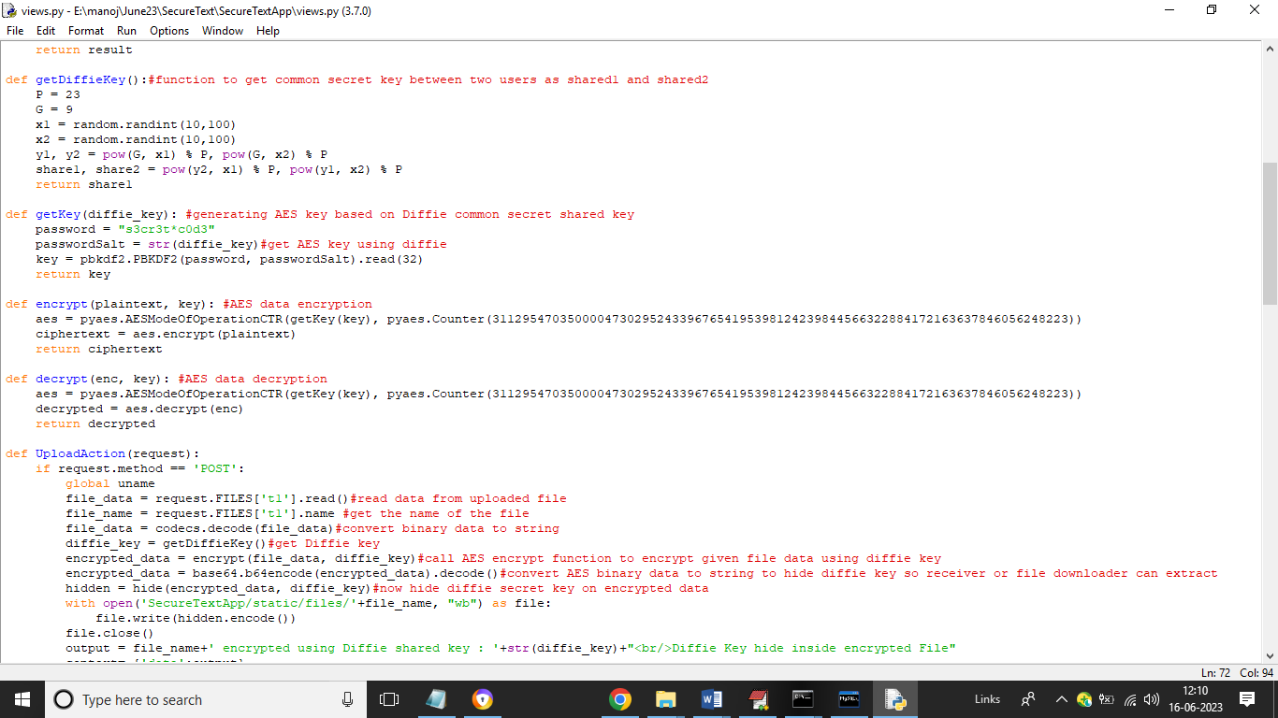
In above screen read red colour comments to know about Diffie key generation, encryption and hiding key as secret message which receiver will extract and decrypt data. Recipient will do reverse process to decrypt and download data.
To implement this project we have designed following modules
- New User Signup: using this module user can signup with the application
- User Login: using this module user can login to application
- File Upload: using this module user will upload file to cloud and then application will generate key, encrypt file and hide key to encrypted data as secret message
- Download File: any genuine user can login to system and then browse list of files uploaded to cloud and then can select desired file to download and this file will get decrypted by extracting hidden keys and then download.
- File Integrity Check: Any time user will use this option to check original SHA code is matching with current file.
To run project install Python 3.7.0 and then install MYSQL database and then copy content from DB.txt file and paste in MYSQL to create database.
SCREEN SHOTS
To run project double click on ‘run.bat’ file to get python web server and get below page
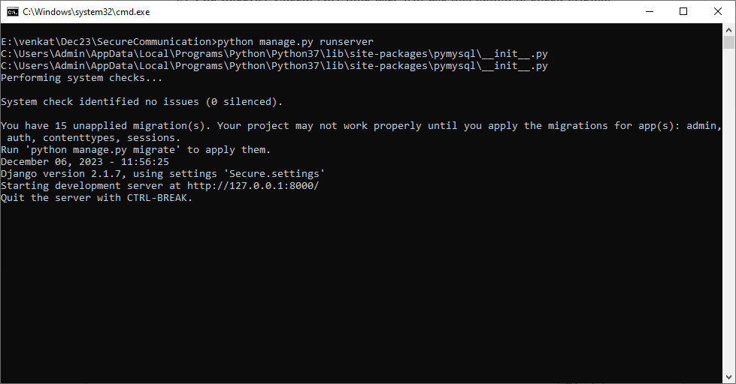
In above screen python server started and now open browser and enter URL as http://127.0.0.1:8000/index.html and press enter key to get below page
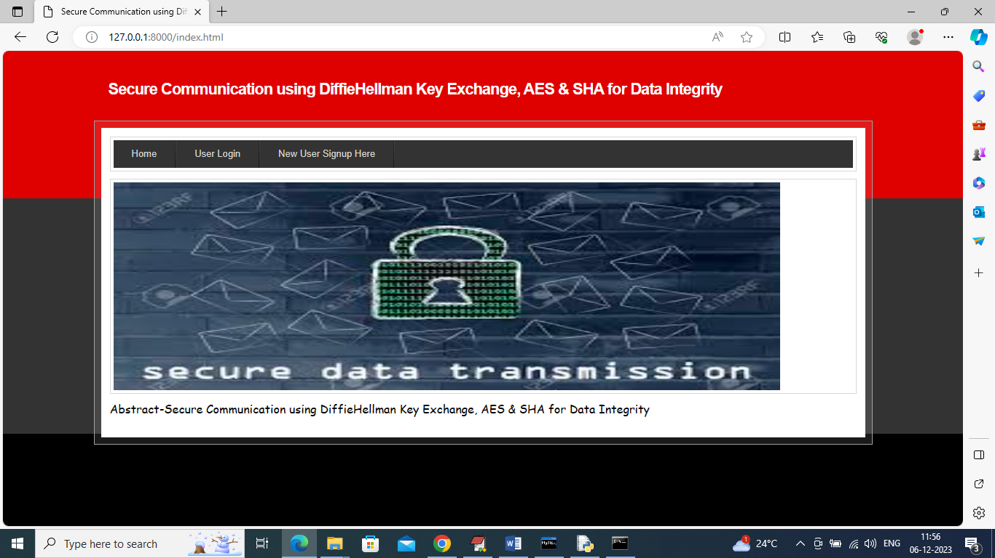
In above screen click on ‘New User Signup Here’ link to get below page
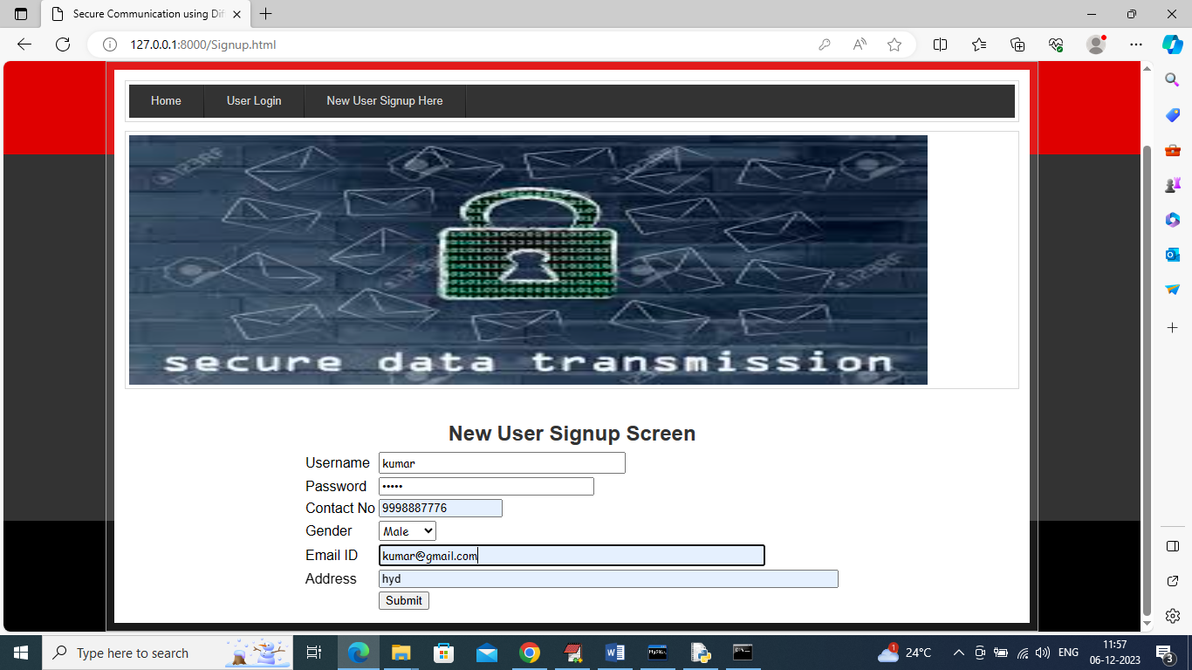
In above screen user is signing up and then press button to get below page
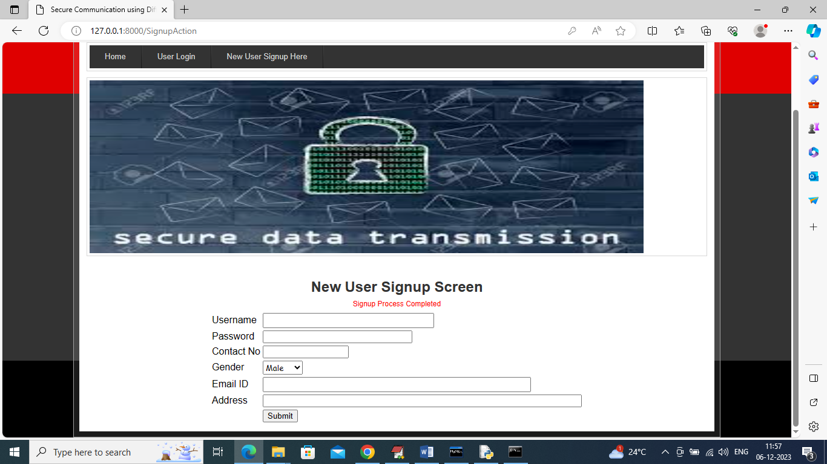
In above screen user sign up completed and similarly you can add many users for sending and receiving files
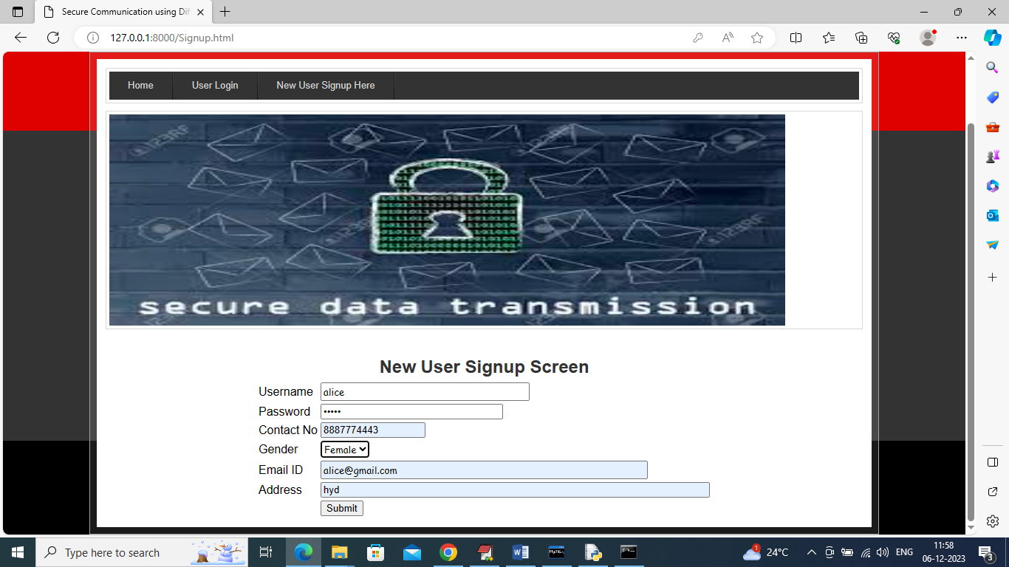
In above screen another user is signing up and now click on ‘User Login’ link to get below page
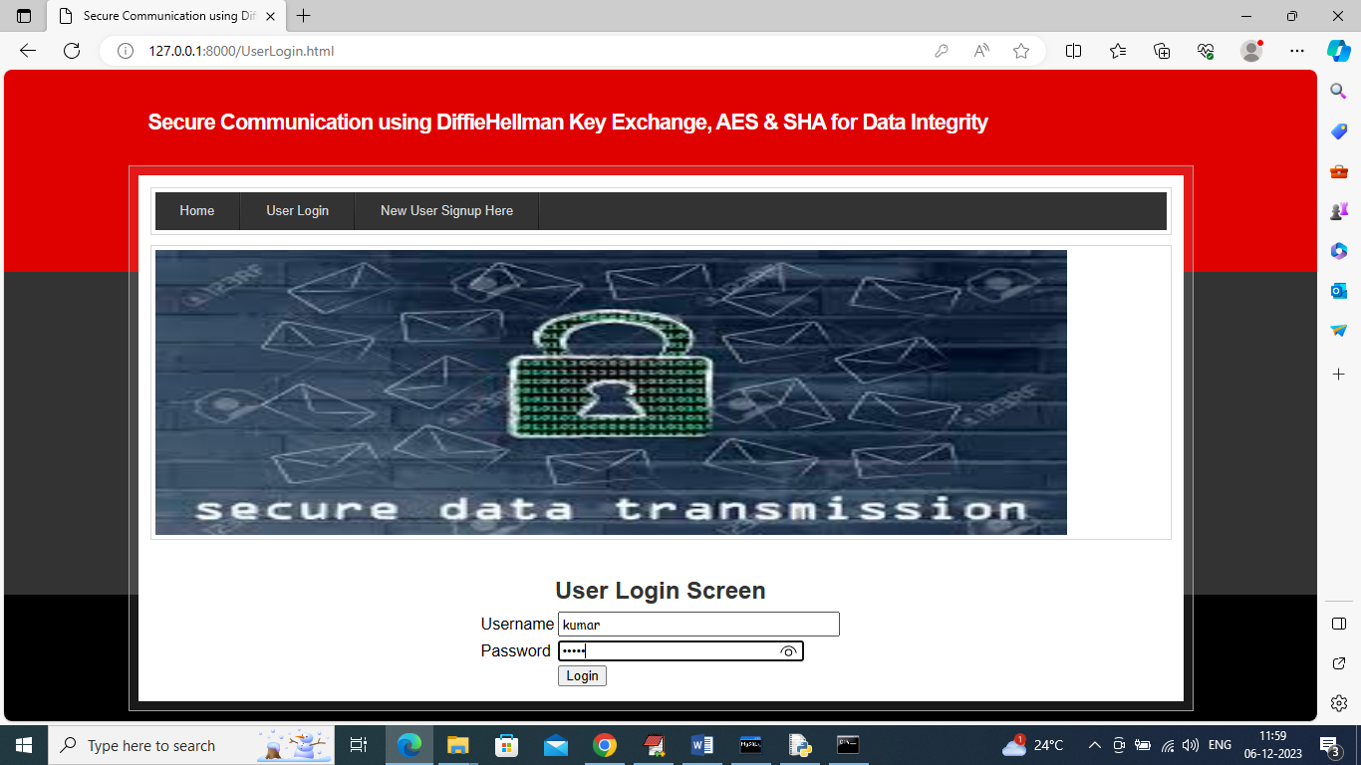
In above screen user is login and after login will get below page
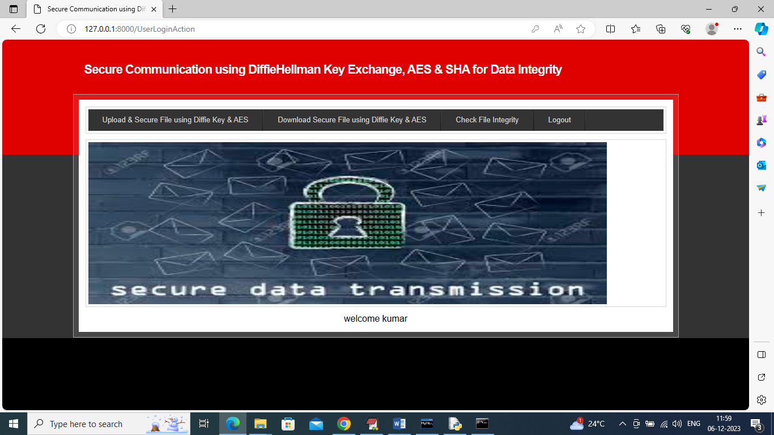
In above screen user can click on ‘Upload & Secure File’ link to upload file like below page
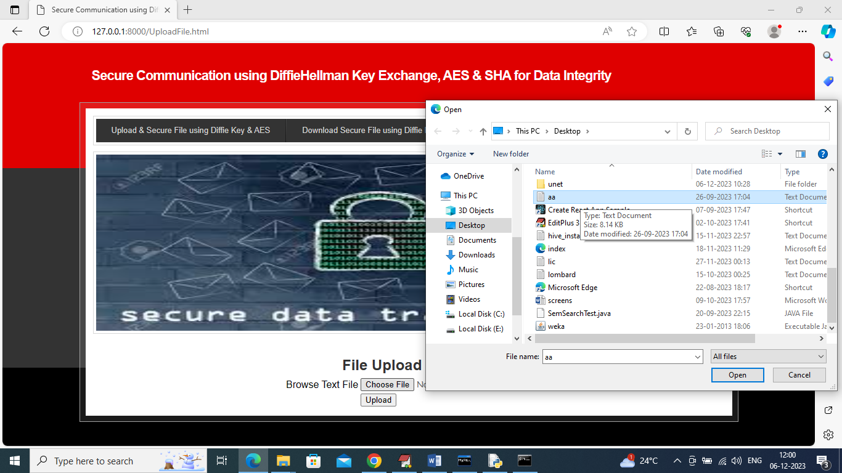
In above screen user is selecting and uploading file and then press button to get below page
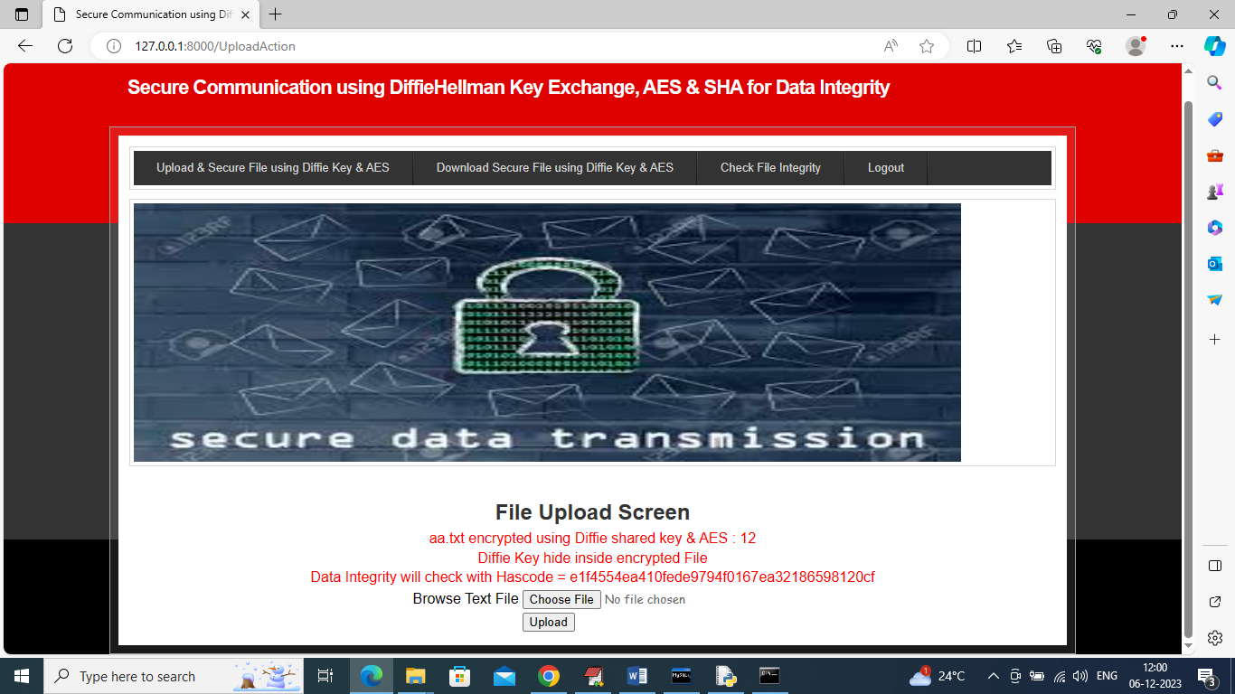
In above screen can see about DiffieHellman key and SHA code generated for uploaded file and this file will get integrity check using above details and now click on ‘Download Secure File’ link to get list of uploaded files like below screen and this file can be view and download by all authenticated users as senders or receivers
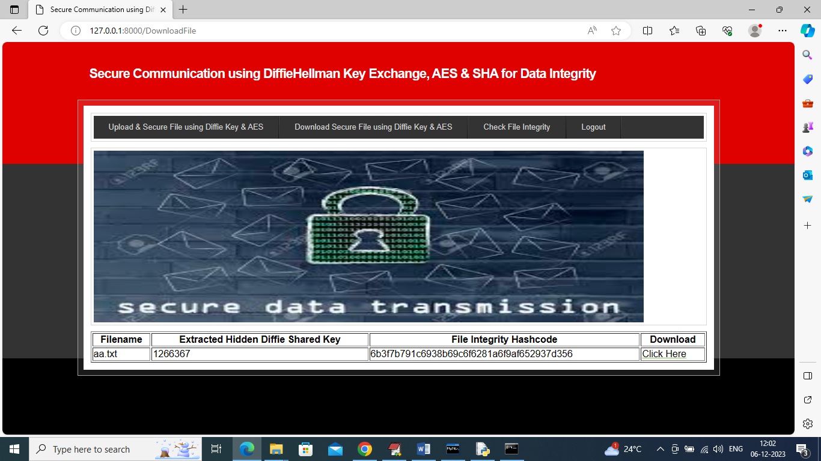
In above screen can see file key, SHA code and can click on ‘Click Here’ link to download file and this file will get downloaded in decrypted format
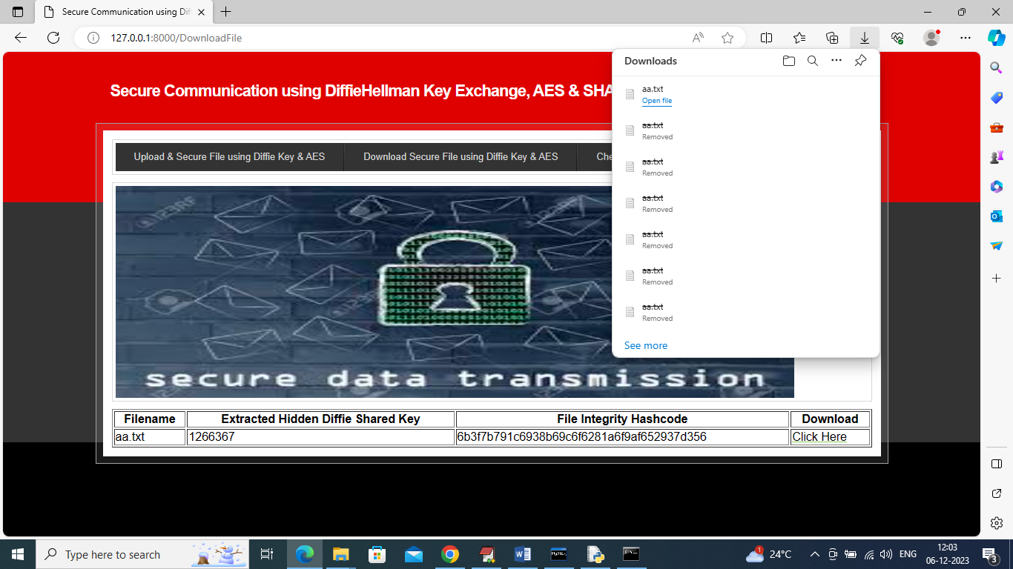
In above screen in browser status bar can see file is downloaded and in below server storage we can see files saved in encrypted mode
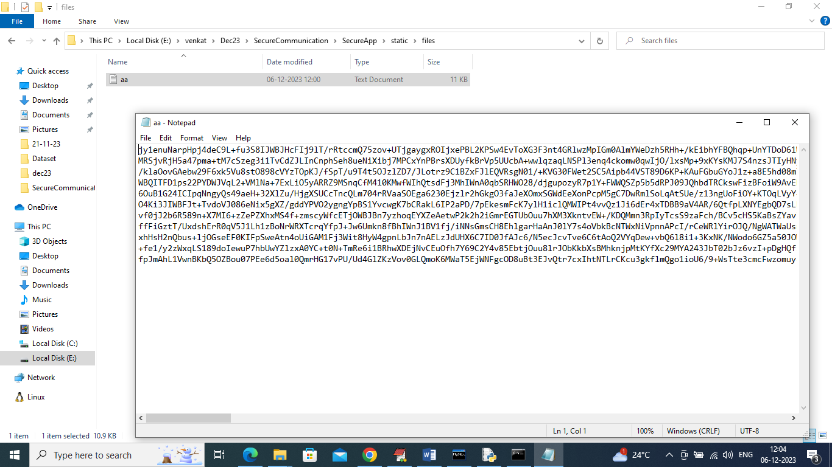
In above screen can see uploaded file saved at server in AES encrypted mode and now click on ‘Check File Integrity’ link to view below list of file
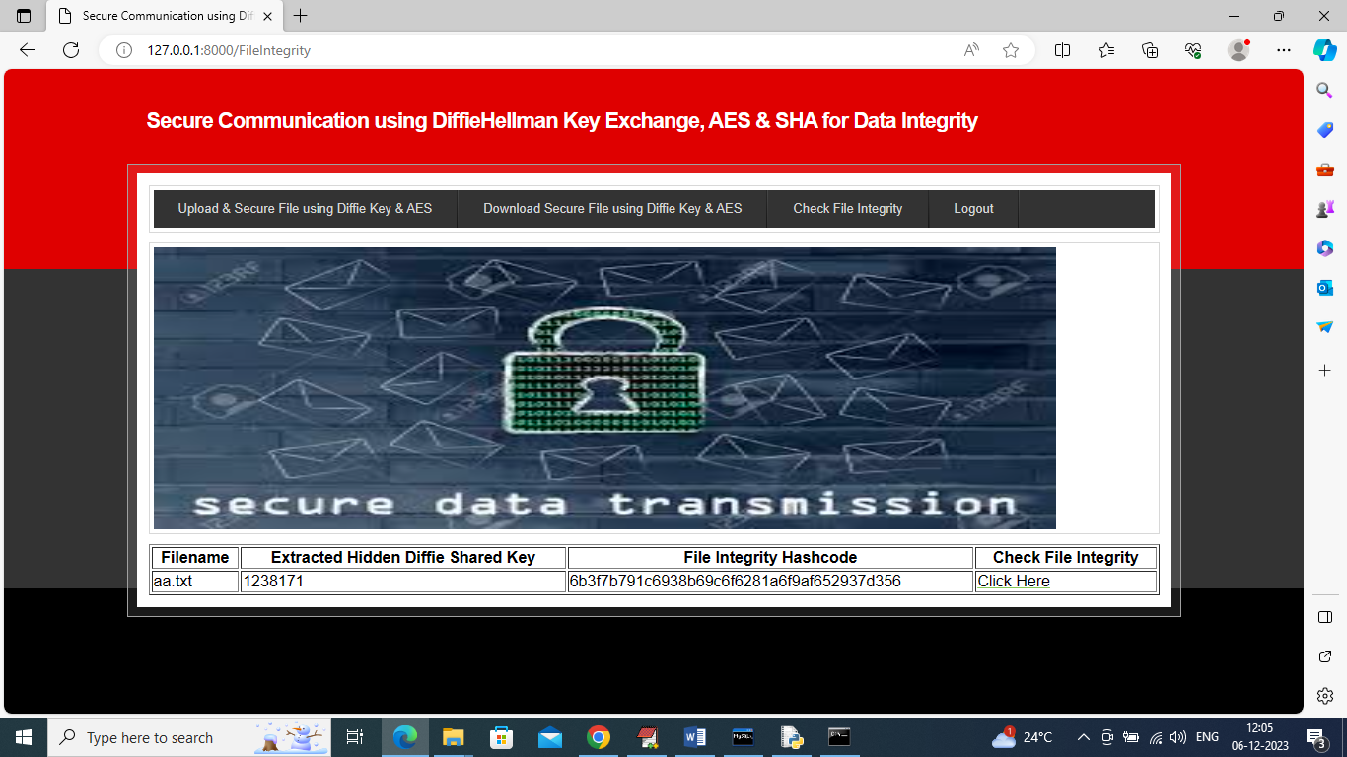
In above screen click on ‘last column’ ‘Click Here’ to generate SHA code on file and then check with original SHA code to get below result
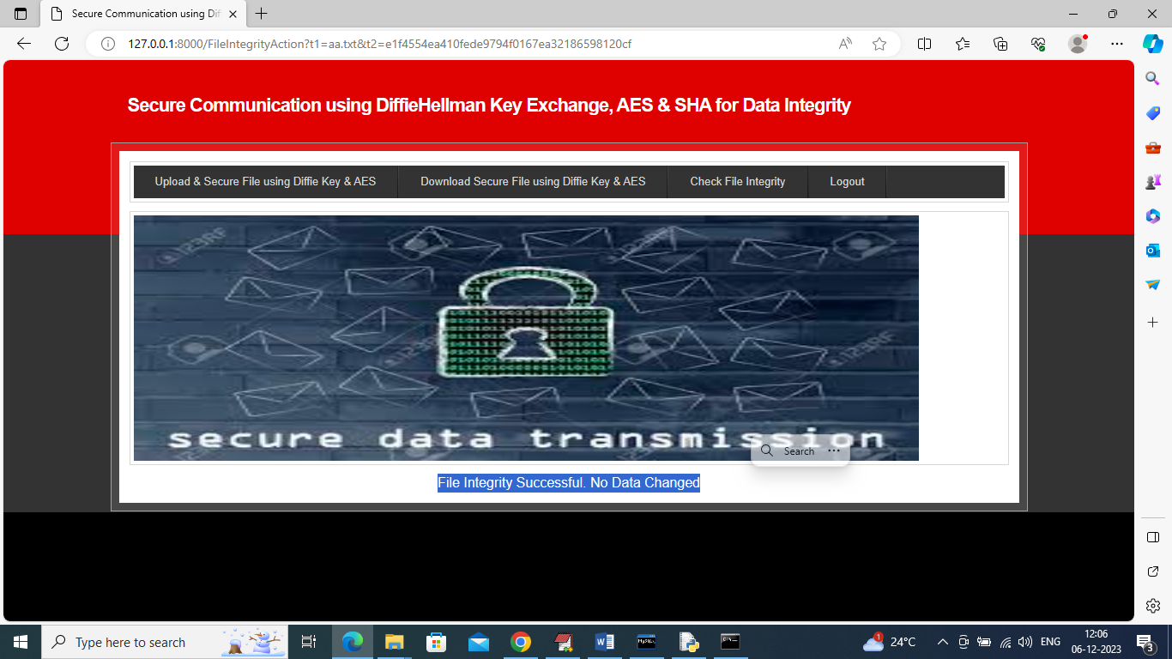
In above screen in blue colour text can see file Integrity is successful and no data changed.
So by using above technique we can saved all files which stored at third parties servers

