**Problem 1: Flipper**

Bob has been assigned N tasks arranged in a row, and in one day, he can perform one task. So, to perform all of the N tasks, he will take N days. He has been given an array A containing N integers where A[i] = X denotes that on the ith day he has to perform the Xth task.

Bob has been given an integer K and has to tell the minimum days he will take to reach the configuration where there are exactly K tasks between a pair of completed tasks, and all these K tasks are not completed.

Help Bob to find the minimum days to reach the configuration mentioned above or print -1 if it's impossible.

**Input:**

* The first line contains a single integer T, denoting the number of test cases.
* The first line of each test case contains two spaced integers,N and K.
* The second line of each test case contains N space-separated integers, denoting the elements of the array.

**Constraints:**

* 1 ≤ N ≤ 10^5
* 1 <= T <= 10
* 1 <= A[i] <= N
* 0 <= K <= 10^5

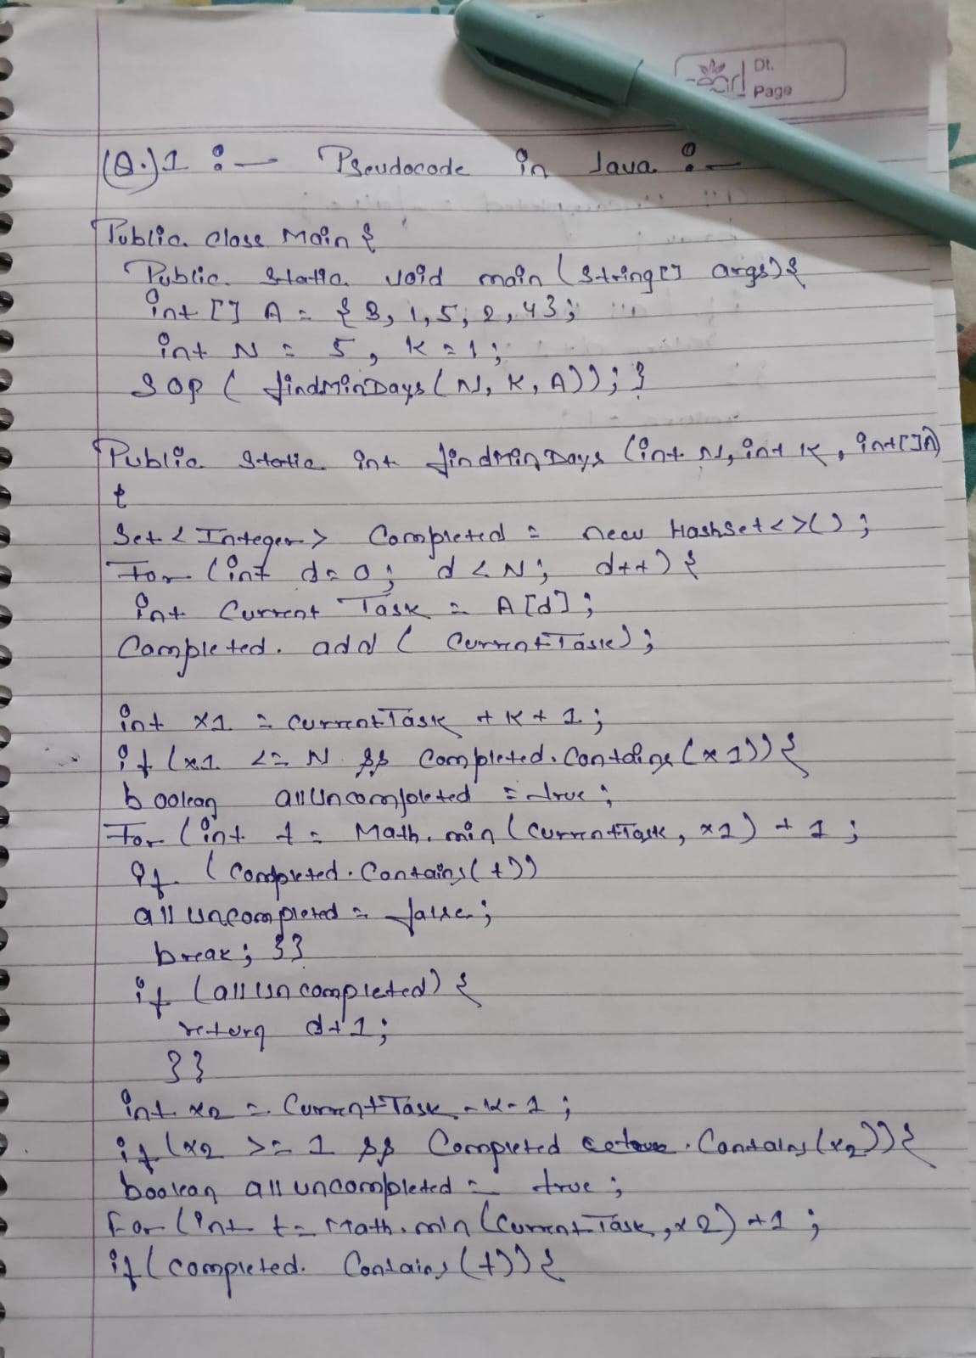

DRY RUN :-

