End-to-End CI/CD Pipeline
for a Java Web Application
Git + Maven + Jenkins + Apache Tomcat on Ubuntu
Project Solution and Documentation
Item | Detail
Application | Student Feedback Portal (Maven WAR)
OS / Runtime | Ubuntu 22.04 LTS, OpenJDK 17
Tools | Git, Maven 3.9, Jenkins LTS, Tomcat 9
Ports | Jenkins 8080, Tomcat 8081
Pipeline | Checkout, Build, Test, Package, Archive, Deploy, Verify, Auto-rollback

1. Overview and Solution Summary
Manual delivery (build locally, copy WAR, restart Tomcat, check in browser) is slow and error-prone. This solution replaces it with a Jenkins declarative pipeline that pulls code from Git, builds and tests with Maven, deploys the WAR to Tomcat, verifies a health endpoint, and automatically restores the previous WAR if verification fails.

Objectives mapped to the solution
Objective | How it is met
SDLC aligned workflow | Plan (issues) > Code (feature branches) > Build/Test (Maven) > Release (tag) > Deploy (Tomcat) > Monitor (health check, logs)
Git branching | main (stable), dev (integration), feature/* (short-lived)
Automated build | Maven packaging = war, output target/feedback-portal.war
Jenkins pipeline | Jenkinsfile in repo root, 7 stages plus post actions
Auto deploy | WAR copied to /opt/tomcat/webapps, Tomcat autoDeploy
Health checks | curl against /feedback-portal/health with retries, expects HTTP 200
Rollback | Pipeline backs up previous WAR and restores it on failure; manual Git revert runbook

2. Architecture
Developer --git push--> Git Repository (main / dev / feature/*)
|
| webhook or SCM poll
v
Jenkins Pipeline
1 Checkout -> 2 Build -> 3 Test -> 4 Package -> 5 Archive
-> 6 Deploy -> 7 Verify (curl)
| |
v | fail
Apache Tomcat <---- restore previous WAR
|
v
http://SERVER:8081/feedback-portal/ (browser / curl)

Quality gates
- Unit test fails: pipeline stops, nothing is deployed.
- WAR not generated: Package stage fails.
- Health check fails: deploy marked failed and previous WAR is restored automatically.

3. Phase 1 - Environment Setup (Ubuntu)

3.1 Install packages
sudo apt update && sudo apt upgrade -y
sudo apt install -y openjdk-17-jdk maven git curl unzip net-tools
java -version
mvn -version
git --version

3.2 Install Jenkins
sudo wget -O /usr/share/keyrings/jenkins-keyring.asc \
https://pkg.jenkins.io/debian-stable/jenkins.io-2023.key
echo "deb [signed-by=/usr/share/keyrings/jenkins-keyring.asc] \
https://pkg.jenkins.io/debian-stable binary/" | \
sudo tee /etc/apt/sources.list.d/jenkins.list > /dev/null
sudo apt update && sudo apt install -y jenkins
sudo systemctl enable --now jenkins
sudo cat /var/lib/jenkins/secrets/initialAdminPassword # unlock at :8080

Note: check the Jenkins install page for the current repository key if the URL above has changed.

3.3 Install Tomcat 9 on port 8081
sudo useradd -r -m -U -d /opt/tomcat -s /bin/false tomcat
cd /tmp
wget https://archive.apache.org/dist/tomcat/tomcat-9/v9.0.89/bin/apache-tomcat-9.0.89.tar.gz
sudo mkdir -p /opt/tomcat
sudo tar xzf apache-tomcat-9.0.89.tar.gz -C /opt/tomcat --strip-components=1
# change connector port 8080 -> 8081
sudo sed -i 's/port="8080"/port="8081"/' /opt/tomcat/conf/server.xml
# permissions: Jenkins can write WARs into webapps
sudo chown -R tomcat:tomcat /opt/tomcat
sudo chmod -R g+rwX /opt/tomcat/webapps
sudo usermod -aG tomcat jenkins
sudo systemctl restart jenkins

3.4 Tomcat systemd service
# /etc/systemd/system/tomcat.service
[Unit]
Description=Apache Tomcat 9
After=network.target
[Service]
Type=forking
User=tomcat
Group=tomcat
Environment=JAVA_HOME=/usr/lib/jvm/java-17-openjdk-amd64
Environment=CATALINA_HOME=/opt/tomcat
Environment=CATALINA_BASE=/opt/tomcat
Environment=CATALINA_PID=/opt/tomcat/temp/tomcat.pid
UMask=0007
ExecStart=/opt/tomcat/bin/startup.sh
ExecStop=/opt/tomcat/bin/shutdown.sh
Restart=on-failure
[Install]
WantedBy=multi-user.target

sudo systemctl daemon-reload
sudo systemctl enable --now tomcat
sudo systemctl status tomcat jenkins
sudo ss -tulpn | grep -E '8080|8081' # confirm no port conflict
sudo ufw allow 8080/tcp && sudo ufw allow 8081/tcp
tail -f /opt/tomcat/logs/catalina.out

4. Phase 2 - Git Strategy
Branch | Purpose | Rules
main | Stable, deployable code | Merge from dev only; tag releases (v1.0.0)
dev | Integration branch | Merge feature branches via pull request
feature/<name> | Short-lived feature work | Branch from dev; delete after merge

git init devops-ci-cd-project && cd devops-ci-cd-project
git remote add origin https://github.com/<user>/devops-ci-cd-project.git
git checkout -b main
git add . && git commit -m "chore: initial project skeleton"
git push -u origin main
git checkout -b dev && git push -u origin dev
git checkout -b feature/feedback-form dev
# after finishing a feature
git checkout dev && git merge --no-ff feature/feedback-form
git push origin dev
# release
git checkout main && git merge --no-ff dev
git tag -a v1.0.0 -m "release 1.0.0" && git push origin main --tags

Commit conventions
- feat: add feedback form page
- fix: correct war packaging in pom
- ci: update Jenkins deploy stage
- test: add FeedbackService unit tests
- docs: add rollback runbook

5. Phase 3 - Maven Project

5.1 Folder structure
devops-ci-cd-project/
|-- src/main/java/com/internship/feedback/
| |-- Feedback.java
| |-- FeedbackService.java
| |-- FeedbackServlet.java
| `-- HealthServlet.java
|-- src/main/webapp/
| |-- index.jsp
| |-- form.jsp
| `-- success.jsp
|-- src/test/java/com/internship/feedback/FeedbackServiceTest.java
|-- data/sample-feedback.csv
|-- pom.xml
|-- Jenkinsfile
|-- docs/ (architecture.md, setup-guide.md, rollback-runbook.md, screenshots/)
`-- README.md

5.2 pom.xml
<project xmlns="http://maven.apache.org/POM/4.0.0"
xmlns:xsi="http://www.w3.org/2001/XMLSchema-instance"
xsi:schemaLocation="http://maven.apache.org/POM/4.0.0
http://maven.apache.org/xsd/maven-4.0.0.xsd">
<modelVersion>4.0.0</modelVersion>
<groupId>com.internship</groupId>
<artifactId>feedback-portal</artifactId>
<version>1.0.0</version>
<packaging>war</packaging>
<properties>
<maven.compiler.source>17</maven.compiler.source>
<maven.compiler.target>17</maven.compiler.target>
<project.build.sourceEncoding>UTF-8</project.build.sourceEncoding>
</properties>
<dependencies>
<dependency>
<groupId>javax.servlet</groupId>
<artifactId>javax.servlet-api</artifactId>
<version>4.0.1</version>
<scope>provided</scope>
</dependency>
<dependency>
<groupId>junit</groupId>
<artifactId>junit</artifactId>
<version>4.13.2</version>
<scope>test</scope>
</dependency>
</dependencies>
<build>
<finalName>feedback-portal</finalName>
<plugins>
<plugin>
<artifactId>maven-surefire-plugin</artifactId>
<version>3.2.5</version>
</plugin>
<plugin>
<artifactId>maven-war-plugin</artifactId>
<version>3.4.0</version>
<configuration>
<failOnMissingWebXml>false</failOnMissingWebXml>
</configuration>
</plugin>
</plugins>
</build>
</project>

Tomcat 9 uses the javax.servlet namespace. If you choose Tomcat 10+, switch to jakarta.servlet imports and the Jakarta servlet API dependency.

5.3 Java sources
// Feedback.java
package com.internship.feedback;
public class Feedback {
private final String name, email, message;
public Feedback(String name, String email, String message) {
this.name = name; this.email = email; this.message = message;
}
public String getName() { return name; }
public String getEmail() { return email; }
public String getMessage() { return message; }
}

// FeedbackService.java (in-memory storage)
package com.internship.feedback;
import java.util.*;
import java.util.concurrent.CopyOnWriteArrayList;
public class FeedbackService {
private static final List<Feedback> STORE = new CopyOnWriteArrayList<>();
public boolean isValid(String name, String email, String msg) {
return name != null && !name.trim().isEmpty()
&& email != null && email.matches("^[^@\\s]+@[^@\\s]+\\.[^@\\s]+$")
&& msg != null && !msg.trim().isEmpty();
}
public boolean add(String name, String email, String msg) {
if (!isValid(name, email, msg)) return false;
STORE.add(new Feedback(name.trim(), email.trim(), msg.trim()));
return true;
}
public List<Feedback> all() { return Collections.unmodifiableList(STORE); }
public int count() { return STORE.size(); }
}

// FeedbackServlet.java
package com.internship.feedback;
import java.io.IOException;
import javax.servlet.annotation.WebServlet;
import javax.servlet.http.*;
@WebServlet("/submit")
public class FeedbackServlet extends HttpServlet {
private final FeedbackService service = new FeedbackService();
@Override
protected void doPost(HttpServletRequest req, HttpServletResponse res)
throws IOException {
boolean ok = service.add(req.getParameter("name"),
req.getParameter("email"),
req.getParameter("message"));
res.sendRedirect(req.getContextPath() + (ok ? "/success.jsp" : "/form.jsp?error=1"));
}
}

// HealthServlet.java
package com.internship.feedback;
import java.io.IOException;
import javax.servlet.annotation.WebServlet;
import javax.servlet.http.*;
@WebServlet("/health")
public class HealthServlet extends HttpServlet {
@Override
protected void doGet(HttpServletRequest req, HttpServletResponse res)
throws IOException {
res.setContentType("application/json");
res.setStatus(200);
res.getWriter().write("{\"status\":\"UP\",\"app\":\"feedback-portal\"}");
}
}

5.4 JSP pages
<!-- index.jsp -->
<%@ page contentType="text/html;charset=UTF-8" %>
<html><head><title>Student Feedback Portal</title></head>
<body>
<h1>Student Feedback Portal</h1>
<p>Internship DevOps project - built and deployed by Jenkins.</p>
<a href="form.jsp">Submit feedback</a> | <a href="health">Health</a>
</body></html>

<!-- form.jsp -->
<%@ page contentType="text/html;charset=UTF-8" %>
<html><body>
<h2>Submit Feedback</h2>
<% if (request.getParameter("error") != null) { %>
<p style="color:red">Please fill all fields with a valid email.</p>
<% } %>
<form method="post" action="submit">
Name: <input name="name"><br>
Email: <input name="email"><br>
Message: <textarea name="message"></textarea><br>
<button type="submit">Send</button>
</form>
</body></html>

<!-- success.jsp -->
<%@ page contentType="text/html;charset=UTF-8" %>
<html><body><h2>Thank you! Your feedback was recorded.</h2>
<a href="index.jsp">Home</a></body></html>

5.5 Unit tests
package com.internship.feedback;
import static org.junit.Assert.*;
import org.junit.Test;
public class FeedbackServiceTest {
private final FeedbackService svc = new FeedbackService();
@Test public void validInputIsAccepted() {
assertTrue(svc.isValid("Asha", "asha@example.com", "Great support"));
}
@Test public void invalidEmailIsRejected() {
assertFalse(svc.isValid("Asha", "not-an-email", "Hi"));
}
@Test public void emptyNameIsRejected() {
assertFalse(svc.isValid(" ", "a@b.com", "Hi"));
}
@Test public void addIncreasesCount() {
int before = svc.count();
assertTrue(svc.add("Ravi", "ravi@example.com", "Nice"));
assertEquals(before + 1, svc.count());
}
}

5.6 Local validation
mvn clean
mvn test
mvn package
ls -lh target/feedback-portal.war

5.7 Optional dataset (data/sample-feedback.csv)
name,email,feedback,rating,date
Asha,asha@example.com,Great mentoring support,5,2026-07-01
Ravi,ravi@example.com,Helpful Jenkins sessions,4,2026-07-02
Meera,meera@example.com,Maven labs were clear,5,2026-07-03
... (extend to 20-50 rows)

If the dataset is not used, state in the report: Dataset not required; primary project input is source-code changes.

6. Phase 4 - Jenkins Pipeline

6.1 Jenkins one-time configuration
- Install suggested plugins plus Pipeline, Git, GitHub (webhook trigger), Timestamper.
- Manage Jenkins > Tools: add JDK named JDK17 (JAVA_HOME /usr/lib/jvm/java-17-openjdk-amd64) and Maven named Maven3.
- Manage Jenkins > Credentials: add the Git credential (id git-creds) for private repos. Never hardcode secrets in the Jenkinsfile.
- New Item > Multibranch Pipeline (or Pipeline) pointing at the repo; Script Path = Jenkinsfile.
- Trigger: GitHub webhook to http://JENKINS:8080/github-webhook/ or Poll SCM H/5 * * * *.

6.2 Jenkinsfile
pipeline {
agent any
tools { maven 'Maven3'; jdk 'JDK17' }
options {
timestamps()
disableConcurrentBuilds()
buildDiscarder(logRotator(numToKeepStr: '20', artifactNumToKeepStr: '10'))
}
environment {
APP_NAME = 'feedback-portal'
TOMCAT_WEBAPPS = '/opt/tomcat/webapps'
BACKUP_DIR = '/var/lib/jenkins/war-backups'
HEALTH_URL = 'http://localhost:8081/feedback-portal/health'
DEPLOY_STARTED = 'false'
}
stages {
stage('Checkout') {
steps {
echo "Branch: ${env.BRANCH_NAME ?: 'default'}"
checkout scm
sh 'git log -1 --oneline'
}
}
stage('Build') {
steps { sh 'mvn -B clean compile' }
}
stage('Test') {
steps { sh 'mvn -B test' }
post {
always { junit 'target/surefire-reports/*.xml' }
}
}
stage('Package') {
steps {
sh 'mvn -B package -DskipTests'
sh 'test -f target/${APP_NAME}.war'
}
}
stage('Archive') {
steps {
archiveArtifacts artifacts: 'target/*.war', fingerprint: true
}
}
stage('Deploy') {
when { anyOf { branch 'main'; branch 'dev' } }
steps {
script { env.DEPLOY_STARTED = 'true' }
sh '''
set -e
mkdir -p "$BACKUP_DIR"
if [ -f "$TOMCAT_WEBAPPS/$APP_NAME.war" ]; then
cp "$TOMCAT_WEBAPPS/$APP_NAME.war" \
"$BACKUP_DIR/$APP_NAME-before-build-$BUILD_NUMBER.war"
echo "Backed up previous WAR"
fi
cp target/$APP_NAME.war "$TOMCAT_WEBAPPS/$APP_NAME.war"
echo "WAR copied; Tomcat autoDeploy will pick it up"
'''
}
}
stage('Verify') {
when { anyOf { branch 'main'; branch 'dev' } }
steps {
sh '''
for i in $(seq 1 12); do
CODE=$(curl -s -o /dev/null -w "%{http_code}" "$HEALTH_URL" || true)
echo "Attempt $i: HTTP $CODE"
if [ "$CODE" = "200" ]; then exit 0; fi
sleep 5
done
echo "Health check FAILED"
exit 1
'''
}
}
}
post {
success { echo "Pipeline OK - ${APP_NAME} deployed and healthy." }
failure {
script {
if (env.DEPLOY_STARTED == 'true') {
echo 'Deploy/verify failed - rolling back to previous WAR'
sh '''
LAST=$(ls -t "$BACKUP_DIR"/$APP_NAME-before-build-*.war 2>/dev/null | head -1)
if [ -n "$LAST" ]; then
cp "$LAST" "$TOMCAT_WEBAPPS/$APP_NAME.war"
echo "Restored $LAST"
sleep 15
curl -s -o /dev/null -w "Post-rollback HTTP %{http_code}\\n" "$HEALTH_URL" || true
else
echo "No backup available to restore"
fi
'''
} else {
echo 'Failed before deploy - nothing to roll back.'
}
}
}
always { cleanWs(deleteDirs: true, notFailBuild: true) }
}
}

Notes: cleanWs needs the Workspace Cleanup plugin (remove that line if not installed). In a single (non-multibranch) Pipeline job, env.BRANCH_NAME is empty and the when { branch ... } conditions never match, so remove those conditions for that job type.

6.3 Stage behaviour summary
Stage | Command | Fail behaviour
Checkout | checkout scm | Stops pipeline
Build | mvn clean compile | Stops pipeline
Test | mvn test (JUnit report published) | Stops; no deploy
Package | mvn package, verify WAR exists | Stops pipeline
Archive | archiveArtifacts target/*.war | Keeps WAR for rollback
Deploy | Backup old WAR, copy new WAR | Triggers rollback
Verify | curl /health x12, expect 200 | Triggers rollback

7. Phase 5 - Tomcat Deployment and Validation
Ensure autoDeploy is enabled (default) in the Host element of /opt/tomcat/conf/server.xml: autoDeploy="true" unpackWARs="true".

Validation commands
# Tomcat running and listening
systemctl status tomcat
ss -tulpn | grep 8081
# WAR present and exploded
ls -l /opt/tomcat/webapps/
ls /opt/tomcat/webapps/feedback-portal/
# Logs
tail -n 50 /opt/tomcat/logs/catalina.out
grep -i "Deployment of web application" /opt/tomcat/logs/catalina.*.log
# HTTP checks
curl -i http://localhost:8081/feedback-portal/
curl -i http://localhost:8081/feedback-portal/health
curl -i -X POST -d "name=Asha&email=asha@example.com&message=Hello" \
http://localhost:8081/feedback-portal/submit # expect 302 -> success.jsp

Expected health output
HTTP/1.1 200
Content-Type: application/json
{"status":"UP","app":"feedback-portal"}

Manual test checklist
- Home page loads and shows the project title.
- Form page loads; valid submission redirects to the success page.
- Invalid email shows the error message.
- /health returns HTTP 200 with status UP.
- Jenkins console shows all stages green and the WAR in Build Artifacts.

8. Phase 6 - Failure and Rollback Demonstrations

Case A - Failing unit test (stops before deploy)
git checkout -b feature/break-test dev
# edit FeedbackServiceTest: change assertTrue(...) to assertFalse(...)
git commit -am "test: intentionally break test for demo"
git push -u origin feature/break-test
# Jenkins: Test stage fails, Deploy never runs. Capture console log + screenshot.

Expected: build FAILURE at Test stage, Tomcat still serves the previous version.

Case B - Bad deploy (automatic and manual WAR restore)
# Simulate a bad release: make /health return 500 in HealthServlet
git commit -am "feat: bad release for rollback demo" && git push
# Jenkins: Verify stage fails 12 times, post-failure block restores previous WAR.
# Manual restore if needed
ls -t /var/lib/jenkins/war-backups/
sudo cp /var/lib/jenkins/war-backups/feedback-portal-before-build-<N>.war \
/opt/tomcat/webapps/feedback-portal.war
curl -i http://localhost:8081/feedback-portal/health
# Or redeploy a previous archived artifact from Jenkins:
# Build #<N> > Build Artifacts > feedback-portal.war > copy to webapps

Case C - Git rollback
git log --oneline -5
git checkout dev
git revert <bad-commit-sha> # creates a new revert commit (safe, history kept)
git push origin dev # Jenkins re-runs and redeploys good code
# Rollback to a tagged release
git checkout -b hotfix/rollback v1.0.0
git push origin hotfix/rollback

Prefer git revert on shared branches; avoid git reset --hard + force-push on main/dev.

9. Risks, Mitigation and Troubleshooting
Problem | Cause | Fix
Jenkins and Tomcat clash | Both default to 8080 | Tomcat on 8081 (done in section 3.3)
Permission denied copying WAR | jenkins user cannot write webapps | usermod -aG tomcat jenkins; chmod g+rwX webapps; restart Jenkins
404 after deploy | Tomcat still unpacking or wrong context path | Wait for log line 'Deployment of web application archive'; URL is /feedback-portal/
Servlet class not found / 500 | Tomcat 10 with javax imports | Use Tomcat 9, or migrate to jakarta.servlet
mvn: release version 17 not supported | JDK 11 selected in Jenkins | Set tool JDK17 and check mvn -version
Flaky dependency download | Network or unstable versions | Pin versions; run mvn dependency:go-offline once
Pipeline green but app broken | No verification | Mandatory Verify stage with HTTP 200 check
Lost good build | Workspace cleaned | archiveArtifacts, backup directory, Git tags

10. Deliverables Checklist
# | Deliverable | Evidence / location
1 | Git repository URL with history | GitHub link, git log --oneline --graph
2 | Maven project source | src/, pom.xml
3 | Jenkinsfile and run screenshots | Stage view, Blue Ocean/console screenshots
4 | Successful and failed build logs | Console output exported for Case A, B and a green run
5 | WAR artifact evidence | Build Artifacts page, ls -lh target/*.war
6 | Tomcat deployment proof | URL screenshot, catalina.out excerpt
7 | Health-check output | curl -i /health
8 | Rollback notes | docs/rollback-runbook.md (section 8)
9 | Dataset and usage notes | data/sample-feedback.csv or 'not required' statement
10 | Final documentation | README.md, docs/*
11 | Explanation video 5-10 min | See outline below

11. Four-Week Plan
Week | Work
1 | Linux setup, Git repo and branches, app skeleton
2 | Maven build/test/package, JSP pages, dataset, unit tests
3 | Jenkins pipeline, Tomcat auto-deploy, health checks, webhook
4 | Failure and rollback demos, documentation, screenshots, video

12. Video Outline (5-10 minutes)
- 0:00 Problem: manual delivery risks and goal of the project.
- 1:00 Architecture diagram and tools.
- 2:00 Repo walkthrough: branches, pom.xml, Jenkinsfile.
- 3:30 Commit to dev: live pipeline run, show every stage.
- 5:30 Open the deployed app: home page, form submit, /health.
- 6:30 Case A: broken test stops the pipeline.
- 7:30 Case B: bad deploy and automatic rollback; mention Case C (git revert).
- 9:00 Learnings and possible improvements (Docker, notifications, Nexus).

13. Conclusion
The pipeline turns a manual, error-prone release into a repeatable path from commit to a verified Tomcat deployment. Automated tests act as a gate, archived artifacts and Git tags provide recovery points, and the health check with automatic WAR restore protects users from broken releases. Future work: Slack/email notifications, Docker-based deployment, an artifact repository such as Nexus, and monitoring with Prometheus/Grafana.

Appendix A - Screenshot Evidence
Save each screenshot as the file name shown (PNG) in docs/screenshots/. Boxes marked 'Paste screenshot here' are to be replaced with real screenshots from your own Jenkins/Tomcat server. Real evidence is required for submission.
Implementation note: the practical was executed on Kali Linux (WSL2) with OpenJDK 21, Maven 3.9.12, Tomcat 10.1.34 on port 8081 and Jenkins started from jenkins.war on port 8080. The built WAR is app.war, so the application context is /app/ (for example /app/health). Tomcat 10 uses the jakarta.servlet namespace. The commands in earlier sections use Ubuntu, Tomcat 9 and the name feedback-portal as a reference; adjust names to match your setup.

Figure 1 - Tool versions and Tomcat install
Capture: Terminal: java -version, mvn -version, git --version, then Tomcat 10.1.34 download and setup
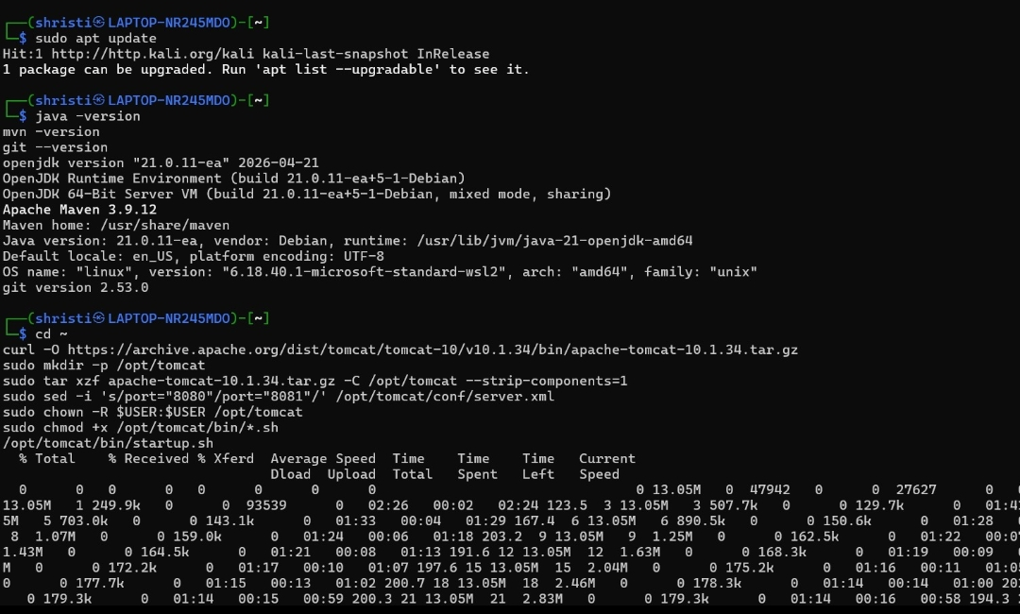

Figure 2 - Tomcat 10.1.34 installed and running
Capture: Browser: Tomcat default page confirming successful installation
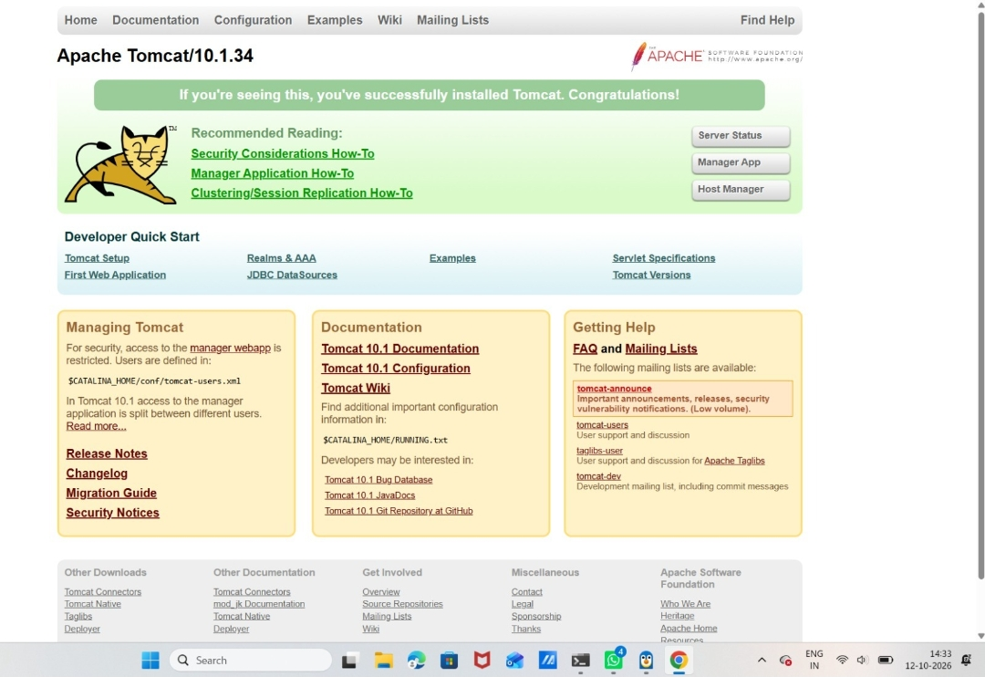

Figure 3 - Git branches and history
Capture: Terminal/GitHub: git branch -a and git log --oneline --graph
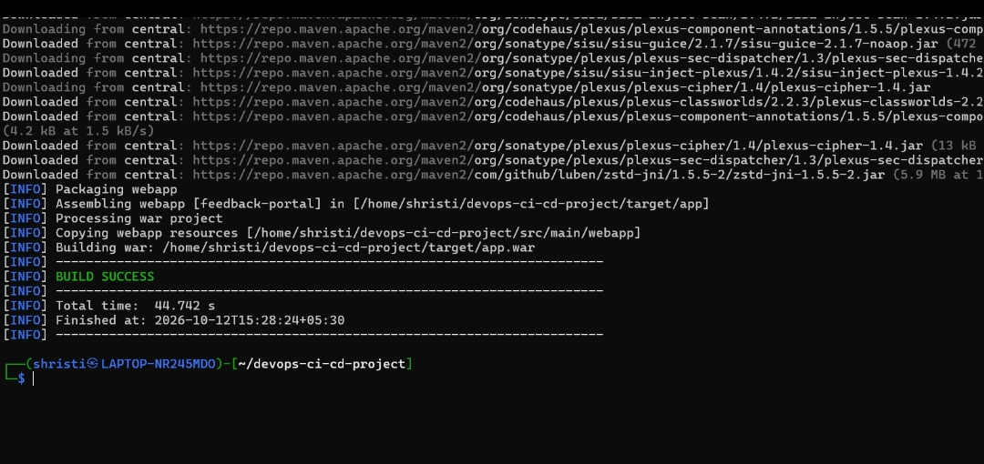

Figure 4 - Maven build success
Capture: Terminal: mvn clean test package ending with BUILD SUCCESS, then ls -lh target/*.war
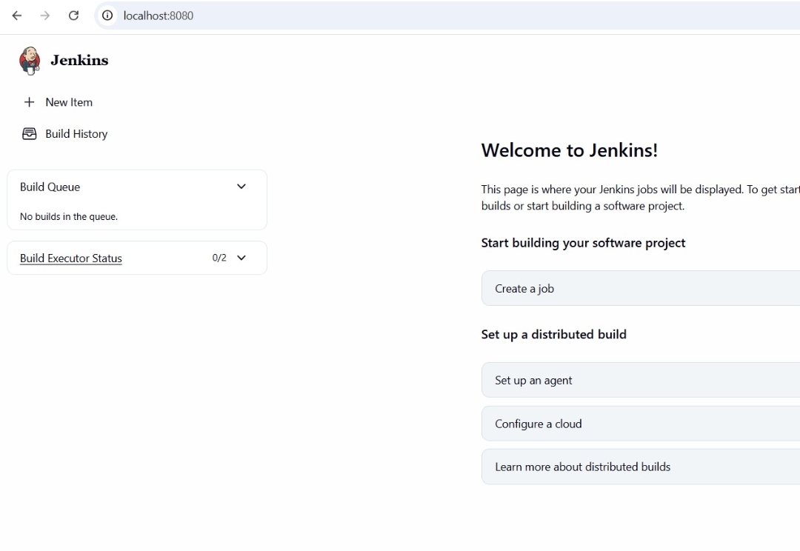

Figure 5 - Jenkins running on localhost:8080
Capture: Browser: Jenkins dashboard after initial setup (job configuration screenshot still to be added)
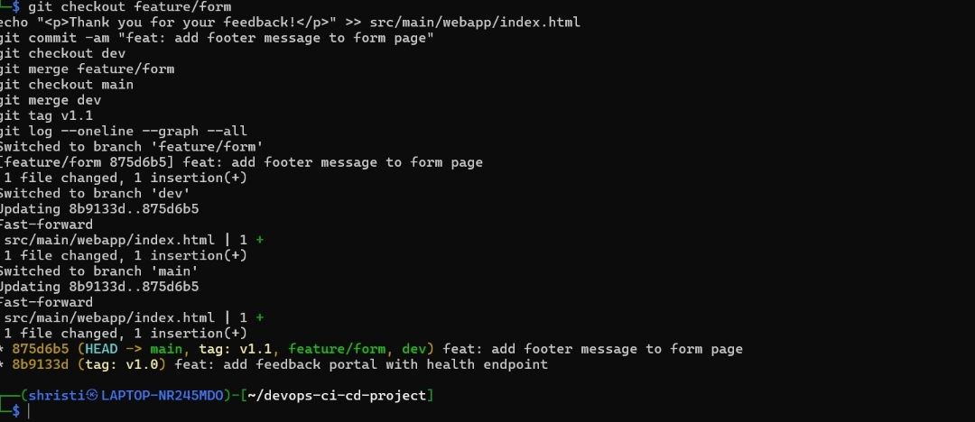

Figure 6 - Successful pipeline run
Capture: Jenkins: Stage View with all 7 stages green
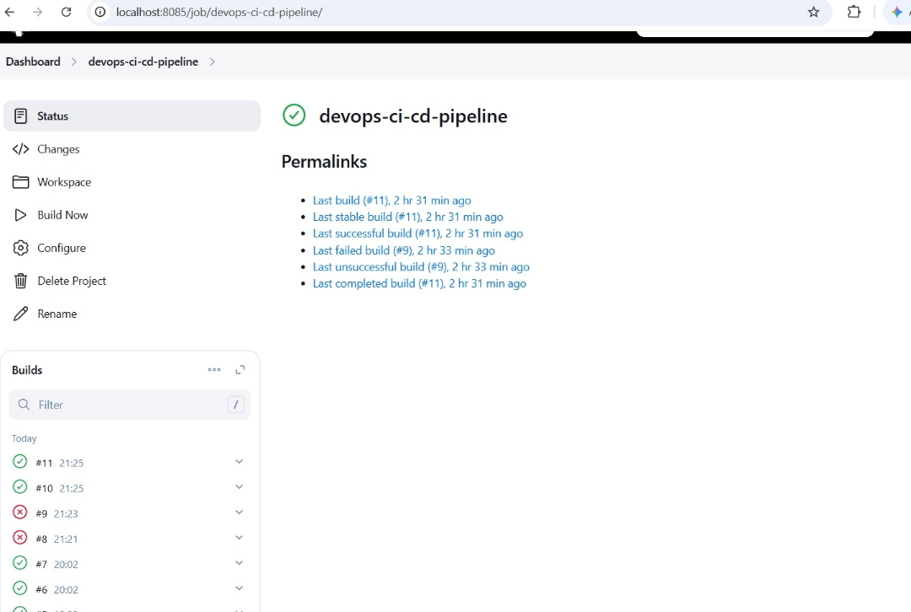

Figure 7 - Successful console log
Capture: Jenkins: Console Output ending with 'Pipeline OK' and Finished: SUCCESS
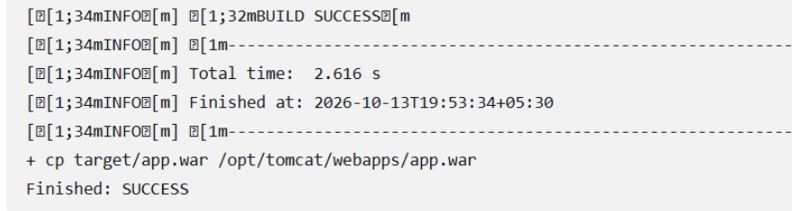

Figure 8 - Archived WAR artifact
Capture: Jenkins: build page, Build Artifacts showing feedback-portal.war
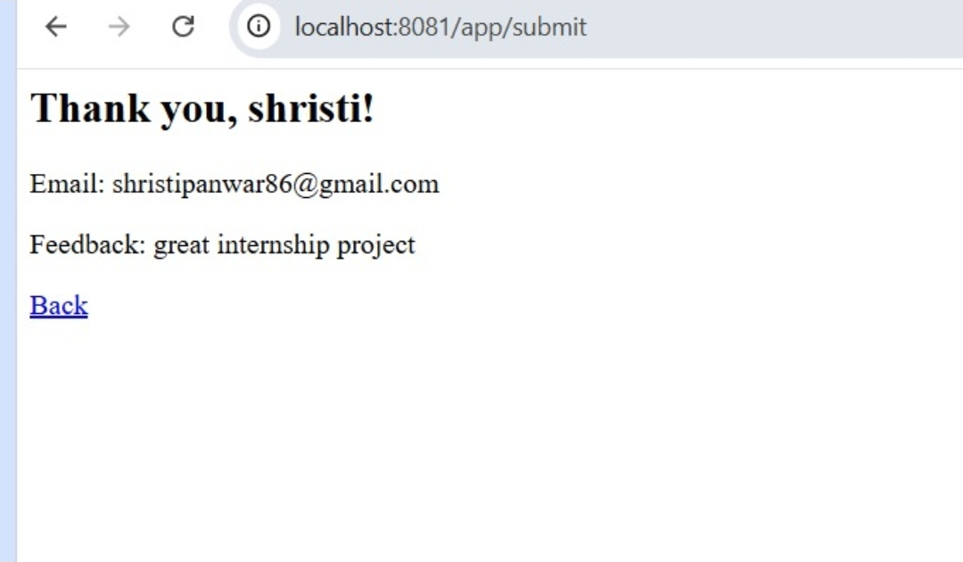

Figure 9 - Feedback form submission result
Capture: Browser: localhost:8081/app/submit showing the confirmation after submitting the form
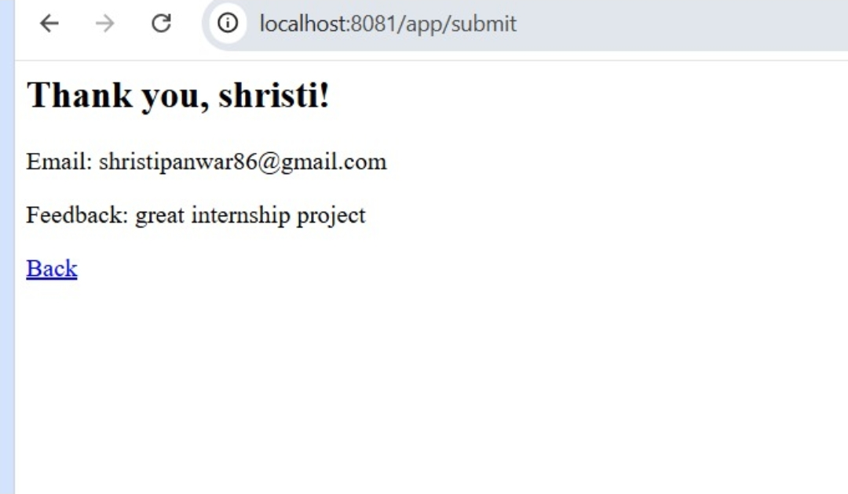

Figure 10 - Health check output
Capture: Browser: localhost:8081/app/health returning OK
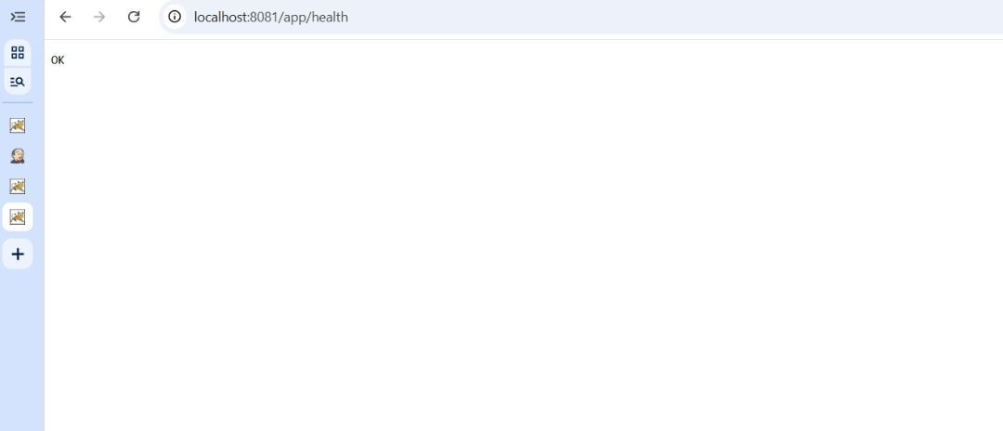

Figure 11 - Tomcat deployment log
Capture: Terminal: tail of catalina.out showing 'Deployment of web application archive'
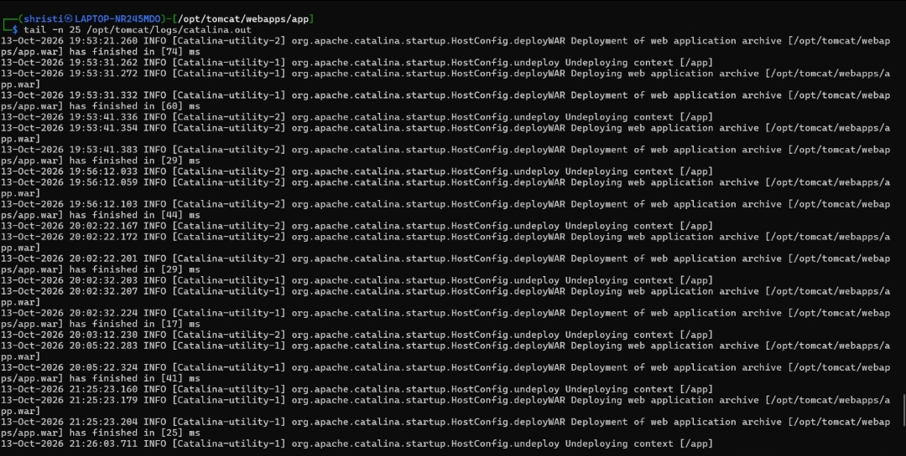
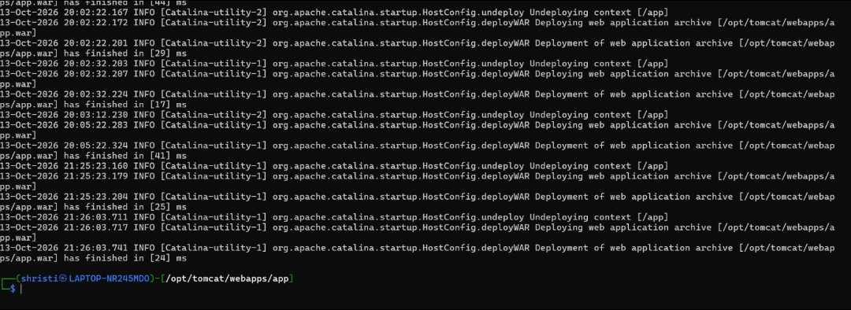

Figure 12 - Case A: failed test
Capture: Jenkins: Stage View with Test stage red, Deploy not executed, plus test report
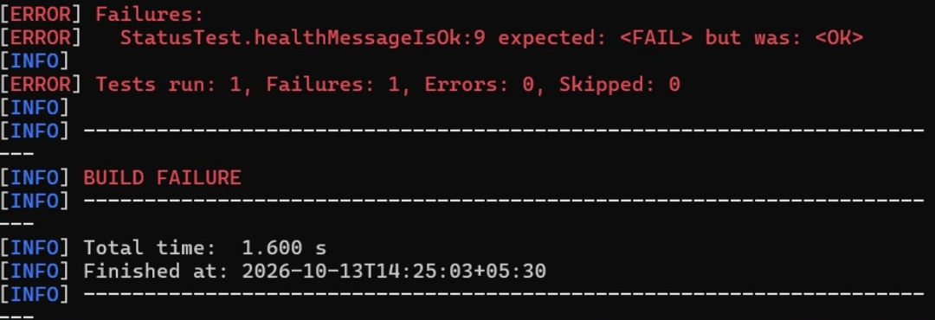

Figure 13 - Case B: bad deploy and rollback
Capture: Jenkins: console showing health check failing, 'Restored ...war', post-rollback HTTP 200
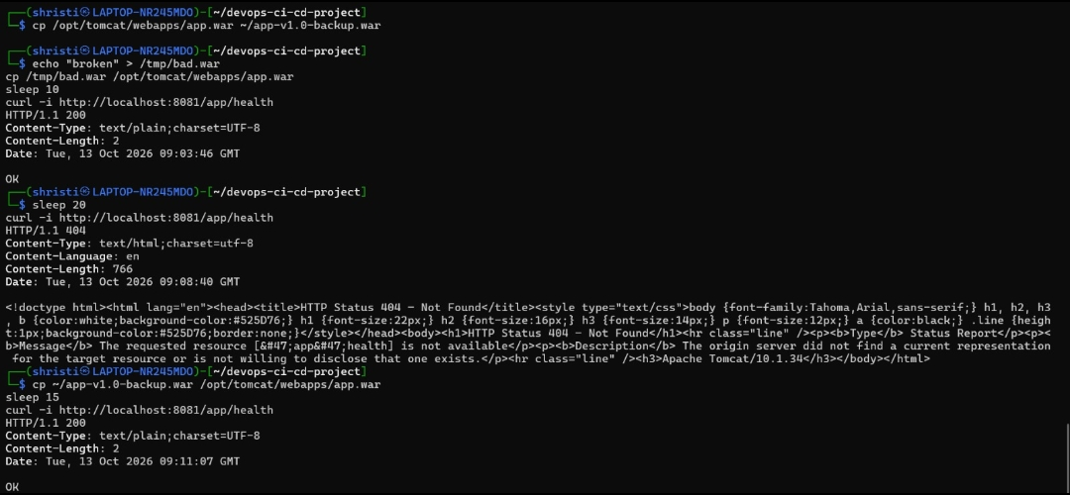

Figure 14 - Case C: git revert
Capture: Terminal/GitHub: git revert commit and the following green build

Appendix B - Additional Evidence

Figure 15 - Git push of main and dev branches to GitHub
Capture: Terminal: pushing main and dev to origin
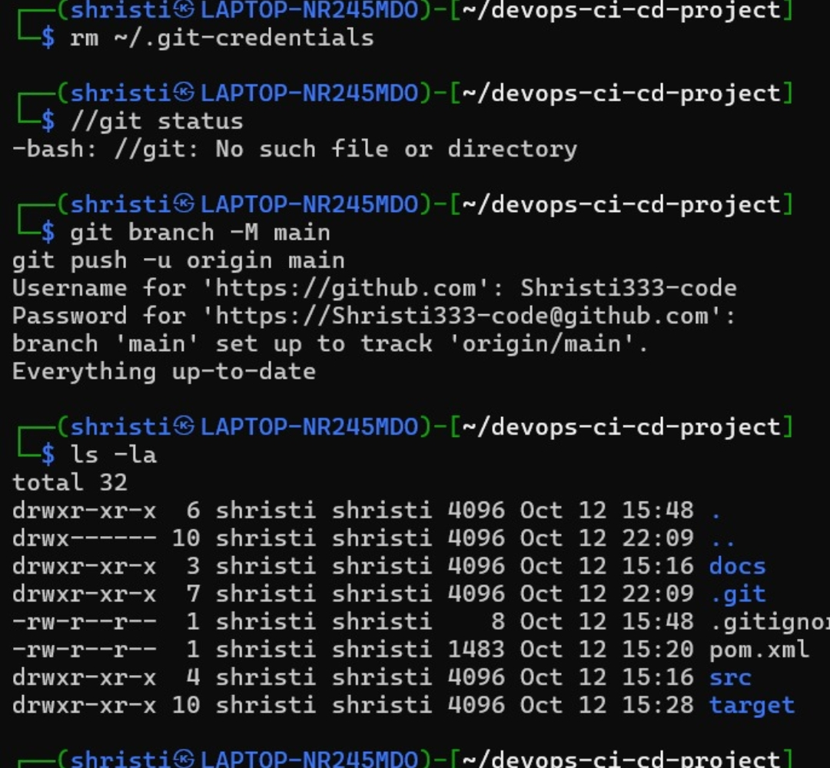

Figure 16 - dev pushed, feature/setup-maven-app created
Capture: Terminal: dev pushed, new feature branch created
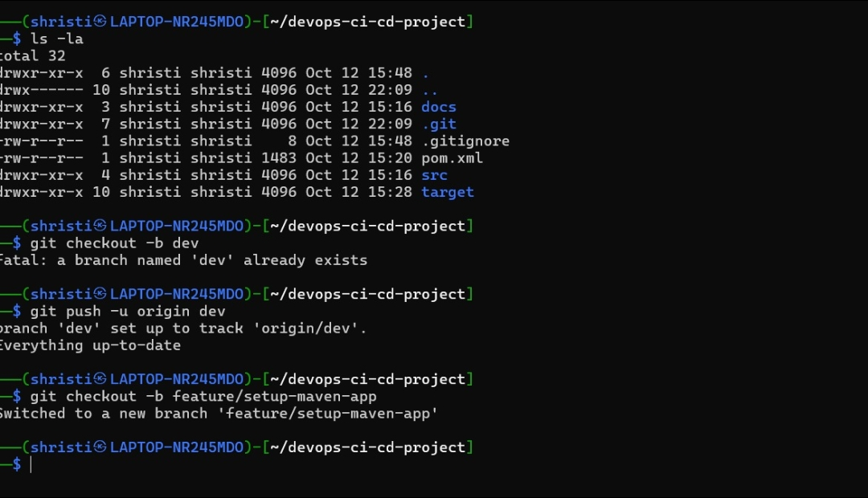

Figure 17 - Jenkins setup complete (localhost:8085)
Capture: Browser: Jenkins is ready page
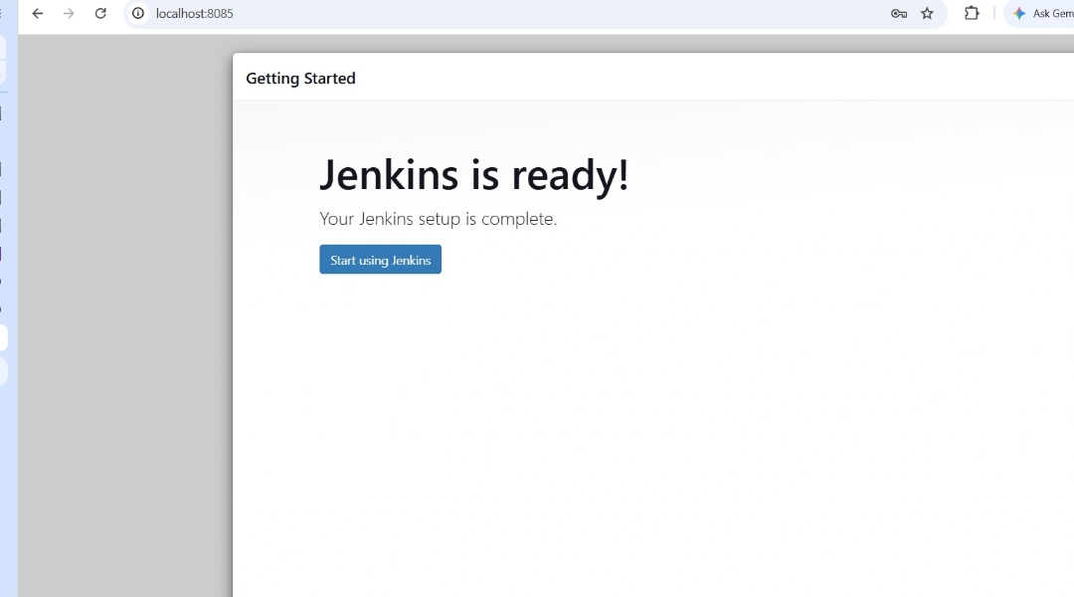

Appendix C - Jenkins Job and Repository Evidence

Figure 18 - Jenkins job devops-ci-cd-pipeline #5 console (start)
Capture: Jenkins: console output of build #5
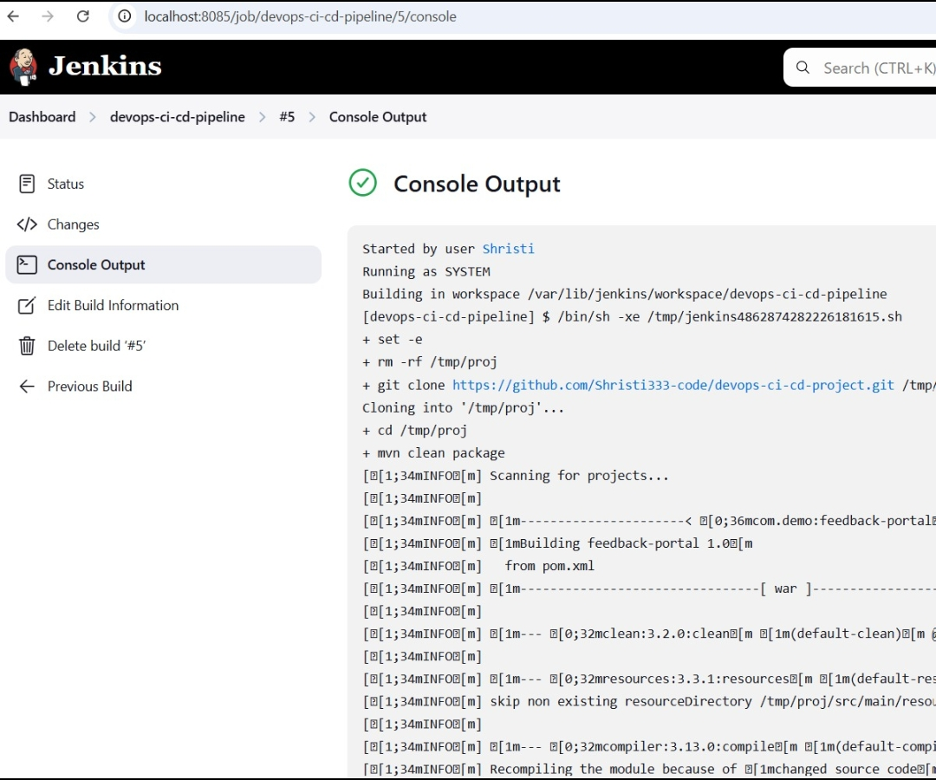

Figure 19 - GitHub repository with Jenkinsfile (4 branches, 2 tags)
Capture: GitHub: repository main page
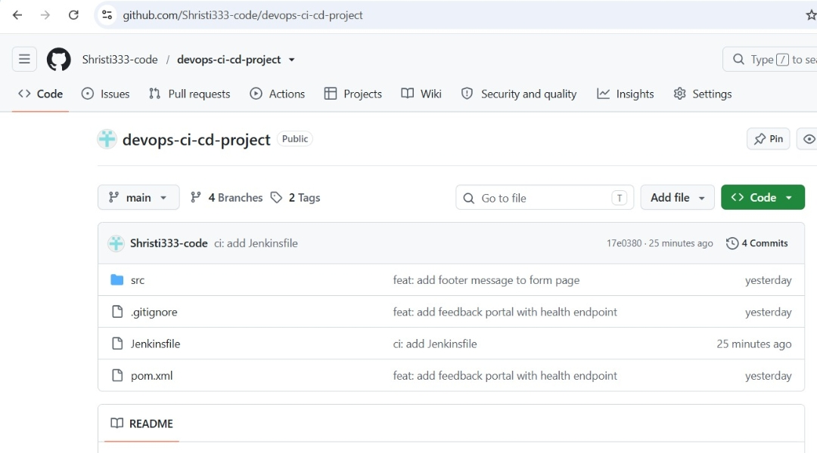

Figure 20 - Health endpoint /app/health returns OK
Capture: Browser: localhost:8081/app/health
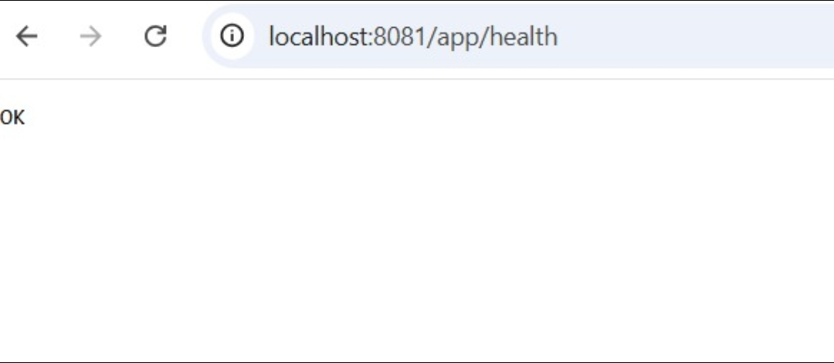

Appendix D - Rollback Demonstration (enlarged)

Figure 21 - Case B enlarged: bad WAR deployed (HTTP 404), backup WAR restored (HTTP 200)
Capture: Terminal: rollback demonstration

Appendix E - Application Versions and Failed Deploy

Figure 22 - Deployed app at /app/ (footer message version)
Capture: Browser: localhost:8081/app/
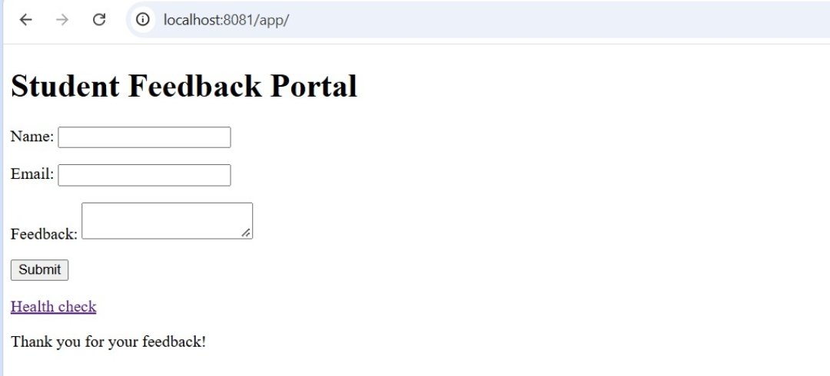

Figure 23 - Updated app version: heading changed to "BY Shristi"
Capture: Browser: localhost:8081/app/
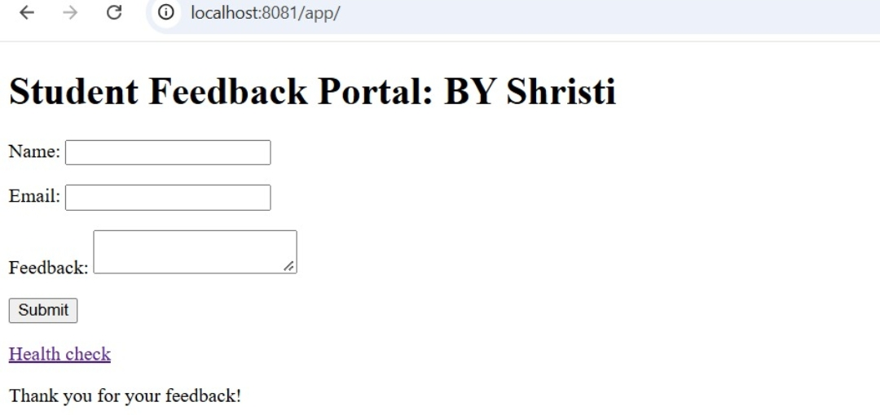

Figure 24 - Bad WAR deployed: /app/ returns HTTP 404 (before rollback)
Capture: Browser: localhost:8081/app/)
