**Artificial Intelligence in Enterprise Systems**

**Lab #1 – Git**

**Shrita Shirish Gaonkar**

**100799307**

Step 1:

Install git in your local machine.

1. After installation, we can see verify if git was installed using the ***git --version*** command.

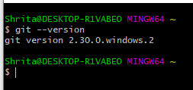

Step 2:

Create user accounts in both Github and Gitlab.

1. Gitlab Profile:

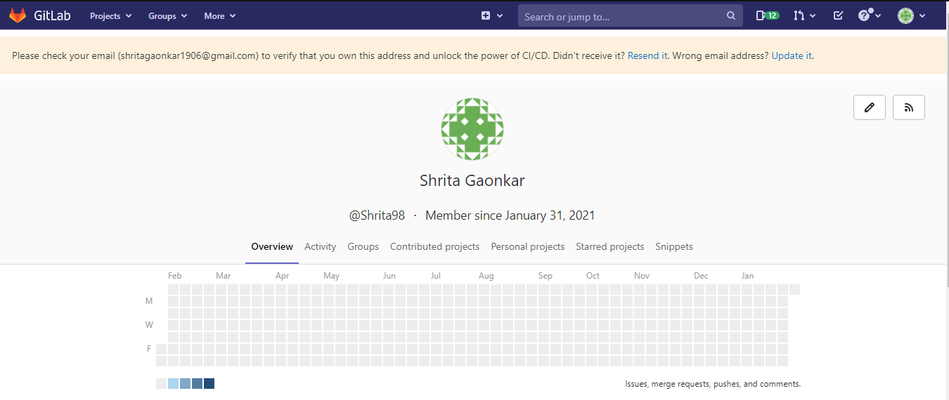

1. Github Profile:

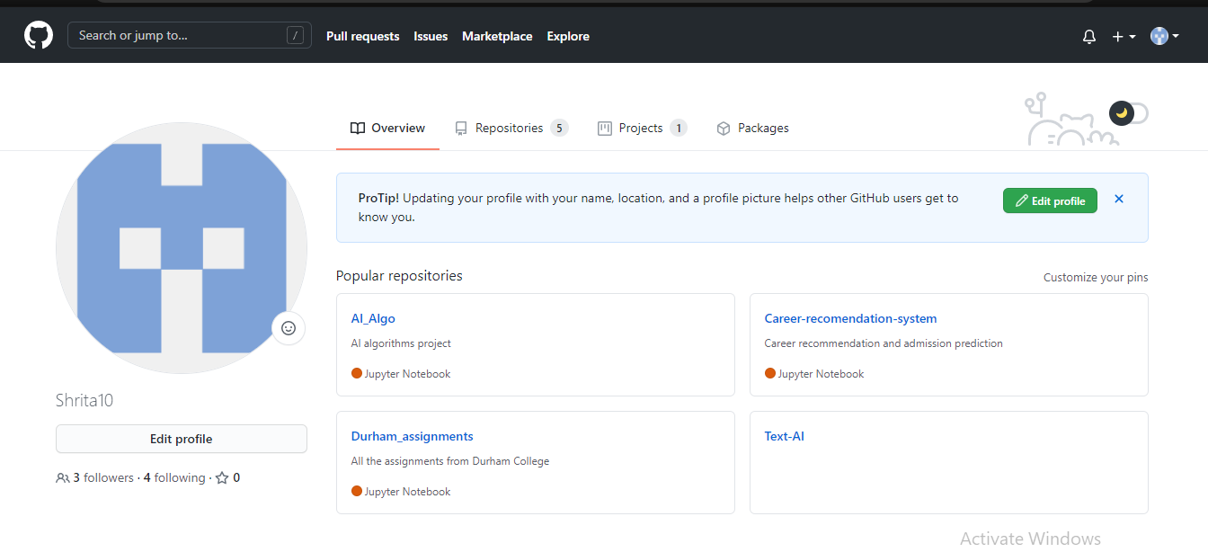

Step 3:

Review github and gitlab. Select your remote host (github or gitlab or any new one) and justify your selection.

1. For this assignment I am using Github as my remote host
2. While Github and Gitlab both offer the distributed version control and the source code management (SCM) functionality of Git, Github is more popular amongst developers.
3. I am also familiar with how github and git integration works that is why I am selecting github as my remote repo.

Step 4:

Write a basic program performing key programming activities.

1. Here, I have written a basic python program that finds the largest number amongst three input numbers in Spyder.

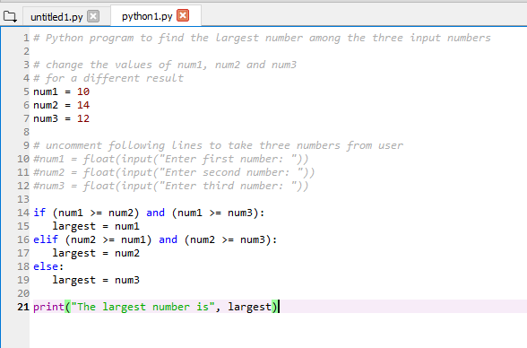

Step 5:

Provide screenshot of your command prompt showing success of your commit in the remote host.

1. I added a new repository to my github account called myapp.
2. After adding all the git info, I took this information and added to my newly created repo on github.

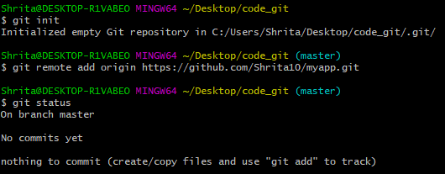

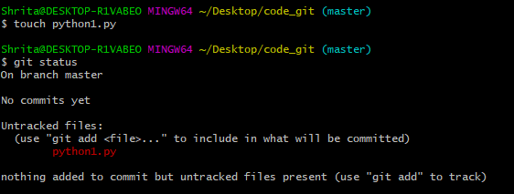

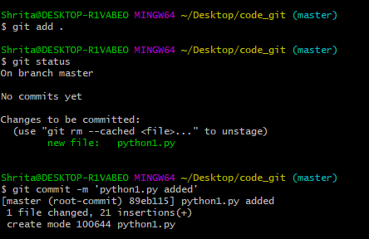

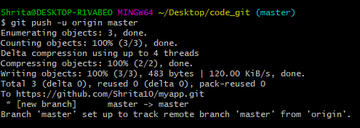

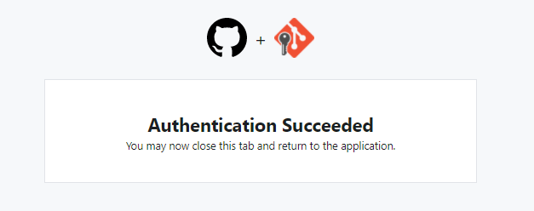

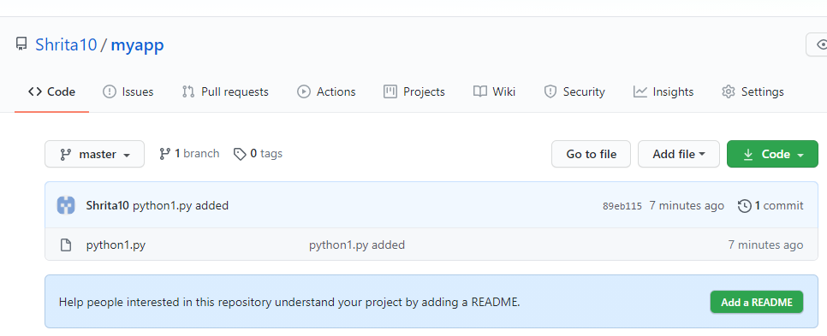

Step 6:

Provide a description of your program in the readme.md file.

1. First, I create the README.md file in my local desktop.
2. Then I edited it and pushed it to my remote repo

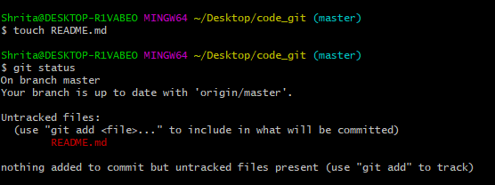

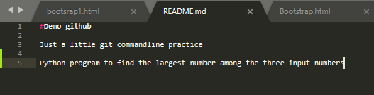

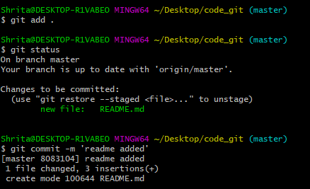

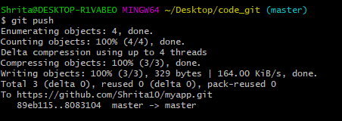

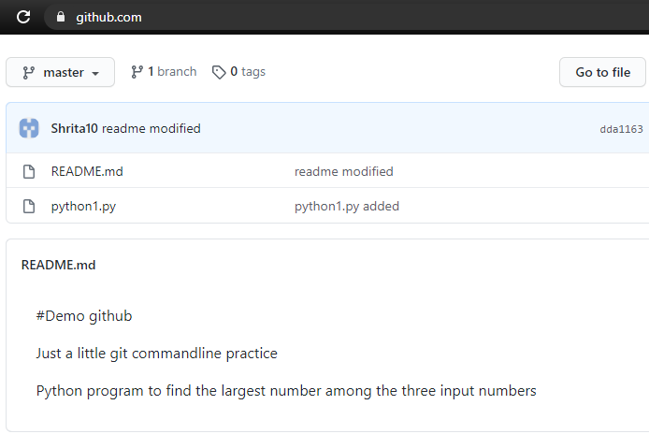

Step 7:

Create a branch in your repo and upload any python script in that branch.

1. I have created a new branch named branch1 and added python2.py to this branch which can not be seen in master branch.
2. Python2.py displays a calendar.

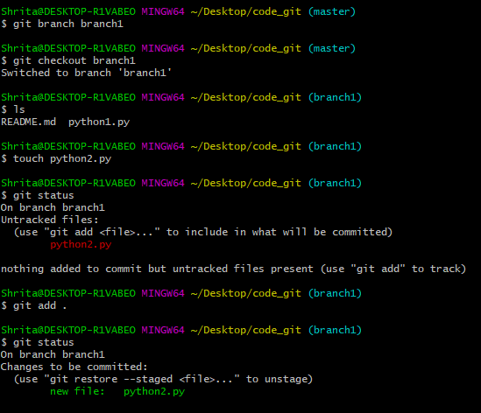

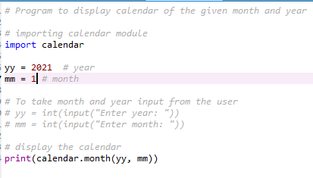

Step 8:

Navigate to your newly created branch and provide screenshot showing status of your repo.

1. The current status of branch1 is that I need to commit the new changes (python2.py) to branch1.

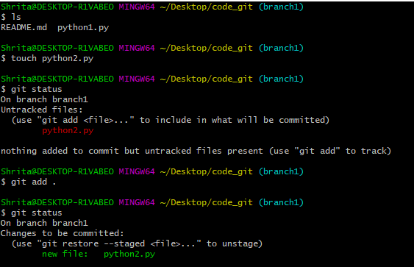

Step 9: Marks: 10

Provide a screenshot showing your log of activities and perform your final commit.

1. The log of activities in my branch branch1

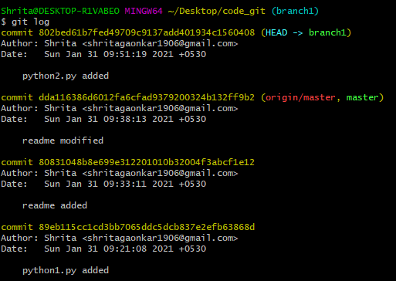

1. Log of activities in master branch

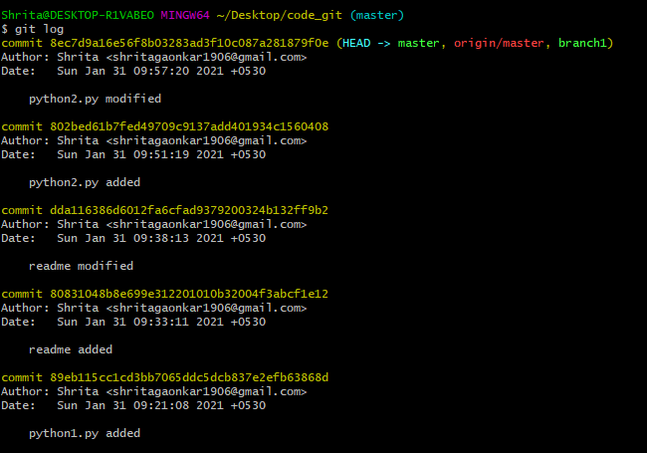

1. In the final commit, I modified python2.py.
2. In the final commit, I merged branch1 and master branch.

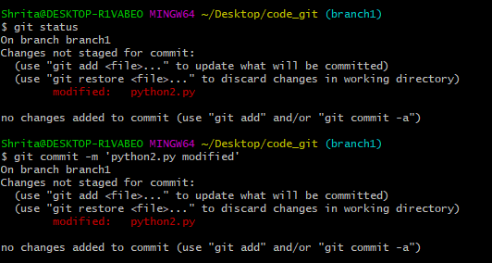

1. Now all the files can be seen in master branch as well.

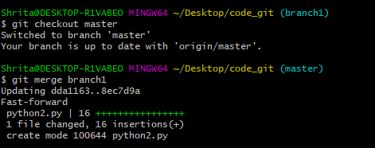

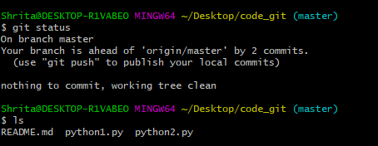

1. In the final step of my commit, I push all the changes to my remote repo.

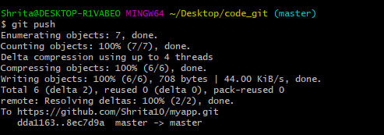

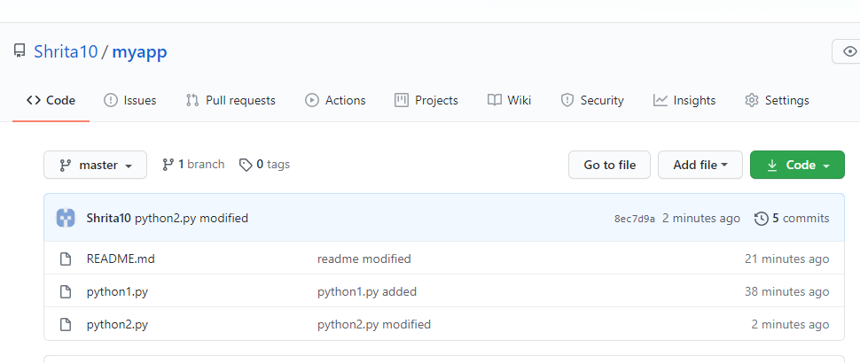

Step 10: Marks: 10

Make your repo public and share the link of your repo for check.

1. This is my github repo link which I created for this lab activity.

https://github.com/Shrita10/myapp.git