**Artificial Intelligence in Enterprise Systems**

**Lab #2 – Enterprise Cloud Computing**

**Shrita Shirish Gaonkar**

**100799307**

Step 1:

In step 1, we create accounts in AWS, Google Cloud and Azure. Unfortuantely, I couldn’t enter my card details (Informed via DC mail) on the other two cloud services so I am going ahead with AWS as that is the cloud I will use today.

Step 2:

|  |  |  |  |
| --- | --- | --- | --- |
| Sr. No. | AWS | Google Cloud | Azure |
| 1. | On-demand cloud computing platform for Amazon | PaaS, FaaS, Virtual Machines Compute Engine | Public cloud platform for Microsoft |
| 2. | Has an edge over Azure in terms of government cloud offerings. | GCP also has government offerings but not as advance | Limited reach when it comes to government cloud offerings. |
| 3. | More mature cloud environment for big data. | Less mature for big data but Azure’s services are improving. | Less mature for big data but Azure’s services are improving. |
| 4. | Elastic Compute Cloud (EC2); pay by the hour. | GCP – pay for only what you use | Azure Infrastructure Services, pay by the minute. |
| 5. | AWS has 66 availability zones with 12 more on the way. | Azure has 54 regions worldwide and is available in 140 countries all around the world. | Google Cloud Platform has been made available in 20 regions around the world with 3 more on their way. |
|  |  |  |  |

**I choose AWS as my cloud service for the lab activity it more secure, easier to learn and the earliest cloud platform in the world making its architecture more intact.**

Step 3:

I have created a virtual machine with 2012 windows using AWS ec2 remote server Instance in this step.

Step 4:

On the **remote desktop**, using the windows command line (cmd) I have created a local repository and inside that repository I have created a python file.

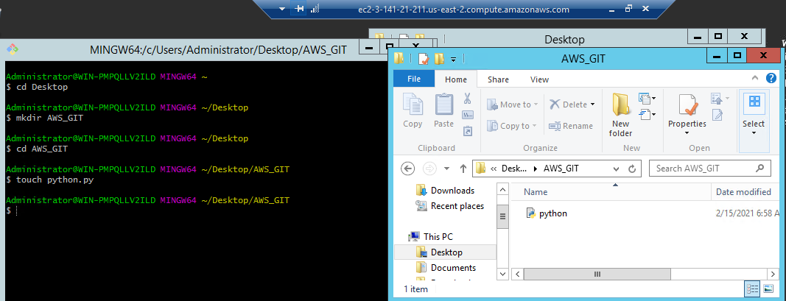

Step 5:

In the python file, I run a basic math operation file.

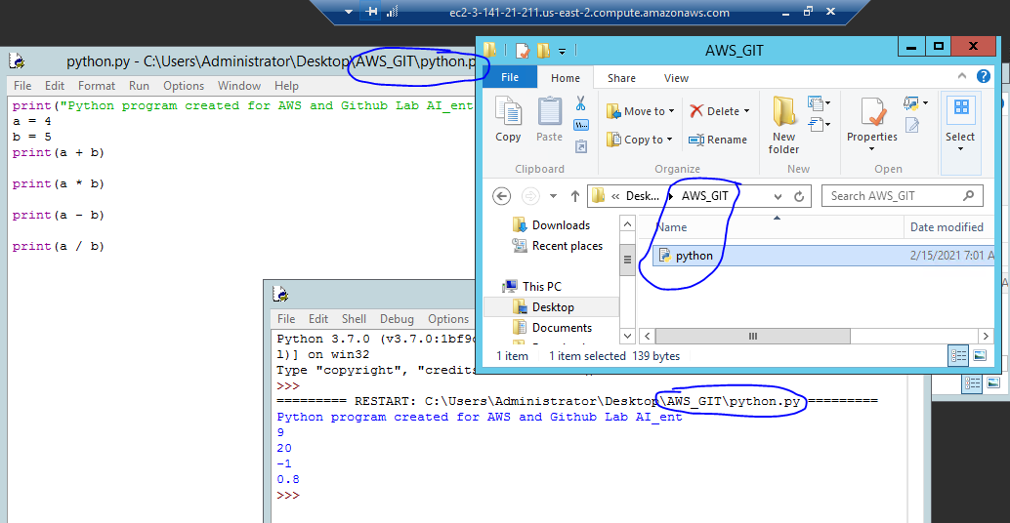

Step 6:

Initializing the GitHub repository and then authorizing GitHub with the git on the remote server. Next, create a remote repo on GitHub and connect this repo to local repo.

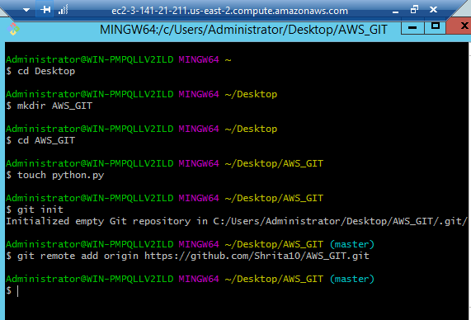

Step 7:

The repository was published to the GitHub account. Pushing the files on remote GitHub.

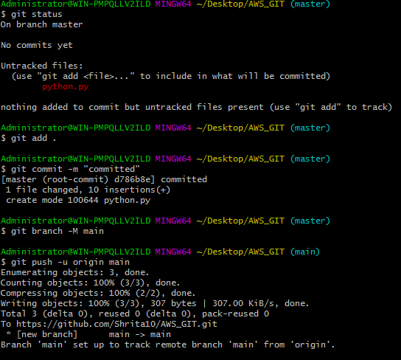

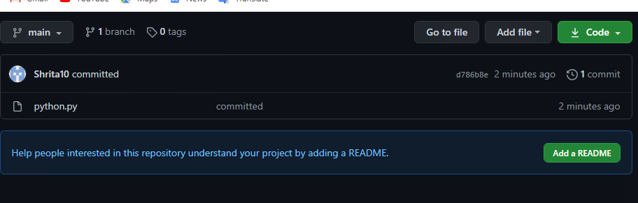

Step 8:

Using the amazon SageMaker, I have created an instance and in that instance. I have created a notebook.

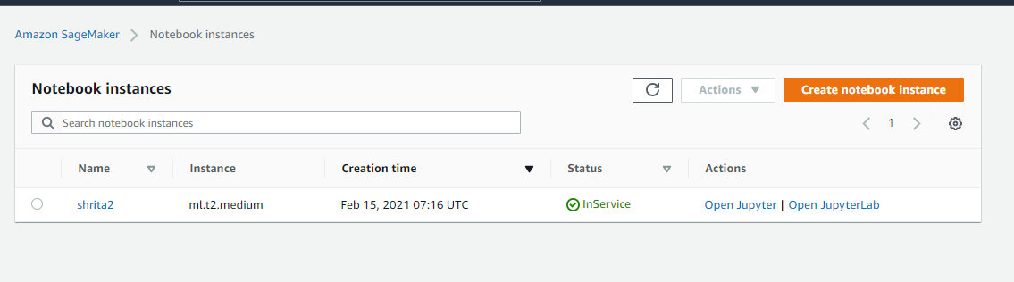

Step 9:

In the notebook created above, I perform basic math functions.

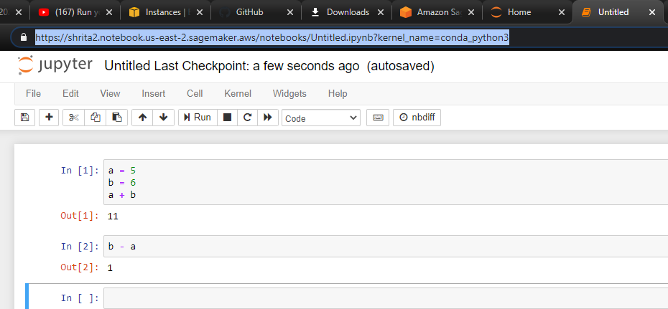

Step 10:

Uploading the SageMaker file on GitHub repo.

