**Creating SSH Key**

Generate SSH key

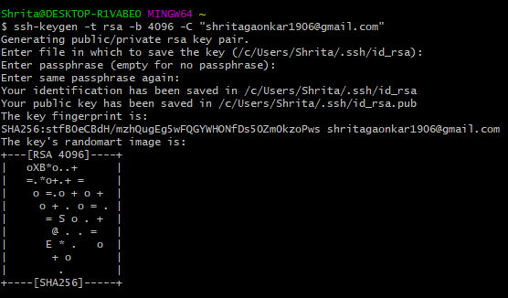

Start SSH Agent and add the SSH key.

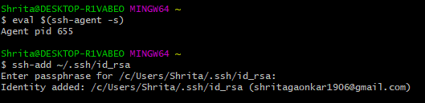

Copy the public key to the clipboard for pasting it on GitHub.



Go to GitHub > Profile > Settings > SSH and GPG keys

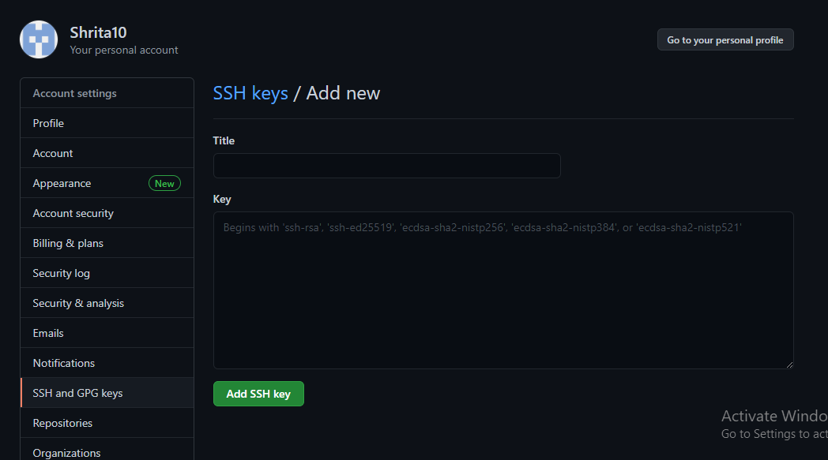

Paste the Key here.

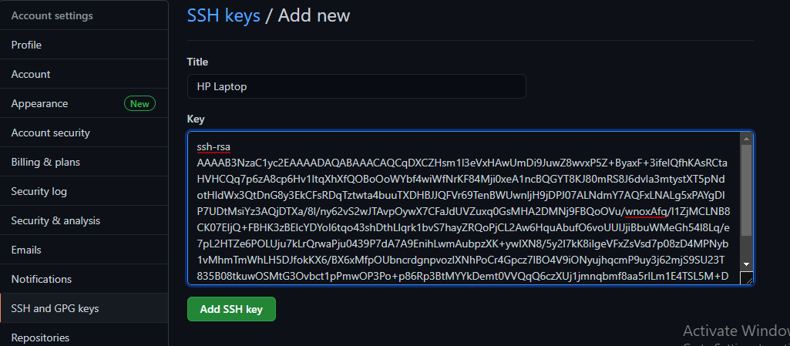

And done!

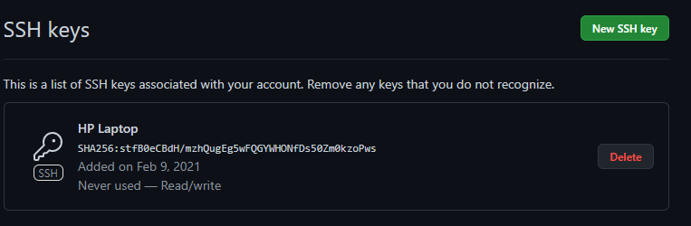

Test if its working

