Github Commit

Creating the file and pushing the file to newly created repo on github

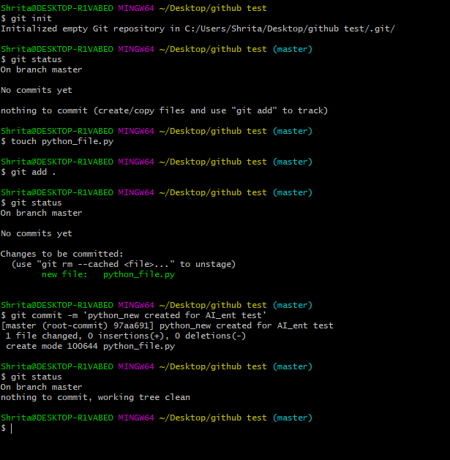

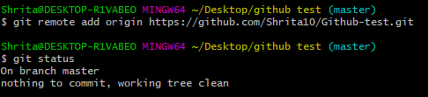

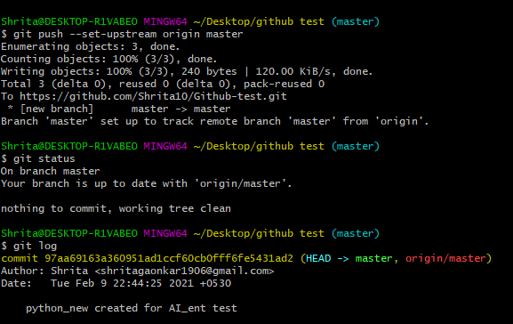

And the changes were comitted

