**1) Install the mlflow and the required libraries**

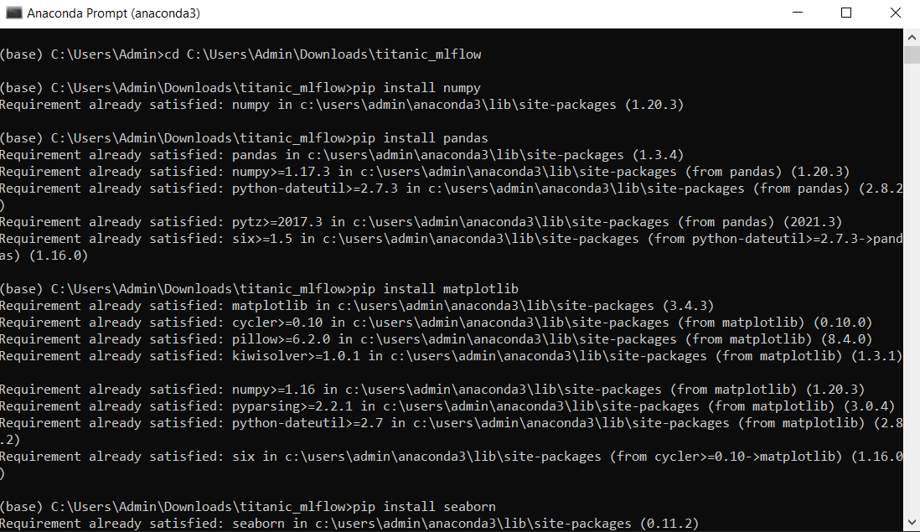

**2) Load the given data**

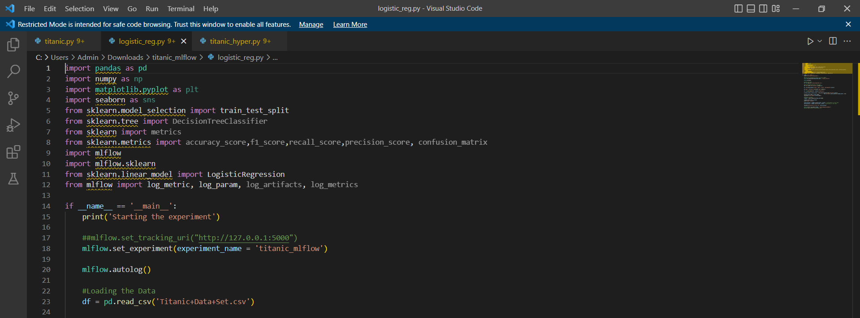

**3) Perform basic EDA**

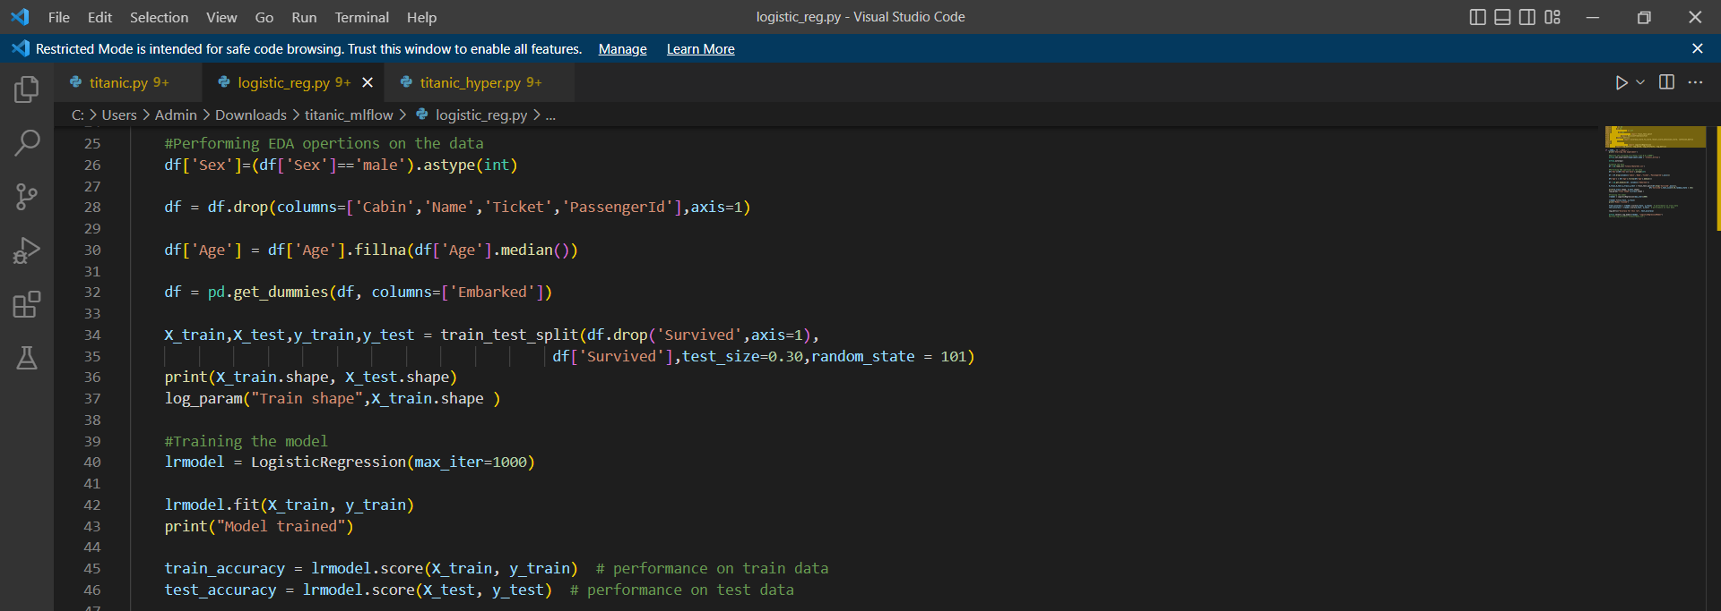

**4) Training the Logistic Regression Model**

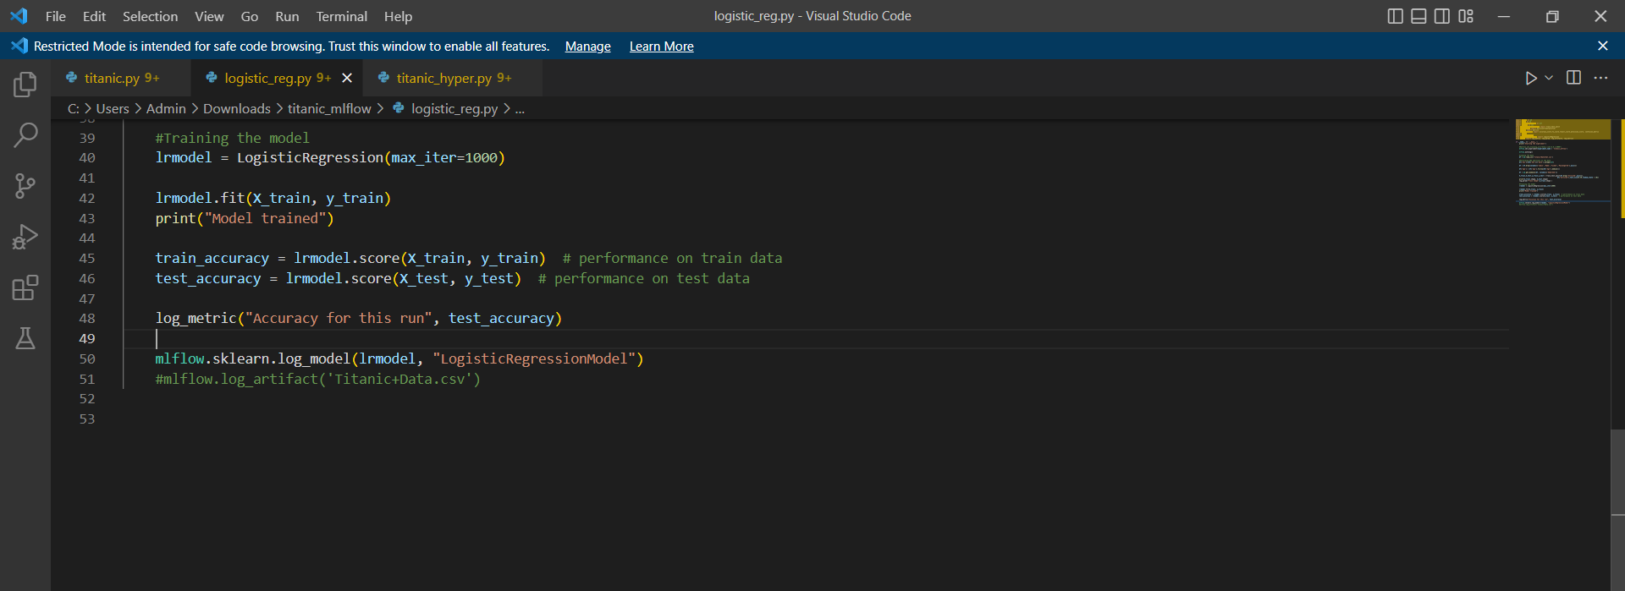

**5) Training the Decision Tree Classifier Model**

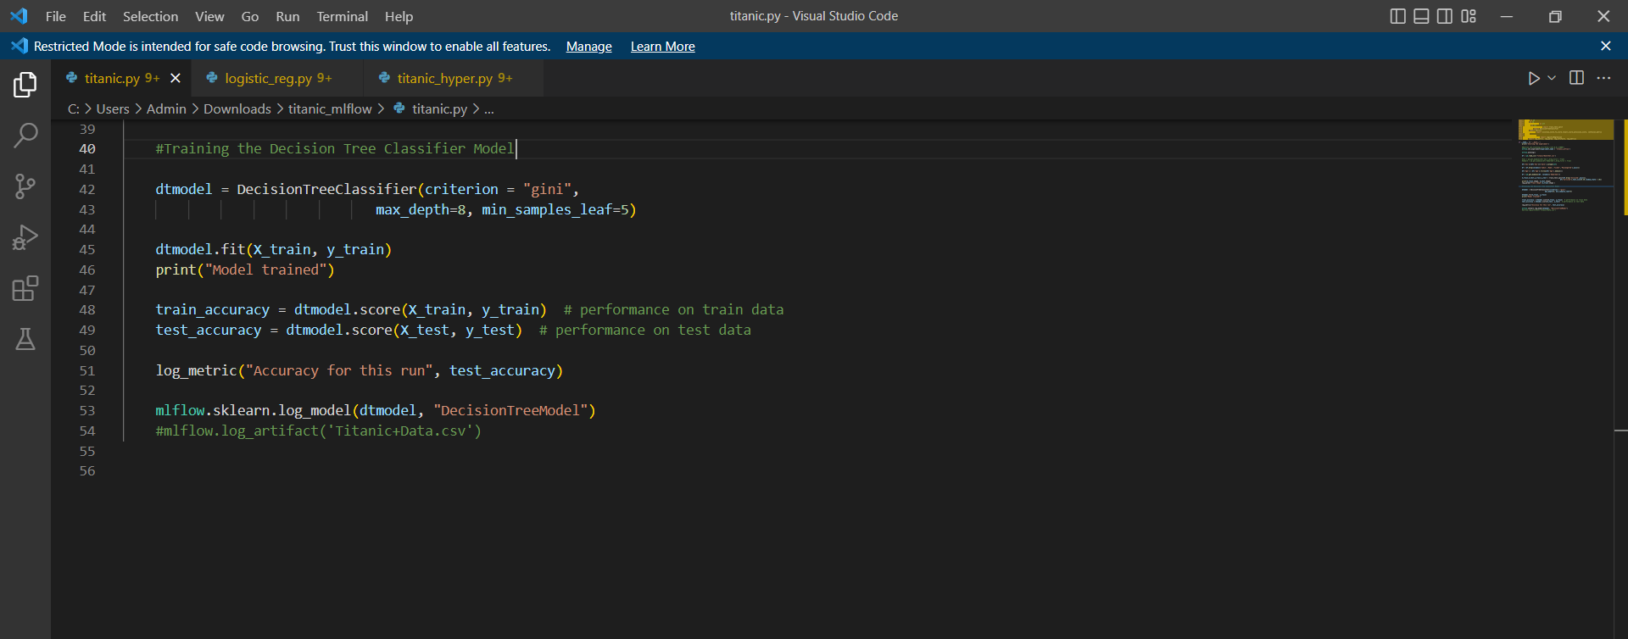

**6) Hyperparameter tuning of Random forest Model and**

**evaluation metrics like accuracy, precision, recall, f1 score**

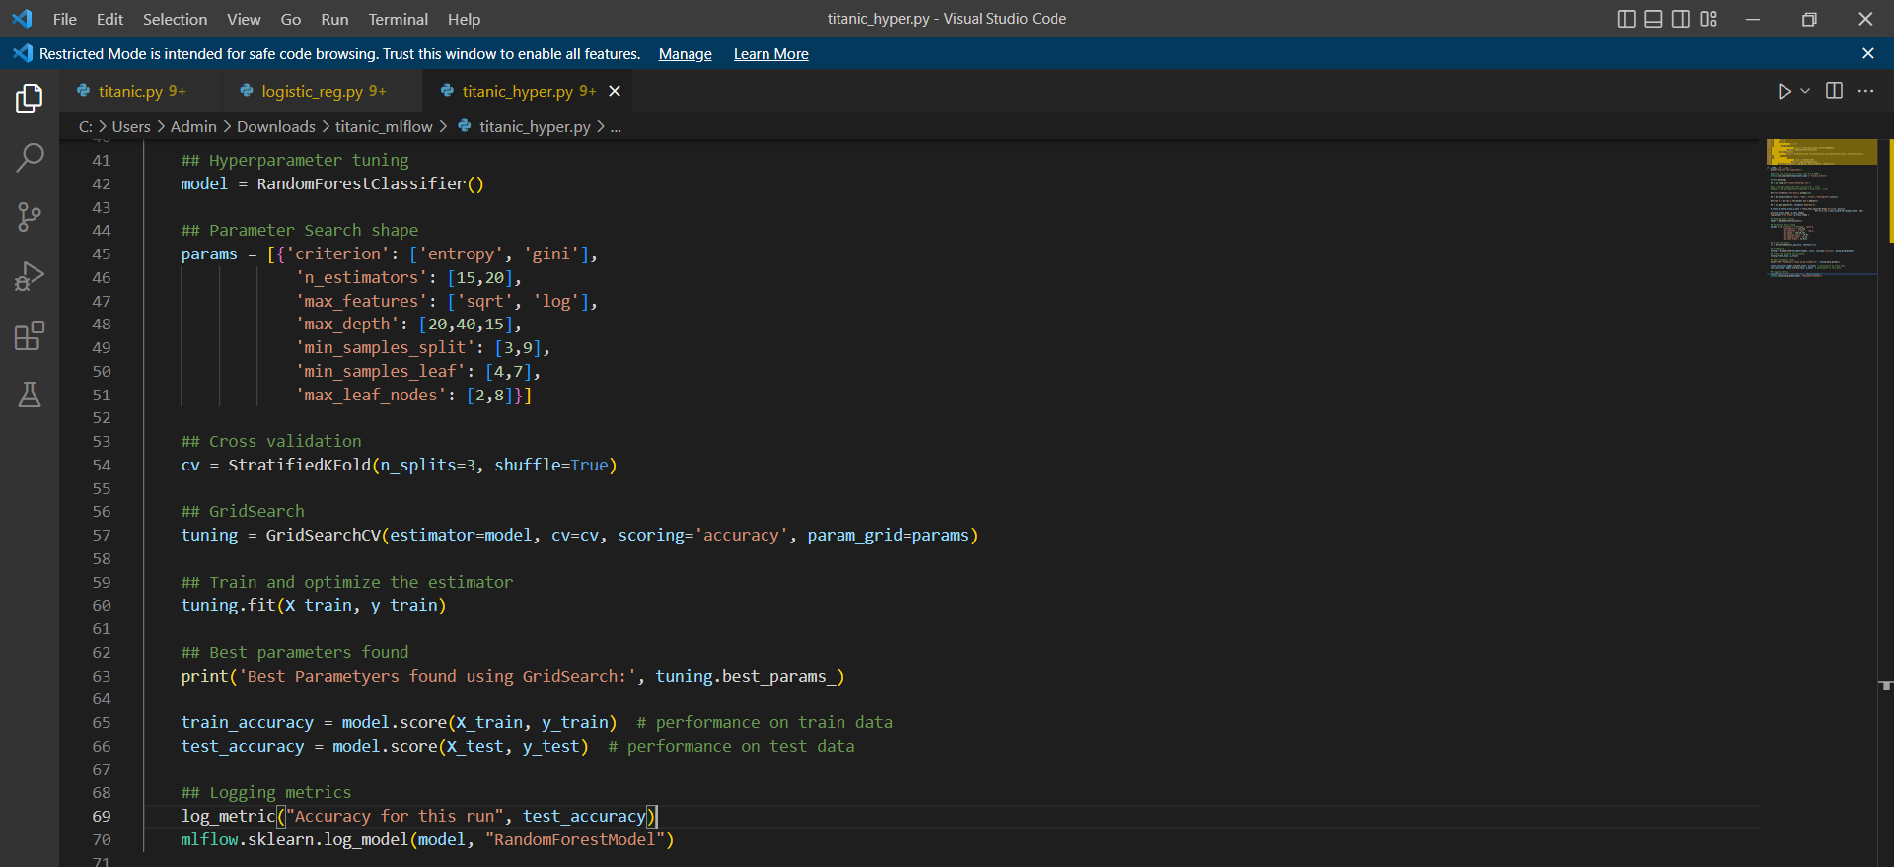

**7) Establishing a connection with mlflow ui**

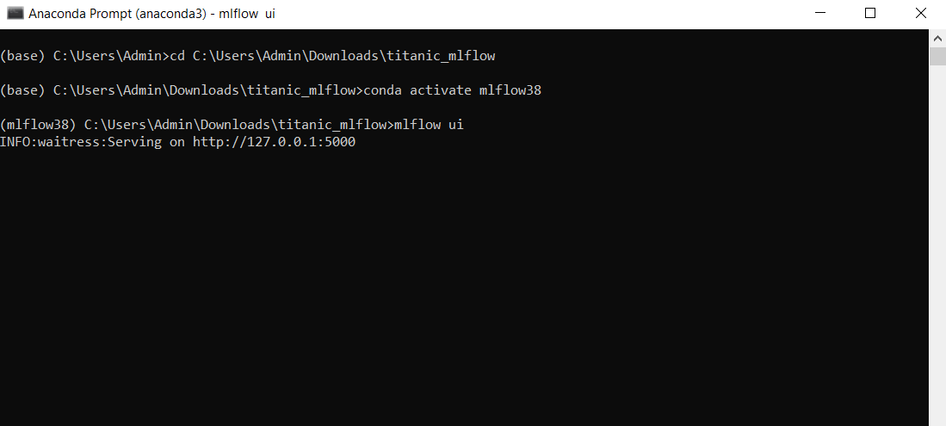

**8) Tracking the logged parameters in mlflow ui**

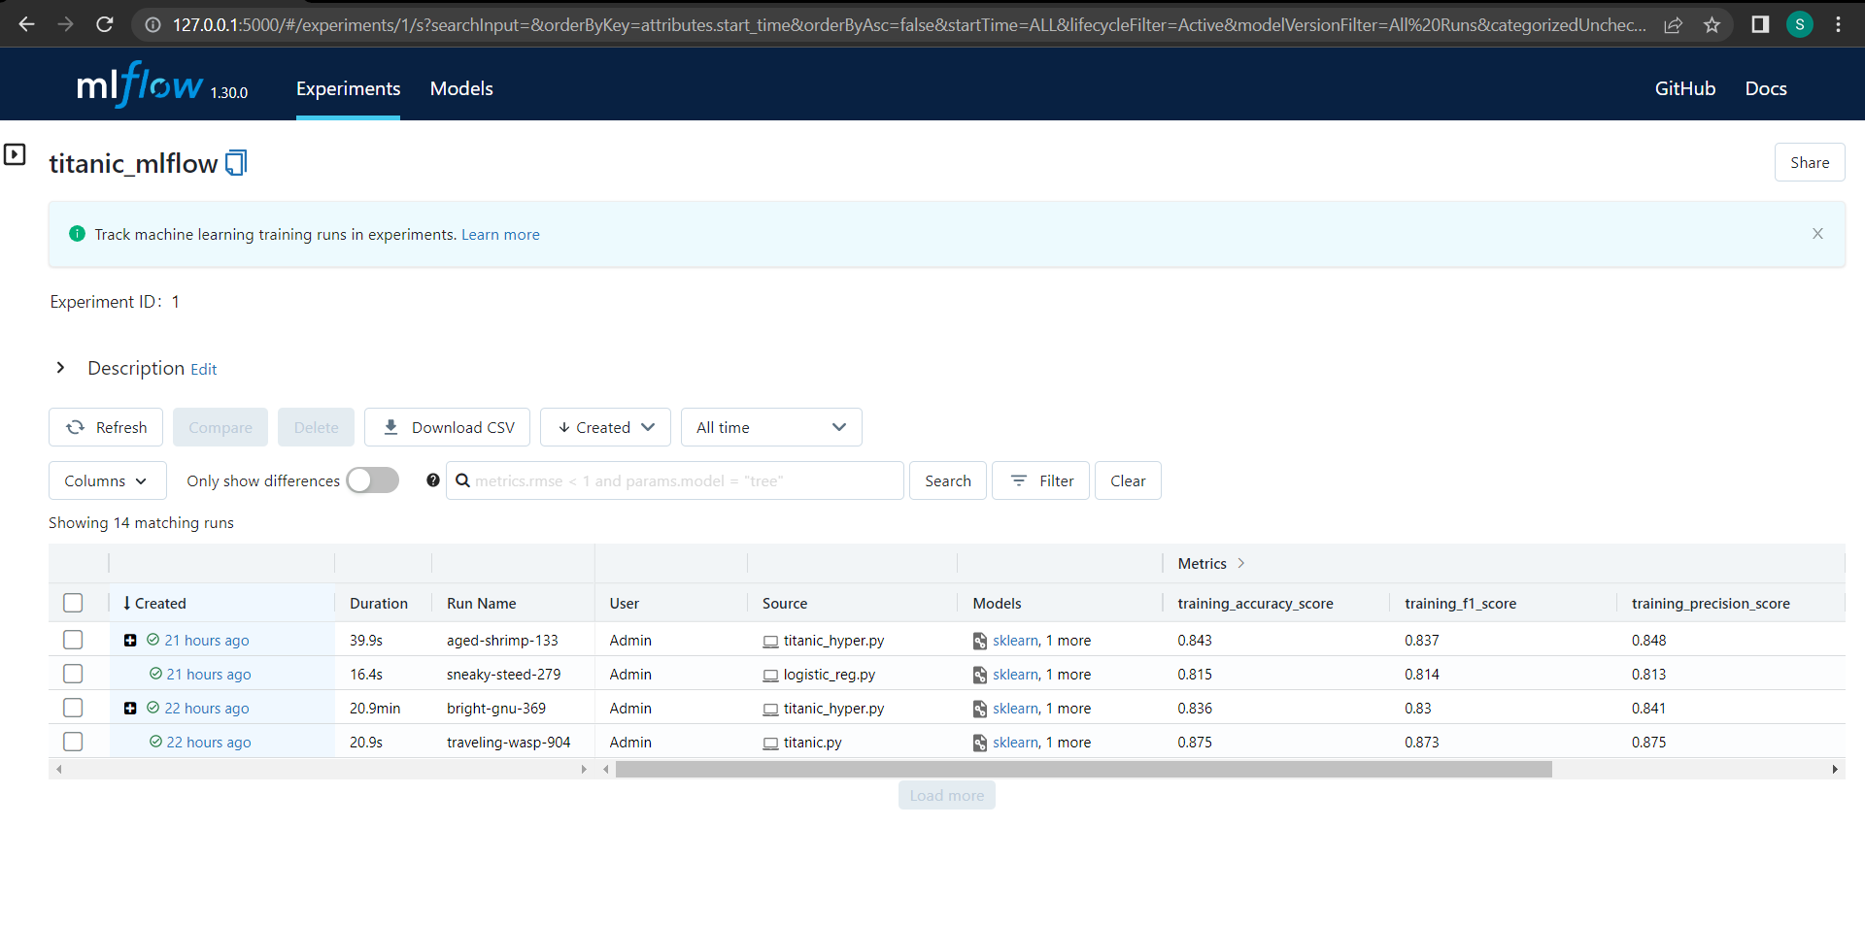

**9) Making some changes in the Hyperparameters of the model**

**(a) bright-gnu-369:**



**(b) aged-shrimp-133:**

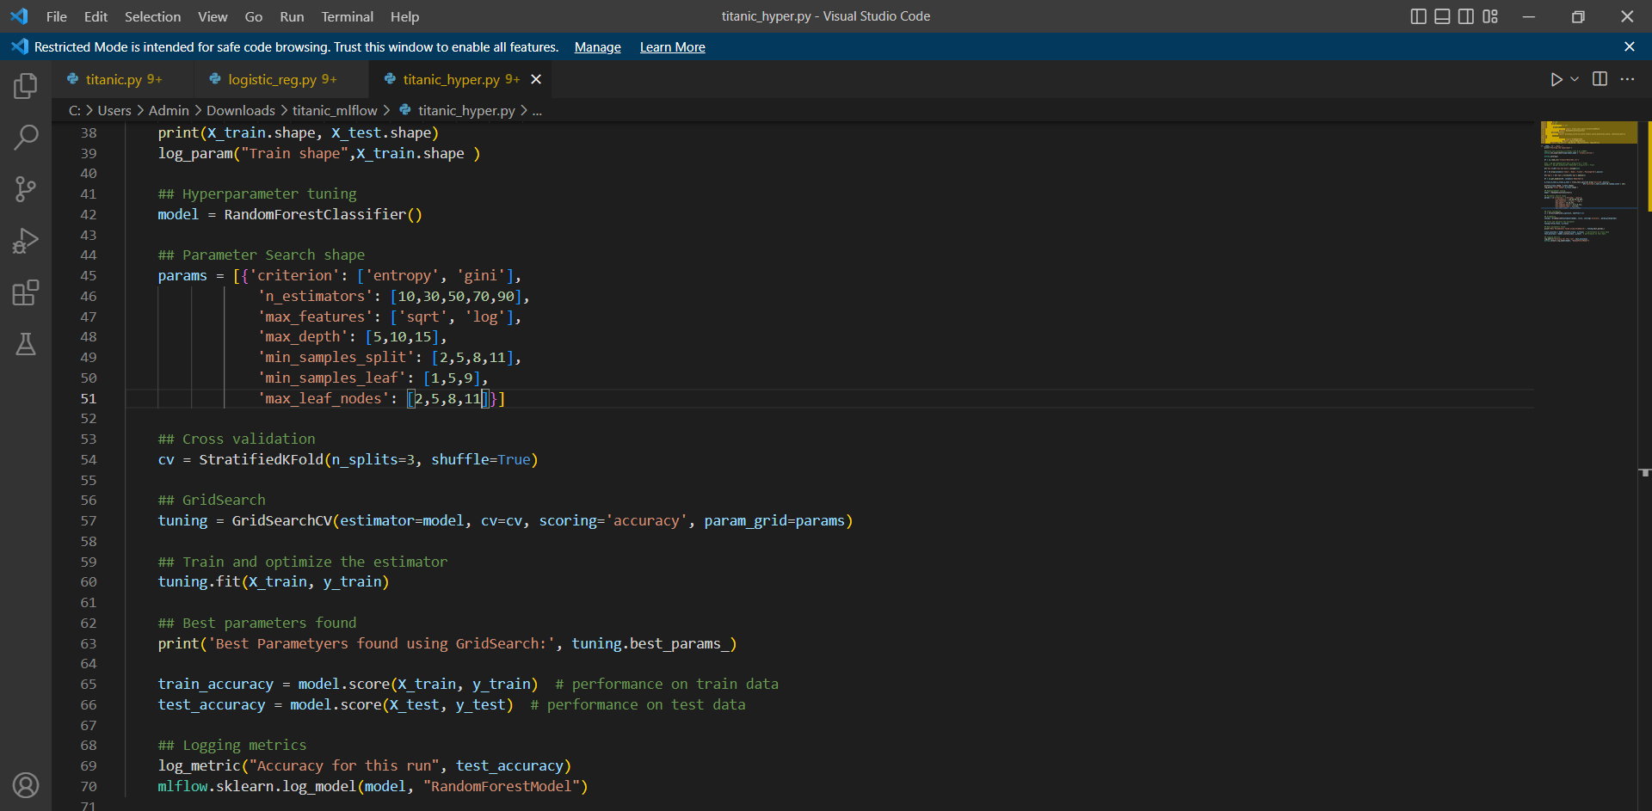

**10) Comparing the models with changed parameters**

