**Assignment Coverage:**

* Classes and Objects,
* Datatypes and Variables,
* Looping,
* Functions / Methods, Decision Making
* Access Modifiers,
* ENUMs and Dictionary

# **Technical Requirements:**

You are required to develop a C# console application to request a doctor appointment.

**Requirement 1:** Create a class with the following properties.

**Class Name: PatientDetail**

|  |  |
| --- | --- |
| **Property Name** | **Data type** |
| PatientName | String |
| PatientAge | Int |
| DoctorName | String |

Note: The above properties must be public

**Requirement 2:** Create an ENUM with the below values to get Patient Complaint department from the user

**Enum Name:** **Specialist**

|  |  |
| --- | --- |
| **Specialist** | **Id** |
| ENT | 1 |
| Gynaecologist | 2 |
| Paediatrician | 3 |
| GeneralPhysician | 4 |
| Cardiologist | 5 |

**Requirement 3:** Create two Arrays one for Key and other for Doctor names with the below values to suggest Doctor names to the user

|  |  |
| --- | --- |
| **Key** | **Value** |
| ENT | Dr. Murugadoss MD DLO |
| Gynaecologist | Dr. Bala Abirami MD DGO |
| Paediatrician | Dr. Amudhan MD DCH |
| GeneralPhysician | Dr. Natarajan MD |
| Cardiologist | Dr. Ashirvatham MD DM |

**Requirement 4:** Create a public class with the following method to verify Appointment request functionality:

**Class Name: AppointmentDateVerification**

**Method:**

|  |  |
| --- | --- |
| **Method Signature** | **Description** |
|  |  |
| public string CheckappointmentRequestDate (DateTime appointmentRequestDate) | This method checks if the input appointment request date is a future date, from the current year and the day of the date is not a Monday. If all 3 conditions are true it returns “Appointment Confirmed!”. Else returns – “Appointment Rejected, Date must be a future date!”,” Appointment Rejected, you can book appointment only for the current year!” or "Sorry!!! Appointment cannot be given on Monday!" |

**Requirement 5:** In the Main Program, Get the following details from the User (Patient Name, Patient Age, Doctor Name, Appointment request date), Validate, if the validation fails, get the user input again else display the output. Refer Sample Input/outputs below

**Sample I/O 1**

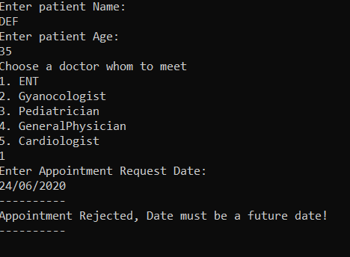

**Sample I/O 2**

