vit chennai
Lab Assignment - 5
Compiler Design Lab

Name – Adityaraj Shrivastava
Reg. No. – 23BCE1968

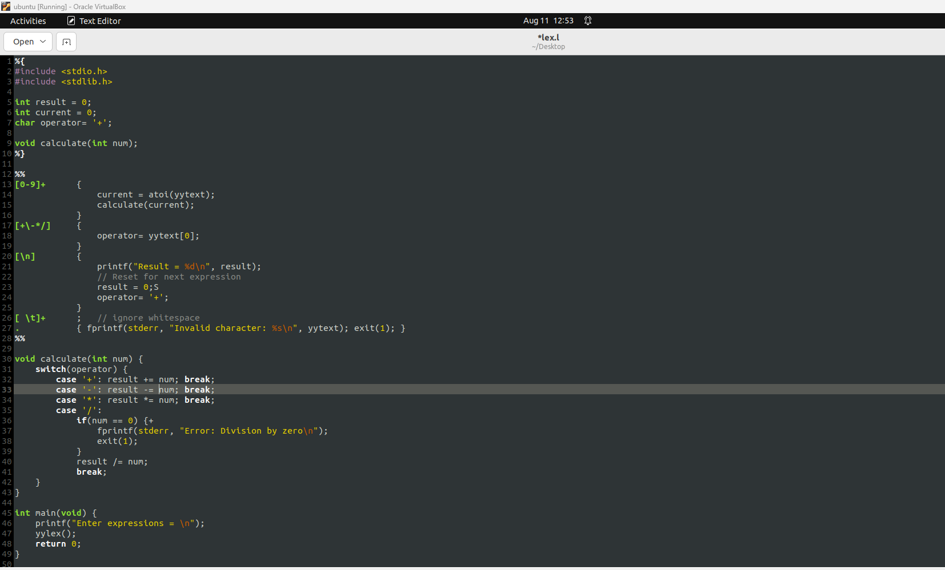

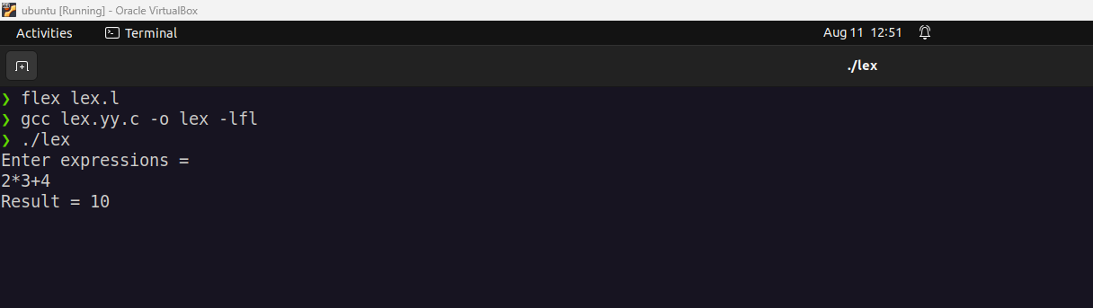

#include <stdio.h>
#include <string.h>

#define MAX 100

char stack[MAX];
int top = -1;

void push(char c) {
if (top == MAX - 1) {
printf("Stack Overflow\n");
return;
}
stack[++top] = c;
}

char pop() {
if (top == -1) {
return '\0';
}
return stack[top--];
}

void printStack() {
for (int i = 0; i <= top; i++) {
printf("%c", stack[i]);
}
printf("\n");
}

int reduce() {
if (top >= 2) {
if (stack[top] == 'E' && (stack[top-1] == '+' || stack[top-1] == '*') && stack[top-2] == 'E') {
stack[top-2] = 'E';
top -= 2;
return 1;
}
}
if (top >= 0) {
if (stack[top] == 'i') {
stack[top] = 'E';
return 1;
}
}
return 0;
}

int main() {
char input[MAX];
printf("Enter input string : ");
scanf("%s", input);

int i = 0;
int len = strlen(input);

printf("Stack\tInput\tAction\n");

while (i < len) {
push(input[i]);
printf("%.*s\t%s\tShift '%c'\n", top+1, stack, &input[i], input[i]);
i++;

while (reduce()) {
printf("%.*s\t%s\tReduce\n", top+1, stack, &input[i]);
}
}

while (reduce()) {
printf("%.*s\t%s\tReduce\n", top+1, stack, &input[i]);
}

if (top == 0 && stack[top] == 'E') {
printf("Input string is accepted.\n");
} else {
printf("Input string is rejected.\n");
}

return 0;
}

OUTPUT:
