**USER MANUAL**

Login

Enter the user ID and password

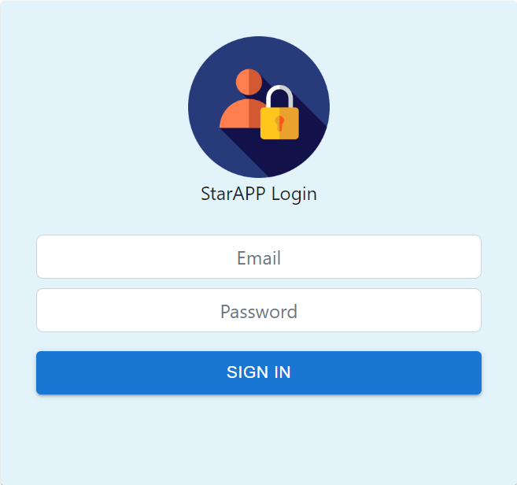

Employee Login View

In this, the employee can view the status of their requests, i.e. whether their employee request is pending, accepted or rejected. 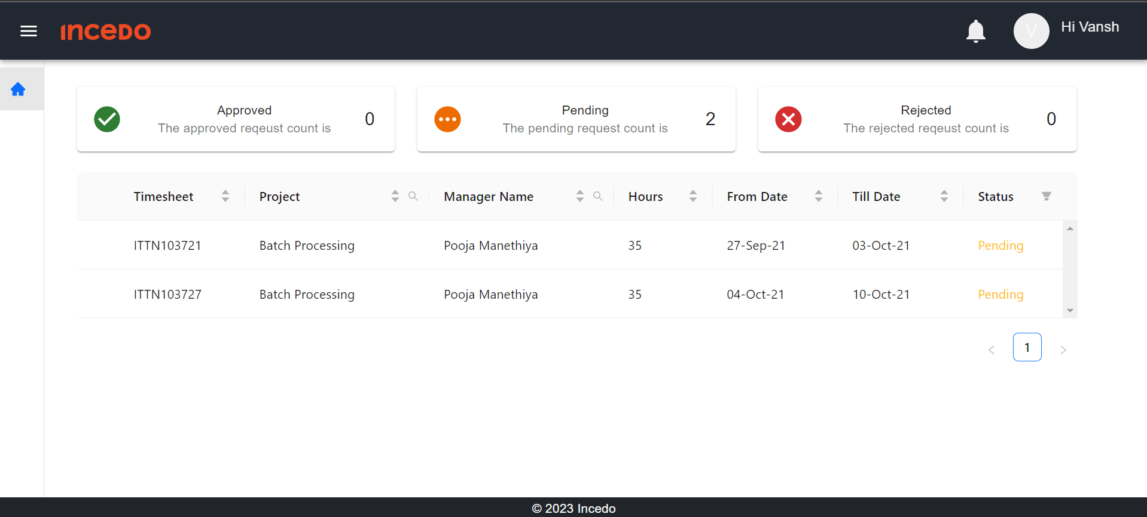

Manager/Employee Login View

In this, the manager can take action on the requests of their employee, i.e. they can either accept or reject the employee’s request.

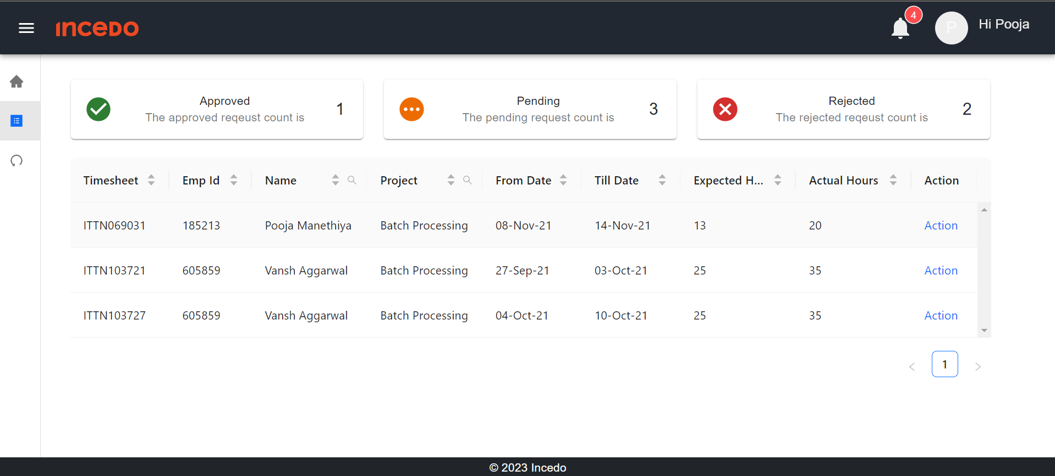

By clicking on action manager can accept or reject the employee’s request, and an email will be sent to the employee.

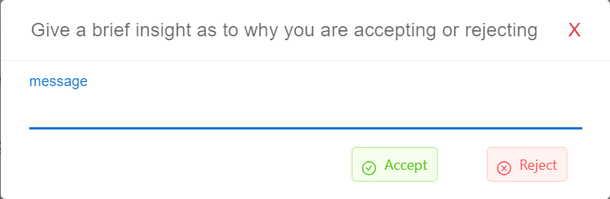

Executive Leader Login View

