Dynamic Programming: Notes
Color code: most important, important, and nothing’s ever enough is it?
Dynamic Programming 101
Parent Problems
- 0-1 Knapsack(6)
  - Subset sum Problem
  - Equal Sum Partitions
  - Count of subset sum
  - Minimum subset sum difference
  - Target Sum
  - Number of subset c given difference
- Unbounded knapsack(5)
- Fibonacci(7)
- LCS(15)
- LIS(10)
- Kadane’s Algorithm(6)
- Matrix chain multiplication(7)
- DP on Trees(4)
- DP on Grid(14)
- Others(5)

- 0-1 Knapsack

Memoize Code;
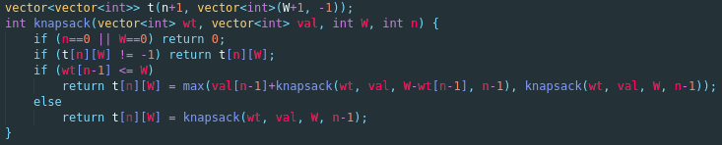

Iterative solution Code;
