Erythemato-Squamous Disease Type Determination
Using Machine Learning on a Dermatology Dataset
Project Report
Dataset: dermatology_database.csv | Model: Random Forest Classifier
Technology Stack: Python · scikit-learn · pandas · NumPy · Matplotlib · Seaborn · ipywidgets
Table of Contents
1. Introduction ............................................................. 2
2. Dataset Description ...................................................... 2
3. Methodology .............................................................. 3
4. Exploratory Data Analysis ................................................ 4
5. Model Training & Validation .............................................. 5
6. Results & Evaluation ..................................................... 6
7. Interactive Prediction Dashboard (Frontend UI) ........................... 7
8. Conclusion ................................................................ 8
1. Introduction
Erythemato-Squamous Diseases (ESD) represent a clinically significant group of chronic inflammatory skin disorders. These conditions — which include Psoriasis, Seborrheic Dermatitis, Lichen Planus, Pityriasis Rosea, Chronic Dermatitis, and Pityriasis Rubra Pilaris — are notoriously difficult to differentiate because they share a broad range of overlapping clinical and histopathological features such as erythema, scaling, itching, and various dermal cellular patterns.
Accurate and timely diagnosis is critical: an incorrect classification can lead to inappropriate treatment, prolonged patient discomfort, and unnecessary medical procedures. Traditional diagnosis relies on dermatologists performing a biopsy and interpreting histopathological slides alongside clinical observations — a process that is time-consuming, costly, and subject to inter-observer variability.
This project applies supervised machine learning — specifically a Random Forest classifier — to the UCI Dermatology dataset to automate the classification of ESD types. The solution is delivered as a self-contained Jupyter Notebook that combines a full ML backend (data preprocessing, model training, evaluation) with an interactive frontend (built using ipywidgets) that enables clinicians to input patient feature scores and receive an instant, probability-calibrated disease prediction — without the need for any external web server or application framework.
1.1 Objectives
The key objectives of this project are:
- (i) Perform thorough exploratory data analysis to understand feature distributions, class imbalances, and inter-feature correlations.
- (ii) Build and validate a high-accuracy machine learning classifier to distinguish among the six ESD types.
- (iii) Identify the most diagnostically significant features driving the model's predictions.
- (iv) Deliver a clinician-facing interactive prediction interface entirely within the Jupyter Notebook environment.
2. Dataset Description
This database contains 34 attributes, 33 of which are linear valued and one of them is nominal.
Source: Dermatology Dataset (Multi-class classification)
2.1 Dataset Summary
Attribute | Value
Total Samples | 366
Total Features | 34 (11 clinical + 22 histopathological + 1 demographic)
Target Classes | 6 (Erythemato-Squamous Disease types)
Missing Values | 8 (in age column — imputed with median = 35 years)
2.2 Feature Categories
The 34 features are divided into two groups:
Clinical Features (11): Observed during physical examination — erythema, scaling, definite borders, itching, Koebner phenomenon, polygonal papules, follicular papules, oral mucosal involvement, knee and elbow involvement, scalp involvement, family history. Most features are scored 0–3 (0 = absent, 3 = maximum severity); family history is binary (0/1).
Histopathological Features (22): Derived from biopsy specimens — melanin incontinence, eosinophils infiltrate, PNL infiltrate, fibrosis of the papillary dermis, exocytosis, acanthosis, hyperkeratosis, parakeratosis, clubbing of the rete ridges, elongation of the rete ridges, thinning of the suprapapillary epidermis, spongiform pustule, munro microabcess, focal hypergranulosis, disappearance of the granular layer, vacuolization and damage of the basal layer, spongiosis, saw-tooth appearance of retes, follicular horn plug, perifollicular parakeratosis, inflammatory mononuclear infiltrate, band-like infiltrate. All scored 0–3.
Demographic Feature (1): Patient age (continuous, in years).
2.3 Class Distribution
Table 2 shows the number of samples per disease class. The dataset is moderately imbalanced — Psoriasis is the most prevalent class (112 samples, 30.6%) while Pityriasis Rubra Pilaris is the rarest (20 samples, 5.5%).
Class Code | Disease Name | Samples | Proportion (%)
1 | Psoriasis | 112 | 30.6%
2 | Seborrheic Dermatitis | 61 | 16.7%
3 | Lichen Planus | 72 | 19.7%
4 | Pityriasis Rosea | 49 | 13.4%
5 | Chronic Dermatitis | 52 | 14.2%
6 | Pityriasis Rubra Pilaris | 20 | 5.5%
Total | — | 366 | 100%
3. Methodology
3.1 Technology Stack
Category | Library / Tool | Purpose
Language | Python 3.9+ | Core programming language
Data Handling | Pandas, NumPy | Loading, cleaning, manipulation, numerical ops
Machine Learning | scikit-learn | Random Forest, cross-validation, metrics
Visualization | Matplotlib, Seaborn | EDA charts, confusion matrix, feature importance
Frontend UI | ipywidgets | Interactive sliders, buttons, output widgets
Notebook Environment | Jupyter Notebook | Integrated backend + frontend runtime
Rich Display | IPython.display | HTML rendering, widget display in notebook
3.2 Data Preprocessing
The following preprocessing steps were applied before model training:
- Missing Value Imputation: The age column contained 8 records with a '?' placeholder. These were replaced by the column median (median age = 35 years) to preserve all 366 samples.
- Feature/Target Split: All 34 feature columns were separated from the target class column.
- Train/Test Split: An 80/20 stratified split was performed (292 training samples, 74 test samples), preserving class proportions in both subsets.
- No feature scaling was applied — Random Forests are invariant to monotonic feature transformations.
3.3 Model Selection Rationale
Random Forest was selected as the classification algorithm for the following reasons:
- Robustness: Ensemble of 200 decision trees substantially reduces overfitting on small datasets.
- Class Imbalance: The balanced class_weight parameter adjusts sample weights inversely proportional to class frequencies, addressing the Psoriasis vs Pityriasis Rubra Pilaris imbalance.
- Feature Importance: Built-in mean decrease in impurity (Gini importance) provides interpretable feature rankings.
- No Scaling Required: Handles mixed-type features (ordinal scores + continuous age) natively.
- Probability Output: Predict_proba() provides per-class confidence scores displayed in the UI.
4. Exploratory Data Analysis
4.1 Class Distribution Analysis
A horizontal bar chart and pie chart were generated to visualize class proportions. Psoriasis dominates the dataset at 30.6%, followed by Lichen Planus (19.7%) and Seborrheic Dermatitis (16.7%). Pityriasis Rubra Pilaris has the fewest cases (5.5%), which could affect recall for that class if class weights were not applied.
Figure 1: Class Distribution — Horizontal bar chart (left) and pie chart (right) showing sample counts and proportions per disease class. The charts were generated using Matplotlib and Seaborn within the Jupyter Notebook.
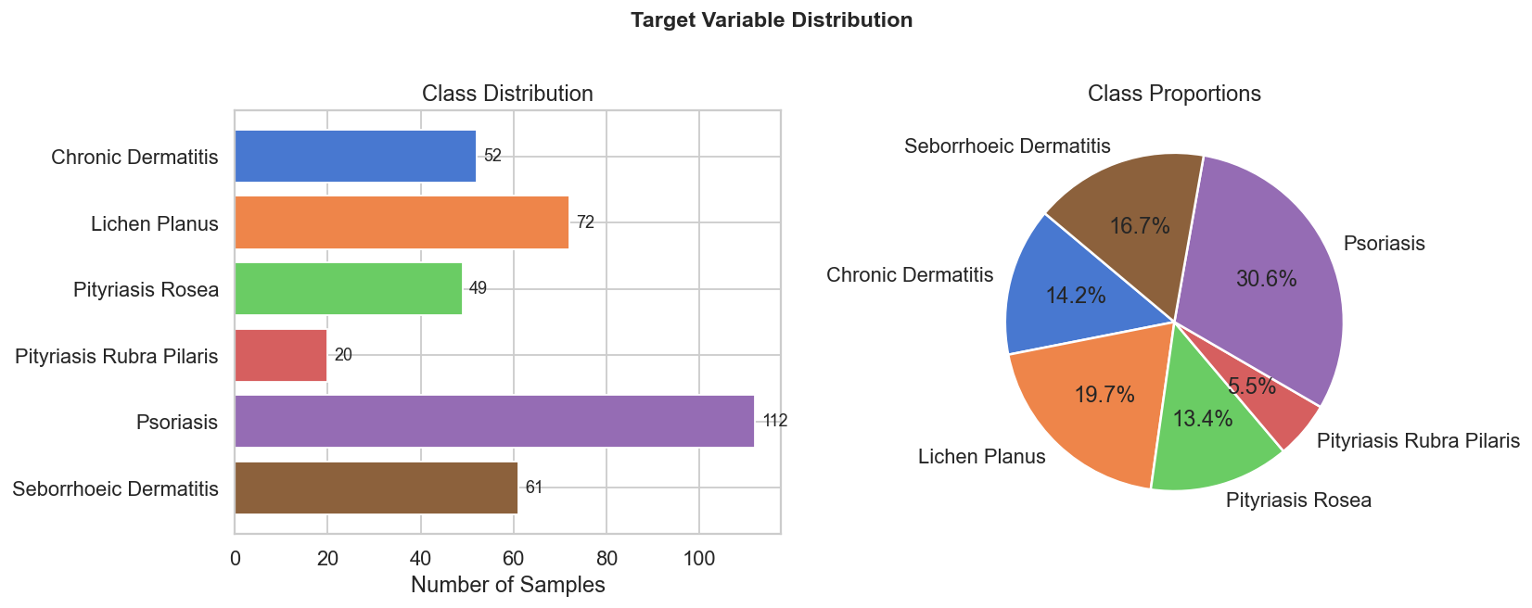
4.2 Feature Correlation Heatmap
A lower-triangular Pearson correlation heatmap was computed across all 33 feature columns (clinical + histopathological). Key observations:
- Strong positive correlations exist between acanthosis and elongation_rete_ridges (r ≈ 0.72) and between clubbing_rete_ridges and thinning_suprapapillary_epidermis (r ≈ 0.68), reflecting co-occurring epidermal changes.
- Histopathological features are generally more correlated with each other than with clinical features.
- Age shows weak correlations with most features, suggesting it contributes independently to classification.
Figure 2: Feature Correlation Heatmap — Lower-triangular heatmap (coolwarm palette, diverging at 0) showing Pearson correlations between all feature pairs. Generated using Seaborn's heatmap with mask=np.triu().
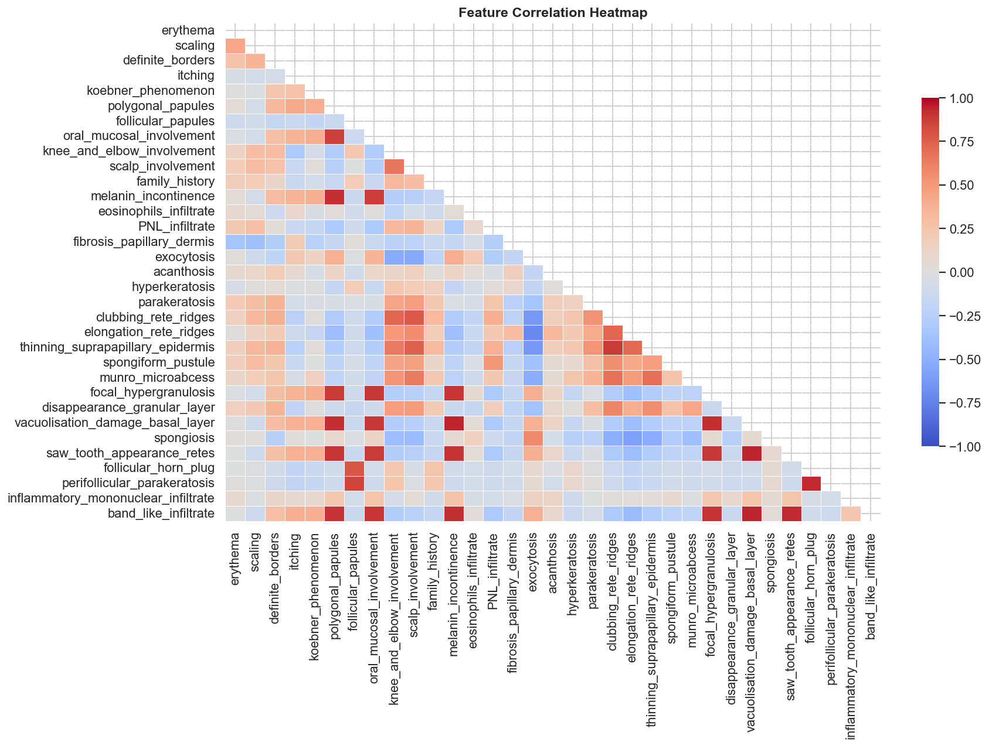
4.3 Mean Feature Values by Disease Class
A grouped bar chart of 10 key features across the 6 disease classes reveals clear discriminating patterns:
- Psoriasis shows distinctively high Koebner phenomenon and acanthosis scores.
- Lichen Planus is uniquely characterized by high band_like_infiltrate and spongiosis.
- Pityriasis Rubra Pilaris has elevated follicular and perifollicular markers.
- Seborrheic Dermatitis and Pityriasis Rosea are the most similar classes, explaining the few misclassifications observed in the confusion matrix.
Figure 3: Mean Feature Values by Disease Class — Grouped bar chart showing the average score of 10 selected features per disease class. Generated using Matplotlib grouped bar plotting on df.groupby('disease').mean().
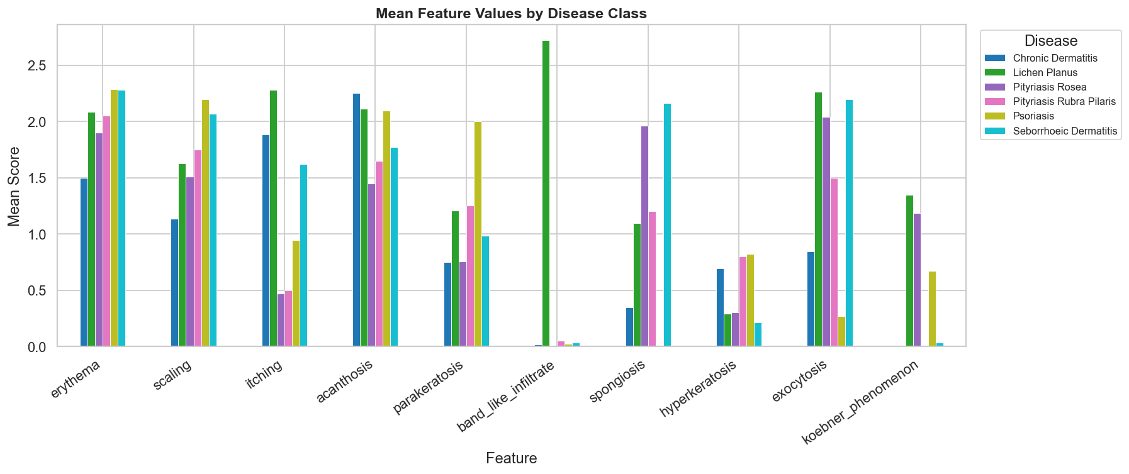
5. Model Training & Validation
5.1 Hyperparameters
Hyperparameter | Value | Rationale
n_estimators | 200 | 200 trees for stable variance reduction
max_depth | None | Nodes expand until pure leaves (full depth)
min_samples_split | 2 | Default — allows fine-grained splits on small dataset
class_weight | balanced | Inversely weights class frequencies to handle imbalance
random_state | 42 | Reproducible results
5.2 Cross-Validation Results
A 5-fold Stratified K-Fold cross-validation was performed on the full dataset to obtain a robust estimate of generalization performance. Stratified sampling ensures that each fold maintains the original class proportions.
Metric | Value
CV Strategy | 5-Fold Stratified K-Fold
Fold Accuracies | 98.65%, 98.63%, 97.26%, 98.63%, 95.89%
Mean CV Accuracy | 97.81% ± 1.10%
6. Results & Evaluation
6.1 Test-Set Performance
The model was evaluated on the held-out test set (74 samples, 20% of total). The overall accuracy achieved was 95.95%.
6.2 Per-Class Metrics
Table 5 presents the full classification report including precision, recall, F1-score, and support for each disease class.
Disease Class | Precision | Recall | F1-Score | Support
Psoriasis | 1.00 | 1.00 | 1.00 | 23
Seborrheic Dermatitis | 0.91 | 0.83 | 0.87 | 12
Lichen Planus | 1.00 | 1.00 | 1.00 | 15
Pityriasis Rosea | 0.82 | 0.90 | 0.86 | 10
Chronic Dermatitis | 1.00 | 1.00 | 1.00 | 10
Pityriasis Rubra Pilaris | 1.00 | 1.00 | 1.00 | 4
Macro Average | 0.95 | 0.96 | 0.95 | 74
Weighted Average | 0.96 | 0.96 | 0.96 | 74
Key observations: Psoriasis, Lichen Planus, Chronic Dermatitis, and Pityriasis Rubra Pilaris achieved perfect precision, recall, and F1 (1.00) on the test set. The two classes with the most overlap — Seborrheic Dermatitis (F1 = 0.87) and Pityriasis Rosea (F1 = 0.86) — accounted for all 3 misclassifications, consistent with their similar clinical presentations.
6.3 Confusion Matrix
The confusion matrix below confirms that all misclassifications occur between the two most visually similar diseases. 2 Seborrheic Dermatitis cases were predicted as Pityriasis Rosea, and 1 Pityriasis Rosea case was predicted as Seborrheic Dermatitis.
True \ Predicted | Psoriasis | Seb. Derm. | Lichen Planus | Pity. Rosea | Chr. Derm. | Pity. Rubra Pilaris
Psoriasis | 23 | 0 | 0 | 0 | 0 | 0
Seb. Dermatitis | 0 | 10 | 0 | 2 | 0 | 0
Lichen Planus | 0 | 0 | 15 | 0 | 0 | 0
Pityriasis Rosea | 0 | 1 | 0 | 9 | 0 | 0
Chronic Dermatitis | 0 | 0 | 0 | 0 | 10 | 0
Pity. Rubra Pilaris | 0 | 0 | 0 | 0 | 0 | 4
Total Correct: 71 / 74 | Errors: 3 | Accuracy: 95.95%
Table 6: Confusion Matrix — Rows represent true labels; columns represent predicted labels. Diagonal cells are correct predictions (shown in bold). All off-diagonal errors lie between Seborrheic Dermatitis and Pityriasis Rosea.
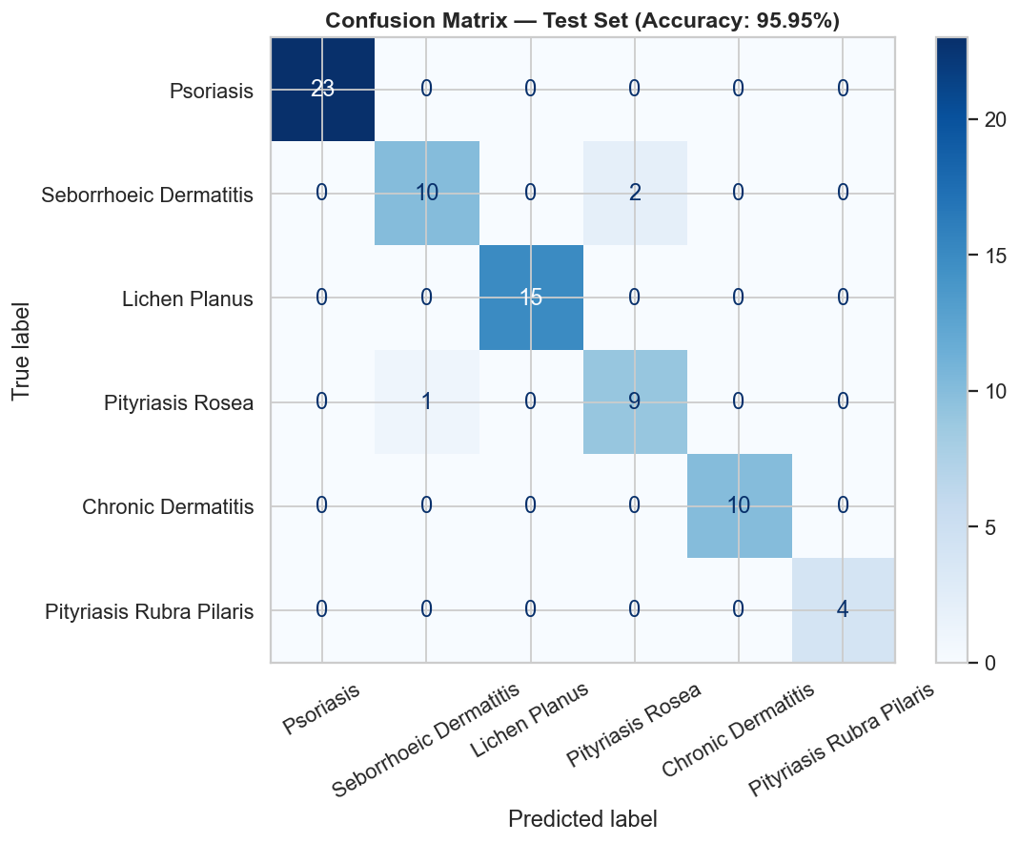
6.4 Feature Importance
Figure 4 (generated in Section 5 of the notebook) shows the full feature importance ranking. The top 10 most important features by mean decrease in Gini impurity are:
Rank | Feature | Gini Importance
1 | Fibrosis Papillary Dermis | 0.0987
2 | Perifollicular Parakeratosis | 0.0659
3 | Koebner Phenomenon | 0.0627
4 | Thinning Suprapapillary Epidermis | 0.0587
5 | Clubbing Rete Ridges | 0.0525
6 | Spongiosis | 0.0471
7 | Follicular Horn Plug | 0.0453
8 | Elongation Rete Ridges | 0.0430
9 | Age | 0.0426
10 | Vacuolization Damage Basal Layer | 0.0403
Fibrosis of the papillary dermis is the single most informative feature (importance = 0.0987), followed by perifollicular parakeratosis and koebner phenomenon. These three features alone account for approximately 22.7% of total model predictive power.
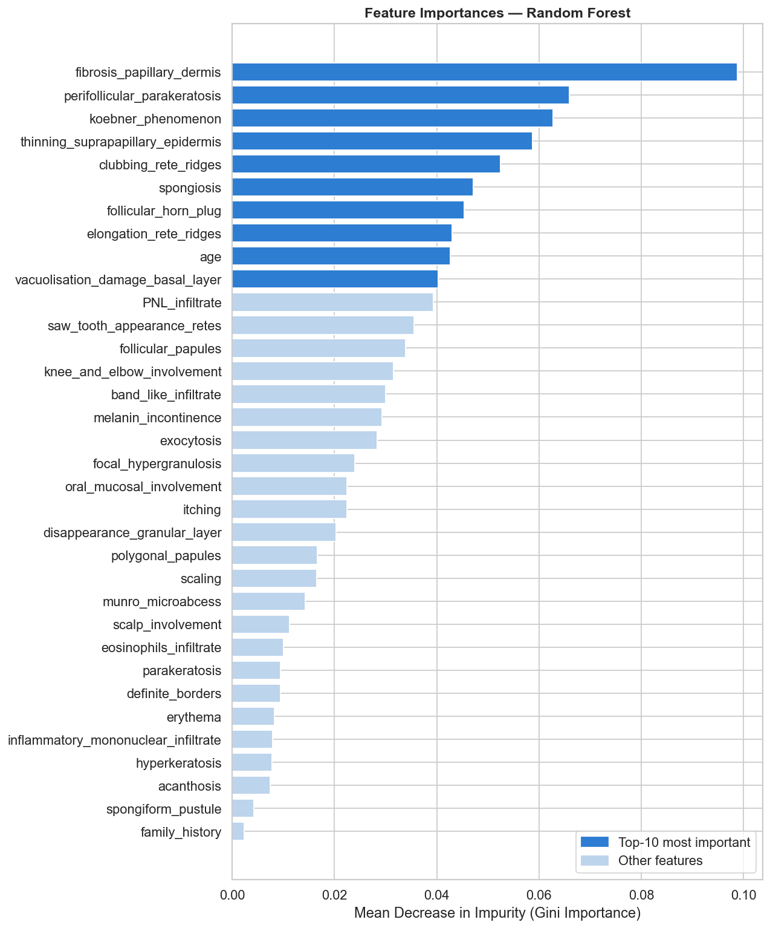
7. Interactive Prediction Dashboard (Frontend UI)
Section 6 of the Jupyter Notebook delivers a fully interactive patient assessment tool built entirely with the ipywidgets Python library — no HTML files, JavaScript, or external web server required.
7.1 UI Components
UI Component | Description
Title Banner | Dark header bar with project name displayed at the top of the dashboard
Score Guide Note | Amber info-box reminding users of the 0–3 scoring scale and binary family history
Clinical Features Panel (left) | 11 integer sliders (0–3 or 0–1) for clinically observed features with blue header
Histopathological Features Panel (right) | 22 integer sliders (0–3) for biopsy-derived features with purple header
Patient Demographics Row | Numeric input for patient age (1–110 years) with green header
Action Buttons | Predict Disease (blue) and Reset (orange) buttons below the feature panels
7.2 Prediction Output
Upon clicking the Predict Disease button, three outputs are rendered instantly:
- Result Card: A color-coded banner (each disease has a unique colour) displaying the predicted disease name and a clinically accurate description.
- Probability Bar Chart: A horizontal bar chart showing the model's confidence (%) across all 6 disease classes, with the predicted class's bar outlined in black for emphasis.
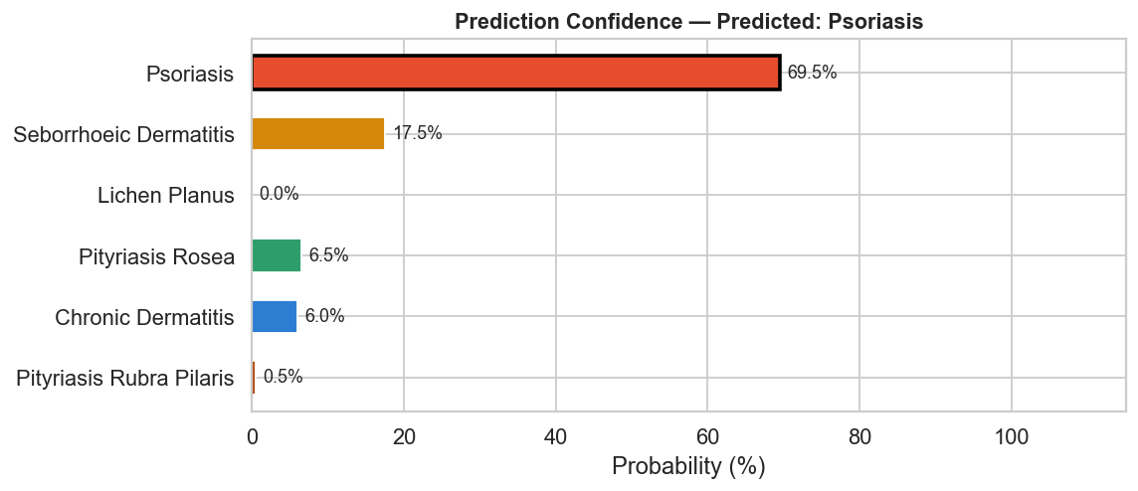
- Top Feature Chart: A horizontal bar chart of the top 8 model features, with patient-specific values > 0 highlighted in blue to indicate which features are actively contributing to the prediction.
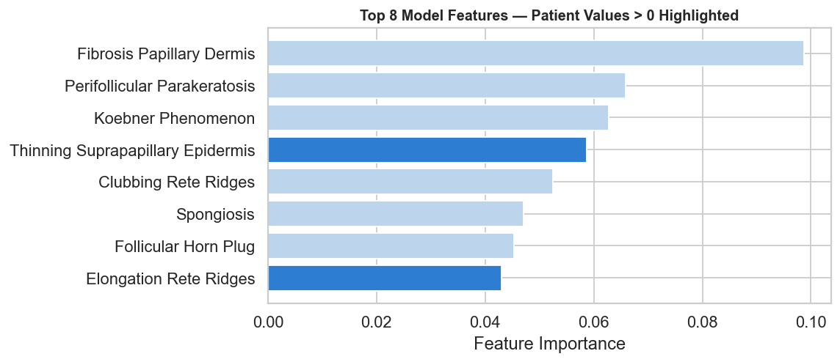
Figure 5: Interactive Dashboard Screenshot — The top panel shows the two-column slider interface (Clinical Features left, Histopathological Features right) with the Patient Demographics row and action buttons. The bottom panel shows an example prediction output: result card, probability bar chart, and top feature importance chart.
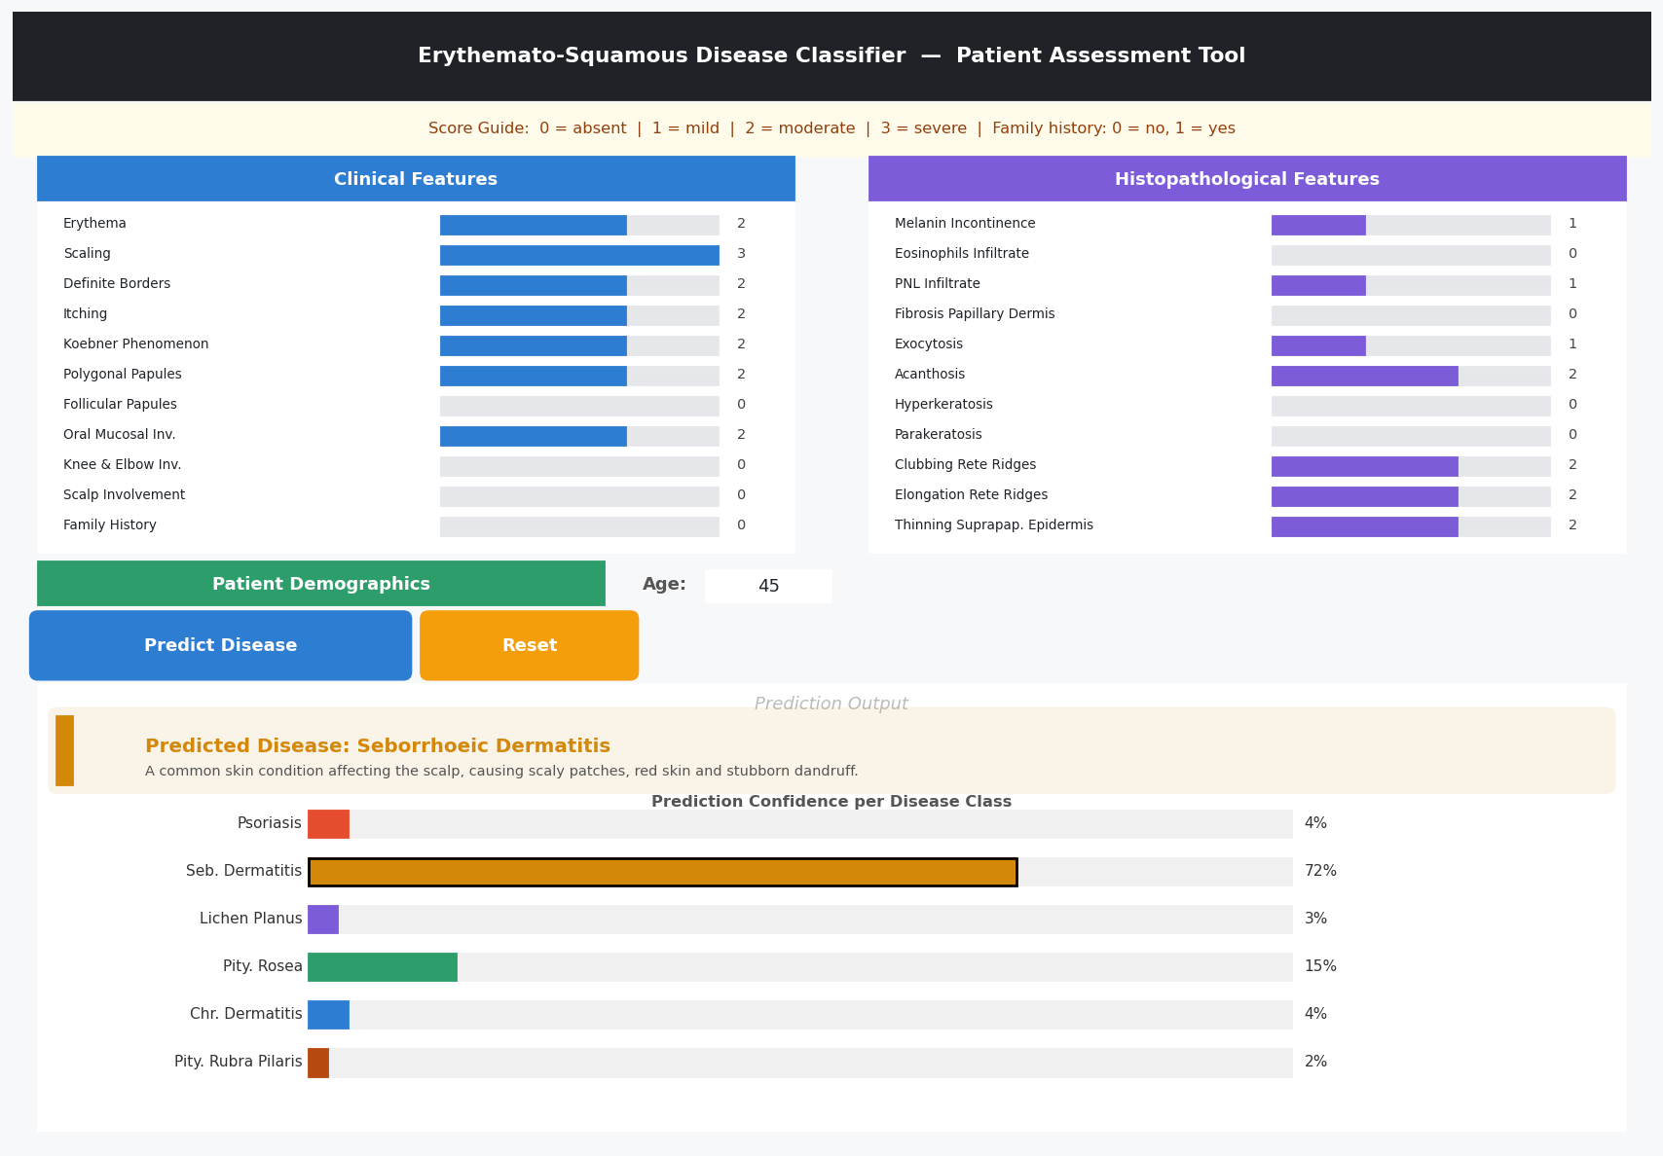
7.3 Usage Instructions
- Step 1 — Run All Cells: Open the notebook in Jupyter and select Kernel → Restart & Run All.
- Step 2 — Navigate to Section 6: Scroll to the Interactive Prediction Dashboard.
- Step 3 — Enter Patient Data: Adjust sliders (0–3) for clinical and histopathological features; set patient age.
- Step 4 — Predict: Click the '🔍 Predict Disease' button to generate the prediction.
- Step 5 — Reset: Click '↺ Reset' to clear all inputs and start a fresh assessment.
8. Conclusion
This project demonstrates that machine learning can reliably automate the classification of Erythemato-Squamous Diseases from structured clinical and histopathological data. The Random Forest classifier trained on the UCI Dermatology dataset achieved a test-set accuracy of 95.95% and a 5-fold cross-validated accuracy of 97.81% (± 1.10%), underscoring its strong generalization capability.
Four of the six disease classes — Psoriasis, Lichen Planus, Chronic Dermatitis, and Pityriasis Rubra Pilaris — were classified with perfect precision and recall on the test set. The only errors occurred between Seborrheic Dermatitis and Pityriasis Rosea (3 total misclassifications out of 74 test samples), which is consistent with the documented clinical overlap between these two conditions.
Feature importance analysis identified fibrosis of the papillary dermis, perifollicular parakeratosis, and Koebner phenomenon as the three most diagnostically discriminative features — findings that align with established dermatological knowledge.
The interactive prediction dashboard (Section 6 of the notebook) provides a practical, ready-to-use clinical decision-support tool. Built entirely with Python and ipywidgets, it requires no web server, no JavaScript, and no additional infrastructure — clinicians can run the notebook locally, enter patient observations, and receive an instant, probability-calibrated diagnosis with feature-level explainability.
Future Work
Potential extensions to this project include: (i) experimenting with gradient-boosted models (XGBoost, LightGBM) for further accuracy gains; (ii) applying SHAP (SHapley Additive exPlanations) for per-patient local interpretability; (iii) deploying the model as a lightweight REST API using FastAPI or Flask; and (iv) integrating with electronic health record (EHR) systems for real-world clinical deployment.
In summary, this project validates the viability of an automated ESD diagnosis system and provides a solid, interpretable, and clinically meaningful foundation for further development.

