PL/SQL Exercises

**Exercise 1: Control Structures**

**Scenario 1:**

The bank wants to apply a discount to loan interest rates for customers above 60 years old.

* + Question: Write a PL/SQL block that loops through all customers, checks their age, and if they are above 60, apply a 1% discount to their current loan interest rates.

**PL/SQL QUERY :**

BEGIN

FOR rec IN (

SELECT customer_id

FROM customers

WHERE age > 60

) LOOP

UPDATE loans

SET interest_rate = interest_rate - 0.01

WHERE customer_id = rec.customer_id;

DBMS_OUTPUT.PUT_LINE('Discount applied to Customer ID: ' || rec.customer_id);

END LOOP;

END;

**OUTPUT :**

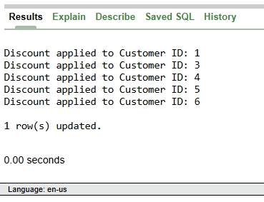

**Scenario 2:**

A customer can be promoted to VIP status based on their balance.

* + Question: Write a PL/SQL block that iterates through all customers and sets a flag IsVIP to TRUE for those with a balance over $10,000.

**PL/SQL QUERY :**

BEGIN

FOR rec IN (

SELECT customer_id

FROM customers

WHERE balance > 10000

) LOOP

UPDATE customers

SET IsVIP = 'TRUE'

WHERE customer_id = rec.customer_id;

DBMS_OUTPUT.PUT_LINE('Customer ID ' || rec.customer_id || ' promoted to VIP.');

END LOOP;

END;

**OUTPUT :**

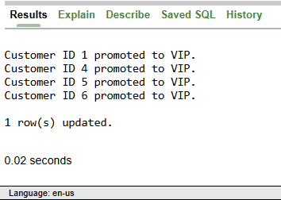

**Scenario 3**: The bank wants to send reminders to customers whose loans are due within the next 30 days.

* + Question: Write a PL/SQL block that fetches all loans due in the next 30 days and prints a reminder message for each customer.

**PL/SQL QUERY :**

BEGIN

FOR rec IN (

SELECT l.loan_id, c.customer_id, c.name, l.due_date

FROM loans l

JOIN customers c ON l.customer_id = c.customer_id

WHERE l.due_date BETWEEN SYSDATE AND SYSDATE + 30

) LOOP

DBMS_OUTPUT.PUT_LINE('Reminder: Loan ID ' || rec.loan_id ||

' for Customer ' || rec.name ||

' is due on ' || TO_CHAR(rec.due_date, 'DD-MON-YYYY'));

END LOOP;

END;

**OUTPUT :**

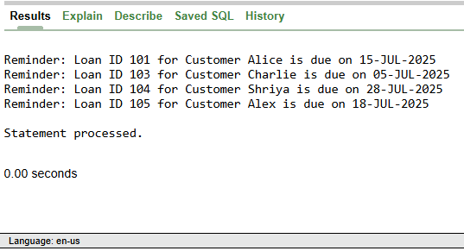

**SELECT * FROM customers;**

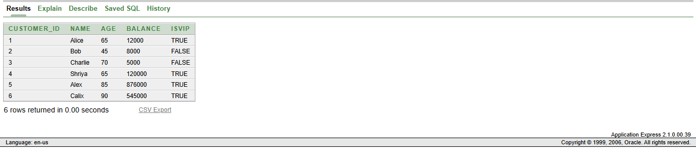

**SELECT * FROM loans;**

