PL/SQL Exercises

**Exercise 3: Stored Procedures**

**Scenario 1:**

The bank needs to process monthly interest for all savings accounts.

* + **Question:** Write a stored procedure **ProcessMonthlyInterest** that calculates and updates the balance of all savings accounts by applying an interest rate of 1% to the current balance.

**PL/SQL QUERY :**

CREATE OR REPLACE PROCEDURE ProcessMonthlyInterest IS

BEGIN

UPDATE savings_account

SET balance = balance + (balance * 0.01);

COMMIT;

END;

/

BEGIN

ProcessMonthlyInterest;

END;

/

SELECT * FROM savings_account;

**OUTPUT :**

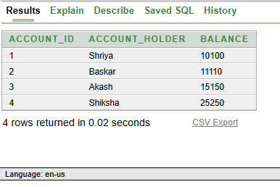

**Scenario 2:**

The bank wants to implement a bonus scheme for employees based on their performance.

* + Question: Write a stored procedure UpdateEmployeeBonus that updates the salary of employees in a given department by adding a bonus percentage passed as a parameter.

**PL/SQL QUERY :**

CREATE OR REPLACE PROCEDURE UpdateEmployeeBonus(

p_department_id IN NUMBER,

p_bonus_percent IN NUMBER

) IS

BEGIN

UPDATE employees_

SET salary = salary + (salary * (p_bonus_percent / 100))

WHERE department_id = p_department_id;

END;

/

BEGIN

UpdateEmployeeBonus(10, 5); -- Example: Add 5% bonus to dept 10

END;

/

SELECT * FROM employees_;

**OUTPUT :**

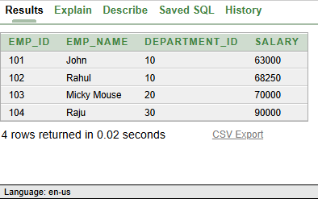

**Scenario 3**: Customers should be able to transfer funds between their accounts.

* + **Question:** Write a stored procedure **TransferFunds** that transfers a specified amount from one account to another, checking that the source account has sufficient balance before making the transfer.

**PL/SQL QUERY :**

CREATE OR REPLACE PROCEDURE TransferFunds(

p_from_account_id IN NUMBER,

p_to_account_id IN NUMBER,

p_amount IN NUMBER

) IS

v_balance NUMBER;

BEGIN

-- Get balance of source account

SELECT balance INTO v_balance

FROM accounts_

WHERE account_id = p_from_account_id;

-- Check sufficient balance

IF v_balance < p_amount THEN

RAISE_APPLICATION_ERROR(-20001, 'Insufficient funds in source account.');

END IF;

-- Deduct from source account

UPDATE accounts_

SET balance = balance - p_amount

WHERE account_id = p_from_account_id;

-- Add to target account

UPDATE accounts_

SET balance = balance + p_amount

WHERE account_id = p_to_account_id;

COMMIT;

END;

/

BEGIN

TransferFunds(101, 102, 500);

END;

/

SELECT * FROM accounts__;

**OUTPUT :**

