SOFTWARE REQUIREMENTS SPECIFICATION (SRS)
Team H3 | Online Internship & Placement Preparation Portal

1. Introduction

1.1 Purpose
This Software Requirements Specification defines the functional, non-functional, security and interface requirements of the Online Internship & Placement Preparation Portal. It provides a baseline for architecture, implementation, testing and validation.

1.2 Scope
The portal centralizes internship and placement opportunity discovery, applications, aptitude tests, preparation progress tracking and analytics for students, administrators and recruiters.

1.3 Intended Users
User Class | Description
Student/Candidate | Finds opportunities, applies, takes aptitude tests and tracks preparation/application progress.
Administrator | Manages users, opportunities, aptitude tests and system information.
Recruiter/Company | Posts internship/placement opportunities and manages candidate applications.

1.4 Definitions and Acronyms
Term | Meaning
FR | Functional Requirement
NFR | Non-Functional Requirement
SR | Security Requirement
RTM | Requirements Traceability Matrix
RBAC | Role-Based Access Control

2. Overall Description

2.1 Product Perspective
The system is a web-based portal with a user interface, application/service layer, security services and relational persistence.

2.2 Product Functions
- Registration and authentication
- Role-based access
- Profile management
- Opportunity browsing, search and filtering
- Opportunity applications and status tracking
- Aptitude tests and results
- Preparation progress tracking
- Analytics
- Administrator and recruiter management

2.3 Assumptions and Constraints
- Users have internet access and a supported browser.
- Users provide valid registration information.
- Administrators and recruiters have appropriate permissions.
- A relational database is used for persistent storage.
- The initial version does not automate hiring decisions or guarantee placement.
- Implementation may use a Python-based web stack or JavaScript MERN stack.

3. Specific Requirements

3.1 Functional Requirements
ID | Name | Requirement
FR-01 | User Registration | The system shall allow a new user to create an account.
FR-02 | User Login | The system shall authenticate registered users.
FR-03 | Role Management | The system shall provide role-based access for students, administrators and recruiters.
FR-04 | Profile Management | The system shall allow students to create and update profiles.
FR-05 | Browse Opportunities | The system shall display available internship and placement opportunities.
FR-06 | Search and Filter | The system shall allow users to search and filter opportunities.
FR-07 | Apply for Opportunity | The system shall allow eligible students to submit applications.
FR-08 | Track Application | The system shall allow students to view application status.
FR-09 | Aptitude Tests | The system shall allow students to attempt available aptitude tests.
FR-10 | Test Results | The system shall display aptitude-test scores/results.
FR-11 | Progress Tracking | The system shall record relevant preparation activities and progress.
FR-12 | Analytics Dashboard | The system shall provide statistics on applications, tests and preparation progress.
FR-13 | Manage Opportunities | Authorized administrators/recruiters shall create, update and manage opportunity listings.
FR-14 | Manage Aptitude Tests | Authorized administrators shall create and manage aptitude tests.
FR-15 | Manage Users | Authorized administrators shall manage registered users.
FR-16 | Application Management | Recruiters shall view and update candidate application statuses.

3.2 Non-Functional Requirements
ID | Category | Requirement
NFR-01 | Performance | At least 95% of common requests shall receive a response within 2 seconds under 100 concurrent users.
NFR-02 | Security | All protected functions shall require authentication and role authorization; unauthorized requests shall be rejected.
NFR-03 | Usability | A first-time student shall be able to locate an opportunity using search/filter controls in no more than 4 UI steps.
NFR-04 | Reliability | Failed transactions shall roll back partial database changes and shall not corrupt valid stored data.
NFR-05 | Availability | The portal shall provide at least 99% monthly availability during the defined operating period, excluding scheduled maintenance.
NFR-06 | Scalability | The architecture shall support at least 10,000 registered users and 100,000 opportunity/application records without redesign of core services.
NFR-07 | Maintainability | Functionality shall be organized into independently identifiable modules with documented interfaces.
NFR-08 | Compatibility | The portal shall support the two latest stable versions of Chrome, Firefox and Edge.
NFR-09 | Data Integrity | Database constraints shall reject updates that violate required referential or domain integrity rules.

3.3 Security Objectives
ID | Objective
SO-01 | Protect credentials and sensitive profile/application information from unauthorized access.
SO-02 | Ensure users can perform only actions permitted by their assigned role.
SO-03 | Preserve integrity and accountability of application, test and administrative data.

3.4 Security Requirements
ID | Category | Requirement
SR-01 | Authentication | Protected functions shall require authenticated credentials.
SR-02 | Password Protection | Passwords shall be stored only as salted one-way hashes and never as plaintext.
SR-03 | Authorization | Role-restricted functions shall reject users without the required permission.
SR-04 | Session Security | Authenticated sessions shall expire after 30 minutes of inactivity.
SR-05 | Input Validation | User-controlled input shall be validated and safely handled before processing or persistence.
SR-06 | Auditability | Security-relevant administrative actions shall record user ID, action, timestamp and result.

4. External Interface Requirements
Interface | Requirement
User Interface | Responsive web interface for student, administrator and recruiter workflows.
API | Authenticated service/API endpoints shall expose portal operations to the UI.
Database | Application services shall use a relational database for persistent data.
Browser | Portal shall support the browser versions specified by NFR-08.

5. Use Cases
Use Case | Actor | Outcome
Register/Login | Student, Admin, Recruiter | User is authenticated and receives role-based access.
Manage Profile | Student | Profile is created or updated.
Browse/Search Opportunities | Student | Relevant opportunities are displayed.
Apply for Opportunity | Student | Eligible application is stored and trackable.
Track Applications | Student | Current application statuses are displayed.
Take Aptitude Test | Student | Answers are submitted and evaluated.
View Analytics | Student/Admin | Statistics and progress information are displayed.
Manage Opportunities | Admin/Recruiter | Opportunity information is created/updated/managed.
Manage Aptitude Tests | Admin | Tests/questions are created or updated.
Manage Applications | Recruiter | Applications are reviewed and statuses updated.

6. UML Use Case Diagram
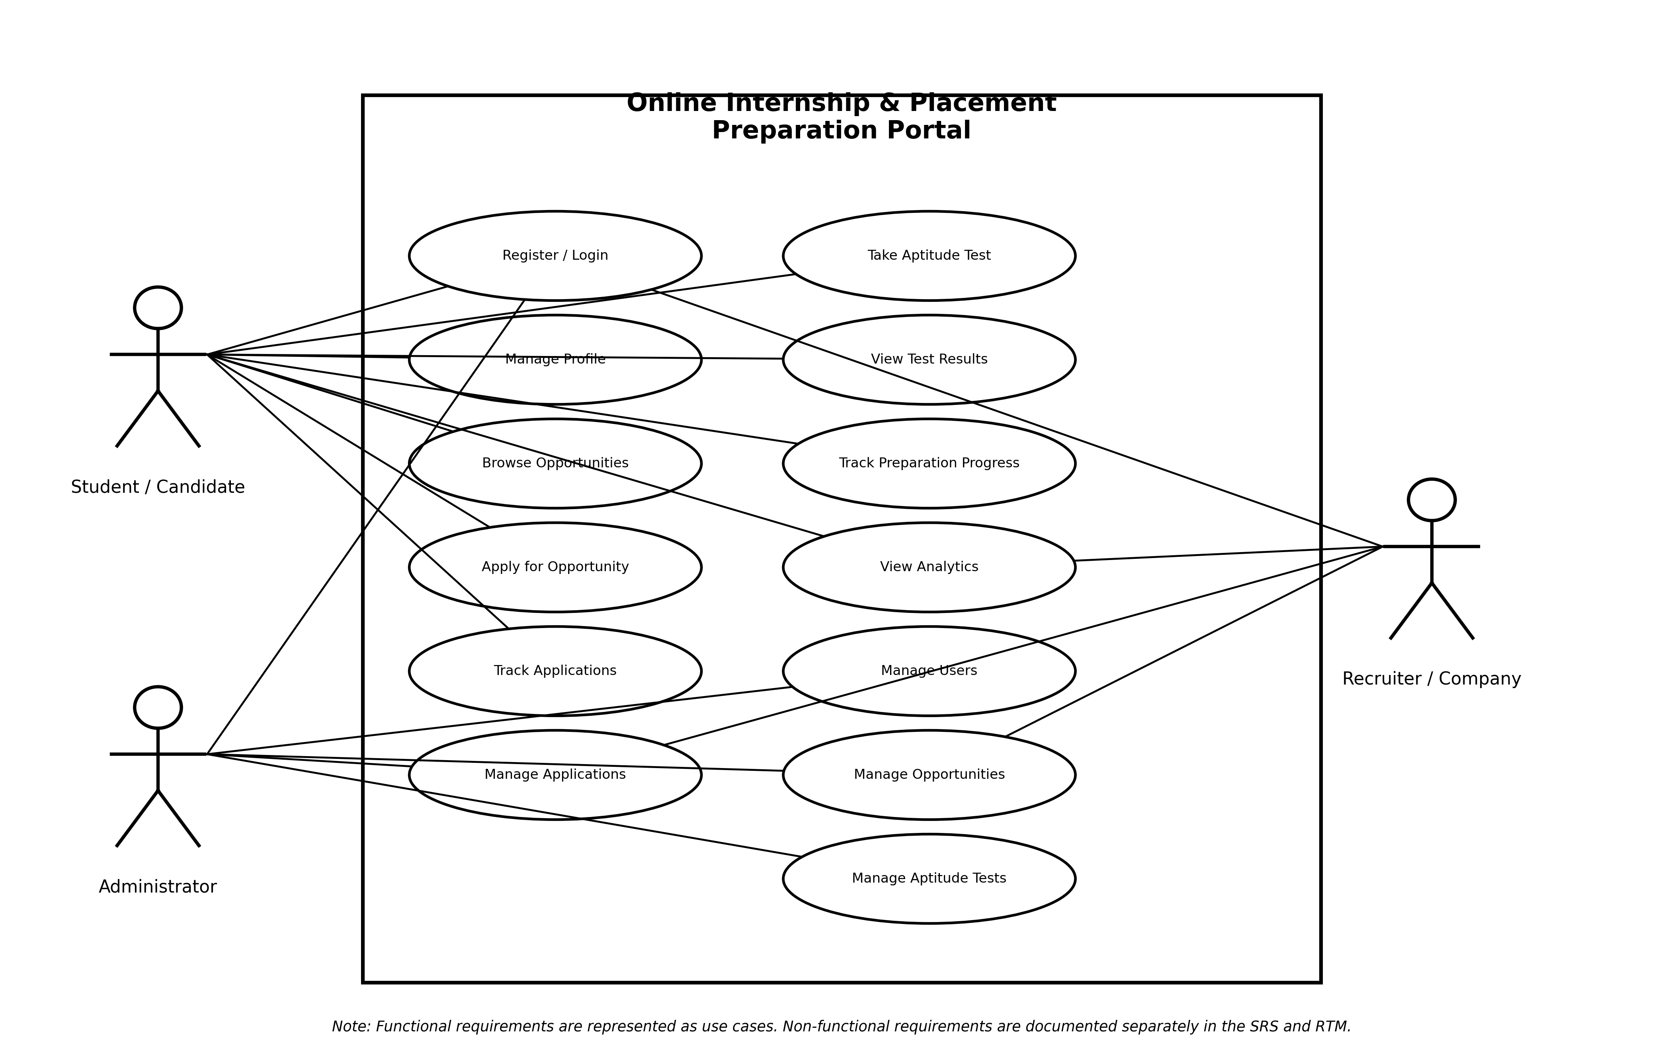
Figure 1. UML Use Case Diagram

7. Requirements Traceability Matrix
Req ID | Use Case | Actor | Module
FR-01 | Register/Login | Student/Recruiter | Authentication
FR-02 | Register/Login | Student/Admin/Recruiter | Authentication
FR-03 | Role-based Access | All roles | Authorization
FR-04 | Manage Profile | Student | Student Profile
FR-05 | Browse Opportunities | Student | Opportunity
FR-06 | Search/Filter Opportunities | Student | Opportunity
FR-07 | Apply | Student | Application
FR-08 | Track Applications | Student | Application
FR-09 | Take Aptitude Test | Student | Test
FR-10 | View Test Results | Student | Test
FR-11 | Track Progress | Student | Progress
FR-12 | View Analytics | Student/Admin | Analytics
FR-13 | Manage/Post Opportunities | Admin/Recruiter | Opportunity
FR-14 | Manage Aptitude Tests | Admin | Test
FR-15 | Manage Users | Admin | Administration
FR-16 | View/Update Applications | Recruiter | Application

8. Acceptance Criteria
- Every FR has a corresponding observable system behavior.
- Every NFR has a measurable acceptance criterion.
- Every security requirement has at least one validation test.
- Requirements remain traceable to design components and test cases.

