SOFTWARE ARCHITECTURE & DESIGN SPECIFICATION
Team H3 | Online Internship & Placement Preparation Portal

1. Introduction

1.1 Purpose
Defines the architecture and detailed design of the Online Internship & Placement Preparation Portal and traces design elements to requirements and validation.

1.2 Design Goals
- Separate presentation, business logic and persistence.
- Enforce role-based authorization at service boundaries.
- Keep domain modules independently maintainable.
- Support future growth in users and records.

2. Architecture

2.1 Architecture Pattern
Layered modular architecture: Presentation Layer → API/Service Layer → Domain/Business Services → Data Access/Persistence, with cross-cutting Security and Audit services.

2.2 Component Diagram
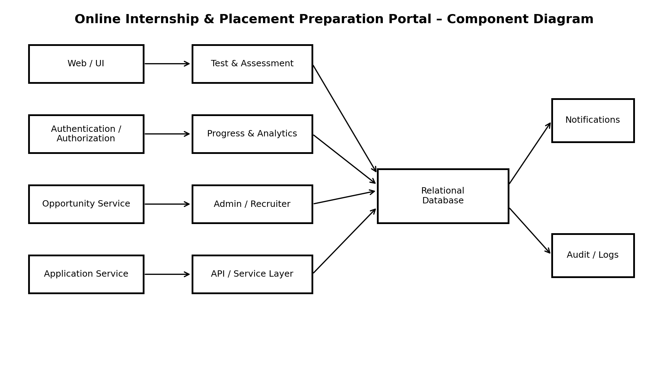
Figure 1. Component Diagram

2.3 Component Descriptions
Component | Description
Web/UI | Student, administrator and recruiter interfaces.
Authentication/Authorization | Registration, login, sessions and role checks.
Opportunity Service | Listing creation, browsing, search and filtering.
Application Service | Application submission and status management.
Test & Assessment | Tests, submissions, scoring and results.
Progress & Analytics | Preparation activity and statistics.
Admin/Recruiter Management | Privileged management operations.
API/Service Layer | Controlled communication between UI and services.
Relational Database | Persistent portal records.
Notifications/Audit | Confirmation messages and security records.

2.4 Architecture Traceability
Requirement | Component
FR-01–FR-03 | Authentication/Authorization
FR-04 | Web/UI + Student Profile
FR-05–FR-06 | Opportunity Service
FR-07–FR-08, FR-16 | Application Service
FR-09–FR-10, FR-14 | Test & Assessment
FR-11–FR-12 | Progress & Analytics
FR-13, FR-15 | Admin/Recruiter Management
NFR-01, NFR-06 | Service Layer + Database
NFR-02, SR-01–SR-06 | Security/Audit
NFR-07 | Modular Components
NFR-08 | Web/UI
NFR-09 | Database

2.5 Security Architecture
- Authenticate users before protected operations.
- Apply RBAC for Student, Administrator and Recruiter roles.
- Store passwords as salted one-way hashes.
- Use HTTPS/TLS in deployed environments.
- Validate user input before processing and persistence.
- Record security-relevant administrative actions.
- Expire sessions after 30 minutes of inactivity.
- Restrict database access to service/data-access components.

3. Detailed Design

3.1 UML Sequence Diagram 1 – Login and Browse
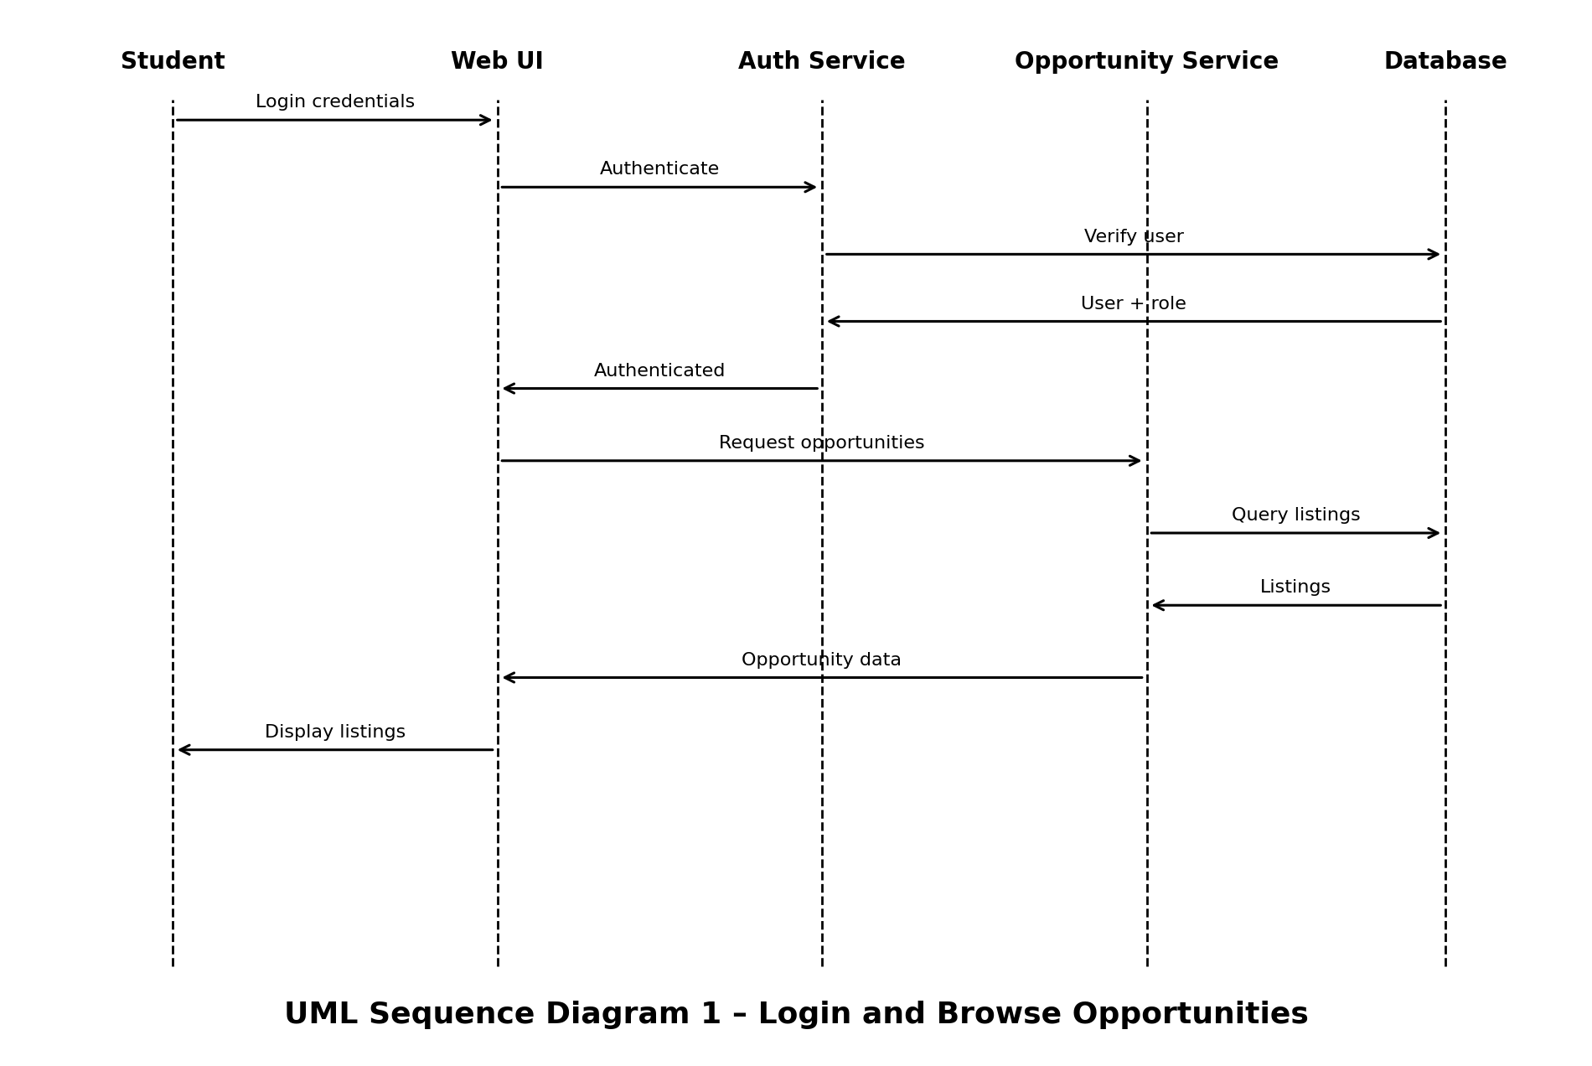

3.2 UML Sequence Diagram 2 – Apply for Opportunity
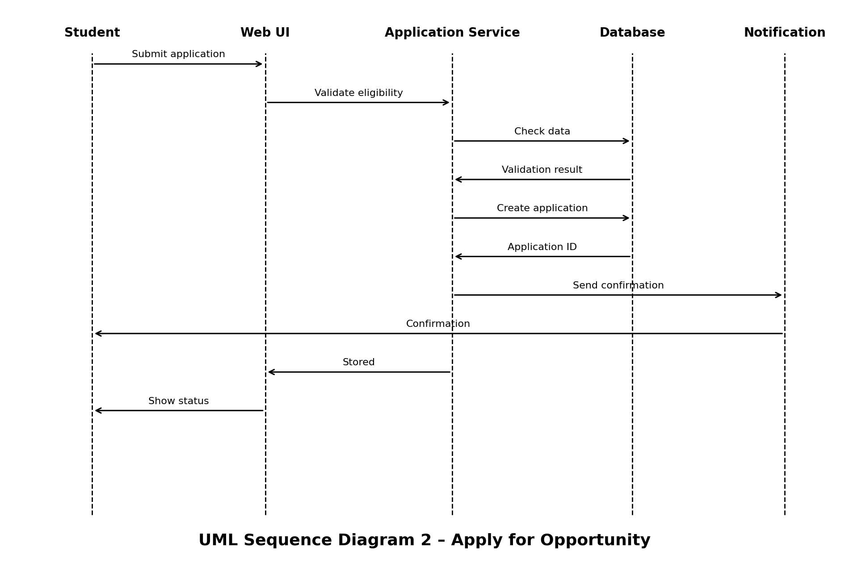

3.3 API Design
Method | Endpoint | Purpose | Req
POST | /api/auth/register | Register user | FR-01
POST | /api/auth/login | Authenticate | FR-02
GET | /api/opportunities | Browse/search/filter | FR-05/FR-06
POST | /api/opportunities/{id}/applications | Submit application | FR-07
GET | /api/applications | View applications | FR-08
PATCH | /api/applications/{id}/status | Update status | FR-16
GET | /api/tests | List tests | FR-09
POST | /api/tests/{id}/attempts | Submit attempt | FR-09/FR-10
GET | /api/analytics | View analytics | FR-12
POST | /api/opportunities | Create opportunity | FR-13
POST | /api/tests | Create aptitude test | FR-14
GET | /api/admin/users | Manage users | FR-15

3.4 API Response Design
Success: { success: true, data: <payload>, message: <optional> }
Error: { success: false, errorCode: <code>, message: <safe message>, details: <optional validation details> }

3.5 Error Handling
HTTP Code | Handling
400 | Malformed or invalid input; return validation errors.
401 | Authentication missing/invalid; require login.
403 | Authenticated but insufficient permission.
404 | Resource not found or inaccessible.
409 | State conflict, e.g. duplicate application.
422 | Valid syntax but invalid business/domain data.
500 | Unexpected failure; log technical details server-side and return safe client message.

3.6 Data Validation and Integrity
- Validate required fields before DB operations.
- Validate identifiers before lookup/update.
- Prevent duplicate applications where business rules disallow them.
- Enforce foreign-key relationships.
- Check authorization before privileged operations.

4. Design Traceability
Requirement | Design Element | Validation
FR-01/FR-02/FR-03 | Auth service/API | TC-01/02/03
FR-05/FR-06 | Opportunity service/API | TC-04
FR-07/FR-08/FR-16 | Application service/API | TC-05/06
FR-09/FR-10 | Assessment service/API | TC-07
FR-11/FR-12 | Progress/Analytics | TC-08
NFR-01 | Service/deployment | TC-09
NFR-02/SR-01/SR-03/SR-04 | Security architecture | TC-10/12
NFR-09/SR-05 | Validation/database | TC-11
SR-02 | Credential storage | TC-13
SR-06 | Audit logging | TC-14

5. Assumptions and Constraints
- Relational database used for persistence.
- Python-based or MERN implementation is acceptable per SRS.
- External job portals remain out of scope.
- Logical service boundaries should remain stable even if deployment technology changes.

