Task 2-linux CLI Assignment
Create new users and groups

Step 1: Create a Group
sudo groupadd devgroup
Step 2: Create a User and Add to Group
sudo useradd -m -G devgroup devuser
sudo passwd devuser
- -m: creates a home directory for the user
- -G: adds user to specified group
Step 3: Verify User and Group
id devuser
groups devuser

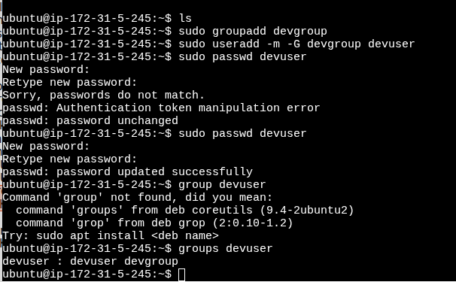

Change File Ownership and Permissions

Step 1: Create a File
touch hello.txt

Step 2: Change Ownership
sudo chown devuser:devgroup hello.txt
- chown user:group filename sets ownership

Step 3: Change Permissions
sudo chmod u+rwx,g+rw,o+r hello.txt
- Gives:
  - User: read, write, execute
  - Group: read, write
  - Others: read

Step 4: Verify Permissions
ls -l hello.tx
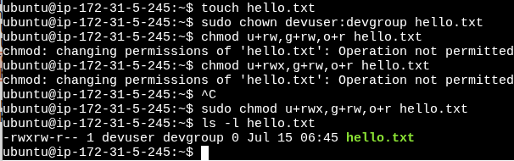

Manage System Services with systemctl with Nginx

Step 1: Install nginx
sudo apt update
sudo apt install nginx -y

Step 2: Start nginx Service
sudo systemctl start nginx

Step 3: Enable nginx on Boot
sudo systemctl enable nginx

Step 4: Check nginx Status
sudo systemctl status nginx
Expected:
