Task 5 – Docker Assignment
- Step 1 – Created a simple Python Django project
- Step 2 – Built a Django app to display an animated HTML success page and tested it locally
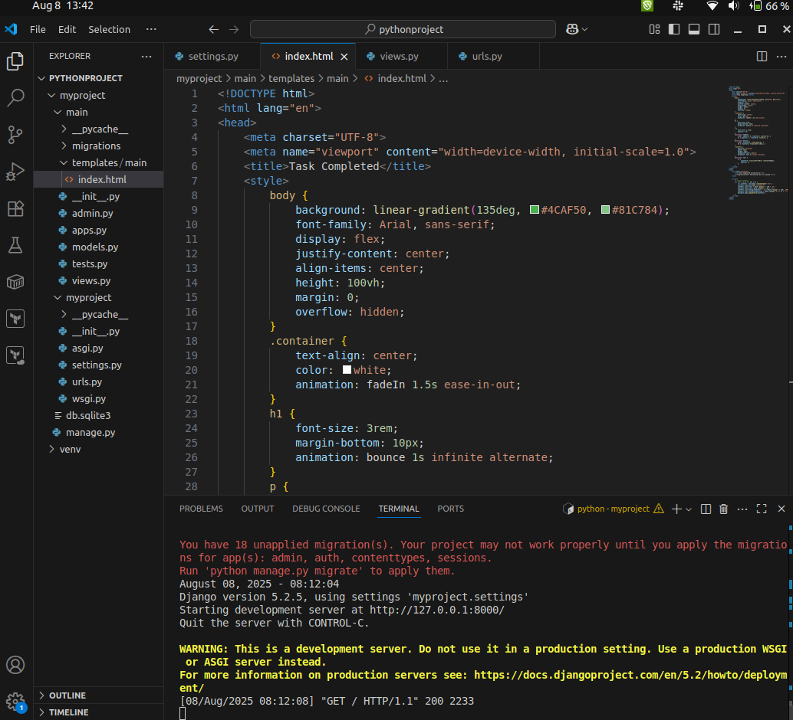
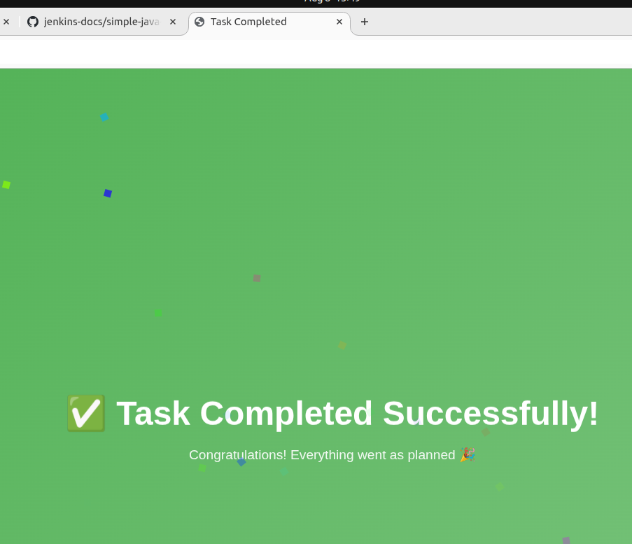

- Step3 – create a requirement.txt file
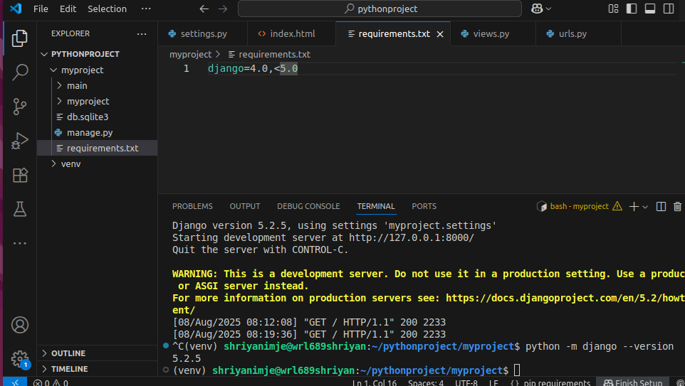

- Step4 – creating a basic docker file with expose port 5000
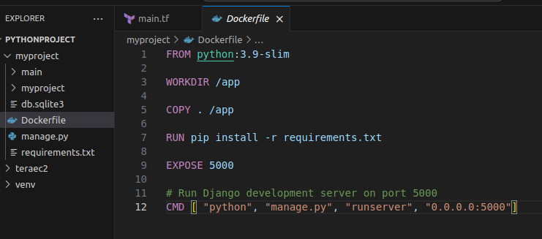

- Step5 – Building Docker image
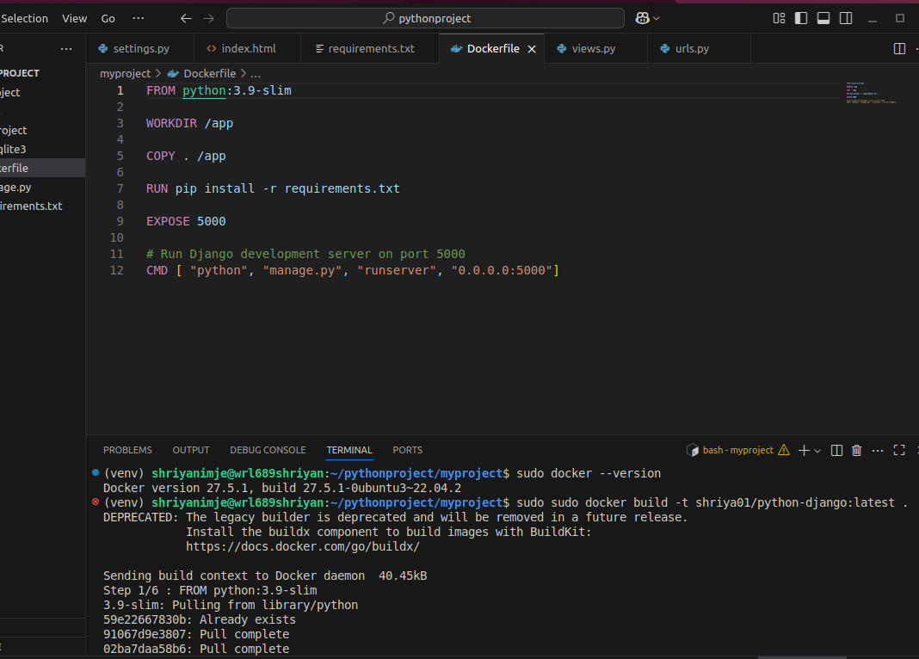

- Step6 – Running docker container locally
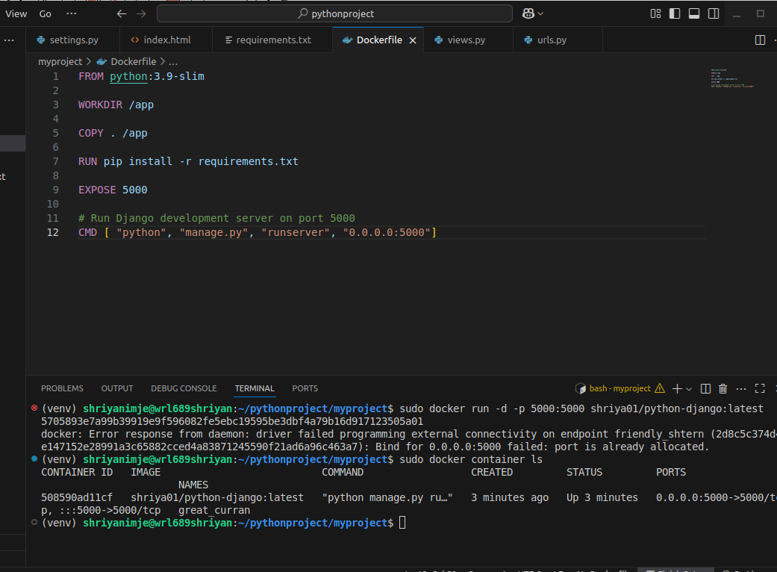
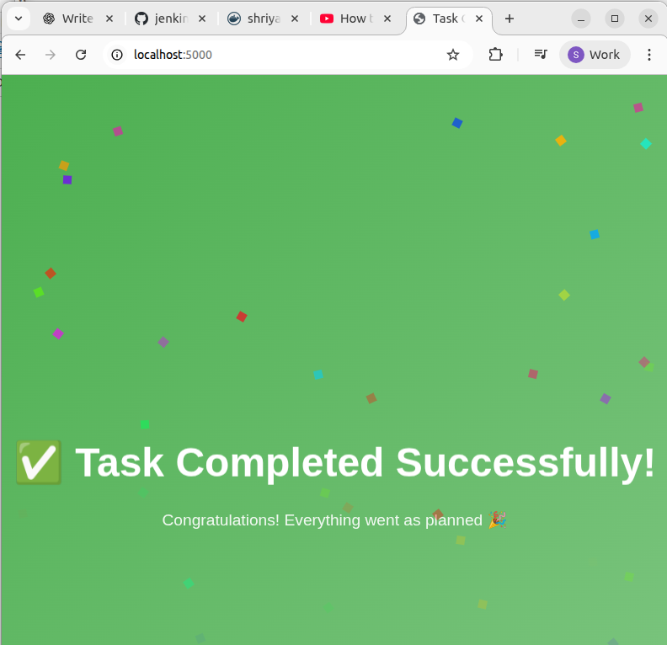

- Step7 – Pushing Image to docker hub
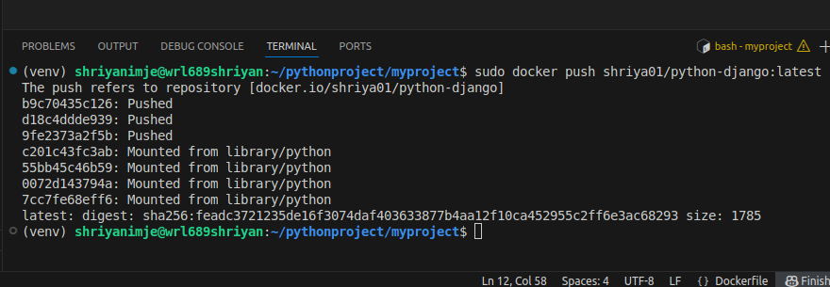
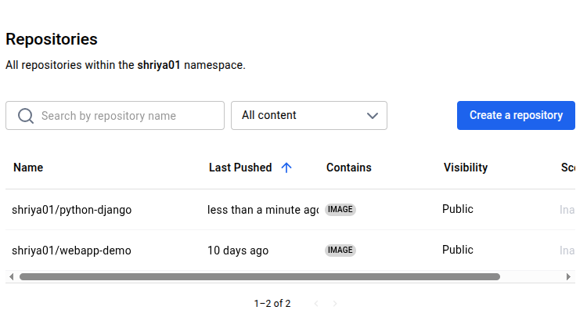

Docker+Terraform
- Using Terraform to create an EC2 instance and perform the following tasks:
  - Create a main.tf file.
  - Create an EC2 instance using an Ubuntu AMI.
  - Start the instance.
  - Install Docker on it.
  - Pull a container image from Docker Hub.
  - Run the container, exposing it on the instance's public IP on port 5000.
